Nombre

# C:\Documents and Settings\admin\Mis documentos\Mis imágenes\CAC75JYQ.jpg

# Para empezar a conocernos, escribe tu nombre y pega tu foto.

Me llamo_________________________________

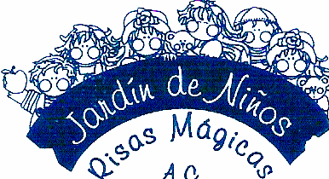

Nombre

Colorea de rojo las vocales mayúsculas y de color azul las minúsculas.





Nombre

Con recortes pega una actividad que realices por la mañana, tarde y noche.

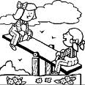



Nombre

Dibuja a los miembros de tu familia.

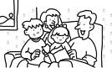



Nombre

Árbol familiar

Observa la ilustración y pega fotos de tu familia donde corresponda.

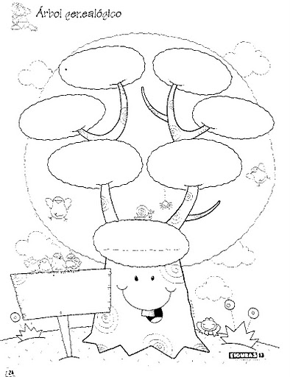

Nombre

Escucha el cuento de los abuelos y haz un dibujo.

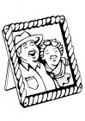



Nombre

Colorea con crayola la figura que corresponda según seas.

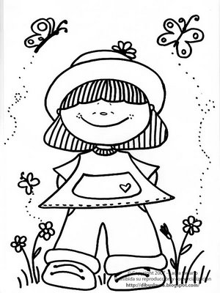 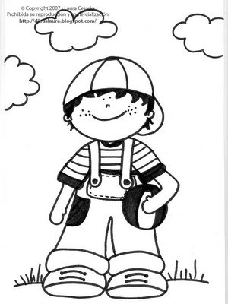

Soy niña o niño



Nombre

# C:\Documents and Settings\admin\Mis documentos\Mis imágenes\CALRFHWW.jpg

“Yo vivo aquí y esta es mi comunidad”

Recorta y pega de diferentes portadores de texto algunos dibujos como referencia de cómo podemos llegar a tu casa.



Nombre

Encierra en un círculo el objeto pequeño y colorea el grande. 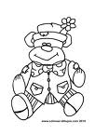

Grande

 

Pequeño

Nombre

Pega objetos grandes y pequeños donde se indica.

Grandes Pequeños



Nombre

Tacha el dibujo de la conducta que crees que sea la correcta.

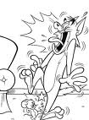

 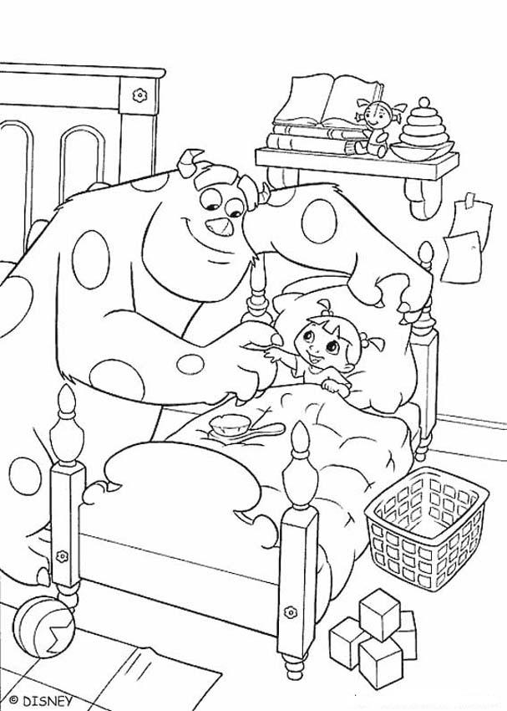

Nombre

Decora el punto y pega con material variado diferentes puntos.

Punto

˚



Nombre

Decora la línea y con diversidad de materiales pega líneas.

Línea



Nombre

Cuenta las colecciones de objetos y pon el número dentro del cuadro.

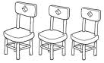 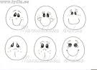

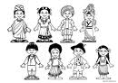 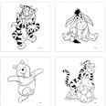

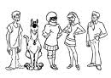 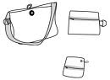

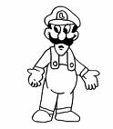 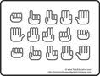



Nombre

Escucha el cuento de “Tomas y Tita” de tu libro de cuenta cuentos e ilustra con recortes lo que más te gusto.



Nombre

Decora con material variado la letra M m

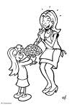

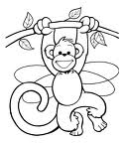



Nombre

Continúa con los ejercicios de caligrafía ubicando el cuadro.

Ejercicio 1

|  |  |  |  |  |  |  |  |  |  |  |  |  |  |  |  |  |  |  |  |
| --- | --- | --- | --- | --- | --- | --- | --- | --- | --- | --- | --- | --- | --- | --- | --- | --- | --- | --- | --- |
|  |  |  |  |  |  |  |  |  |  |  |  |  |  |  |  |  |  |  |  |
|  |  |  |  |  |  |  |  |  |  |  |  |  |  |  |  |  |  |  |  |
|  |  |  |  |  |  |  |  |  |  |  |  |  |  |  |  |  |  |  |  |
|  |  |  |  |  |  |  |  |  |  |  |  |  |  |  |  |  |  |  |  |
|  |  |  |  |  |  |  |  |  |  |  |  |  |  |  |  |  |  |  |  |
|  |  |  |  |  |  |  |  |  |  |  |  |  |  |  |  |  |  |  |  |

Ejercicio 2

|  |  |  |  |  |  |  |  |  |  |  |  |  |  |  |  |  |  |  |  |
| --- | --- | --- | --- | --- | --- | --- | --- | --- | --- | --- | --- | --- | --- | --- | --- | --- | --- | --- | --- |
|  |  |  |  |  |  |  |  |  |  |  |  |  |  |  |  |  |  |  |  |
|  |  |  |  |  |  |  |  |  |  |  |  |  |  |  |  |  |  |  |  |
|  |  |  |  |  |  |  |  |  |  |  |  |  |  |  |  |  |  |  |  |
|  |  |  |  |  |  |  |  |  |  |  |  |  |  |  |  |  |  |  |  |
|  |  |  |  |  |  |  |  |  |  |  |  |  |  |  |  |  |  |  |  |
|  |  |  |  |  |  |  |  |  |  |  |  |  |  |  |  |  |  |  |  |

Ejercicio 3

|  |  |  |  |  |  |  |  |  |  |  |  |  |  |  |  |  |  |  |  |
| --- | --- | --- | --- | --- | --- | --- | --- | --- | --- | --- | --- | --- | --- | --- | --- | --- | --- | --- | --- |
|  |  |  |  |  |  |  |  |  |  |  |  |  |  |  |  |  |  |  |  |
|  |  |  |  |  |  |  |  |  |  |  |  |  |  |  |  |  |  |  |  |
|  |  |  |  |  |  |  |  |  |  |  |  |  |  |  |  |  |  |  |  |
|  |  |  |  |  |  |  |  |  |  |  |  |  |  |  |  |  |  |  |  |
|  |  |  |  |  |  |  |  |  |  |  |  |  |  |  |  |  |  |  |  |
|  |  |  |  |  |  |  |  |  |  |  |  |  |  |  |  |  |  |  |  |

Ejercicio 4

|  |  |  |  |  |  |  |  |  |  |  |  |  |  |  |  |  |  |  |  |
| --- | --- | --- | --- | --- | --- | --- | --- | --- | --- | --- | --- | --- | --- | --- | --- | --- | --- | --- | --- |
|  |  |  |  |  |  |  |  |  |  |  |  |  |  |  |  |  |  |  |  |
|  |  |  |  |  |  |  |  |  |  |  |  |  |  |  |  |  |  |  |  |
|  |  |  |  |  |  |  |  |  |  |  |  |  |  |  |  |  |  |  |  |
|  |  |  |  |  |  |  |  |  |  |  |  |  |  |  |  |  |  |  |  |
|  |  |  |  |  |  |  |  |  |  |  |  |  |  |  |  |  |  |  |  |
|  |  |  |  |  |  |  |  |  |  |  |  |  |  |  |  |  |  |  |  |

Ejercicio 5

|  |  |  |  |  |  |  |  |  |  |  |  |  |  |  |  |  |  |  |  |
| --- | --- | --- | --- | --- | --- | --- | --- | --- | --- | --- | --- | --- | --- | --- | --- | --- | --- | --- | --- |
|  |  |  |  |  |  |  |  |  |  |  |  |  |  |  |  |  |  |  |  |
|  |  |  |  |  |  |  |  |  |  |  |  |  |  |  |  |  |  |  |  |
|  |  |  |  |  |  |  |  |  |  |  |  |  |  |  |  |  |  |  |  |
|  |  |  |  |  |  |  |  |  |  |  |  |  |  |  |  |  |  |  |  |
|  |  |  |  |  |  |  |  |  |  |  |  |  |  |  |  |  |  |  |  |
|  |  |  |  |  |  |  |  |  |  |  |  |  |  |  |  |  |  |  |  |



Nombre

Continúa con la plana ubicando cuadro.

Ejercicio 1

|  |  |  |  |  |  |  |  |  |  |  |  |  |  |  |  |  |  |  |  |
| --- | --- | --- | --- | --- | --- | --- | --- | --- | --- | --- | --- | --- | --- | --- | --- | --- | --- | --- | --- |
|  |  |  |  |  |  |  |  |  |  |  |  |  |  |  |  |  |  |  |  |
|  |  |  |  |  |  |  |  |  |  |  |  |  |  |  |  |  |  |  |  |
|  |  |  |  |  |  |  |  |  |  |  |  |  |  |  |  |  |  |  |  |
|  |  |  |  |  |  |  |  |  |  |  |  |  |  |  |  |  |  |  |  |
|  |  |  |  |  |  |  |  |  |  |  |  |  |  |  |  |  |  |  |  |
|  |  |  |  |  |  |  |  |  |  |  |  |  |  |  |  |  |  |  |  |

Ejercicio 2

|  |  |  |  |  |  |  |  |  |  |  |  |  |  |  |  |  |  |  |  |
| --- | --- | --- | --- | --- | --- | --- | --- | --- | --- | --- | --- | --- | --- | --- | --- | --- | --- | --- | --- |
|  |  |  |  |  |  |  |  |  |  |  |  |  |  |  |  |  |  |  |  |
|  |  |  |  |  |  |  |  |  |  |  |  |  |  |  |  |  |  |  |  |
|  |  |  |  |  |  |  |  |  |  |  |  |  |  |  |  |  |  |  |  |
|  |  |  |  |  |  |  |  |  |  |  |  |  |  |  |  |  |  |  |  |
|  |  |  |  |  |  |  |  |  |  |  |  |  |  |  |  |  |  |  |  |
|  |  |  |  |  |  |  |  |  |  |  |  |  |  |  |  |  |  |  |  |

Ejercicio 3

|  |  |  |  |  |  |  |  |  |  |  |  |  |  |  |  |  |  |  |  |
| --- | --- | --- | --- | --- | --- | --- | --- | --- | --- | --- | --- | --- | --- | --- | --- | --- | --- | --- | --- |
|  |  |  |  |  |  |  |  |  |  |  |  |  |  |  |  |  |  |  |  |
|  |  |  |  |  |  |  |  |  |  |  |  |  |  |  |  |  |  |  |  |
|  |  |  |  |  |  |  |  |  |  |  |  |  |  |  |  |  |  |  |  |
|  |  |  |  |  |  |  |  |  |  |  |  |  |  |  |  |  |  |  |  |
|  |  |  |  |  |  |  |  |  |  |  |  |  |  |  |  |  |  |  |  |
|  |  |  |  |  |  |  |  |  |  |  |  |  |  |  |  |  |  |  |  |

Ejercicio 4

|  |  |  |  |  |  |  |  |  |  |  |  |  |  |  |  |  |  |  |  |
| --- | --- | --- | --- | --- | --- | --- | --- | --- | --- | --- | --- | --- | --- | --- | --- | --- | --- | --- | --- |
|  |  |  |  |  |  |  |  |  |  |  |  |  |  |  |  |  |  |  |  |
|  |  |  |  |  |  |  |  |  |  |  |  |  |  |  |  |  |  |  |  |
|  |  |  |  |  |  |  |  |  |  |  |  |  |  |  |  |  |  |  |  |
|  |  |  |  |  |  |  |  |  |  |  |  |  |  |  |  |  |  |  |  |
|  |  |  |  |  |  |  |  |  |  |  |  |  |  |  |  |  |  |  |  |
|  |  |  |  |  |  |  |  |  |  |  |  |  |  |  |  |  |  |  |  |

Ejercicio 5

|  |  |  |  |  |  |  |  |  |  |  |  |  |  |  |  |  |  |  |  |
| --- | --- | --- | --- | --- | --- | --- | --- | --- | --- | --- | --- | --- | --- | --- | --- | --- | --- | --- | --- |
|  |  |  |  |  |  |  |  |  |  |  |  |  |  |  |  |  |  |  |  |
|  |  |  |  |  |  |  |  |  |  |  |  |  |  |  |  |  |  |  |  |
|  |  |  |  |  |  |  |  |  |  |  |  |  |  |  |  |  |  |  |  |
|  |  |  |  |  |  |  |  |  |  |  |  |  |  |  |  |  |  |  |  |
|  |  |  |  |  |  |  |  |  |  |  |  |  |  |  |  |  |  |  |  |
|  |  |  |  |  |  |  |  |  |  |  |  |  |  |  |  |  |  |  |  |



Nombre

Reconoce e ilumina los dibujos de las culturas que son distintas a la nuestra.

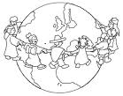

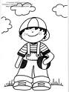 

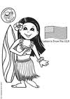 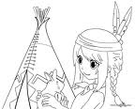 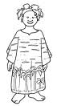

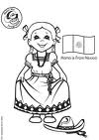 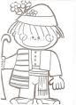 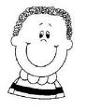

Nombre

El tendedero mágico

Escucha la siguiente lectura y escribe, con ayuda de tu maestra, un mensaje con buenos deseos a un niño(a) de otra parte de nuestro mundo.

Vivimos en la tierra. En ella crecemos, aprendemos y jugamos.

Fíjate en los niños y unos tienen los ojos rasgados, otros la piel muy oscura y el cabello rizado. Pero todo lo demás es igual.

También están creciendo, aprenden todos los días algo nuevo y desean estar en paz y ser felices.

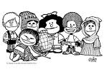

Este es mi mensaje para un niño o una niña de otra parte del mundo, que irá al tendedero mágico:

____________________________________________________________________________________________________________________________________________________________________________________________________________

Nombre

Nombre

Une correctamente con colores las colecciones con el número que tengan la misma cantidad.

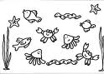 8

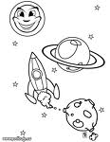 7

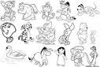 11

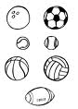 4

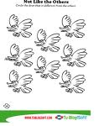 16

Nombre

Decora al niño que crees que cuida de su persona.

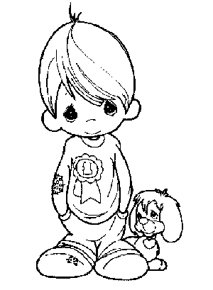

 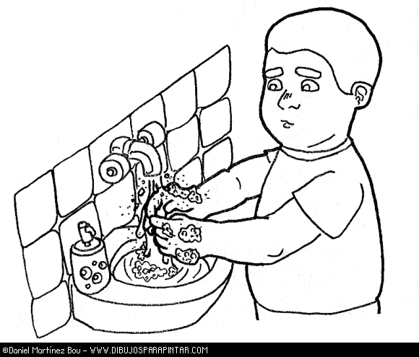

Nombre

Colorea la colección que tenga más y tacha la que tenga menos.

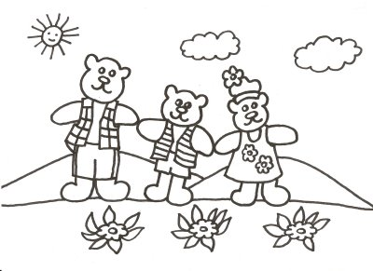

 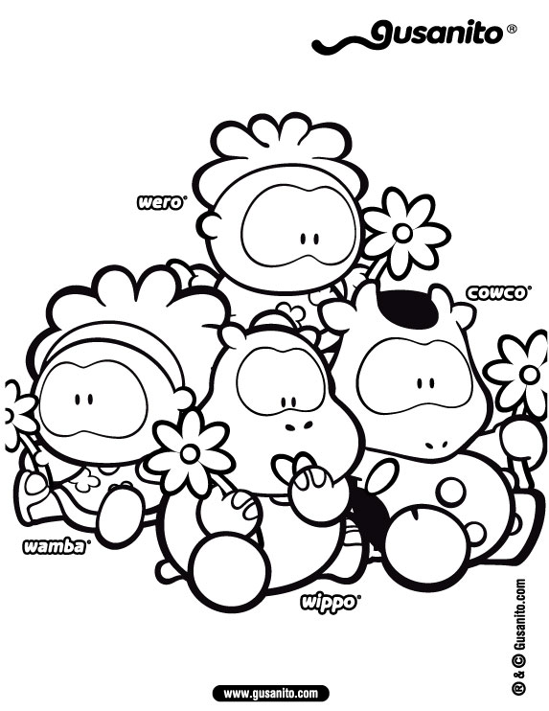

Nombre

Decora la familia del 0 con material variado.



Nombre

Continúa con la escritura de números ubicando cuadro.

Ejercicio 1

|  |  |  |  |  |  |  |  |  |  |  |  |  |  |  |  |  |  |  |  |
| --- | --- | --- | --- | --- | --- | --- | --- | --- | --- | --- | --- | --- | --- | --- | --- | --- | --- | --- | --- |
|  |  |  |  |  |  |  |  |  |  |  |  |  |  |  |  |  |  |  |  |
|  |  |  |  |  |  |  |  |  |  |  |  |  |  |  |  |  |  |  |  |
|  |  |  |  |  |  |  |  |  |  |  |  |  |  |  |  |  |  |  |  |
|  |  |  |  |  |  |  |  |  |  |  |  |  |  |  |  |  |  |  |  |
|  |  |  |  |  |  |  |  |  |  |  |  |  |  |  |  |  |  |  |  |
|  |  |  |  |  |  |  |  |  |  |  |  |  |  |  |  |  |  |  |  |

Ejercicio 2

|  |  |  |  |  |  |  |  |  |  |  |  |  |  |  |  |  |  |  |  |
| --- | --- | --- | --- | --- | --- | --- | --- | --- | --- | --- | --- | --- | --- | --- | --- | --- | --- | --- | --- |
|  |  |  |  |  |  |  |  |  |  |  |  |  |  |  |  |  |  |  |  |
|  |  |  |  |  |  |  |  |  |  |  |  |  |  |  |  |  |  |  |  |
|  |  |  |  |  |  |  |  |  |  |  |  |  |  |  |  |  |  |  |  |
|  |  |  |  |  |  |  |  |  |  |  |  |  |  |  |  |  |  |  |  |
|  |  |  |  |  |  |  |  |  |  |  |  |  |  |  |  |  |  |  |  |
|  |  |  |  |  |  |  |  |  |  |  |  |  |  |  |  |  |  |  |  |

Ejercicio 3

|  |  |  |  |  |  |  |  |  |  |  |  |  |  |  |  |  |  |  |  |
| --- | --- | --- | --- | --- | --- | --- | --- | --- | --- | --- | --- | --- | --- | --- | --- | --- | --- | --- | --- |
|  |  |  |  |  |  |  |  |  |  |  |  |  |  |  |  |  |  |  |  |
|  |  |  |  |  |  |  |  |  |  |  |  |  |  |  |  |  |  |  |  |
|  |  |  |  |  |  |  |  |  |  |  |  |  |  |  |  |  |  |  |  |
|  |  |  |  |  |  |  |  |  |  |  |  |  |  |  |  |  |  |  |  |
|  |  |  |  |  |  |  |  |  |  |  |  |  |  |  |  |  |  |  |  |
|  |  |  |  |  |  |  |  |  |  |  |  |  |  |  |  |  |  |  |  |

Ejercicio 4

|  |  |  |  |  |  |  |  |  |  |  |  |  |  |  |  |  |  |  |  |
| --- | --- | --- | --- | --- | --- | --- | --- | --- | --- | --- | --- | --- | --- | --- | --- | --- | --- | --- | --- |
|  |  |  |  |  |  |  |  |  |  |  |  |  |  |  |  |  |  |  |  |
|  |  |  |  |  |  |  |  |  |  |  |  |  |  |  |  |  |  |  |  |
|  |  |  |  |  |  |  |  |  |  |  |  |  |  |  |  |  |  |  |  |
|  |  |  |  |  |  |  |  |  |  |  |  |  |  |  |  |  |  |  |  |
|  |  |  |  |  |  |  |  |  |  |  |  |  |  |  |  |  |  |  |  |
|  |  |  |  |  |  |  |  |  |  |  |  |  |  |  |  |  |  |  |  |

Ejercicio 5

|  |  |  |  |  |  |  |  |  |  |  |  |  |  |  |  |  |  |  |  |
| --- | --- | --- | --- | --- | --- | --- | --- | --- | --- | --- | --- | --- | --- | --- | --- | --- | --- | --- | --- |
|  |  |  |  |  |  |  |  |  |  |  |  |  |  |  |  |  |  |  |  |
|  |  |  |  |  |  |  |  |  |  |  |  |  |  |  |  |  |  |  |  |
|  |  |  |  |  |  |  |  |  |  |  |  |  |  |  |  |  |  |  |  |
|  |  |  |  |  |  |  |  |  |  |  |  |  |  |  |  |  |  |  |  |
|  |  |  |  |  |  |  |  |  |  |  |  |  |  |  |  |  |  |  |  |
|  |  |  |  |  |  | Scan0005 |  |  |  |  |  |  |  |  |  |  |  |  |  |

Nombre

Decora con material variado en donde depositarias la basura.

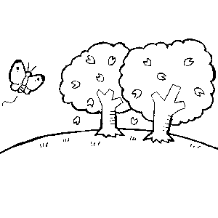

 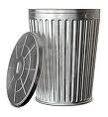

Nombre

Con pintura dactilar plasma tu mano y pie:

Mano derecha Pie derecho



Nombre

Colorea todos los círculos de color amarillo.

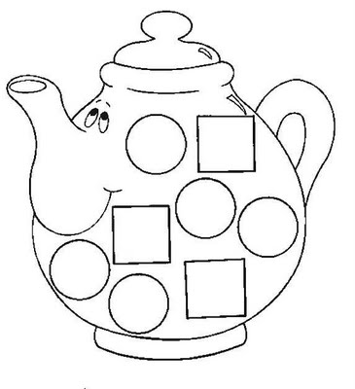



Nombre

Y CON USTEDES: ¡NUESTRO ALFABETO!

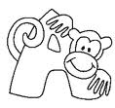Localiza el alfabeto recortable de la pagina y pégalo aquí como te indique tu maestra.

 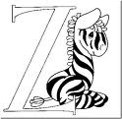

Nombre

Con recortes de letras de diferentes portadores de texto arma tu nombre completo.

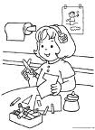



Nombre

Busca la página Recortable y pega a los niños y niñas por estaturas del más pequeño al más grande.

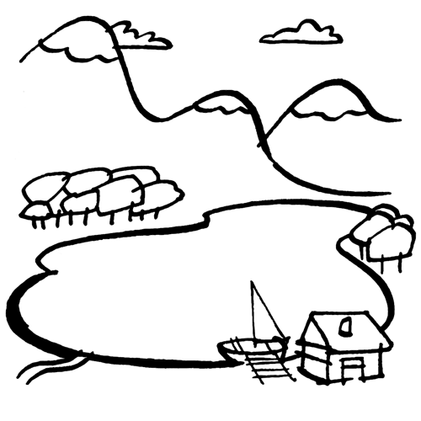



Nombre

Elabora la receta siguiendo correctamente los pasos con ayuda de un adulto y comenta lo que más te gusto al realizarla.

(Avena, azúcar, mantequilla, chochitos de colores)

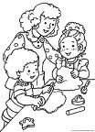

Copos de nieve

1. Batir la mantequilla en un recipiente hasta que quede solida.
2. Agregarle a la mantequilla la azúcar.
3. Revolver muy bien.
4. Agregarle la avena y revolver bien.
5. Haz bolitas con tus manos.
6. Y ahora si disfruta tus copos de nieve.

Lo que más me gusto:

_______________________________________________________________________________________________________________________________________________________________________________________________________________________________________________________________

Nombre

Sobre las líneas escribe tu nombre y dibújate.

____________________________________

____________________________________



Nombre

Recorta las piezas de la página recortable Y tú mismo arma el rompecabezas.

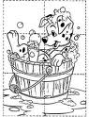



Nombre

Realiza los siguientes ejercicios de caligrafía.

Ejercicio 1

|  |  |  |  |  |  |  |  |  |  |  |  |  |  |  |  |  |  |  |  |
| --- | --- | --- | --- | --- | --- | --- | --- | --- | --- | --- | --- | --- | --- | --- | --- | --- | --- | --- | --- |
|  |  |  |  |  |  |  |  |  |  |  |  |  |  |  |  |  |  |  |  |
|  |  |  |  |  |  |  |  |  |  |  |  |  |  |  |  |  |  |  |  |
|  |  |  |  |  |  |  |  |  |  |  |  |  |  |  |  |  |  |  |  |
|  |  |  |  |  |  |  |  |  |  |  |  |  |  |  |  |  |  |  |  |
|  |  |  |  |  |  |  |  |  |  |  |  |  |  |  |  |  |  |  |  |
|  |  |  |  |  |  |  |  |  |  |  |  |  |  |  |  |  |  |  |  |

Ejercicio 2

|  |  |  |  |  |  |  |  |  |  |  |  |  |  |  |  |  |  |  |  |
| --- | --- | --- | --- | --- | --- | --- | --- | --- | --- | --- | --- | --- | --- | --- | --- | --- | --- | --- | --- |
|  |  |  |  |  |  |  |  |  |  |  |  |  |  |  |  |  |  |  |  |
|  |  |  |  |  |  |  |  |  |  |  |  |  |  |  |  |  |  |  |  |
|  |  |  |  |  |  |  |  |  |  |  |  |  |  |  |  |  |  |  |  |
|  |  |  |  |  |  |  |  |  |  |  |  |  |  |  |  |  |  |  |  |
|  |  |  |  |  |  |  |  |  |  |  |  |  |  |  |  |  |  |  |  |
|  |  |  |  |  |  |  |  |  |  |  |  |  |  |  |  |  |  |  |  |

Ejercicio 3

|  |  |  |  |  |  |  |  |  |  |  |  |  |  |  |  |  |  |  |  |
| --- | --- | --- | --- | --- | --- | --- | --- | --- | --- | --- | --- | --- | --- | --- | --- | --- | --- | --- | --- |
|  |  |  |  |  |  |  |  |  |  |  |  |  |  |  |  |  |  |  |  |
|  |  |  |  |  |  |  |  |  |  |  |  |  |  |  |  |  |  |  |  |
|  |  |  |  |  |  |  |  |  |  |  |  |  |  |  |  |  |  |  |  |
|  |  |  |  |  |  |  |  |  |  |  |  |  |  |  |  |  |  |  |  |
|  |  |  |  |  |  |  |  |  |  |  |  |  |  |  |  |  |  |  |  |
|  |  |  |  |  |  |  |  |  |  |  |  |  |  |  |  |  |  |  |  |

Ejercicio 4

|  |  |  |  |  |  |  |  |  |  |  |  |  |  |  |  |  |  |  |  |
| --- | --- | --- | --- | --- | --- | --- | --- | --- | --- | --- | --- | --- | --- | --- | --- | --- | --- | --- | --- |
|  |  |  |  |  |  |  |  |  |  |  |  |  |  |  |  |  |  |  |  |
|  |  |  |  |  |  |  |  |  |  |  |  |  |  |  |  |  |  |  |  |
|  |  |  |  |  |  |  |  |  |  |  |  |  |  |  |  |  |  |  |  |
|  |  |  |  |  |  |  |  |  |  |  |  |  |  |  |  |  |  |  |  |
|  |  |  |  |  |  |  |  |  |  |  |  |  |  |  |  |  |  |  |  |
|  |  |  |  |  |  |  |  |  |  |  |  |  |  |  |  |  |  |  |  |

Ejercicio 5

|  |  |  |  |  |  |  |  |  |  |  |  |  |  |  |  |  |  |  |  |
| --- | --- | --- | --- | --- | --- | --- | --- | --- | --- | --- | --- | --- | --- | --- | --- | --- | --- | --- | --- |
|  |  |  |  |  |  |  |  |  |  |  |  |  |  |  |  |  |  |  |  |
|  |  |  |  |  |  |  |  |  |  |  |  |  |  |  |  |  |  |  |  |
|  |  |  |  |  |  |  |  |  |  |  |  |  |  |  |  |  |  |  |  |
|  |  |  |  |  |  |  |  |  |  |  |  |  |  |  |  |  |  |  |  |
|  |  |  |  |  |  |  |  |  |  |  |  |  |  |  |  |  |  |  |  |
|  |  |  |  |  |  |  | Scan0005 |  |  |  |  |  |  |  |  |  |  |  |  |

Nombre

Une correctamente los instrumentos de medición con lo que deseamos medir.

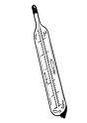 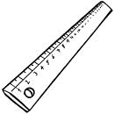 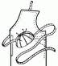 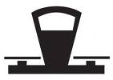

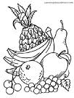 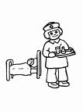 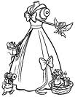



Nombre

Busca la página recortable y pega el juguete cerca de los niños.

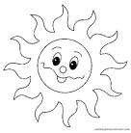

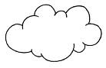

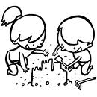



Nombre

Decora el cuadrado con el material que prefieras.

Cuadrado



Nombre

Encierra en un círculo los alimentos nutritivos y tacha los alimentos chatarras.

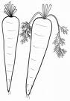 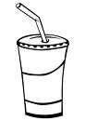 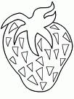

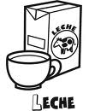  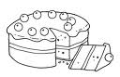

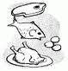 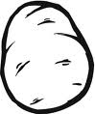 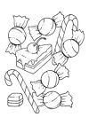



Nombre

Decora las líneas con el material variado.

Horizontal

Inclinada

Curva

Quebrada



Quebrada

Nombre

Realiza los siguientes ejercicios.

Ejercicio 1

|  |  |  |  |  |  |  |  |  |  |  |  |  |  |  |  |  |  |  |  |
| --- | --- | --- | --- | --- | --- | --- | --- | --- | --- | --- | --- | --- | --- | --- | --- | --- | --- | --- | --- |
|  |  |  |  |  |  |  |  |  |  |  |  |  |  |  |  |  |  |  |  |
|  |  |  |  |  |  |  |  |  |  |  |  |  |  |  |  |  |  |  |  |
|  |  |  |  |  |  |  |  |  |  |  |  |  |  |  |  |  |  |  |  |
|  |  |  |  |  |  |  |  |  |  |  |  |  |  |  |  |  |  |  |  |
|  |  |  |  |  |  |  |  |  |  |  |  |  |  |  |  |  |  |  |  |
|  |  |  |  |  |  |  |  |  |  |  |  |  |  |  |  |  |  |  |  |

Ejercicio 2

|  |  |  |  |  |  |  |  |  |  |  |  |  |  |  |  |  |  |  |  |
| --- | --- | --- | --- | --- | --- | --- | --- | --- | --- | --- | --- | --- | --- | --- | --- | --- | --- | --- | --- |
|  |  |  |  |  |  |  |  |  |  |  |  |  |  |  |  |  |  |  |  |
|  |  |  |  |  |  |  |  |  |  |  |  |  |  |  |  |  |  |  |  |
|  |  |  |  |  |  |  |  |  |  |  |  |  |  |  |  |  |  |  |  |
|  |  |  |  |  |  |  |  |  |  |  |  |  |  |  |  |  |  |  |  |
|  |  |  |  |  |  |  |  |  |  |  |  |  |  |  |  |  |  |  |  |
|  |  |  |  |  |  |  |  |  |  |  |  |  |  |  |  |  |  |  |  |

Ejercicio 3

|  |  |  |  |  |  |  |  |  |  |  |  |  |  |  |  |  |  |  |  |
| --- | --- | --- | --- | --- | --- | --- | --- | --- | --- | --- | --- | --- | --- | --- | --- | --- | --- | --- | --- |
|  |  |  |  |  |  |  |  |  |  |  |  |  |  |  |  |  |  |  |  |
|  |  |  |  |  |  |  |  |  |  |  |  |  |  |  |  |  |  |  |  |
|  |  |  |  |  |  |  |  |  |  |  |  |  |  |  |  |  |  |  |  |
|  |  |  |  |  |  |  |  |  |  |  |  |  |  |  |  |  |  |  |  |
|  |  |  |  |  |  |  |  |  |  |  |  |  |  |  |  |  |  |  |  |
|  |  |  |  |  |  |  |  |  |  |  |  |  |  |  |  |  |  |  |  |

Ejercicio 4

|  |  |  |  |  |  |  |  |  |  |  |  |  |  |  |  |  |  |  |  |
| --- | --- | --- | --- | --- | --- | --- | --- | --- | --- | --- | --- | --- | --- | --- | --- | --- | --- | --- | --- |
|  |  |  |  |  |  |  |  |  |  |  |  |  |  |  |  |  |  |  |  |
|  |  |  |  |  |  |  |  |  |  |  |  |  |  |  |  |  |  |  |  |
|  |  |  |  |  |  |  |  |  |  |  |  |  |  |  |  |  |  |  |  |
|  |  |  |  |  |  |  |  |  |  |  |  |  |  |  |  |  |  |  |  |
|  |  |  |  |  |  |  |  |  |  |  |  |  |  |  |  |  |  |  |  |
|  |  |  |  |  |  |  |  |  |  |  |  |  |  |  |  |  |  |  |  |

Ejercicio 5

|  |  |  |  |  |  |  |  |  |  |  |  |  |  |  |  |  |  |  |  |
| --- | --- | --- | --- | --- | --- | --- | --- | --- | --- | --- | --- | --- | --- | --- | --- | --- | --- | --- | --- |
|  |  |  |  |  |  |  |  |  |  |  |  |  |  |  |  |  |  |  |  |
|  |  |  |  |  |  |  |  |  |  |  |  |  |  |  |  |  |  |  |  |
|  |  |  |  |  |  |  |  |  |  |  |  |  |  |  |  |  |  |  |  |
|  |  |  |  |  |  |  |  |  |  |  |  |  |  |  |  |  |  |  |  |
|  |  |  |  |  |  |  |  |  |  |  |  |  |  |  |  |  |  |  |  |
|  |  |  |  |  |  | Scan0005 |  |  |  |  |  |  |  |  |  |  |  |  |  |

Nombre

Remarca con colores las siguientes líneas

|  |
| --- |
| Rojo Azul Naranja Amarillo Verde  Curva inclinada horizontal vertical quebrada |

TREEC013.WMF

 CHILD033.WMFC:\Program Files (x86)\Microsoft Office\MEDIA\CAGCAT10\j0299763.wmf

Nombre

Decora el objeto grueso y encierra el delgado.

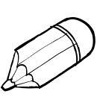

Grueso

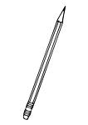

 Delgado

Nombre

EL PERIODICO 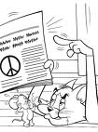

Revisa el periódico para que empieces a conocerlo.

El periódico nos informa cada día más de lo que sucede en el mundo, en el nos enteramos de los conflictos entre países, de catástrofes que a veces ocurren, como huracanes, terremotos, etc. El periódico se publica cada día, de tu país y de tu ciudad.

Escribe el nombre del periódico:

_________________________________________

Recorta una noticia y pégala aquí.



Nombre

Con recortes de letras de diferentes portadores de texto arma tu nombre completo.





Nombre

Dentro del ovalo escribe la familia del 0

Ovalo



Nombre

Escribe las silabas en cada dedo correctamente.

ma me mi mo mu

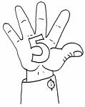

mosco maleta mesero



Nombre

Ordena la secuencia del cuento poniéndole los números dentro del cuadrado.

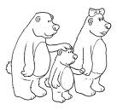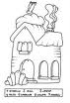

 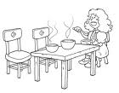

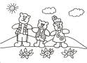 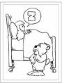

Nombre

Colorea los óvalos que encuentres y escribe sobre la raya que forma tiene.

Ovalo

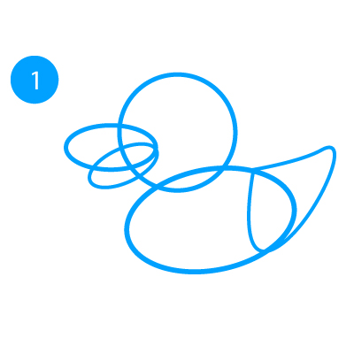

__________________________

Nombre

Decora con material variado la letra P p.

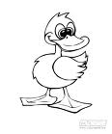

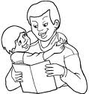



Nombre

Continúa con la plana ubicando el cuadro.

Ejercicio 1

|  |  |  |  |  |  |  |  |  |  |  |  |  |  |  |  |  |  |  |  |
| --- | --- | --- | --- | --- | --- | --- | --- | --- | --- | --- | --- | --- | --- | --- | --- | --- | --- | --- | --- |
|  |  |  |  |  |  |  |  |  |  |  |  |  |  |  |  |  |  |  |  |
|  |  |  |  |  |  |  |  |  |  |  |  |  |  |  |  |  |  |  |  |
|  |  |  |  |  |  |  |  |  |  |  |  |  |  |  |  |  |  |  |  |
|  |  |  |  |  |  |  |  |  |  |  |  |  |  |  |  |  |  |  |  |
|  |  |  |  |  |  |  |  |  |  |  |  |  |  |  |  |  |  |  |  |
|  |  |  |  |  |  |  |  |  |  |  |  |  |  |  |  |  |  |  |  |

Ejercicio 2

|  |  |  |  |  |  |  |  |  |  |  |  |  |  |  |  |  |  |  |  |
| --- | --- | --- | --- | --- | --- | --- | --- | --- | --- | --- | --- | --- | --- | --- | --- | --- | --- | --- | --- |
|  |  |  |  |  |  |  |  |  |  |  |  |  |  |  |  |  |  |  |  |
|  |  |  |  |  |  |  |  |  |  |  |  |  |  |  |  |  |  |  |  |
|  |  |  |  |  |  |  |  |  |  |  |  |  |  |  |  |  |  |  |  |
|  |  |  |  |  |  |  |  |  |  |  |  |  |  |  |  |  |  |  |  |
|  |  |  |  |  |  |  |  |  |  |  |  |  |  |  |  |  |  |  |  |
|  |  |  |  |  |  |  |  |  |  |  |  |  |  |  |  |  |  |  |  |

Ejercicio 3

|  |  |  |  |  |  |  |  |  |  |  |  |  |  |  |  |  |  |  |  |
| --- | --- | --- | --- | --- | --- | --- | --- | --- | --- | --- | --- | --- | --- | --- | --- | --- | --- | --- | --- |
|  |  |  |  |  |  |  |  |  |  |  |  |  |  |  |  |  |  |  |  |
|  |  |  |  |  |  |  |  |  |  |  |  |  |  |  |  |  |  |  |  |
|  |  |  |  |  |  |  |  |  |  |  |  |  |  |  |  |  |  |  |  |
|  |  |  |  |  |  |  |  |  |  |  |  |  |  |  |  |  |  |  |  |
|  |  |  |  |  |  |  |  |  |  |  |  |  |  |  |  |  |  |  |  |
|  |  |  |  |  |  |  |  |  |  |  |  |  |  |  |  |  |  |  |  |

Ejercicio 4

|  |  |  |  |  |  |  |  |  |  |  |  |  |  |  |  |  |  |  |  |
| --- | --- | --- | --- | --- | --- | --- | --- | --- | --- | --- | --- | --- | --- | --- | --- | --- | --- | --- | --- |
|  |  |  |  |  |  |  |  |  |  |  |  |  |  |  |  |  |  |  |  |
|  |  |  |  |  |  |  |  |  |  |  |  |  |  |  |  |  |  |  |  |
|  |  |  |  |  |  |  |  |  |  |  |  |  |  |  |  |  |  |  |  |
|  |  |  |  |  |  |  |  |  |  |  |  |  |  |  |  |  |  |  |  |
|  |  |  |  |  |  |  |  |  |  |  |  |  |  |  |  |  |  |  |  |
|  |  |  |  |  |  |  |  |  |  |  |  |  |  |  |  |  |  |  |  |

Ejercicio 5

|  |  |  |  |  |  |  |  |  |  |  |  |  |  |  |  |  |  |  |  |
| --- | --- | --- | --- | --- | --- | --- | --- | --- | --- | --- | --- | --- | --- | --- | --- | --- | --- | --- | --- |
|  |  |  |  |  |  |  |  |  |  |  |  |  |  |  |  |  |  |  |  |
|  |  |  |  |  |  |  |  |  |  |  |  |  |  |  |  |  |  |  |  |
|  |  |  |  |  |  |  |  |  |  |  |  |  |  |  |  |  |  |  |  |
|  |  |  |  |  |  |  |  |  |  |  |  |  |  |  |  |  |  |  |  |
|  |  |  |  |  |  |  |  |  |  |  |  |  |  |  |  |  |  |  |  |
|  |  |  |  |  |  |  |  |  |  |  |  |  |  |  |  |  |  |  |  |



Nombre

Continúa con la plana ubicando el cuadro.

Ejercicio 1

|  |  |  |  |  |  |  |  |  |  |  |  |  |  |  |  |  |  |  |  |
| --- | --- | --- | --- | --- | --- | --- | --- | --- | --- | --- | --- | --- | --- | --- | --- | --- | --- | --- | --- |
|  |  |  |  |  |  |  |  |  |  |  |  |  |  |  |  |  |  |  |  |
|  |  |  |  |  |  |  |  |  |  |  |  |  |  |  |  |  |  |  |  |
|  |  |  |  |  |  |  |  |  |  |  |  |  |  |  |  |  |  |  |  |
|  |  |  |  |  |  |  |  |  |  |  |  |  |  |  |  |  |  |  |  |
|  |  |  |  |  |  |  |  |  |  |  |  |  |  |  |  |  |  |  |  |
|  |  |  |  |  |  |  |  |  |  |  |  |  |  |  |  |  |  |  |  |

Ejercicio 2

|  |  |  |  |  |  |  |  |  |  |  |  |  |  |  |  |  |  |  |  |
| --- | --- | --- | --- | --- | --- | --- | --- | --- | --- | --- | --- | --- | --- | --- | --- | --- | --- | --- | --- |
|  |  |  |  |  |  |  |  |  |  |  |  |  |  |  |  |  |  |  |  |
|  |  |  |  |  |  |  |  |  |  |  |  |  |  |  |  |  |  |  |  |
|  |  |  |  |  |  |  |  |  |  |  |  |  |  |  |  |  |  |  |  |
|  |  |  |  |  |  |  |  |  |  |  |  |  |  |  |  |  |  |  |  |
|  |  |  |  |  |  |  |  |  |  |  |  |  |  |  |  |  |  |  |  |
|  |  |  |  |  |  |  |  |  |  |  |  |  |  |  |  |  |  |  |  |

Ejercicio 3

|  |  |  |  |  |  |  |  |  |  |  |  |  |  |  |  |  |  |  |  |
| --- | --- | --- | --- | --- | --- | --- | --- | --- | --- | --- | --- | --- | --- | --- | --- | --- | --- | --- | --- |
|  |  |  |  |  |  |  |  |  |  |  |  |  |  |  |  |  |  |  |  |
|  |  |  |  |  |  |  |  |  |  |  |  |  |  |  |  |  |  |  |  |
|  |  |  |  |  |  |  |  |  |  |  |  |  |  |  |  |  |  |  |  |
|  |  |  |  |  |  |  |  |  |  |  |  |  |  |  |  |  |  |  |  |
|  |  |  |  |  |  |  |  |  |  |  |  |  |  |  |  |  |  |  |  |
|  |  |  |  |  |  |  |  |  |  |  |  |  |  |  |  |  |  |  |  |

Ejercicio 4

|  |  |  |  |  |  |  |  |  |  |  |  |  |  |  |  |  |  |  |  |
| --- | --- | --- | --- | --- | --- | --- | --- | --- | --- | --- | --- | --- | --- | --- | --- | --- | --- | --- | --- |
|  |  |  |  |  |  |  |  |  |  |  |  |  |  |  |  |  |  |  |  |
|  |  |  |  |  |  |  |  |  |  |  |  |  |  |  |  |  |  |  |  |
|  |  |  |  |  |  |  |  |  |  |  |  |  |  |  |  |  |  |  |  |
|  |  |  |  |  |  |  |  |  |  |  |  |  |  |  |  |  |  |  |  |
|  |  |  |  |  |  |  |  |  |  |  |  |  |  |  |  |  |  |  |  |
|  |  |  |  |  |  |  |  |  |  |  |  |  |  |  |  |  |  |  |  |

Ejercicio 5

|  |  |  |  |  |  |  |  |  |  |  |  |  |  |  |  |  |  |  |  |
| --- | --- | --- | --- | --- | --- | --- | --- | --- | --- | --- | --- | --- | --- | --- | --- | --- | --- | --- | --- |
|  |  |  |  |  |  |  |  |  |  |  |  |  |  |  |  |  |  |  |  |
|  |  |  |  |  |  |  |  |  |  |  |  |  |  |  |  |  |  |  |  |
|  |  |  |  |  |  |  |  |  |  |  |  |  |  |  |  |  |  |  |  |
|  |  |  |  |  |  |  |  |  |  |  |  |  |  |  |  |  |  |  |  |
|  |  |  |  |  |  |  |  |  |  |  |  |  |  |  |  |  |  |  |  |
|  |  |  |  |  |  |  |  |  |  |  |  |  |  |  |  |  |  |  |  |



Nombre

Recorta y pega palabras con P p.



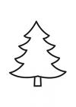Nombre

Escribe las silabas que faltan.

____no

_____lota

_____to

_____ma

_____llo

pa pe pi po pu



Nombre

Resuelve las siguientes sumas.

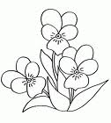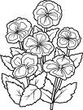 _______

6 + 3 =

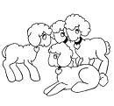

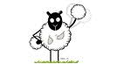

4 + 1 = _______



Nombre

Pega dentro del triangulo números 11 y repasa con colores el contorno.

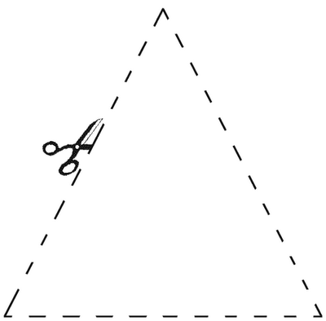

Triangulo

Nombre

Decora con material variado las siguientes letras.

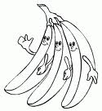



Nombre

Continúa con la plana de la pl ubicando el cuadro correctamente.

Ejercicio 1

|  |  |  |  |  |  |  |  |  |  |  |  |  |  |  |  |  |  |  |  |  |  |  |  |  |  |  |  |  |  |
| --- | --- | --- | --- | --- | --- | --- | --- | --- | --- | --- | --- | --- | --- | --- | --- | --- | --- | --- | --- | --- | --- | --- | --- | --- | --- | --- | --- | --- | --- |
|  |  |  |  |  |  |  |  |  |  |  |  |  |  |  |  |  |  |  |  |  |  |  |  |  |  |  |  |  |  |
|  |  |  |  |  |  |  |  |  |  |  |  |  |  |  |  |  |  |  |  |  |  |  |  |  |  |  |  |  |  |
|  |  |  |  |  |  |  |  |  |  |  |  |  |  |  |  |  |  |  |  |  |  |  |  |  |  |  |  |  |  |
|  |  |  |  |  |  |  |  |  |  |  |  |  |  |  |  |  |  |  |  |  |  |  |  |  |  |  |  |  |  |
|  |  |  |  |  |  |  |  |  |  |  |  |  |  |  |  |  |  |  |  |  |  |  |  |  |  |  |  |  |  |
|  |  |  |  |  |  |  |  |  |  |  |  |  |  |  |  |  |  |  |  |  |  |  |  |  |  |  |  |  |  |

Ejercicio 2

|  |  |  |  |  |  |  |  |  |  |  |  |  |  |  |  |  |  |  |  |  |  |  |  |  |  |  |  |  |  |
| --- | --- | --- | --- | --- | --- | --- | --- | --- | --- | --- | --- | --- | --- | --- | --- | --- | --- | --- | --- | --- | --- | --- | --- | --- | --- | --- | --- | --- | --- |
|  |  |  |  |  |  |  |  |  |  |  |  |  |  |  |  |  |  |  |  |  |  |  |  |  |  |  |  |  |  |
|  |  |  |  |  |  |  |  |  |  |  |  |  |  |  |  |  |  |  |  |  |  |  |  |  |  |  |  |  |  |
|  |  |  |  |  |  |  |  |  |  |  |  |  |  |  |  |  |  |  |  |  |  |  |  |  |  |  |  |  |  |
|  |  |  |  |  |  |  |  |  |  |  |  |  |  |  |  |  |  |  |  |  |  |  |  |  |  |  |  |  |  |
|  |  |  |  |  |  |  |  |  |  |  |  |  |  |  |  |  |  |  |  |  |  |  |  |  |  |  |  |  |  |
|  |  |  |  |  |  |  |  |  |  |  |  |  |  |  |  |  |  |  |  |  |  |  |  |  |  |  |  |  |  |

Ejercicio 3

|  |  |  |  |  |  |  |  |  |  |  |  |  |  |  |  |  |  |  |  |  |  |  |  |  |  |  |  |  |  |
| --- | --- | --- | --- | --- | --- | --- | --- | --- | --- | --- | --- | --- | --- | --- | --- | --- | --- | --- | --- | --- | --- | --- | --- | --- | --- | --- | --- | --- | --- |
|  |  |  |  |  |  |  |  |  |  |  |  |  |  |  |  |  |  |  |  |  |  |  |  |  |  |  |  |  |  |
|  |  |  |  |  |  |  |  |  |  |  |  |  |  |  |  |  |  |  |  |  |  |  |  |  |  |  |  |  |  |
|  |  |  |  |  |  |  |  |  |  |  |  |  |  |  |  |  |  |  |  |  |  |  |  |  |  |  |  |  |  |
|  |  |  |  |  |  |  |  |  |  |  |  |  |  |  |  |  |  |  |  |  |  |  |  |  |  |  |  |  |  |
|  |  |  |  |  |  |  |  |  |  |  |  |  |  |  |  |  |  |  |  |  |  |  |  |  |  |  |  |  |  |
|  |  |  |  |  |  |  |  |  |  |  |  |  |  |  |  |  |  |  |  |  |  |  |  |  |  |  |  |  |  |

Ejercicio 4

|  |  |  |  |  |  |  |  |  |  |  |  |  |  |  |  |  |  |  |  |  |  |  |  |  |  |  |  |  |  |
| --- | --- | --- | --- | --- | --- | --- | --- | --- | --- | --- | --- | --- | --- | --- | --- | --- | --- | --- | --- | --- | --- | --- | --- | --- | --- | --- | --- | --- | --- |
|  |  |  |  |  |  |  |  |  |  |  |  |  |  |  |  |  |  |  |  |  |  |  |  |  |  |  |  |  |  |
|  |  |  |  |  |  |  |  |  |  |  |  |  |  |  |  |  |  |  |  |  |  |  |  |  |  |  |  |  |  |
|  |  |  |  |  |  |  |  |  |  |  |  |  |  |  |  |  |  |  |  |  |  |  |  |  |  |  |  |  |  |
|  |  |  |  |  |  |  |  |  |  |  |  |  |  |  |  |  |  |  |  |  |  |  |  |  |  |  |  |  |  |
|  |  |  |  |  |  |  |  |  |  |  |  |  |  |  |  |  |  |  |  |  |  |  |  |  |  |  |  |  |  |
|  |  |  |  |  |  |  |  |  |  |  |  |  |  |  |  |  |  |  |  |  |  |  |  |  |  |  |  |  |  |

Ejercicio 5

|  |  |  |  |  |  |  |  |  |  |  |  |  |  |  |  |  |  |  |  |  |  |  |  |  |  |  |  |  |  |
| --- | --- | --- | --- | --- | --- | --- | --- | --- | --- | --- | --- | --- | --- | --- | --- | --- | --- | --- | --- | --- | --- | --- | --- | --- | --- | --- | --- | --- | --- |
|  |  |  |  |  |  |  |  |  |  |  |  |  |  |  |  |  |  |  |  |  |  |  |  |  |  |  |  |  |  |
|  |  |  |  |  |  |  |  |  |  |  |  |  |  |  |  |  |  |  |  |  |  |  |  |  |  |  |  |  |  |
|  |  |  |  |  |  |  |  |  |  |  |  |  |  |  |  |  |  |  |  |  |  |  |  |  |  |  |  |  |  |
|  |  |  |  |  |  |  |  |  |  |  |  |  |  |  |  |  |  |  |  |  |  |  |  |  |  |  |  |  |  |
|  |  |  |  |  |  |  |  |  |  |  |  |  |  |  |  |  |  |  |  |  |  |  |  |  |  |  |  |  |  |
|  |  |  |  |  |  |  |  |  | Scan0005 |  |  |  |  |  |  |  |  |  |  |  |  |  |  |  |  |  |  |  |  |

Nombre

Escucha la lectura de “Trabalenguas” de tu cuenta cuentos y pega palabras con pl que conozcas.



Nombre Nombre

Decora con material variado la letra PR pr.

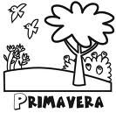



Nombre

Continúa con la plana de la pr ubicando el cuadro correctamente.

Ejercicio 1

|  |  |  |  |  |  |  |  |  |  |  |  |  |  |  |  |  |  |  |  |  |  |  |  |  |  |  |  |  |  |
| --- | --- | --- | --- | --- | --- | --- | --- | --- | --- | --- | --- | --- | --- | --- | --- | --- | --- | --- | --- | --- | --- | --- | --- | --- | --- | --- | --- | --- | --- |
|  |  |  |  |  |  |  |  |  |  |  |  |  |  |  |  |  |  |  |  |  |  |  |  |  |  |  |  |  |  |
|  |  |  |  |  |  |  |  |  |  |  |  |  |  |  |  |  |  |  |  |  |  |  |  |  |  |  |  |  |  |
|  |  |  |  |  |  |  |  |  |  |  |  |  |  |  |  |  |  |  |  |  |  |  |  |  |  |  |  |  |  |
|  |  |  |  |  |  |  |  |  |  |  |  |  |  |  |  |  |  |  |  |  |  |  |  |  |  |  |  |  |  |
|  |  |  |  |  |  |  |  |  |  |  |  |  |  |  |  |  |  |  |  |  |  |  |  |  |  |  |  |  |  |
|  |  |  |  |  |  |  |  |  |  |  |  |  |  |  |  |  |  |  |  |  |  |  |  |  |  |  |  |  |  |

Ejercicio 2

|  |  |  |  |  |  |  |  |  |  |  |  |  |  |  |  |  |  |  |  |  |  |  |  |  |  |  |  |  |  |
| --- | --- | --- | --- | --- | --- | --- | --- | --- | --- | --- | --- | --- | --- | --- | --- | --- | --- | --- | --- | --- | --- | --- | --- | --- | --- | --- | --- | --- | --- |
|  |  |  |  |  |  |  |  |  |  |  |  |  |  |  |  |  |  |  |  |  |  |  |  |  |  |  |  |  |  |
|  |  |  |  |  |  |  |  |  |  |  |  |  |  |  |  |  |  |  |  |  |  |  |  |  |  |  |  |  |  |
|  |  |  |  |  |  |  |  |  |  |  |  |  |  |  |  |  |  |  |  |  |  |  |  |  |  |  |  |  |  |
|  |  |  |  |  |  |  |  |  |  |  |  |  |  |  |  |  |  |  |  |  |  |  |  |  |  |  |  |  |  |
|  |  |  |  |  |  |  |  |  |  |  |  |  |  |  |  |  |  |  |  |  |  |  |  |  |  |  |  |  |  |
|  |  |  |  |  |  |  |  |  |  |  |  |  |  |  |  |  |  |  |  |  |  |  |  |  |  |  |  |  |  |

Ejercicio 3

|  |  |  |  |  |  |  |  |  |  |  |  |  |  |  |  |  |  |  |  |  |  |  |  |  |  |  |  |  |  |
| --- | --- | --- | --- | --- | --- | --- | --- | --- | --- | --- | --- | --- | --- | --- | --- | --- | --- | --- | --- | --- | --- | --- | --- | --- | --- | --- | --- | --- | --- |
|  |  |  |  |  |  |  |  |  |  |  |  |  |  |  |  |  |  |  |  |  |  |  |  |  |  |  |  |  |  |
|  |  |  |  |  |  |  |  |  |  |  |  |  |  |  |  |  |  |  |  |  |  |  |  |  |  |  |  |  |  |
|  |  |  |  |  |  |  |  |  |  |  |  |  |  |  |  |  |  |  |  |  |  |  |  |  |  |  |  |  |  |
|  |  |  |  |  |  |  |  |  |  |  |  |  |  |  |  |  |  |  |  |  |  |  |  |  |  |  |  |  |  |
|  |  |  |  |  |  |  |  |  |  |  |  |  |  |  |  |  |  |  |  |  |  |  |  |  |  |  |  |  |  |
|  |  |  |  |  |  |  |  |  |  |  |  |  |  |  |  |  |  |  |  |  |  |  |  |  |  |  |  |  |  |

Ejercicio 4

|  |  |  |  |  |  |  |  |  |  |  |  |  |  |  |  |  |  |  |  |  |  |  |  |  |  |  |  |  |  |
| --- | --- | --- | --- | --- | --- | --- | --- | --- | --- | --- | --- | --- | --- | --- | --- | --- | --- | --- | --- | --- | --- | --- | --- | --- | --- | --- | --- | --- | --- |
|  |  |  |  |  |  |  |  |  |  |  |  |  |  |  |  |  |  |  |  |  |  |  |  |  |  |  |  |  |  |
|  |  |  |  |  |  |  |  |  |  |  |  |  |  |  |  |  |  |  |  |  |  |  |  |  |  |  |  |  |  |
|  |  |  |  |  |  |  |  |  |  |  |  |  |  |  |  |  |  |  |  |  |  |  |  |  |  |  |  |  |  |
|  |  |  |  |  |  |  |  |  |  |  |  |  |  |  |  |  |  |  |  |  |  |  |  |  |  |  |  |  |  |
|  |  |  |  |  |  |  |  |  |  |  |  |  |  |  |  |  |  |  |  |  |  |  |  |  |  |  |  |  |  |
|  |  |  |  |  |  |  |  |  |  |  |  |  |  |  |  |  |  |  |  |  |  |  |  |  |  |  |  |  |  |

Ejercicio 5

|  |  |  |  |  |  |  |  |  |  |  |  |  |  |  |  |  |  |  |  |  |  |  |  |  |  |  |  |  |  |
| --- | --- | --- | --- | --- | --- | --- | --- | --- | --- | --- | --- | --- | --- | --- | --- | --- | --- | --- | --- | --- | --- | --- | --- | --- | --- | --- | --- | --- | --- |
|  |  |  |  |  |  |  |  |  |  |  |  |  |  |  |  |  |  |  |  |  |  |  |  |  |  |  |  |  |  |
|  |  |  |  |  |  |  |  |  |  |  |  |  |  |  |  |  |  |  |  |  |  |  |  |  |  |  |  |  |  |
|  |  |  |  |  |  |  |  |  |  |  |  |  |  |  |  |  |  |  |  |  |  |  |  |  |  |  |  |  |  |
|  |  |  |  |  |  |  |  |  |  |  |  |  |  |  |  |  |  |  |  |  |  |  |  |  |  |  |  |  |  |
|  |  |  |  |  |  |  |  |  |  |  |  |  |  |  |  |  |  |  |  |  |  |  |  |  |  |  |  |  |  |
|  |  |  |  |  |  |  |  |  | Scan0005 |  |  |  |  |  |  |  |  |  |  |  |  |  |  |  |  |  |  |  |  |

Nombre

Escucha la lectura de “Prudencia, preciosa princesa de Praga” de tu cuenta cuentos, decora el dibujo y pégale palabras con PR alrededor.

PR

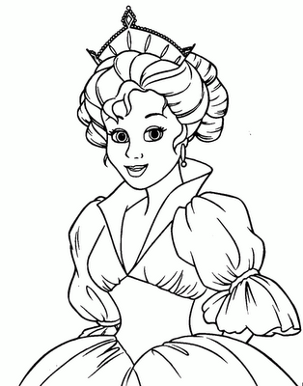



Nombre

Observa la ilustración, responde las preguntas en los espacios correspondientes.

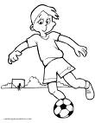 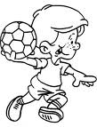

¿Cuántos años crees

que tengan los niños de la ilustración?

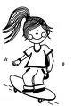 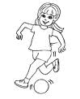

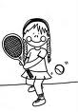 ¿Cuántas 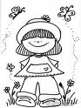 hay?

¿Cuántos  hay?

 ¿Cuántos años tienes?

Nombre

Acomoda en forma ascendente los siguientes números.

10-15-8-6-19-13-11-4-5-9

12-1-7-16-0-2-20-3-14-17-18

___ ___ ___ ___ ___ ___

___ ___ ___ ___ ___ ___

___ ___ ___ ___ ___ ___

___ ___



Nombre

Subraya la palabra correcta.

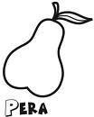 para pera pora

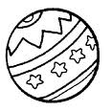 palota pulota pelota

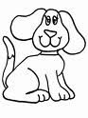 pirro perro porro

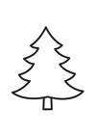 pano peno pino

Nombre

Con pintura dactilar plasma tu mano y pie:

Mano izquierda Pie izquierdo



Nombre

Realiza las sumas

10 8 5 3

+ + + +

5 1 4 5

_______ _______ ______ _____

Dibuja diferentes objetos según el resultado de cada suma.

10 + 4 =

10 +7 =

10 + 8 =

10 + 2 =



Nombre

“Conoce los días de la semana”

Los días de la semana son 7 remárcalos con diferentes colores y encierra las letras m, p que encuentres.

Lunes

Martes

Miércoles

Jueves

Viernes

Sábado

Domingo

Nombre

“Aprendo a conocer mi cuerpo”

Busca la pág. recortable, pega la figura según seas niño o niña colorea, y escríbele sus nombres.



Nombre

Repasa con colores los números ordinales.

1º

2º

3º

4º

5º

Nombre

Busca la página recortable, observa en que lugar ocupa cada automóvil y pégale el número ordinal correspondiente.

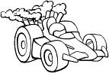







 

META

Nombre

Busca la pagina recortable y pega los días de la semana donde corresponda.

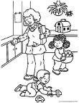 ¿Cuál es primer día de la semana?

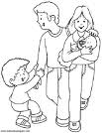¿Cual es el último día de clases?

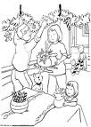¿Qué días de emana no hay clases?



Nombre

“Números ordinales”

Desacuerdo con el orden de los días de la semana une a cada niño con el globo que corresponda.

Sábado

Domingo

Lunes

Martes

Miércoles

Jueves

Viernes

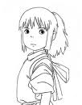 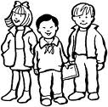 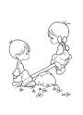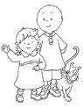 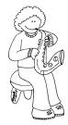 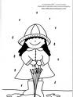 

1º 2º 3 º 4º 5 º 6º 7º



Nombre

“Y con ustedes los meses del año”

Utilizando tus 12 colores repasa cada uno de los meses.

Enero

Febrero

Marzo

Abril

Mayo

Junio

Julio

Agosto

Septiembre

Octubre

Noviembre

Diciembre

¿Cuántos meses son?



Nombre

Ilustra lo que se celebra en cada mes del año.



Nombre

Pega recortes de lo que celebramos en octubre.

12 de octubre día del descubrimiento de América.

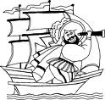Cristóbal Colon

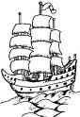

La niña



La pinta



La santa María



Nombre

Colorea de color verde todos los rectángulos que encuentres.

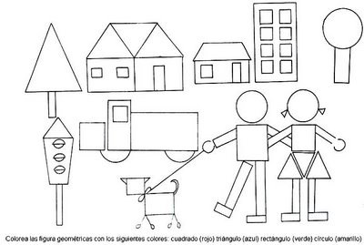



Nombre Nombre

De la lectura que escuchaste de tu libro de cuenta cuentos de la letra p. colorea el cuento correcto.

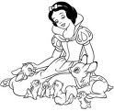

Blanca nieves

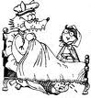

Caperucita roja

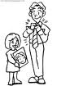

El papá Pepe



Nombre

Pégale manzanas a los árboles según se indica.

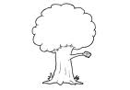muchos

 Pocos

 nada 

Nombre

Observa y completa.

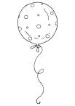 había_____

Se fue_____

Quedaron_____

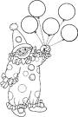

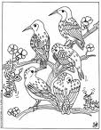 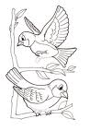

Había____

Volaron____

 Quedaron_____  
Nombre

Observa y completa las restas

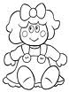   ______

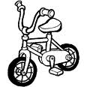





Nombre

Realiza las restas



Nombre

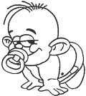Decora con diversidad de material la letra B b.

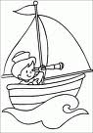



Nombre

Pega palabras con B b



Nombre

Realiza la plana ubicando el cuadro.

Ejercicio 1

|  |  |  |  |  |  |  |  |  |  |  |  |  |  |  |  |  |  |  |  |
| --- | --- | --- | --- | --- | --- | --- | --- | --- | --- | --- | --- | --- | --- | --- | --- | --- | --- | --- | --- |
|  |  |  |  |  |  |  |  |  |  |  |  |  |  |  |  |  |  |  |  |
|  |  |  |  |  |  |  |  |  |  |  |  |  |  |  |  |  |  |  |  |
|  |  |  |  |  |  |  |  |  |  |  |  |  |  |  |  |  |  |  |  |
|  |  |  |  |  |  |  |  |  |  |  |  |  |  |  |  |  |  |  |  |
|  |  |  |  |  |  |  |  |  |  |  |  |  |  |  |  |  |  |  |  |
|  |  |  |  |  |  |  |  |  |  |  |  |  |  |  |  |  |  |  |  |

Ejercicio 2

|  |  |  |  |  |  |  |  |  |  |  |  |  |  |  |  |  |  |  |  |
| --- | --- | --- | --- | --- | --- | --- | --- | --- | --- | --- | --- | --- | --- | --- | --- | --- | --- | --- | --- |
|  |  |  |  |  |  |  |  |  |  |  |  |  |  |  |  |  |  |  |  |
|  |  |  |  |  |  |  |  |  |  |  |  |  |  |  |  |  |  |  |  |
|  |  |  |  |  |  |  |  |  |  |  |  |  |  |  |  |  |  |  |  |
|  |  |  |  |  |  |  |  |  |  |  |  |  |  |  |  |  |  |  |  |
|  |  |  |  |  |  |  |  |  |  |  |  |  |  |  |  |  |  |  |  |
|  |  |  |  |  |  |  |  |  |  |  |  |  |  |  |  |  |  |  |  |

Ejercicio 3

|  |  |  |  |  |  |  |  |  |  |  |  |  |  |  |  |  |  |  |  |
| --- | --- | --- | --- | --- | --- | --- | --- | --- | --- | --- | --- | --- | --- | --- | --- | --- | --- | --- | --- |
|  |  |  |  |  |  |  |  |  |  |  |  |  |  |  |  |  |  |  |  |
|  |  |  |  |  |  |  |  |  |  |  |  |  |  |  |  |  |  |  |  |
|  |  |  |  |  |  |  |  |  |  |  |  |  |  |  |  |  |  |  |  |
|  |  |  |  |  |  |  |  |  |  |  |  |  |  |  |  |  |  |  |  |
|  |  |  |  |  |  |  |  |  |  |  |  |  |  |  |  |  |  |  |  |
|  |  |  |  |  |  |  |  |  |  |  |  |  |  |  |  |  |  |  |  |

Ejercicio 4

|  |  |  |  |  |  |  |  |  |  |  |  |  |  |  |  |  |  |  |  |
| --- | --- | --- | --- | --- | --- | --- | --- | --- | --- | --- | --- | --- | --- | --- | --- | --- | --- | --- | --- |
|  |  |  |  |  |  |  |  |  |  |  |  |  |  |  |  |  |  |  |  |
|  |  |  |  |  |  |  |  |  |  |  |  |  |  |  |  |  |  |  |  |
|  |  |  |  |  |  |  |  |  |  |  |  |  |  |  |  |  |  |  |  |
|  |  |  |  |  |  |  |  |  |  |  |  |  |  |  |  |  |  |  |  |
|  |  |  |  |  |  |  |  |  |  |  |  |  |  |  |  |  |  |  |  |
|  |  |  |  |  |  |  |  |  |  |  |  |  |  |  |  |  |  |  |  |

Ejercicio 5

|  |  |  |  |  |  |  |  |  |  |  |  |  |  |  |  |  |  |  |  |
| --- | --- | --- | --- | --- | --- | --- | --- | --- | --- | --- | --- | --- | --- | --- | --- | --- | --- | --- | --- |
|  |  |  |  |  |  |  |  |  |  |  |  |  |  |  |  |  |  |  |  |
|  |  |  |  |  |  |  |  |  |  |  |  |  |  |  |  |  |  |  |  |
|  |  |  |  |  |  |  |  |  |  |  |  |  |  |  |  |  |  |  |  |
|  |  |  |  |  |  |  |  |  |  |  |  |  |  |  |  |  |  |  |  |
|  |  |  |  |  |  |  |  |  |  |  |  |  |  |  |  |  |  |  |  |
|  |  |  |  |  |  |  | Scan0005 |  |  |  |  |  |  |  |  |  |  |  |  |

Nombre

Realiza la plana ubicando el cuadro.

|  |  |  |  |  |  |  |  |  |  |  |  |  |  |  |  |  |  |  |  |
| --- | --- | --- | --- | --- | --- | --- | --- | --- | --- | --- | --- | --- | --- | --- | --- | --- | --- | --- | --- |
|  |  |  |  |  |  |  |  |  |  |  |  |  |  |  |  |  |  |  |  |
|  |  |  |  |  |  |  |  |  |  |  |  |  |  |  |  |  |  |  |  |
|  |  |  |  |  |  |  |  |  |  |  |  |  |  |  |  |  |  |  |  |
|  |  |  |  |  |  |  |  |  |  |  |  |  |  |  |  |  |  |  |  |
|  |  |  |  |  |  |  |  |  |  |  |  |  |  |  |  |  |  |  |  |
|  |  |  |  |  |  |  |  |  |  |  |  |  |  |  |  |  |  |  |  |

Ejercicio 2

|  |  |  |  |  |  |  |  |  |  |  |  |  |  |  |  |  |  |  |  |
| --- | --- | --- | --- | --- | --- | --- | --- | --- | --- | --- | --- | --- | --- | --- | --- | --- | --- | --- | --- |
|  |  |  |  |  |  |  |  |  |  |  |  |  |  |  |  |  |  |  |  |
|  |  |  |  |  |  |  |  |  |  |  |  |  |  |  |  |  |  |  |  |
|  |  |  |  |  |  |  |  |  |  |  |  |  |  |  |  |  |  |  |  |
|  |  |  |  |  |  |  |  |  |  |  |  |  |  |  |  |  |  |  |  |
|  |  |  |  |  |  |  |  |  |  |  |  |  |  |  |  |  |  |  |  |
|  |  |  |  |  |  |  |  |  |  |  |  |  |  |  |  |  |  |  |  |

Ejercicio 3

|  |  |  |  |  |  |  |  |  |  |  |  |  |  |  |  |  |  |  |  |
| --- | --- | --- | --- | --- | --- | --- | --- | --- | --- | --- | --- | --- | --- | --- | --- | --- | --- | --- | --- |
|  |  |  |  |  |  |  |  |  |  |  |  |  |  |  |  |  |  |  |  |
|  |  |  |  |  |  |  |  |  |  |  |  |  |  |  |  |  |  |  |  |
|  |  |  |  |  |  |  |  |  |  |  |  |  |  |  |  |  |  |  |  |
|  |  |  |  |  |  |  |  |  |  |  |  |  |  |  |  |  |  |  |  |
|  |  |  |  |  |  |  |  |  |  |  |  |  |  |  |  |  |  |  |  |
|  |  |  |  |  |  |  |  |  |  |  |  |  |  |  |  |  |  |  |  |

Ejercicio 4

|  |  |  |  |  |  |  |  |  |  |  |  |  |  |  |  |  |  |  |  |
| --- | --- | --- | --- | --- | --- | --- | --- | --- | --- | --- | --- | --- | --- | --- | --- | --- | --- | --- | --- |
|  |  |  |  |  |  |  |  |  |  |  |  |  |  |  |  |  |  |  |  |
|  |  |  |  |  |  |  |  |  |  |  |  |  |  |  |  |  |  |  |  |
|  |  |  |  |  |  |  |  |  |  |  |  |  |  |  |  |  |  |  |  |
|  |  |  |  |  |  |  |  |  |  |  |  |  |  |  |  |  |  |  |  |
|  |  |  |  |  |  |  |  |  |  |  |  |  |  |  |  |  |  |  |  |
|  |  |  |  |  |  |  |  |  |  |  |  |  |  |  |  |  |  |  |  |

Ejercicio 5

|  |  |  |  |  |  |  |  |  |  |  |  |  |  |  |  |  |  |  |  |
| --- | --- | --- | --- | --- | --- | --- | --- | --- | --- | --- | --- | --- | --- | --- | --- | --- | --- | --- | --- |
|  |  |  |  |  |  |  |  |  |  |  |  |  |  |  |  |  |  |  |  |
|  |  |  |  |  |  |  |  |  |  |  |  |  |  |  |  |  |  |  |  |
|  |  |  |  |  |  |  |  |  |  |  |  |  |  |  |  |  |  |  |  |
|  |  |  |  |  |  |  |  |  |  |  |  |  |  |  |  |  |  |  |  |
|  |  |  |  |  |  |  |  |  |  |  |  |  |  |  |  |  |  |  |  |
|  |  |  |  |  |  |  |  |  |  |  |  |  |  |  |  |  |  |  |  |



Nombre

De las siguientes palabras encierra las sílabas que encuentres.

Ba Be Bi Bo Bu

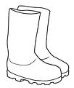 ba be bi bo bu

burro barril bota balón

bicicleta Berenice bola

abuelo taburete barco

Nombre

De diferentes portadores de texto recorta palabras y pégalas donde corresponda.

Ba-

Be-

Bi-

Bo-

Bu-



Nombre

Decora con material variado la unidad y colorea de azul el cuadrado representándola.

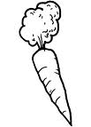 azul

Unidad



Nombre

Decora con material variado las decenas y colorea el cuadrado de rojo representando la decena.

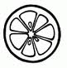





Decena



Nombre

Decora con material variado la letra BL br.

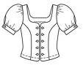



Nombre

Continúa con la plana de la bl ubicando el cuadro correctamente.

Ejercicio 1

|  |  |  |  |  |  |  |  |  |  |  |  |  |  |  |  |  |  |  |  |  |  |  |  |  |  |  |  |  |  |
| --- | --- | --- | --- | --- | --- | --- | --- | --- | --- | --- | --- | --- | --- | --- | --- | --- | --- | --- | --- | --- | --- | --- | --- | --- | --- | --- | --- | --- | --- |
|  |  |  |  |  |  |  |  |  |  |  |  |  |  |  |  |  |  |  |  |  |  |  |  |  |  |  |  |  |  |
|  |  |  |  |  |  |  |  |  |  |  |  |  |  |  |  |  |  |  |  |  |  |  |  |  |  |  |  |  |  |
|  |  |  |  |  |  |  |  |  |  |  |  |  |  |  |  |  |  |  |  |  |  |  |  |  |  |  |  |  |  |
|  |  |  |  |  |  |  |  |  |  |  |  |  |  |  |  |  |  |  |  |  |  |  |  |  |  |  |  |  |  |
|  |  |  |  |  |  |  |  |  |  |  |  |  |  |  |  |  |  |  |  |  |  |  |  |  |  |  |  |  |  |
|  |  |  |  |  |  |  |  |  |  |  |  |  |  |  |  |  |  |  |  |  |  |  |  |  |  |  |  |  |  |

Ejercicio 2

|  |  |  |  |  |  |  |  |  |  |  |  |  |  |  |  |  |  |  |  |  |  |  |  |  |  |  |  |  |  |
| --- | --- | --- | --- | --- | --- | --- | --- | --- | --- | --- | --- | --- | --- | --- | --- | --- | --- | --- | --- | --- | --- | --- | --- | --- | --- | --- | --- | --- | --- |
|  |  |  |  |  |  |  |  |  |  |  |  |  |  |  |  |  |  |  |  |  |  |  |  |  |  |  |  |  |  |
|  |  |  |  |  |  |  |  |  |  |  |  |  |  |  |  |  |  |  |  |  |  |  |  |  |  |  |  |  |  |
|  |  |  |  |  |  |  |  |  |  |  |  |  |  |  |  |  |  |  |  |  |  |  |  |  |  |  |  |  |  |
|  |  |  |  |  |  |  |  |  |  |  |  |  |  |  |  |  |  |  |  |  |  |  |  |  |  |  |  |  |  |
|  |  |  |  |  |  |  |  |  |  |  |  |  |  |  |  |  |  |  |  |  |  |  |  |  |  |  |  |  |  |
|  |  |  |  |  |  |  |  |  |  |  |  |  |  |  |  |  |  |  |  |  |  |  |  |  |  |  |  |  |  |

Ejercicio 3

|  |  |  |  |  |  |  |  |  |  |  |  |  |  |  |  |  |  |  |  |  |  |  |  |  |  |  |  |  |  |
| --- | --- | --- | --- | --- | --- | --- | --- | --- | --- | --- | --- | --- | --- | --- | --- | --- | --- | --- | --- | --- | --- | --- | --- | --- | --- | --- | --- | --- | --- |
|  |  |  |  |  |  |  |  |  |  |  |  |  |  |  |  |  |  |  |  |  |  |  |  |  |  |  |  |  |  |
|  |  |  |  |  |  |  |  |  |  |  |  |  |  |  |  |  |  |  |  |  |  |  |  |  |  |  |  |  |  |
|  |  |  |  |  |  |  |  |  |  |  |  |  |  |  |  |  |  |  |  |  |  |  |  |  |  |  |  |  |  |
|  |  |  |  |  |  |  |  |  |  |  |  |  |  |  |  |  |  |  |  |  |  |  |  |  |  |  |  |  |  |
|  |  |  |  |  |  |  |  |  |  |  |  |  |  |  |  |  |  |  |  |  |  |  |  |  |  |  |  |  |  |
|  |  |  |  |  |  |  |  |  |  |  |  |  |  |  |  |  |  |  |  |  |  |  |  |  |  |  |  |  |  |

Ejercicio 4

|  |  |  |  |  |  |  |  |  |  |  |  |  |  |  |  |  |  |  |  |  |  |  |  |  |  |  |  |  |  |
| --- | --- | --- | --- | --- | --- | --- | --- | --- | --- | --- | --- | --- | --- | --- | --- | --- | --- | --- | --- | --- | --- | --- | --- | --- | --- | --- | --- | --- | --- |
|  |  |  |  |  |  |  |  |  |  |  |  |  |  |  |  |  |  |  |  |  |  |  |  |  |  |  |  |  |  |
|  |  |  |  |  |  |  |  |  |  |  |  |  |  |  |  |  |  |  |  |  |  |  |  |  |  |  |  |  |  |
|  |  |  |  |  |  |  |  |  |  |  |  |  |  |  |  |  |  |  |  |  |  |  |  |  |  |  |  |  |  |
|  |  |  |  |  |  |  |  |  |  |  |  |  |  |  |  |  |  |  |  |  |  |  |  |  |  |  |  |  |  |
|  |  |  |  |  |  |  |  |  |  |  |  |  |  |  |  |  |  |  |  |  |  |  |  |  |  |  |  |  |  |
|  |  |  |  |  |  |  |  |  |  |  |  |  |  |  |  |  |  |  |  |  |  |  |  |  |  |  |  |  |  |

Ejercicio 5

|  |  |  |  |  |  |  |  |  |  |  |  |  |  |  |  |  |  |  |  |  |  |  |  |  |  |  |  |  |  |
| --- | --- | --- | --- | --- | --- | --- | --- | --- | --- | --- | --- | --- | --- | --- | --- | --- | --- | --- | --- | --- | --- | --- | --- | --- | --- | --- | --- | --- | --- |
|  |  |  |  |  |  |  |  |  |  |  |  |  |  |  |  |  |  |  |  |  |  |  |  |  |  |  |  |  |  |
|  |  |  |  |  |  |  |  |  |  |  |  |  |  |  |  |  |  |  |  |  |  |  |  |  |  |  |  |  |  |
|  |  |  |  |  |  |  |  |  |  |  |  |  |  |  |  |  |  |  |  |  |  |  |  |  |  |  |  |  |  |
|  |  |  |  |  |  |  |  |  |  |  |  |  |  |  |  |  |  |  |  |  |  |  |  |  |  |  |  |  |  |
|  |  |  |  |  |  |  |  |  |  |  |  |  |  |  |  |  |  |  |  |  |  |  |  |  |  |  |  |  |  |
|  |  |  |  |  |  |  |  |  | Scan0005 |  |  |  |  |  |  |  |  |  |  |  |  |  |  |  |  |  |  |  |  |

Nombre

Escucha la lectura de “La blusa blanca” de tu cuenta cuentos, ilustra el tema y pégale palabras bl alrededor.



Nombre

“Mi amigo el libro”

Ve a la mesa llena de libros y selecciona el que más te agrade, y escribe porque te gusta.

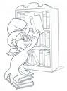

El libro que elegí me agrada porque:

___________________________________________________________________________________________________________________________________________________________________________________________________________

Nombre

Decora tu nombre completo en cursiva.





Nombre

Decora con material variado la letra BR br.

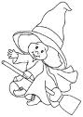



Nombre

Continúa con la plana de la br ubicando el cuadro correctamente.

Ejercicio 1

|  |  |  |  |  |  |  |  |  |  |  |  |  |  |  |  |  |  |  |  |  |  |  |  |  |  |  |  |  |  |
| --- | --- | --- | --- | --- | --- | --- | --- | --- | --- | --- | --- | --- | --- | --- | --- | --- | --- | --- | --- | --- | --- | --- | --- | --- | --- | --- | --- | --- | --- |
|  |  |  |  |  |  |  |  |  |  |  |  |  |  |  |  |  |  |  |  |  |  |  |  |  |  |  |  |  |  |
|  |  |  |  |  |  |  |  |  |  |  |  |  |  |  |  |  |  |  |  |  |  |  |  |  |  |  |  |  |  |
|  |  |  |  |  |  |  |  |  |  |  |  |  |  |  |  |  |  |  |  |  |  |  |  |  |  |  |  |  |  |
|  |  |  |  |  |  |  |  |  |  |  |  |  |  |  |  |  |  |  |  |  |  |  |  |  |  |  |  |  |  |
|  |  |  |  |  |  |  |  |  |  |  |  |  |  |  |  |  |  |  |  |  |  |  |  |  |  |  |  |  |  |
|  |  |  |  |  |  |  |  |  |  |  |  |  |  |  |  |  |  |  |  |  |  |  |  |  |  |  |  |  |  |

Ejercicio 2

|  |  |  |  |  |  |  |  |  |  |  |  |  |  |  |  |  |  |  |  |  |  |  |  |  |  |  |  |  |  |
| --- | --- | --- | --- | --- | --- | --- | --- | --- | --- | --- | --- | --- | --- | --- | --- | --- | --- | --- | --- | --- | --- | --- | --- | --- | --- | --- | --- | --- | --- |
|  |  |  |  |  |  |  |  |  |  |  |  |  |  |  |  |  |  |  |  |  |  |  |  |  |  |  |  |  |  |
|  |  |  |  |  |  |  |  |  |  |  |  |  |  |  |  |  |  |  |  |  |  |  |  |  |  |  |  |  |  |
|  |  |  |  |  |  |  |  |  |  |  |  |  |  |  |  |  |  |  |  |  |  |  |  |  |  |  |  |  |  |
|  |  |  |  |  |  |  |  |  |  |  |  |  |  |  |  |  |  |  |  |  |  |  |  |  |  |  |  |  |  |
|  |  |  |  |  |  |  |  |  |  |  |  |  |  |  |  |  |  |  |  |  |  |  |  |  |  |  |  |  |  |
|  |  |  |  |  |  |  |  |  |  |  |  |  |  |  |  |  |  |  |  |  |  |  |  |  |  |  |  |  |  |

Ejercicio 3

|  |  |  |  |  |  |  |  |  |  |  |  |  |  |  |  |  |  |  |  |  |  |  |  |  |  |  |  |  |  |
| --- | --- | --- | --- | --- | --- | --- | --- | --- | --- | --- | --- | --- | --- | --- | --- | --- | --- | --- | --- | --- | --- | --- | --- | --- | --- | --- | --- | --- | --- |
|  |  |  |  |  |  |  |  |  |  |  |  |  |  |  |  |  |  |  |  |  |  |  |  |  |  |  |  |  |  |
|  |  |  |  |  |  |  |  |  |  |  |  |  |  |  |  |  |  |  |  |  |  |  |  |  |  |  |  |  |  |
|  |  |  |  |  |  |  |  |  |  |  |  |  |  |  |  |  |  |  |  |  |  |  |  |  |  |  |  |  |  |
|  |  |  |  |  |  |  |  |  |  |  |  |  |  |  |  |  |  |  |  |  |  |  |  |  |  |  |  |  |  |
|  |  |  |  |  |  |  |  |  |  |  |  |  |  |  |  |  |  |  |  |  |  |  |  |  |  |  |  |  |  |
|  |  |  |  |  |  |  |  |  |  |  |  |  |  |  |  |  |  |  |  |  |  |  |  |  |  |  |  |  |  |

Ejercicio 4

|  |  |  |  |  |  |  |  |  |  |  |  |  |  |  |  |  |  |  |  |  |  |  |  |  |  |  |  |  |  |
| --- | --- | --- | --- | --- | --- | --- | --- | --- | --- | --- | --- | --- | --- | --- | --- | --- | --- | --- | --- | --- | --- | --- | --- | --- | --- | --- | --- | --- | --- |
|  |  |  |  |  |  |  |  |  |  |  |  |  |  |  |  |  |  |  |  |  |  |  |  |  |  |  |  |  |  |
|  |  |  |  |  |  |  |  |  |  |  |  |  |  |  |  |  |  |  |  |  |  |  |  |  |  |  |  |  |  |
|  |  |  |  |  |  |  |  |  |  |  |  |  |  |  |  |  |  |  |  |  |  |  |  |  |  |  |  |  |  |
|  |  |  |  |  |  |  |  |  |  |  |  |  |  |  |  |  |  |  |  |  |  |  |  |  |  |  |  |  |  |
|  |  |  |  |  |  |  |  |  |  |  |  |  |  |  |  |  |  |  |  |  |  |  |  |  |  |  |  |  |  |
|  |  |  |  |  |  |  |  |  |  |  |  |  |  |  |  |  |  |  |  |  |  |  |  |  |  |  |  |  |  |

Ejercicio 5

|  |  |  |  |  |  |  |  |  |  |  |  |  |  |  |  |  |  |  |  |  |  |  |  |  |  |  |  |  |  |
| --- | --- | --- | --- | --- | --- | --- | --- | --- | --- | --- | --- | --- | --- | --- | --- | --- | --- | --- | --- | --- | --- | --- | --- | --- | --- | --- | --- | --- | --- |
|  |  |  |  |  |  |  |  |  |  |  |  |  |  |  |  |  |  |  |  |  |  |  |  |  |  |  |  |  |  |
|  |  |  |  |  |  |  |  |  |  |  |  |  |  |  |  |  |  |  |  |  |  |  |  |  |  |  |  |  |  |
|  |  |  |  |  |  |  |  |  |  |  |  |  |  |  |  |  |  |  |  |  |  |  |  |  |  |  |  |  |  |
|  |  |  |  |  |  |  |  |  |  |  |  |  |  |  |  |  |  |  |  |  |  |  |  |  |  |  |  |  |  |
|  |  |  |  |  |  |  |  |  |  |  |  |  |  |  |  |  |  |  |  |  |  |  |  |  |  |  |  |  |  |
|  |  |  |  |  |  |  |  |  |  |  |  | Scan0005 |  |  |  |  |  |  |  |  |  |  |  |  |  |  |  |  |  |

Nombre

Representa las unidades y decenas con cuadritos de papel del color correspondiente.

d u d u d u u u

1 5 1 8 1 1 2 9



Nombre

Escucha la lectura de tu libro de cuenta cuentos, “Beto” y escribe tu nombre sobre la línea y comenta con tus compañeros si es largo o corto.

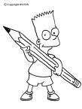

_______________________________________________

_______________________________________________



Nombre

Encierra las palabras largas y tacha las palabras cortas.



Ferrocarril piso

Papalote renacuajo

Palo ángel edificio

Intercambiar carro característica

Lomo oso popocatepetl



Nombre

Realiza la plana de los siguientes números.

Ejercicio 1

|  |  |  |  |  |  |  |  |  |  |  |  |  |  |  |  |  |  |  |  |
| --- | --- | --- | --- | --- | --- | --- | --- | --- | --- | --- | --- | --- | --- | --- | --- | --- | --- | --- | --- |
|  |  |  |  |  |  |  |  |  |  |  |  |  |  |  |  |  |  |  |  |
|  |  |  |  |  |  |  |  |  |  |  |  |  |  |  |  |  |  |  |  |
|  |  |  |  |  |  |  |  |  |  |  |  |  |  |  |  |  |  |  |  |
|  |  |  |  |  |  |  |  |  |  |  |  |  |  |  |  |  |  |  |  |
|  |  |  |  |  |  |  |  |  |  |  |  |  |  |  |  |  |  |  |  |
|  |  |  |  |  |  |  |  |  |  |  |  |  |  |  |  |  |  |  |  |

Ejercicio 2

|  |  |  |  |  |  |  |  |  |  |  |  |  |  |  |  |  |  |  |  |
| --- | --- | --- | --- | --- | --- | --- | --- | --- | --- | --- | --- | --- | --- | --- | --- | --- | --- | --- | --- |
|  |  |  |  |  |  |  |  |  |  |  |  |  |  |  |  |  |  |  |  |
|  |  |  |  |  |  |  |  |  |  |  |  |  |  |  |  |  |  |  |  |
|  |  |  |  |  |  |  |  |  |  |  |  |  |  |  |  |  |  |  |  |
|  |  |  |  |  |  |  |  |  |  |  |  |  |  |  |  |  |  |  |  |
|  |  |  |  |  |  |  |  |  |  |  |  |  |  |  |  |  |  |  |  |
|  |  |  |  |  |  |  |  |  |  |  |  |  |  |  |  |  |  |  |  |

Ejercicio 3

|  |  |  |  |  |  |  |  |  |  |  |  |  |  |  |  |  |  |  |  |
| --- | --- | --- | --- | --- | --- | --- | --- | --- | --- | --- | --- | --- | --- | --- | --- | --- | --- | --- | --- |
|  |  |  |  |  |  |  |  |  |  |  |  |  |  |  |  |  |  |  |  |
|  |  |  |  |  |  |  |  |  |  |  |  |  |  |  |  |  |  |  |  |
|  |  |  |  |  |  |  |  |  |  |  |  |  |  |  |  |  |  |  |  |
|  |  |  |  |  |  |  |  |  |  |  |  |  |  |  |  |  |  |  |  |
|  |  |  |  |  |  |  |  |  |  |  |  |  |  |  |  |  |  |  |  |
|  |  |  |  |  |  |  |  |  |  |  |  |  |  |  |  |  |  |  |  |

Ejercicio 4

|  |  |  |  |  |  |  |  |  |  |  |  |  |  |  |  |  |  |  |  |
| --- | --- | --- | --- | --- | --- | --- | --- | --- | --- | --- | --- | --- | --- | --- | --- | --- | --- | --- | --- |
|  |  |  |  |  |  |  |  |  |  |  |  |  |  |  |  |  |  |  |  |
|  |  |  |  |  |  |  |  |  |  |  |  |  |  |  |  |  |  |  |  |
|  |  |  |  |  |  |  |  |  |  |  |  |  |  |  |  |  |  |  |  |
|  |  |  |  |  |  |  |  |  |  |  |  |  |  |  |  |  |  |  |  |
|  |  |  |  |  |  |  |  |  |  |  |  |  |  |  |  |  |  |  |  |
|  |  |  |  |  |  |  |  |  |  |  |  |  |  |  |  |  |  |  |  |

Ejercicio 5

|  |  |  |  |  |  |  |  |  |  |  |  |  |  |  |  |  |  |  |  |
| --- | --- | --- | --- | --- | --- | --- | --- | --- | --- | --- | --- | --- | --- | --- | --- | --- | --- | --- | --- |
|  |  |  |  |  |  |  |  |  |  |  |  |  |  |  |  |  |  |  |  |
|  |  |  |  |  |  |  |  |  |  |  |  |  |  |  |  |  |  |  |  |
|  |  |  |  |  |  |  |  |  |  |  |  |  |  |  |  |  |  |  |  |
|  |  |  |  |  |  |  |  |  |  |  |  |  |  |  |  |  |  |  |  |
|  |  |  |  |  |  |  |  |  |  |  |  |  |  |  |  |  |  |  |  |
|  |  |  |  |  |  |  | Scan0005 |  |  |  |  |  |  |  |  |  |  |  |  |

Nombre

Completa los números que faltan de la siguiente familia del 10

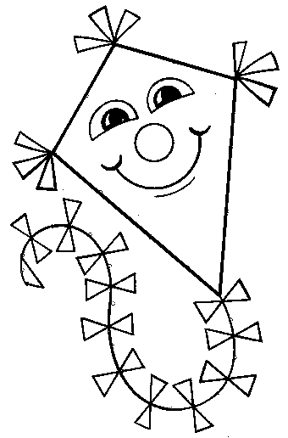

10

12

14

16

18



Nombre Nombre

“Cuida tu medio ambiente.”

Colorea lo que debemos hacer para cuidar nuestro planeta y encierra lo que no debemos hacer.

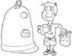 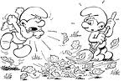

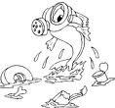 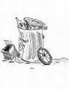

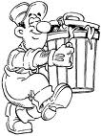 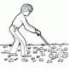

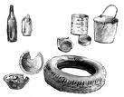

Nombre Nombre

Busca la página recortable y pega como se te indica.

Pega la canasta arriba de la mesa y la manzana abajo del árbol.

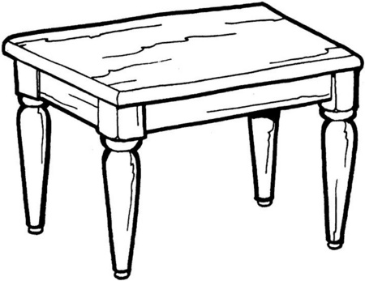

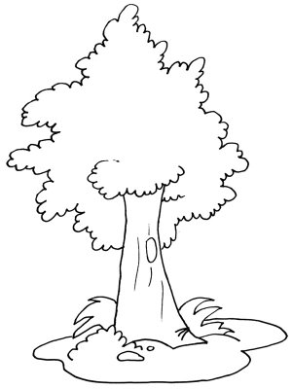



Nombre

Decora con diversidad de materiales de color rosa.

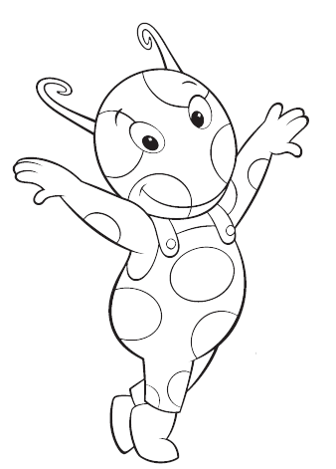

Rosa



Nombre

Decora con material variado de color rosa el rombo.

Rombo

Nombre

Con recortes pega objetos que tengan forma de rombo.



Nombre

# C:\Documents and Settings\admin\Mis documentos\Mis imágenes\bbb.bmpDecora con material variado la letra V v.

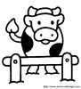



Nombre

De diferentes portadores de texto recorta y pega palabras con

V v.



Nombre

Continúa con la plana ubicando correctamente el cuadro.

Ejercicio 1

|  |  |  |  |  |  |  |  |  |  |  |  |  |  |  |  |  |  |  |  |
| --- | --- | --- | --- | --- | --- | --- | --- | --- | --- | --- | --- | --- | --- | --- | --- | --- | --- | --- | --- |
|  |  |  |  |  |  |  |  |  |  |  |  |  |  |  |  |  |  |  |  |
|  |  |  |  |  |  |  |  |  |  |  |  |  |  |  |  |  |  |  |  |
|  |  |  |  |  |  |  |  |  |  |  |  |  |  |  |  |  |  |  |  |
|  |  |  |  |  |  |  |  |  |  |  |  |  |  |  |  |  |  |  |  |
|  |  |  |  |  |  |  |  |  |  |  |  |  |  |  |  |  |  |  |  |
|  |  |  |  |  |  |  |  |  |  |  |  |  |  |  |  |  |  |  |  |

Ejercicio 2

|  |  |  |  |  |  |  |  |  |  |  |  |  |  |  |  |  |  |  |  |
| --- | --- | --- | --- | --- | --- | --- | --- | --- | --- | --- | --- | --- | --- | --- | --- | --- | --- | --- | --- |
|  |  |  |  |  |  |  |  |  |  |  |  |  |  |  |  |  |  |  |  |
|  |  |  |  |  |  |  |  |  |  |  |  |  |  |  |  |  |  |  |  |
|  |  |  |  |  |  |  |  |  |  |  |  |  |  |  |  |  |  |  |  |
|  |  |  |  |  |  |  |  |  |  |  |  |  |  |  |  |  |  |  |  |
|  |  |  |  |  |  |  |  |  |  |  |  |  |  |  |  |  |  |  |  |
|  |  |  |  |  |  |  |  |  |  |  |  |  |  |  |  |  |  |  |  |

Ejercicio 3

|  |  |  |  |  |  |  |  |  |  |  |  |  |  |  |  |  |  |  |  |
| --- | --- | --- | --- | --- | --- | --- | --- | --- | --- | --- | --- | --- | --- | --- | --- | --- | --- | --- | --- |
|  |  |  |  |  |  |  |  |  |  |  |  |  |  |  |  |  |  |  |  |
|  |  |  |  |  |  |  |  |  |  |  |  |  |  |  |  |  |  |  |  |
|  |  |  |  |  |  |  |  |  |  |  |  |  |  |  |  |  |  |  |  |
|  |  |  |  |  |  |  |  |  |  |  |  |  |  |  |  |  |  |  |  |
|  |  |  |  |  |  |  |  |  |  |  |  |  |  |  |  |  |  |  |  |
|  |  |  |  |  |  |  |  |  |  |  |  |  |  |  |  |  |  |  |  |

Ejercicio 4

|  |  |  |  |  |  |  |  |  |  |  |  |  |  |  |  |  |  |  |  |
| --- | --- | --- | --- | --- | --- | --- | --- | --- | --- | --- | --- | --- | --- | --- | --- | --- | --- | --- | --- |
|  |  |  |  |  |  |  |  |  |  |  |  |  |  |  |  |  |  |  |  |
|  |  |  |  |  |  |  |  |  |  |  |  |  |  |  |  |  |  |  |  |
|  |  |  |  |  |  |  |  |  |  |  |  |  |  |  |  |  |  |  |  |
|  |  |  |  |  |  |  |  |  |  |  |  |  |  |  |  |  |  |  |  |
|  |  |  |  |  |  |  |  |  |  |  |  |  |  |  |  |  |  |  |  |
|  |  |  |  |  |  |  |  |  |  |  |  |  |  |  |  |  |  |  |  |

Ejercicio 5

|  |  |  |  |  |  |  |  |  |  |  |  |  |  |  |  |  |  |  |  |
| --- | --- | --- | --- | --- | --- | --- | --- | --- | --- | --- | --- | --- | --- | --- | --- | --- | --- | --- | --- |
|  |  |  |  |  |  |  |  |  |  |  |  |  |  |  |  |  |  |  |  |
|  |  |  |  |  |  |  |  |  |  |  |  |  |  |  |  |  |  |  |  |
|  |  |  |  |  |  |  |  |  |  |  |  |  |  |  |  |  |  |  |  |
|  |  |  |  |  |  |  |  |  |  |  |  |  |  |  |  |  |  |  |  |
|  |  |  |  |  |  |  |  |  |  |  |  |  |  |  |  |  |  |  |  |
|  |  |  |  |  |  |  |  |  |  |  |  |  |  |  |  |  |  |  |  |



Nombre

Continúa con la plana ubicando correctamente el cuadro.

Ejercicio 1

|  |  |  |  |  |  |  |  |  |  |  |  |  |  |  |  |  |  |  |  |
| --- | --- | --- | --- | --- | --- | --- | --- | --- | --- | --- | --- | --- | --- | --- | --- | --- | --- | --- | --- |
|  |  |  |  |  |  |  |  |  |  |  |  |  |  |  |  |  |  |  |  |
|  |  |  |  |  |  |  |  |  |  |  |  |  |  |  |  |  |  |  |  |
|  |  |  |  |  |  |  |  |  |  |  |  |  |  |  |  |  |  |  |  |
|  |  |  |  |  |  |  |  |  |  |  |  |  |  |  |  |  |  |  |  |
|  |  |  |  |  |  |  |  |  |  |  |  |  |  |  |  |  |  |  |  |
|  |  |  |  |  |  |  |  |  |  |  |  |  |  |  |  |  |  |  |  |

Ejercicio 2

|  |  |  |  |  |  |  |  |  |  |  |  |  |  |  |  |  |  |  |  |
| --- | --- | --- | --- | --- | --- | --- | --- | --- | --- | --- | --- | --- | --- | --- | --- | --- | --- | --- | --- |
|  |  |  |  |  |  |  |  |  |  |  |  |  |  |  |  |  |  |  |  |
|  |  |  |  |  |  |  |  |  |  |  |  |  |  |  |  |  |  |  |  |
|  |  |  |  |  |  |  |  |  |  |  |  |  |  |  |  |  |  |  |  |
|  |  |  |  |  |  |  |  |  |  |  |  |  |  |  |  |  |  |  |  |
|  |  |  |  |  |  |  |  |  |  |  |  |  |  |  |  |  |  |  |  |
|  |  |  |  |  |  |  |  |  |  |  |  |  |  |  |  |  |  |  |  |

Ejercicio 3

|  |  |  |  |  |  |  |  |  |  |  |  |  |  |  |  |  |  |  |  |
| --- | --- | --- | --- | --- | --- | --- | --- | --- | --- | --- | --- | --- | --- | --- | --- | --- | --- | --- | --- |
|  |  |  |  |  |  |  |  |  |  |  |  |  |  |  |  |  |  |  |  |
|  |  |  |  |  |  |  |  |  |  |  |  |  |  |  |  |  |  |  |  |
|  |  |  |  |  |  |  |  |  |  |  |  |  |  |  |  |  |  |  |  |
|  |  |  |  |  |  |  |  |  |  |  |  |  |  |  |  |  |  |  |  |
|  |  |  |  |  |  |  |  |  |  |  |  |  |  |  |  |  |  |  |  |
|  |  |  |  |  |  |  |  |  |  |  |  |  |  |  |  |  |  |  |  |

Ejercicio 4

|  |  |  |  |  |  |  |  |  |  |  |  |  |  |  |  |  |  |  |  |
| --- | --- | --- | --- | --- | --- | --- | --- | --- | --- | --- | --- | --- | --- | --- | --- | --- | --- | --- | --- |
|  |  |  |  |  |  |  |  |  |  |  |  |  |  |  |  |  |  |  |  |
|  |  |  |  |  |  |  |  |  |  |  |  |  |  |  |  |  |  |  |  |
|  |  |  |  |  |  |  |  |  |  |  |  |  |  |  |  |  |  |  |  |
|  |  |  |  |  |  |  |  |  |  |  |  |  |  |  |  |  |  |  |  |
|  |  |  |  |  |  |  |  |  |  |  |  |  |  |  |  |  |  |  |  |
|  |  |  |  |  |  |  |  |  |  |  |  |  |  |  |  |  |  |  |  |

Ejercicio 5

|  |  |  |  |  |  |  |  |  |  |  |  |  |  |  |  |  |  |  |  |
| --- | --- | --- | --- | --- | --- | --- | --- | --- | --- | --- | --- | --- | --- | --- | --- | --- | --- | --- | --- |
|  |  |  |  |  |  |  |  |  |  |  |  |  |  |  |  |  |  |  |  |
|  |  |  |  |  |  |  |  |  |  |  |  |  |  |  |  |  |  |  |  |
|  |  |  |  |  |  |  |  |  |  |  |  |  |  |  |  |  |  |  |  |
|  |  |  |  |  |  |  |  |  |  |  |  |  |  |  |  |  |  |  |  |
|  |  |  |  |  |  |  |  |  |  |  |  |  |  |  |  |  |  |  |  |
|  |  |  |  |  |  |  |  |  |  |  |  |  |  |  |  |  |  |  |  |



Nombre

Lee las oraciones y únelas con el dibujo correspondiente.

La vaca da leche

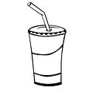

Las uvas son dulces



El vaso tiene agua

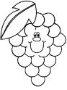



Nombre

Observa las imágenes y únelas con una línea con sus nombres.

Vestido

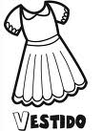 Vampiro 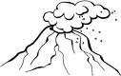

Avión

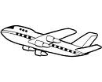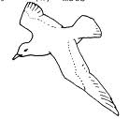 Ave

Violín

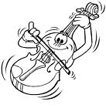 Volcán 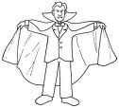

 Vestido

Nombre

Decora con material variado de color morado las uvas.

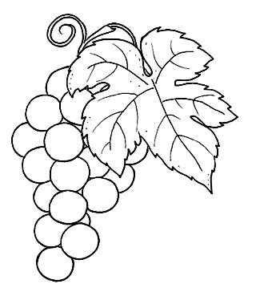

Morado



Nombre

Decora con diversidad de materiales el trapecio.

Trapecio



Nombre

De la lectura que escuchaste de tu libro cuenta cuentos “El viaje de la tortuga” pega que otros animales viven en el mar que tú conozcas.



Nombre

Cuenta los dibujos y encierra el número correcto.

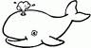

  8 5 2

 

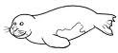   

   

19 27 20

   

   

   



Nombre

De diferentes portadores de texto pega trapecios.



Nombre

Realiza la plana de tu nombre completo en letra script y cursivas.

Ejercicio 1

|  |  |  |  |  |  |  |  |  |  |  |  |  |  |  |  |  |  |  |  |
| --- | --- | --- | --- | --- | --- | --- | --- | --- | --- | --- | --- | --- | --- | --- | --- | --- | --- | --- | --- |
|  |  |  |  |  |  |  |  |  |  |  |  |  |  |  |  |  |  |  |  |
|  |  |  |  |  |  |  |  |  |  |  |  |  |  |  |  |  |  |  |  |
|  |  |  |  |  |  |  |  |  |  |  |  |  |  |  |  |  |  |  |  |
|  |  |  |  |  |  |  |  |  |  |  |  |  |  |  |  |  |  |  |  |
|  |  |  |  |  |  |  |  |  |  |  |  |  |  |  |  |  |  |  |  |
|  |  |  |  |  |  |  |  |  |  |  |  |  |  |  |  |  |  |  |  |

Ejercicio 2

|  |  |  |  |  |  |  |  |  |  |  |  |  |  |  |  |  |  |  |  |
| --- | --- | --- | --- | --- | --- | --- | --- | --- | --- | --- | --- | --- | --- | --- | --- | --- | --- | --- | --- |
|  |  |  |  |  |  |  |  |  |  |  |  |  |  |  |  |  |  |  |  |
|  |  |  |  |  |  |  |  |  |  |  |  |  |  |  |  |  |  |  |  |
|  |  |  |  |  |  |  |  |  |  |  |  |  |  |  |  |  |  |  |  |
|  |  |  |  |  |  |  |  |  |  |  |  |  |  |  |  |  |  |  |  |
|  |  |  |  |  |  |  |  |  |  |  |  |  |  |  |  |  |  |  |  |
|  |  |  |  |  |  |  |  |  |  |  |  |  |  |  |  |  |  |  |  |

Ejercicio 3

|  |  |  |  |  |  |  |  |  |  |  |  |  |  |  |  |  |  |  |  |
| --- | --- | --- | --- | --- | --- | --- | --- | --- | --- | --- | --- | --- | --- | --- | --- | --- | --- | --- | --- |
|  |  |  |  |  |  |  |  |  |  |  |  |  |  |  |  |  |  |  |  |
|  |  |  |  |  |  |  |  |  |  |  |  |  |  |  |  |  |  |  |  |
|  |  |  |  |  |  |  |  |  |  |  |  |  |  |  |  |  |  |  |  |
|  |  |  |  |  |  |  |  |  |  |  |  |  |  |  |  |  |  |  |  |
|  |  |  |  |  |  |  |  |  |  |  |  |  |  |  |  |  |  |  |  |
|  |  |  |  |  |  |  |  |  |  |  |  |  |  |  |  |  |  |  |  |

Ejercicio 4

|  |  |  |  |  |  |  |  |  |  |  |  |  |  |  |  |  |  |  |  |
| --- | --- | --- | --- | --- | --- | --- | --- | --- | --- | --- | --- | --- | --- | --- | --- | --- | --- | --- | --- |
|  |  |  |  |  |  |  |  |  |  |  |  |  |  |  |  |  |  |  |  |
|  |  |  |  |  |  |  |  |  |  |  |  |  |  |  |  |  |  |  |  |
|  |  |  |  |  |  |  |  |  |  |  |  |  |  |  |  |  |  |  |  |
|  |  |  |  |  |  |  |  |  |  |  |  |  |  |  |  |  |  |  |  |
|  |  |  |  |  |  |  |  |  |  |  |  |  |  |  |  |  |  |  |  |
|  |  |  |  |  |  |  |  |  |  |  |  |  |  |  |  |  |  |  |  |

Ejercicio 5

|  |  |  |  |  |  |  |  |  |  |  |  |  |  |  |  |  |  |  |  |
| --- | --- | --- | --- | --- | --- | --- | --- | --- | --- | --- | --- | --- | --- | --- | --- | --- | --- | --- | --- |
|  |  |  |  |  |  |  |  |  |  |  |  |  |  |  |  |  |  |  |  |
|  |  |  |  |  |  |  |  |  |  |  |  |  |  |  |  |  |  |  |  |
|  |  |  |  |  |  |  |  |  |  |  |  |  |  |  |  |  |  |  |  |
|  |  |  |  |  |  |  |  |  |  |  |  |  |  |  |  |  |  |  |  |
|  |  |  |  |  |  |  |  |  |  |  |  |  |  |  |  |  |  |  |  |
|  |  |  |  |  |  | Scan0005 |  |  |  |  |  |  |  |  |  |  |  |  |  |

Nombre

Busca la página recortable y pega como se te indica.

Pega la pelota delante del niño, y la muñeca atrás de la niña.

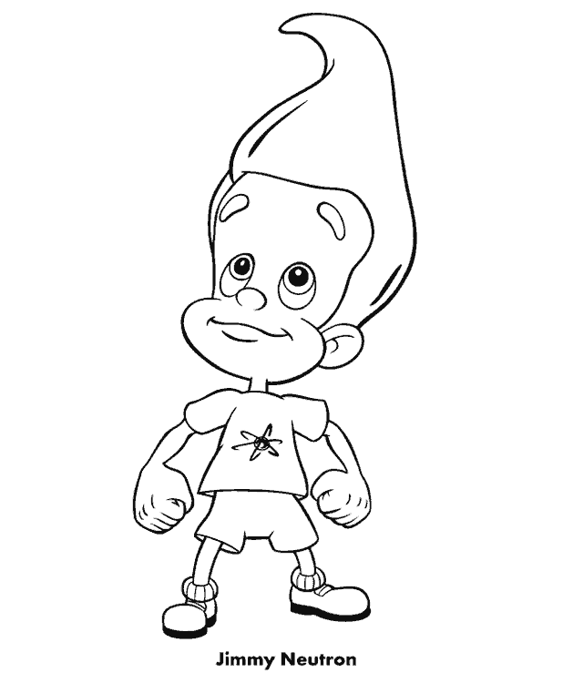

Adelante

 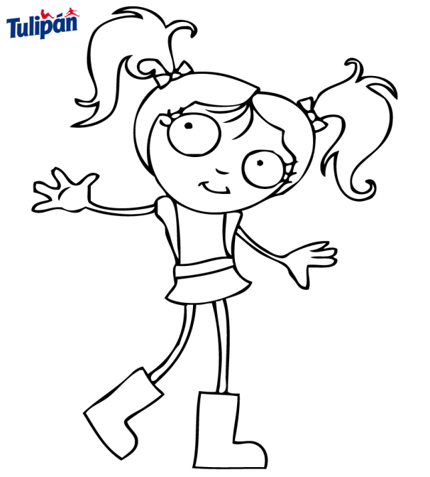

Atrás Nombre

Decora con diversidad de materiales.

Halloween

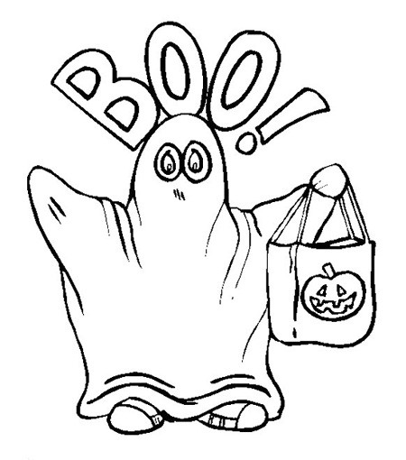 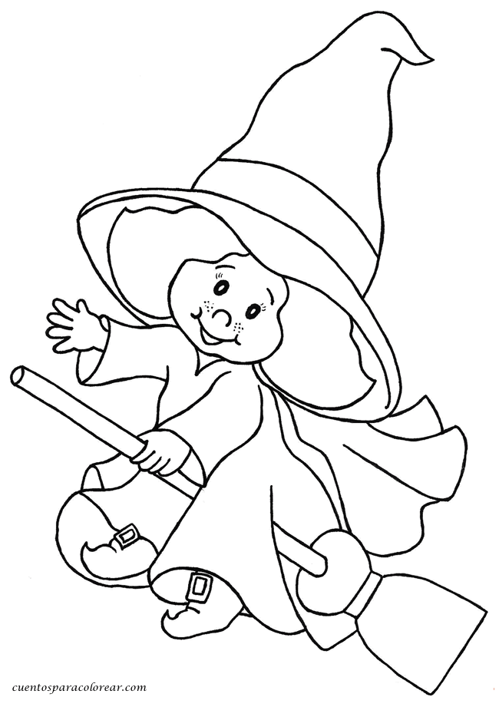 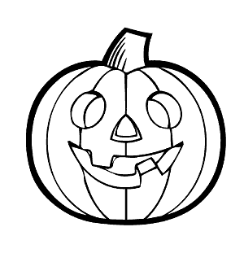

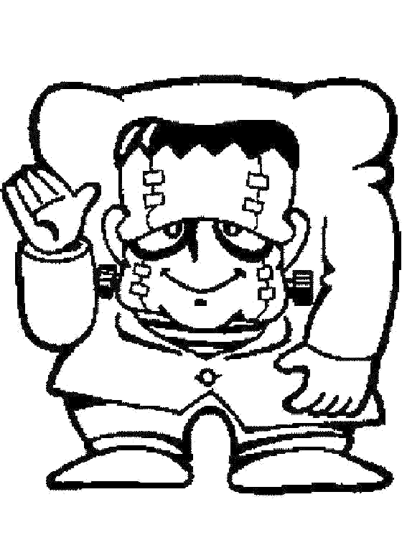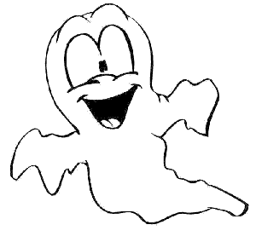  
Nombre

Decora el oso con material variado.

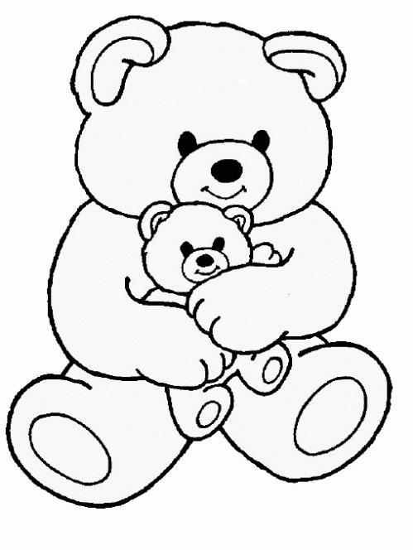

Café

Nombre

Decora lo que celebramos en noviembre.

2 DE NOVIEMBRE DIA DE MUERTOS

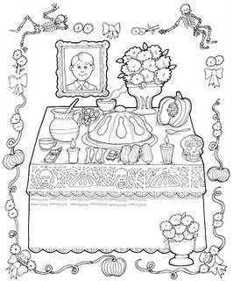

OFRENDA



Nombre

Representa las unidades y decenas de los siguientes números.

d u d u d u d u d u

2 0 2 5 2 8 2 1 2 6



Nombre

Decora con material variado la letra T t.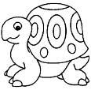

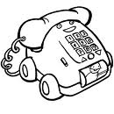



Nombre

Completa las silabas.

a ta ta ta ___ ___

e te te te ___ ___ ___

T t i ti ti ti ___ ___ ___

o to to to ___ ___ ___

u tu tu tu tu ___ ___ ___



Nombre

El libro y sus secretos, contesta las siguientes preguntas.

Responde:

Cuando ves el libro, ¿Cómo puedes saber de qué se trata?

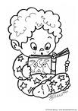

¿Qué otras palabras suenan a **portada**?



Nombre

Ahora que ya sabes que es la portada, pega de diferentes portadores de texto distintas portadas.

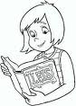



Nombre

Continúa con la plana ubicando correctamente el cuadro.

Ejercicio 1

|  |  |  |  |  |  |  |  |  |  |  |  |  |  |  |  |  |  |  |  |
| --- | --- | --- | --- | --- | --- | --- | --- | --- | --- | --- | --- | --- | --- | --- | --- | --- | --- | --- | --- |
|  |  |  |  |  |  |  |  |  |  |  |  |  |  |  |  |  |  |  |  |
|  |  |  |  |  |  |  |  |  |  |  |  |  |  |  |  |  |  |  |  |
|  |  |  |  |  |  |  |  |  |  |  |  |  |  |  |  |  |  |  |  |
|  |  |  |  |  |  |  |  |  |  |  |  |  |  |  |  |  |  |  |  |
|  |  |  |  |  |  |  |  |  |  |  |  |  |  |  |  |  |  |  |  |
|  |  |  |  |  |  |  |  |  |  |  |  |  |  |  |  |  |  |  |  |

Ejercicio 2

|  |  |  |  |  |  |  |  |  |  |  |  |  |  |  |  |  |  |  |  |
| --- | --- | --- | --- | --- | --- | --- | --- | --- | --- | --- | --- | --- | --- | --- | --- | --- | --- | --- | --- |
|  |  |  |  |  |  |  |  |  |  |  |  |  |  |  |  |  |  |  |  |
|  |  |  |  |  |  |  |  |  |  |  |  |  |  |  |  |  |  |  |  |
|  |  |  |  |  |  |  |  |  |  |  |  |  |  |  |  |  |  |  |  |
|  |  |  |  |  |  |  |  |  |  |  |  |  |  |  |  |  |  |  |  |
|  |  |  |  |  |  |  |  |  |  |  |  |  |  |  |  |  |  |  |  |
|  |  |  |  |  |  |  |  |  |  |  |  |  |  |  |  |  |  |  |  |

Ejercicio 3

|  |  |  |  |  |  |  |  |  |  |  |  |  |  |  |  |  |  |  |  |
| --- | --- | --- | --- | --- | --- | --- | --- | --- | --- | --- | --- | --- | --- | --- | --- | --- | --- | --- | --- |
|  |  |  |  |  |  |  |  |  |  |  |  |  |  |  |  |  |  |  |  |
|  |  |  |  |  |  |  |  |  |  |  |  |  |  |  |  |  |  |  |  |
|  |  |  |  |  |  |  |  |  |  |  |  |  |  |  |  |  |  |  |  |
|  |  |  |  |  |  |  |  |  |  |  |  |  |  |  |  |  |  |  |  |
|  |  |  |  |  |  |  |  |  |  |  |  |  |  |  |  |  |  |  |  |
|  |  |  |  |  |  |  |  |  |  |  |  |  |  |  |  |  |  |  |  |

Ejercicio 4

|  |  |  |  |  |  |  |  |  |  |  |  |  |  |  |  |  |  |  |  |
| --- | --- | --- | --- | --- | --- | --- | --- | --- | --- | --- | --- | --- | --- | --- | --- | --- | --- | --- | --- |
|  |  |  |  |  |  |  |  |  |  |  |  |  |  |  |  |  |  |  |  |
|  |  |  |  |  |  |  |  |  |  |  |  |  |  |  |  |  |  |  |  |
|  |  |  |  |  |  |  |  |  |  |  |  |  |  |  |  |  |  |  |  |
|  |  |  |  |  |  |  |  |  |  |  |  |  |  |  |  |  |  |  |  |
|  |  |  |  |  |  |  |  |  |  |  |  |  |  |  |  |  |  |  |  |
|  |  |  |  |  |  |  |  |  |  |  |  |  |  |  |  |  |  |  |  |

Ejercicio 5

|  |  |  |  |  |  |  |  |  |  |  |  |  |  |  |  |  |  |  |  |
| --- | --- | --- | --- | --- | --- | --- | --- | --- | --- | --- | --- | --- | --- | --- | --- | --- | --- | --- | --- |
|  |  |  |  |  |  |  |  |  |  |  |  |  |  |  |  |  |  |  |  |
|  |  |  |  |  |  |  |  |  |  |  |  |  |  |  |  |  |  |  |  |
|  |  |  |  |  |  |  |  |  |  |  |  |  |  |  |  |  |  |  |  |
|  |  |  |  |  |  |  |  |  |  |  |  |  |  |  |  |  |  |  |  |
|  |  |  |  |  |  |  |  |  |  |  |  |  |  |  |  |  |  |  |  |
|  |  |  |  |  |  |  |  |  |  |  |  |  |  |  |  |  |  |  |  |



Nombre

De diferentes portadores de texto recorta y pega objetos que comienzan con T t.



Nombre

Busca la página recortable y pega como se indica.

Pega el barco cerca de la playa y al tiburón lejos de ella.

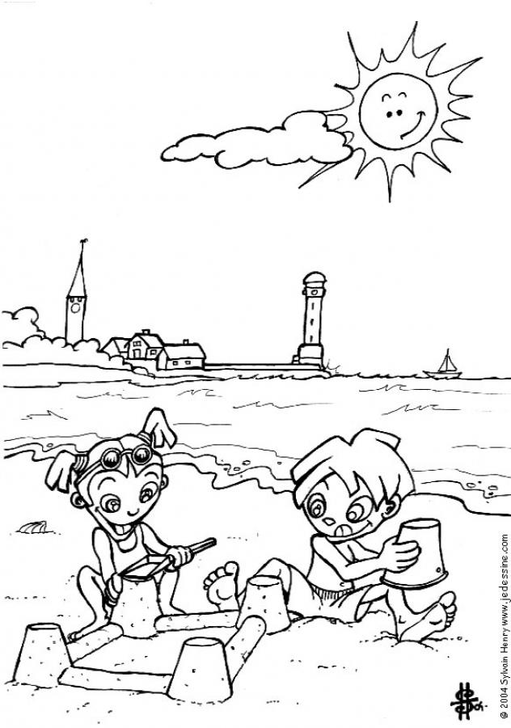



Nombre

Decora con material variado la letra TR tr.

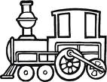



Nombre

Continúa con la plana de la tr ubicando el cuadro correctamente.

Ejercicio 1

|  |  |  |  |  |  |  |  |  |  |  |  |  |  |  |  |  |  |  |  |  |  |  |  |  |  |  |  |  |  |
| --- | --- | --- | --- | --- | --- | --- | --- | --- | --- | --- | --- | --- | --- | --- | --- | --- | --- | --- | --- | --- | --- | --- | --- | --- | --- | --- | --- | --- | --- |
|  |  |  |  |  |  |  |  |  |  |  |  |  |  |  |  |  |  |  |  |  |  |  |  |  |  |  |  |  |  |
|  |  |  |  |  |  |  |  |  |  |  |  |  |  |  |  |  |  |  |  |  |  |  |  |  |  |  |  |  |  |
|  |  |  |  |  |  |  |  |  |  |  |  |  |  |  |  |  |  |  |  |  |  |  |  |  |  |  |  |  |  |
|  |  |  |  |  |  |  |  |  |  |  |  |  |  |  |  |  |  |  |  |  |  |  |  |  |  |  |  |  |  |
|  |  |  |  |  |  |  |  |  |  |  |  |  |  |  |  |  |  |  |  |  |  |  |  |  |  |  |  |  |  |
|  |  |  |  |  |  |  |  |  |  |  |  |  |  |  |  |  |  |  |  |  |  |  |  |  |  |  |  |  |  |

Ejercicio 2

|  |  |  |  |  |  |  |  |  |  |  |  |  |  |  |  |  |  |  |  |  |  |  |  |  |  |  |  |  |  |
| --- | --- | --- | --- | --- | --- | --- | --- | --- | --- | --- | --- | --- | --- | --- | --- | --- | --- | --- | --- | --- | --- | --- | --- | --- | --- | --- | --- | --- | --- |
|  |  |  |  |  |  |  |  |  |  |  |  |  |  |  |  |  |  |  |  |  |  |  |  |  |  |  |  |  |  |
|  |  |  |  |  |  |  |  |  |  |  |  |  |  |  |  |  |  |  |  |  |  |  |  |  |  |  |  |  |  |
|  |  |  |  |  |  |  |  |  |  |  |  |  |  |  |  |  |  |  |  |  |  |  |  |  |  |  |  |  |  |
|  |  |  |  |  |  |  |  |  |  |  |  |  |  |  |  |  |  |  |  |  |  |  |  |  |  |  |  |  |  |
|  |  |  |  |  |  |  |  |  |  |  |  |  |  |  |  |  |  |  |  |  |  |  |  |  |  |  |  |  |  |
|  |  |  |  |  |  |  |  |  |  |  |  |  |  |  |  |  |  |  |  |  |  |  |  |  |  |  |  |  |  |

Ejercicio 3

|  |  |  |  |  |  |  |  |  |  |  |  |  |  |  |  |  |  |  |  |  |  |  |  |  |  |  |  |  |  |
| --- | --- | --- | --- | --- | --- | --- | --- | --- | --- | --- | --- | --- | --- | --- | --- | --- | --- | --- | --- | --- | --- | --- | --- | --- | --- | --- | --- | --- | --- |
|  |  |  |  |  |  |  |  |  |  |  |  |  |  |  |  |  |  |  |  |  |  |  |  |  |  |  |  |  |  |
|  |  |  |  |  |  |  |  |  |  |  |  |  |  |  |  |  |  |  |  |  |  |  |  |  |  |  |  |  |  |
|  |  |  |  |  |  |  |  |  |  |  |  |  |  |  |  |  |  |  |  |  |  |  |  |  |  |  |  |  |  |
|  |  |  |  |  |  |  |  |  |  |  |  |  |  |  |  |  |  |  |  |  |  |  |  |  |  |  |  |  |  |
|  |  |  |  |  |  |  |  |  |  |  |  |  |  |  |  |  |  |  |  |  |  |  |  |  |  |  |  |  |  |
|  |  |  |  |  |  |  |  |  |  |  |  |  |  |  |  |  |  |  |  |  |  |  |  |  |  |  |  |  |  |

Ejercicio 4

|  |  |  |  |  |  |  |  |  |  |  |  |  |  |  |  |  |  |  |  |  |  |  |  |  |  |  |  |  |  |
| --- | --- | --- | --- | --- | --- | --- | --- | --- | --- | --- | --- | --- | --- | --- | --- | --- | --- | --- | --- | --- | --- | --- | --- | --- | --- | --- | --- | --- | --- |
|  |  |  |  |  |  |  |  |  |  |  |  |  |  |  |  |  |  |  |  |  |  |  |  |  |  |  |  |  |  |
|  |  |  |  |  |  |  |  |  |  |  |  |  |  |  |  |  |  |  |  |  |  |  |  |  |  |  |  |  |  |
|  |  |  |  |  |  |  |  |  |  |  |  |  |  |  |  |  |  |  |  |  |  |  |  |  |  |  |  |  |  |
|  |  |  |  |  |  |  |  |  |  |  |  |  |  |  |  |  |  |  |  |  |  |  |  |  |  |  |  |  |  |
|  |  |  |  |  |  |  |  |  |  |  |  |  |  |  |  |  |  |  |  |  |  |  |  |  |  |  |  |  |  |
|  |  |  |  |  |  |  |  |  |  |  |  |  |  |  |  |  |  |  |  |  |  |  |  |  |  |  |  |  |  |

Ejercicio 5

|  |  |  |  |  |  |  |  |  |  |  |  |  |  |  |  |  |  |  |  |  |  |  |  |  |  |  |  |  |  |
| --- | --- | --- | --- | --- | --- | --- | --- | --- | --- | --- | --- | --- | --- | --- | --- | --- | --- | --- | --- | --- | --- | --- | --- | --- | --- | --- | --- | --- | --- |
|  |  |  |  |  |  |  |  |  |  |  |  |  |  |  |  |  |  |  |  |  |  |  |  |  |  |  |  |  |  |
|  |  |  |  |  |  |  |  |  |  |  |  |  |  |  |  |  |  |  |  |  |  |  |  |  |  |  |  |  |  |
|  |  |  |  |  |  |  |  |  |  |  |  |  |  |  |  |  |  |  |  |  |  |  |  |  |  |  |  |  |  |
|  |  |  |  |  |  |  |  |  |  |  |  |  |  |  |  |  |  |  |  |  |  |  |  |  |  |  |  |  |  |
|  |  |  |  |  |  |  |  |  |  |  |  |  |  |  |  |  |  |  |  |  |  |  |  |  |  |  |  |  |  |
|  |  |  |  |  |  |  |  | Scan0005 |  |  |  |  |  |  |  |  |  |  |  |  |  |  |  |  |  |  |  |  |  |

Nombre

Escucha la lectura de la “Estrella traviesa” de tu cuenta cuentos, decorael dibujo y pégale palabras tr alrededor.



Nombre

Con las figuras geométricas que has visto forma la figura que más te guste.



Nombre

“Me gusta investigar en libros”

Reúnete con tus compañeros de mesa y decidan que van a investigar. Explica por escrito cual va a ser el tema de investigación.

El tema de nuestra investigación es:

____________________________________________________________________________________________________________________________________________________________________________________________________________

Nombre

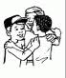

Pongan un nombre a su equipo y decidan que va a ser cada quien.

1. Mi equipo se llama______________________________
2. El tema que elegimos fue_________________________
3. Puedo ser: lector o lectora, escritor o escritora, ilustrador o ilustradora, relator o relatora.
4. En esta investigación soy_________________________

5. y me corresponde______________________________

“ASI PLANEO MI INVESTIGACION”



Nombre

Realiza las siguientes sumas y restas

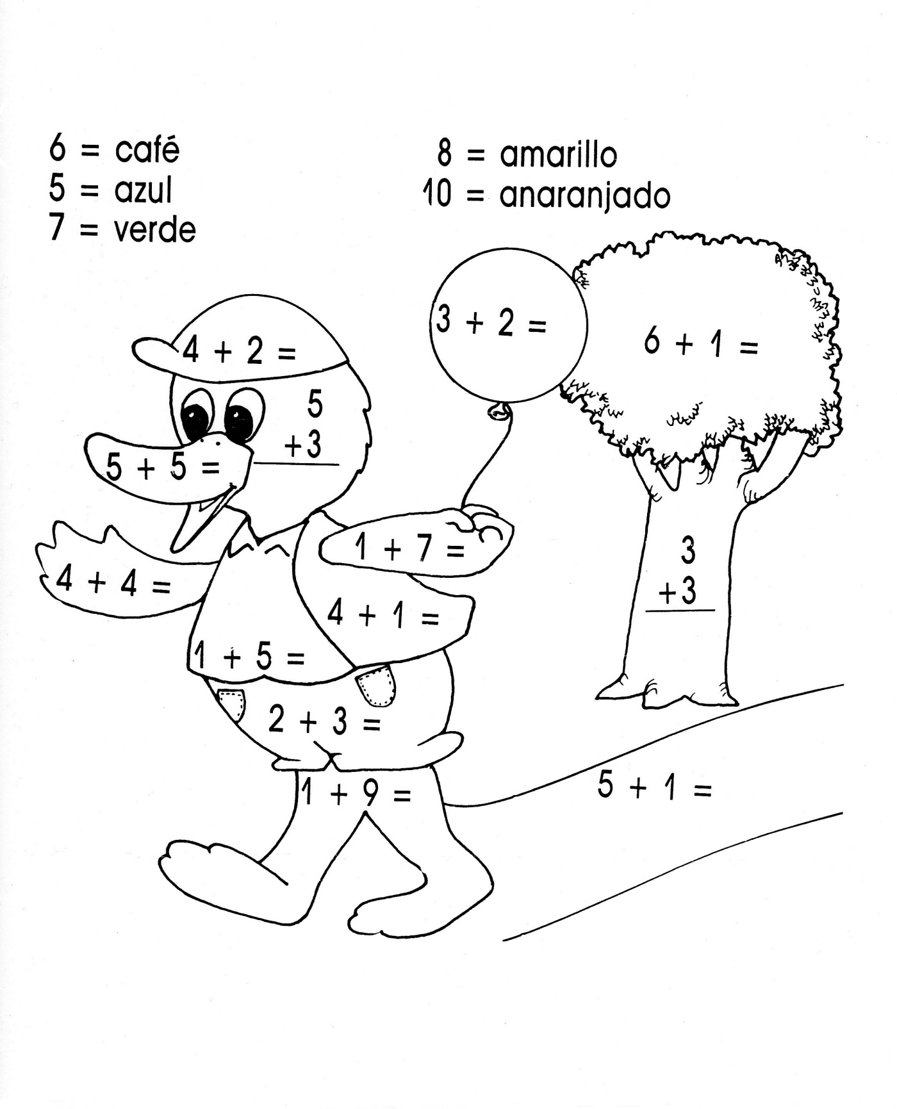

Nombre

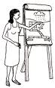

Copia el texto del pizarrón en cursiva e ilústralo con dibujos.

_________________________________________________________________________________________________________________________________________________________



Nombre

Decora con diversidad de materiales el siguiente dibujo.

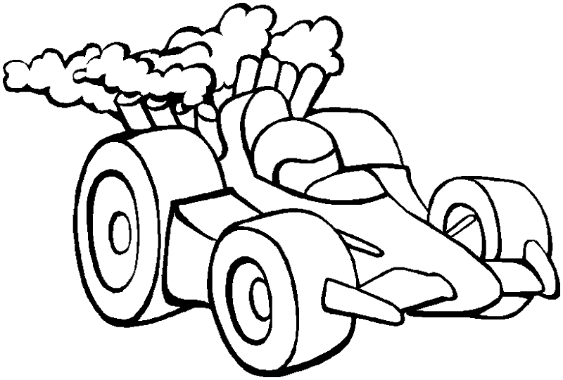

Negro



Nombre

Recorta y pega objetos de color negro.



Nombre

¿Qué animales viven en el circo?

Pégalos alrededor del dibujo.

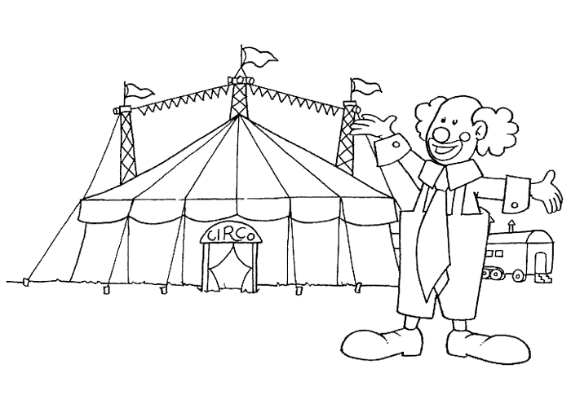

El circo

Nombre

Recorta y pega de diferentes portadores de texto la familia del 20



Nombre

Encierra en un círculo los instrumentos musicales que conozcas.

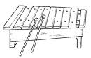

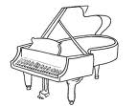

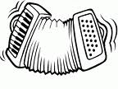

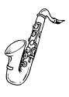

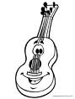 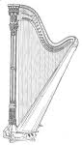



Nombre

Continúa con la plana de la familia del 20.

Ejercicio 1

|  |  |  |  |  |  |  |  |  |  |  |  |  |  |  |  |  |  |  |  |
| --- | --- | --- | --- | --- | --- | --- | --- | --- | --- | --- | --- | --- | --- | --- | --- | --- | --- | --- | --- |
|  |  |  |  |  |  |  |  |  |  |  |  |  |  |  |  |  |  |  |  |
|  |  |  |  |  |  |  |  |  |  |  |  |  |  |  |  |  |  |  |  |
|  |  |  |  |  |  |  |  |  |  |  |  |  |  |  |  |  |  |  |  |
|  |  |  |  |  |  |  |  |  |  |  |  |  |  |  |  |  |  |  |  |
|  |  |  |  |  |  |  |  |  |  |  |  |  |  |  |  |  |  |  |  |
|  |  |  |  |  |  |  |  |  |  |  |  |  |  |  |  |  |  |  |  |

Ejercicio 2

|  |  |  |  |  |  |  |  |  |  |  |  |  |  |  |  |  |  |  |  |
| --- | --- | --- | --- | --- | --- | --- | --- | --- | --- | --- | --- | --- | --- | --- | --- | --- | --- | --- | --- |
|  |  |  |  |  |  |  |  |  |  |  |  |  |  |  |  |  |  |  |  |
|  |  |  |  |  |  |  |  |  |  |  |  |  |  |  |  |  |  |  |  |
|  |  |  |  |  |  |  |  |  |  |  |  |  |  |  |  |  |  |  |  |
|  |  |  |  |  |  |  |  |  |  |  |  |  |  |  |  |  |  |  |  |
|  |  |  |  |  |  |  |  |  |  |  |  |  |  |  |  |  |  |  |  |
|  |  |  |  |  |  |  |  |  |  |  |  |  |  |  |  |  |  |  |  |

Ejercicio 3

|  |  |  |  |  |  |  |  |  |  |  |  |  |  |  |  |  |  |  |  |
| --- | --- | --- | --- | --- | --- | --- | --- | --- | --- | --- | --- | --- | --- | --- | --- | --- | --- | --- | --- |
|  |  |  |  |  |  |  |  |  |  |  |  |  |  |  |  |  |  |  |  |
|  |  |  |  |  |  |  |  |  |  |  |  |  |  |  |  |  |  |  |  |
|  |  |  |  |  |  |  |  |  |  |  |  |  |  |  |  |  |  |  |  |
|  |  |  |  |  |  |  |  |  |  |  |  |  |  |  |  |  |  |  |  |
|  |  |  |  |  |  |  |  |  |  |  |  |  |  |  |  |  |  |  |  |
|  |  |  |  |  |  |  |  |  |  |  |  |  |  |  |  |  |  |  |  |

Ejercicio 4

|  |  |  |  |  |  |  |  |  |  |  |  |  |  |  |  |  |  |  |  |
| --- | --- | --- | --- | --- | --- | --- | --- | --- | --- | --- | --- | --- | --- | --- | --- | --- | --- | --- | --- |
|  |  |  |  |  |  |  |  |  |  |  |  |  |  |  |  |  |  |  |  |
|  |  |  |  |  |  |  |  |  |  |  |  |  |  |  |  |  |  |  |  |
|  |  |  |  |  |  |  |  |  |  |  |  |  |  |  |  |  |  |  |  |
|  |  |  |  |  |  |  |  |  |  |  |  |  |  |  |  |  |  |  |  |
|  |  |  |  |  |  |  |  |  |  |  |  |  |  |  |  |  |  |  |  |
|  |  |  |  |  |  |  |  |  |  |  |  |  |  |  |  |  |  |  |  |

Ejercicio 5

|  |  |  |  |  |  |  |  |  |  |  |  |  |  |  |  |  |  |  |  |
| --- | --- | --- | --- | --- | --- | --- | --- | --- | --- | --- | --- | --- | --- | --- | --- | --- | --- | --- | --- |
|  |  |  |  |  |  |  |  |  |  |  |  |  |  |  |  |  |  |  |  |
|  |  |  |  |  |  |  |  |  |  |  |  |  |  |  |  |  |  |  |  |
|  |  |  |  |  |  |  |  |  |  |  |  |  |  |  |  |  |  |  |  |
|  |  |  |  |  |  |  |  |  |  |  |  |  |  |  |  |  |  |  |  |
|  |  |  |  |  |  |  |  |  |  |  |  |  |  |  |  |  |  |  |  |
|  |  |  |  |  |  | Scan0005 |  |  |  |  |  |  |  |  |  |  |  |  |  |

Nombre

Encierra el perro que está adentro de la casa y tacha al que esta afuera.

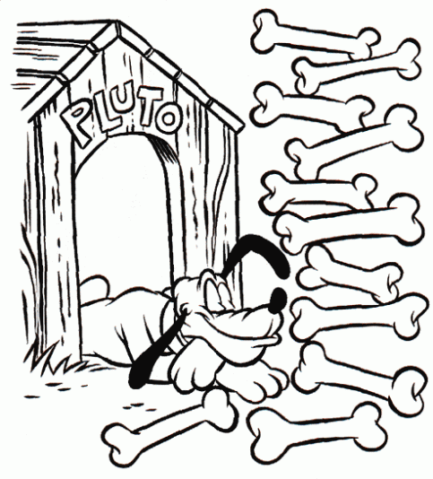

Adentro

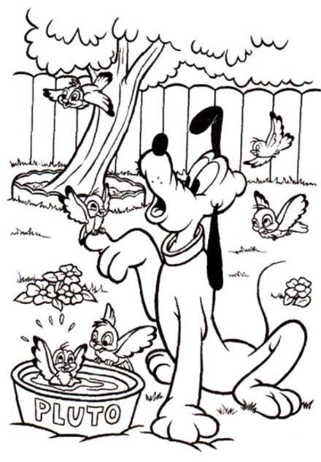

 Afuera

Nombre

Decora con material variado la letra D d.

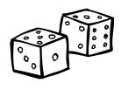

 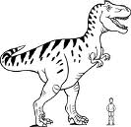

Nombre:

Encierra las letras D d que encuentres y completa sobre las líneas las silabas que faltan.

D A T L P

P r z s l

M E Q O H

D d b d p

Da De _____ Do _____

______ ______ di ______ du

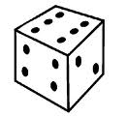 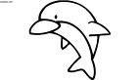 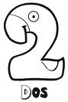 D   
Nombre

Continúa con la plana ubicando correctamente el cuadro.

Ejercicio 1

|  |  |  |  |  |  |  |  |  |  |  |  |  |  |  |  |  |  |  |  |
| --- | --- | --- | --- | --- | --- | --- | --- | --- | --- | --- | --- | --- | --- | --- | --- | --- | --- | --- | --- |
|  |  |  |  |  |  |  |  |  |  |  |  |  |  |  |  |  |  |  |  |
|  |  |  |  |  |  |  |  |  |  |  |  |  |  |  |  |  |  |  |  |
|  |  |  |  |  |  |  |  |  |  |  |  |  |  |  |  |  |  |  |  |
|  |  |  |  |  |  |  |  |  |  |  |  |  |  |  |  |  |  |  |  |
|  |  |  |  |  |  |  |  |  |  |  |  |  |  |  |  |  |  |  |  |
|  |  |  |  |  |  |  |  |  |  |  |  |  |  |  |  |  |  |  |  |

Ejercicio 2

|  |  |  |  |  |  |  |  |  |  |  |  |  |  |  |  |  |  |  |  |
| --- | --- | --- | --- | --- | --- | --- | --- | --- | --- | --- | --- | --- | --- | --- | --- | --- | --- | --- | --- |
|  |  |  |  |  |  |  |  |  |  |  |  |  |  |  |  |  |  |  |  |
|  |  |  |  |  |  |  |  |  |  |  |  |  |  |  |  |  |  |  |  |
|  |  |  |  |  |  |  |  |  |  |  |  |  |  |  |  |  |  |  |  |
|  |  |  |  |  |  |  |  |  |  |  |  |  |  |  |  |  |  |  |  |
|  |  |  |  |  |  |  |  |  |  |  |  |  |  |  |  |  |  |  |  |
|  |  |  |  |  |  |  |  |  |  |  |  |  |  |  |  |  |  |  |  |

Ejercicio 3

|  |  |  |  |  |  |  |  |  |  |  |  |  |  |  |  |  |  |  |  |
| --- | --- | --- | --- | --- | --- | --- | --- | --- | --- | --- | --- | --- | --- | --- | --- | --- | --- | --- | --- |
|  |  |  |  |  |  |  |  |  |  |  |  |  |  |  |  |  |  |  |  |
|  |  |  |  |  |  |  |  |  |  |  |  |  |  |  |  |  |  |  |  |
|  |  |  |  |  |  |  |  |  |  |  |  |  |  |  |  |  |  |  |  |
|  |  |  |  |  |  |  |  |  |  |  |  |  |  |  |  |  |  |  |  |
|  |  |  |  |  |  |  |  |  |  |  |  |  |  |  |  |  |  |  |  |
|  |  |  |  |  |  |  |  |  |  |  |  |  |  |  |  |  |  |  |  |

Ejercicio 4

|  |  |  |  |  |  |  |  |  |  |  |  |  |  |  |  |  |  |  |  |
| --- | --- | --- | --- | --- | --- | --- | --- | --- | --- | --- | --- | --- | --- | --- | --- | --- | --- | --- | --- |
|  |  |  |  |  |  |  |  |  |  |  |  |  |  |  |  |  |  |  |  |
|  |  |  |  |  |  |  |  |  |  |  |  |  |  |  |  |  |  |  |  |
|  |  |  |  |  |  |  |  |  |  |  |  |  |  |  |  |  |  |  |  |
|  |  |  |  |  |  |  |  |  |  |  |  |  |  |  |  |  |  |  |  |
|  |  |  |  |  |  |  |  |  |  |  |  |  |  |  |  |  |  |  |  |
|  |  |  |  |  |  |  |  |  |  |  |  |  |  |  |  |  |  |  |  |

Ejercicio 5

|  |  |  |  |  |  |  |  |  |  |  |  |  |  |  |  |  |  |  |  |
| --- | --- | --- | --- | --- | --- | --- | --- | --- | --- | --- | --- | --- | --- | --- | --- | --- | --- | --- | --- |
|  |  |  |  |  |  |  |  |  |  |  |  |  |  |  |  |  |  |  |  |
|  |  |  |  |  |  |  |  |  |  |  |  |  |  |  |  |  |  |  |  |
|  |  |  |  |  |  |  |  |  |  |  |  |  |  |  |  |  |  |  |  |
|  |  |  |  |  |  |  |  |  |  |  |  |  |  |  |  |  |  |  |  |
|  |  |  |  |  |  |  |  |  |  |  |  |  |  |  |  |  |  |  |  |
|  |  |  |  |  |  | Scan0005 |  |  |  |  |  |  |  |  |  |  |  |  |  |

Nombre

Continúa con la plana ubicando correctamente el cuadro.

Ejercicio 1

|  |  |  |  |  |  |  |  |  |  |  |  |  |  |  |  |  |  |  |  |
| --- | --- | --- | --- | --- | --- | --- | --- | --- | --- | --- | --- | --- | --- | --- | --- | --- | --- | --- | --- |
|  |  |  |  |  |  |  |  |  |  |  |  |  |  |  |  |  |  |  |  |
|  |  |  |  |  |  |  |  |  |  |  |  |  |  |  |  |  |  |  |  |
|  |  |  |  |  |  |  |  |  |  |  |  |  |  |  |  |  |  |  |  |
|  |  |  |  |  |  |  |  |  |  |  |  |  |  |  |  |  |  |  |  |
|  |  |  |  |  |  |  |  |  |  |  |  |  |  |  |  |  |  |  |  |
|  |  |  |  |  |  |  |  |  |  |  |  |  |  |  |  |  |  |  |  |

Ejercicio 2

|  |  |  |  |  |  |  |  |  |  |  |  |  |  |  |  |  |  |  |  |
| --- | --- | --- | --- | --- | --- | --- | --- | --- | --- | --- | --- | --- | --- | --- | --- | --- | --- | --- | --- |
|  |  |  |  |  |  |  |  |  |  |  |  |  |  |  |  |  |  |  |  |
|  |  |  |  |  |  |  |  |  |  |  |  |  |  |  |  |  |  |  |  |
|  |  |  |  |  |  |  |  |  |  |  |  |  |  |  |  |  |  |  |  |
|  |  |  |  |  |  |  |  |  |  |  |  |  |  |  |  |  |  |  |  |
|  |  |  |  |  |  |  |  |  |  |  |  |  |  |  |  |  |  |  |  |
|  |  |  |  |  |  |  |  |  |  |  |  |  |  |  |  |  |  |  |  |

Ejercicio 3

|  |  |  |  |  |  |  |  |  |  |  |  |  |  |  |  |  |  |  |  |
| --- | --- | --- | --- | --- | --- | --- | --- | --- | --- | --- | --- | --- | --- | --- | --- | --- | --- | --- | --- |
|  |  |  |  |  |  |  |  |  |  |  |  |  |  |  |  |  |  |  |  |
|  |  |  |  |  |  |  |  |  |  |  |  |  |  |  |  |  |  |  |  |
|  |  |  |  |  |  |  |  |  |  |  |  |  |  |  |  |  |  |  |  |
|  |  |  |  |  |  |  |  |  |  |  |  |  |  |  |  |  |  |  |  |
|  |  |  |  |  |  |  |  |  |  |  |  |  |  |  |  |  |  |  |  |
|  |  |  |  |  |  |  |  |  |  |  |  |  |  |  |  |  |  |  |  |

Ejercicio 4

|  |  |  |  |  |  |  |  |  |  |  |  |  |  |  |  |  |  |  |  |
| --- | --- | --- | --- | --- | --- | --- | --- | --- | --- | --- | --- | --- | --- | --- | --- | --- | --- | --- | --- |
|  |  |  |  |  |  |  |  |  |  |  |  |  |  |  |  |  |  |  |  |
|  |  |  |  |  |  |  |  |  |  |  |  |  |  |  |  |  |  |  |  |
|  |  |  |  |  |  |  |  |  |  |  |  |  |  |  |  |  |  |  |  |
|  |  |  |  |  |  |  |  |  |  |  |  |  |  |  |  |  |  |  |  |
|  |  |  |  |  |  |  |  |  |  |  |  |  |  |  |  |  |  |  |  |
|  |  |  |  |  |  |  |  |  |  |  |  |  |  |  |  |  |  |  |  |

Ejercicio 5

|  |  |  |  |  |  |  |  |  |  |  |  |  |  |  |  |  |  |  |  |
| --- | --- | --- | --- | --- | --- | --- | --- | --- | --- | --- | --- | --- | --- | --- | --- | --- | --- | --- | --- |
|  |  |  |  |  |  |  |  |  |  |  |  |  |  |  |  |  |  |  |  |
|  |  |  |  |  |  |  |  |  |  |  |  |  |  |  |  |  |  |  |  |
|  |  |  |  |  |  |  |  |  |  |  |  |  |  |  |  |  |  |  |  |
|  |  |  |  |  |  |  |  |  |  |  |  |  |  |  |  |  |  |  |  |
|  |  |  |  |  |  |  |  |  |  |  |  |  |  |  |  |  |  |  |  |
|  |  |  |  |  |  | Scan0005 |  |  |  |  |  |  |  |  |  |  |  |  |  |

Nombre

De la lectura de tu libro de cuenta cuentos “Diego” pega los animales salvajes que aparezcan en el cuento.



Nombre

Decora con materiales variados el dibujo.

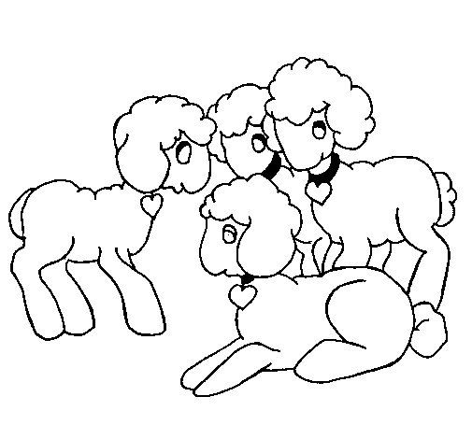

Blanco

Nombre

Decora el dibujo cuyo nombre inicie con la letra D d. y tacha los animales que creas que son salvajes.

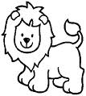  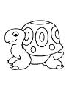

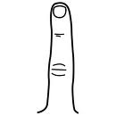 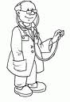 

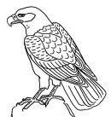 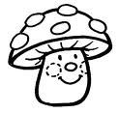 



Nombre

De diferentes portadores de texto recorta y pega palabras con

D d.



Nombre

Decora con material variado la letra DR dr.

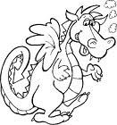



Nombre

Continúa con la plana de la dr ubicando el cuadro correctamente.

Ejercicio 1

|  |  |  |  |  |  |  |  |  |  |  |  |  |  |  |  |  |  |  |  |  |  |  |  |  |  |  |  |  |  |
| --- | --- | --- | --- | --- | --- | --- | --- | --- | --- | --- | --- | --- | --- | --- | --- | --- | --- | --- | --- | --- | --- | --- | --- | --- | --- | --- | --- | --- | --- |
|  |  |  |  |  |  |  |  |  |  |  |  |  |  |  |  |  |  |  |  |  |  |  |  |  |  |  |  |  |  |
|  |  |  |  |  |  |  |  |  |  |  |  |  |  |  |  |  |  |  |  |  |  |  |  |  |  |  |  |  |  |
|  |  |  |  |  |  |  |  |  |  |  |  |  |  |  |  |  |  |  |  |  |  |  |  |  |  |  |  |  |  |
|  |  |  |  |  |  |  |  |  |  |  |  |  |  |  |  |  |  |  |  |  |  |  |  |  |  |  |  |  |  |
|  |  |  |  |  |  |  |  |  |  |  |  |  |  |  |  |  |  |  |  |  |  |  |  |  |  |  |  |  |  |
|  |  |  |  |  |  |  |  |  |  |  |  |  |  |  |  |  |  |  |  |  |  |  |  |  |  |  |  |  |  |

Ejercicio 2

|  |  |  |  |  |  |  |  |  |  |  |  |  |  |  |  |  |  |  |  |  |  |  |  |  |  |  |  |  |  |
| --- | --- | --- | --- | --- | --- | --- | --- | --- | --- | --- | --- | --- | --- | --- | --- | --- | --- | --- | --- | --- | --- | --- | --- | --- | --- | --- | --- | --- | --- |
|  |  |  |  |  |  |  |  |  |  |  |  |  |  |  |  |  |  |  |  |  |  |  |  |  |  |  |  |  |  |
|  |  |  |  |  |  |  |  |  |  |  |  |  |  |  |  |  |  |  |  |  |  |  |  |  |  |  |  |  |  |
|  |  |  |  |  |  |  |  |  |  |  |  |  |  |  |  |  |  |  |  |  |  |  |  |  |  |  |  |  |  |
|  |  |  |  |  |  |  |  |  |  |  |  |  |  |  |  |  |  |  |  |  |  |  |  |  |  |  |  |  |  |
|  |  |  |  |  |  |  |  |  |  |  |  |  |  |  |  |  |  |  |  |  |  |  |  |  |  |  |  |  |  |
|  |  |  |  |  |  |  |  |  |  |  |  |  |  |  |  |  |  |  |  |  |  |  |  |  |  |  |  |  |  |

Ejercicio 3

|  |  |  |  |  |  |  |  |  |  |  |  |  |  |  |  |  |  |  |  |  |  |  |  |  |  |  |  |  |  |
| --- | --- | --- | --- | --- | --- | --- | --- | --- | --- | --- | --- | --- | --- | --- | --- | --- | --- | --- | --- | --- | --- | --- | --- | --- | --- | --- | --- | --- | --- |
|  |  |  |  |  |  |  |  |  |  |  |  |  |  |  |  |  |  |  |  |  |  |  |  |  |  |  |  |  |  |
|  |  |  |  |  |  |  |  |  |  |  |  |  |  |  |  |  |  |  |  |  |  |  |  |  |  |  |  |  |  |
|  |  |  |  |  |  |  |  |  |  |  |  |  |  |  |  |  |  |  |  |  |  |  |  |  |  |  |  |  |  |
|  |  |  |  |  |  |  |  |  |  |  |  |  |  |  |  |  |  |  |  |  |  |  |  |  |  |  |  |  |  |
|  |  |  |  |  |  |  |  |  |  |  |  |  |  |  |  |  |  |  |  |  |  |  |  |  |  |  |  |  |  |
|  |  |  |  |  |  |  |  |  |  |  |  |  |  |  |  |  |  |  |  |  |  |  |  |  |  |  |  |  |  |

Ejercicio 4

|  |  |  |  |  |  |  |  |  |  |  |  |  |  |  |  |  |  |  |  |  |  |  |  |  |  |  |  |  |  |
| --- | --- | --- | --- | --- | --- | --- | --- | --- | --- | --- | --- | --- | --- | --- | --- | --- | --- | --- | --- | --- | --- | --- | --- | --- | --- | --- | --- | --- | --- |
|  |  |  |  |  |  |  |  |  |  |  |  |  |  |  |  |  |  |  |  |  |  |  |  |  |  |  |  |  |  |
|  |  |  |  |  |  |  |  |  |  |  |  |  |  |  |  |  |  |  |  |  |  |  |  |  |  |  |  |  |  |
|  |  |  |  |  |  |  |  |  |  |  |  |  |  |  |  |  |  |  |  |  |  |  |  |  |  |  |  |  |  |
|  |  |  |  |  |  |  |  |  |  |  |  |  |  |  |  |  |  |  |  |  |  |  |  |  |  |  |  |  |  |
|  |  |  |  |  |  |  |  |  |  |  |  |  |  |  |  |  |  |  |  |  |  |  |  |  |  |  |  |  |  |
|  |  |  |  |  |  |  |  |  |  |  |  |  |  |  |  |  |  |  |  |  |  |  |  |  |  |  |  |  |  |

Ejercicio 5

|  |  |  |  |  |  |  |  |  |  |  |  |  |  |  |  |  |  |  |  |  |  |  |  |  |  |  |  |  |  |
| --- | --- | --- | --- | --- | --- | --- | --- | --- | --- | --- | --- | --- | --- | --- | --- | --- | --- | --- | --- | --- | --- | --- | --- | --- | --- | --- | --- | --- | --- |
|  |  |  |  |  |  |  |  |  |  |  |  |  |  |  |  |  |  |  |  |  |  |  |  |  |  |  |  |  |  |
|  |  |  |  |  |  |  |  |  |  |  |  |  |  |  |  |  |  |  |  |  |  |  |  |  |  |  |  |  |  |
|  |  |  |  |  |  |  |  |  |  |  |  |  |  |  |  |  |  |  |  |  |  |  |  |  |  |  |  |  |  |
|  |  |  |  |  |  |  |  |  |  |  |  |  |  |  |  |  |  |  |  |  |  |  |  |  |  |  |  |  |  |
|  |  |  |  |  |  |  |  |  |  |  |  |  |  |  |  |  |  |  |  |  |  |  |  |  |  |  |  |  |  |
|  |  |  |  |  |  |  | Scan0005 |  |  |  |  |  |  |  |  |  |  |  |  |  |  |  |  |  |  |  |  |  |  |

Nombre

Escucha la lectura de “El dragón Dragoberto” de tu cuenta cuentos, decora el dibujo y pega palabras con dr alrededor.

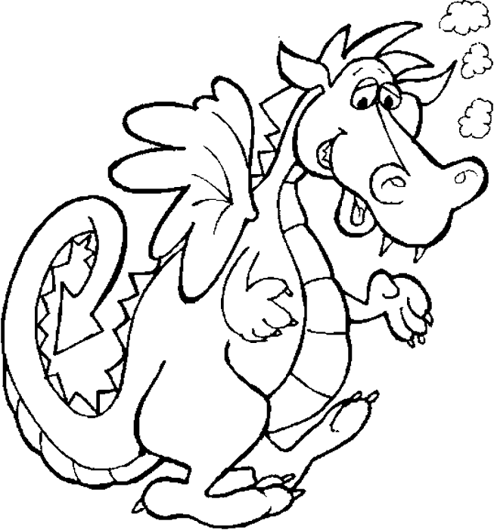



Nombre

“EL QUE SIGUE”

Escribe el número que falta para completar las series.

20

21

__

23

__

25

__

27

28

__

Nombre

Escribe los números completando las series de forma descenderte.

__ 8 __ 6 __ 4 __ 2 __ 0

19 __ 17 __ 15 __ 13 __ 11 __



Nombre

Remarca con colores los saltitos que dan la ranita y el conejito.

Seriaciones

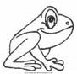 ___________________________________

0 1 2 3 4 5 6 7 8 9 10

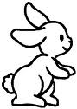 ____________________________________

2 4 6 8 10 12 14 16 18 20



Nombre

Realiza la recta numérica.

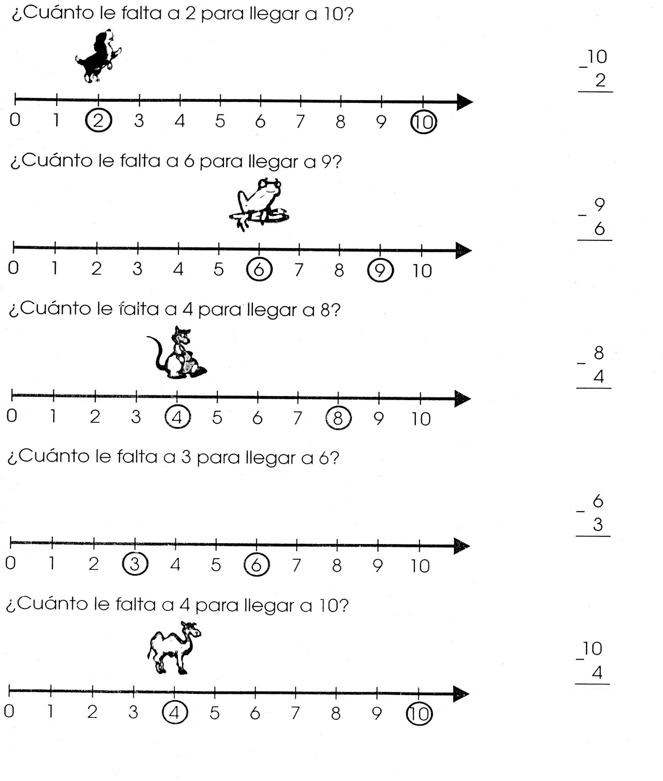

Nombre

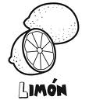Decora con diversidad de materiales la letra L l.

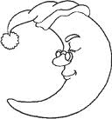



Nombre

Escribe la sílaba de la letra L l sobre la línea.

Lancha =____

Lotería =____

Lupa =_____

Lima =_____

Letra =____



Nombre

Continúa con la plana ubicando correctamente.

Ejercicio 1

|  |  |  |  |  |  |  |  |  |  |  |  |  |  |  |  |  |  |  |  |
| --- | --- | --- | --- | --- | --- | --- | --- | --- | --- | --- | --- | --- | --- | --- | --- | --- | --- | --- | --- |
|  |  |  |  |  |  |  |  |  |  |  |  |  |  |  |  |  |  |  |  |
|  |  |  |  |  |  |  |  |  |  |  |  |  |  |  |  |  |  |  |  |
|  |  |  |  |  |  |  |  |  |  |  |  |  |  |  |  |  |  |  |  |
|  |  |  |  |  |  |  |  |  |  |  |  |  |  |  |  |  |  |  |  |
|  |  |  |  |  |  |  |  |  |  |  |  |  |  |  |  |  |  |  |  |
|  |  |  |  |  |  |  |  |  |  |  |  |  |  |  |  |  |  |  |  |

Ejercicio 2

|  |  |  |  |  |  |  |  |  |  |  |  |  |  |  |  |  |  |  |  |
| --- | --- | --- | --- | --- | --- | --- | --- | --- | --- | --- | --- | --- | --- | --- | --- | --- | --- | --- | --- |
|  |  |  |  |  |  |  |  |  |  |  |  |  |  |  |  |  |  |  |  |
|  |  |  |  |  |  |  |  |  |  |  |  |  |  |  |  |  |  |  |  |
|  |  |  |  |  |  |  |  |  |  |  |  |  |  |  |  |  |  |  |  |
|  |  |  |  |  |  |  |  |  |  |  |  |  |  |  |  |  |  |  |  |
|  |  |  |  |  |  |  |  |  |  |  |  |  |  |  |  |  |  |  |  |
|  |  |  |  |  |  |  |  |  |  |  |  |  |  |  |  |  |  |  |  |

Ejercicio 3

|  |  |  |  |  |  |  |  |  |  |  |  |  |  |  |  |  |  |  |  |
| --- | --- | --- | --- | --- | --- | --- | --- | --- | --- | --- | --- | --- | --- | --- | --- | --- | --- | --- | --- |
|  |  |  |  |  |  |  |  |  |  |  |  |  |  |  |  |  |  |  |  |
|  |  |  |  |  |  |  |  |  |  |  |  |  |  |  |  |  |  |  |  |
|  |  |  |  |  |  |  |  |  |  |  |  |  |  |  |  |  |  |  |  |
|  |  |  |  |  |  |  |  |  |  |  |  |  |  |  |  |  |  |  |  |
|  |  |  |  |  |  |  |  |  |  |  |  |  |  |  |  |  |  |  |  |
|  |  |  |  |  |  |  |  |  |  |  |  |  |  |  |  |  |  |  |  |

Ejercicio 4

|  |  |  |  |  |  |  |  |  |  |  |  |  |  |  |  |  |  |  |  |
| --- | --- | --- | --- | --- | --- | --- | --- | --- | --- | --- | --- | --- | --- | --- | --- | --- | --- | --- | --- |
|  |  |  |  |  |  |  |  |  |  |  |  |  |  |  |  |  |  |  |  |
|  |  |  |  |  |  |  |  |  |  |  |  |  |  |  |  |  |  |  |  |
|  |  |  |  |  |  |  |  |  |  |  |  |  |  |  |  |  |  |  |  |
|  |  |  |  |  |  |  |  |  |  |  |  |  |  |  |  |  |  |  |  |
|  |  |  |  |  |  |  |  |  |  |  |  |  |  |  |  |  |  |  |  |
|  |  |  |  |  |  |  |  |  |  |  |  |  |  |  |  |  |  |  |  |

Ejercicio 5

|  |  |  |  |  |  |  |  |  |  |  |  |  |  |  |  |  |  |  |  |
| --- | --- | --- | --- | --- | --- | --- | --- | --- | --- | --- | --- | --- | --- | --- | --- | --- | --- | --- | --- |
|  |  |  |  |  |  |  |  |  |  |  |  |  |  |  |  |  |  |  |  |
|  |  |  |  |  |  |  |  |  |  |  |  |  |  |  |  |  |  |  |  |
|  |  |  |  |  |  |  |  |  |  |  |  |  |  |  |  |  |  |  |  |
|  |  |  |  |  |  |  |  |  |  |  |  |  |  |  |  |  |  |  |  |
|  |  |  |  |  |  |  |  |  |  |  |  |  |  |  |  |  |  |  |  |
|  |  |  |  |  |  | Scan0005 |  |  |  |  |  |  |  |  |  |  |  |  |  |

Nombre

Continúa con la plana ubicando correctamente el cuadro.

Ejercicio 1

|  |  |  |  |  |  |  |  |  |  |  |  |  |  |  |  |  |  |  |  |
| --- | --- | --- | --- | --- | --- | --- | --- | --- | --- | --- | --- | --- | --- | --- | --- | --- | --- | --- | --- |
|  |  |  |  |  |  |  |  |  |  |  |  |  |  |  |  |  |  |  |  |
|  |  |  |  |  |  |  |  |  |  |  |  |  |  |  |  |  |  |  |  |
|  |  |  |  |  |  |  |  |  |  |  |  |  |  |  |  |  |  |  |  |
|  |  |  |  |  |  |  |  |  |  |  |  |  |  |  |  |  |  |  |  |
|  |  |  |  |  |  |  |  |  |  |  |  |  |  |  |  |  |  |  |  |
|  |  |  |  |  |  |  |  |  |  |  |  |  |  |  |  |  |  |  |  |

Ejercicio 2

|  |  |  |  |  |  |  |  |  |  |  |  |  |  |  |  |  |  |  |  |
| --- | --- | --- | --- | --- | --- | --- | --- | --- | --- | --- | --- | --- | --- | --- | --- | --- | --- | --- | --- |
|  |  |  |  |  |  |  |  |  |  |  |  |  |  |  |  |  |  |  |  |
|  |  |  |  |  |  |  |  |  |  |  |  |  |  |  |  |  |  |  |  |
|  |  |  |  |  |  |  |  |  |  |  |  |  |  |  |  |  |  |  |  |
|  |  |  |  |  |  |  |  |  |  |  |  |  |  |  |  |  |  |  |  |
|  |  |  |  |  |  |  |  |  |  |  |  |  |  |  |  |  |  |  |  |
|  |  |  |  |  |  |  |  |  |  |  |  |  |  |  |  |  |  |  |  |

Ejercicio 3

|  |  |  |  |  |  |  |  |  |  |  |  |  |  |  |  |  |  |  |  |
| --- | --- | --- | --- | --- | --- | --- | --- | --- | --- | --- | --- | --- | --- | --- | --- | --- | --- | --- | --- |
|  |  |  |  |  |  |  |  |  |  |  |  |  |  |  |  |  |  |  |  |
|  |  |  |  |  |  |  |  |  |  |  |  |  |  |  |  |  |  |  |  |
|  |  |  |  |  |  |  |  |  |  |  |  |  |  |  |  |  |  |  |  |
|  |  |  |  |  |  |  |  |  |  |  |  |  |  |  |  |  |  |  |  |
|  |  |  |  |  |  |  |  |  |  |  |  |  |  |  |  |  |  |  |  |
|  |  |  |  |  |  |  |  |  |  |  |  |  |  |  |  |  |  |  |  |

Ejercicio 4

|  |  |  |  |  |  |  |  |  |  |  |  |  |  |  |  |  |  |  |  |
| --- | --- | --- | --- | --- | --- | --- | --- | --- | --- | --- | --- | --- | --- | --- | --- | --- | --- | --- | --- |
|  |  |  |  |  |  |  |  |  |  |  |  |  |  |  |  |  |  |  |  |
|  |  |  |  |  |  |  |  |  |  |  |  |  |  |  |  |  |  |  |  |
|  |  |  |  |  |  |  |  |  |  |  |  |  |  |  |  |  |  |  |  |
|  |  |  |  |  |  |  |  |  |  |  |  |  |  |  |  |  |  |  |  |
|  |  |  |  |  |  |  |  |  |  |  |  |  |  |  |  |  |  |  |  |
|  |  |  |  |  |  |  |  |  |  |  |  |  |  |  |  |  |  |  |  |

Ejercicio 5

|  |  |  |  |  |  |  |  |  |  |  |  |  |  |  |  |  |  |  |  |
| --- | --- | --- | --- | --- | --- | --- | --- | --- | --- | --- | --- | --- | --- | --- | --- | --- | --- | --- | --- |
|  |  |  |  |  |  |  |  |  |  |  |  |  |  |  |  |  |  |  |  |
|  |  |  |  |  |  |  |  |  |  |  |  |  |  |  |  |  |  |  |  |
|  |  |  |  |  |  |  |  |  |  |  |  |  |  |  |  |  |  |  |  |
|  |  |  |  |  |  |  |  |  |  |  |  |  |  |  |  |  |  |  |  |
|  |  |  |  |  |  | Scan0005 |  |  |  |  |  |  |  |  |  |  |  |  |  |

Nombre

Completa con dibujos o con palabras lo siguiente.

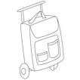

Luna

________________ ________________

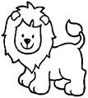

Maleta

 ________________ ________________

Nombre

Realiza los ejercicios de caligrafía con diferentes colores.

Ejercicio 1

|  |  |  |  |  |  |  |  |  |  |  |  |  |  |  |  |  |  |  |  |
| --- | --- | --- | --- | --- | --- | --- | --- | --- | --- | --- | --- | --- | --- | --- | --- | --- | --- | --- | --- |
|  |  |  |  |  |  |  |  |  |  |  |  |  |  |  |  |  |  |  |  |
|  |  |  |  |  |  |  |  |  |  |  |  |  |  |  |  |  |  |  |  |
|  |  |  |  |  |  |  |  |  |  |  |  |  |  |  |  |  |  |  |  |
|  |  |  |  |  |  |  |  |  |  |  |  |  |  |  |  |  |  |  |  |
|  |  |  |  |  |  |  |  |  |  |  |  |  |  |  |  |  |  |  |  |
|  |  |  |  |  |  |  |  |  |  |  |  |  |  |  |  |  |  |  |  |

Ejercicio 2

|  |  |  |  |  |  |  |  |  |  |  |  |  |  |  |  |  |  |  |  |
| --- | --- | --- | --- | --- | --- | --- | --- | --- | --- | --- | --- | --- | --- | --- | --- | --- | --- | --- | --- |
|  |  |  |  |  |  |  |  |  |  |  |  |  |  |  |  |  |  |  |  |
|  |  |  |  |  |  |  |  |  |  |  |  |  |  |  |  |  |  |  |  |
|  |  |  |  |  |  |  |  |  |  |  |  |  |  |  |  |  |  |  |  |
|  |  |  |  |  |  |  |  |  |  |  |  |  |  |  |  |  |  |  |  |
|  |  |  |  |  |  |  |  |  |  |  |  |  |  |  |  |  |  |  |  |
|  |  |  |  |  |  |  |  |  |  |  |  |  |  |  |  |  |  |  |  |

Ejercicio 3

|  |  |  |  |  |  |  |  |  |  |  |  |  |  |  |  |  |  |  |  |
| --- | --- | --- | --- | --- | --- | --- | --- | --- | --- | --- | --- | --- | --- | --- | --- | --- | --- | --- | --- |
|  |  |  |  |  |  |  |  |  |  |  |  |  |  |  |  |  |  |  |  |
|  |  |  |  |  |  |  |  |  |  |  |  |  |  |  |  |  |  |  |  |
|  |  |  |  |  |  |  |  |  |  |  |  |  |  |  |  |  |  |  |  |
|  |  |  |  |  |  |  |  |  |  |  |  |  |  |  |  |  |  |  |  |
|  |  |  |  |  |  |  |  |  |  |  |  |  |  |  |  |  |  |  |  |
|  |  |  |  |  |  |  |  |  |  |  |  |  |  |  |  |  |  |  |  |

Ejercicio 4

|  |  |  |  |  |  |  |  |  |  |  |  |  |  |  |  |  |  |  |  |
| --- | --- | --- | --- | --- | --- | --- | --- | --- | --- | --- | --- | --- | --- | --- | --- | --- | --- | --- | --- |
|  |  |  |  |  |  |  |  |  |  |  |  |  |  |  |  |  |  |  |  |
|  |  |  |  |  |  |  |  |  |  |  |  |  |  |  |  |  |  |  |  |
|  |  |  |  |  |  |  |  |  |  |  |  |  |  |  |  |  |  |  |  |
|  |  |  |  |  |  |  |  |  |  |  |  |  |  |  |  |  |  |  |  |
|  |  |  |  |  |  |  |  |  |  |  |  |  |  |  |  |  |  |  |  |
|  |  |  |  |  |  |  |  |  |  |  |  |  |  |  |  |  |  |  |  |

Ejercicio 5

|  |  |  |  |  |  |  |  |  |  |  |  |  |  |  |  |  |  |  |  |
| --- | --- | --- | --- | --- | --- | --- | --- | --- | --- | --- | --- | --- | --- | --- | --- | --- | --- | --- | --- |
|  |  |  |  |  |  |  |  |  |  |  |  |  |  |  |  |  |  |  |  |
|  |  |  |  |  |  |  |  |  |  |  |  |  |  |  |  |  |  |  |  |
|  |  |  |  |  |  |  |  |  |  |  |  |  |  |  |  |  |  |  |  |
|  |  |  |  |  |  |  |  |  |  |  |  |  |  |  |  |  |  |  |  |
|  |  |  |  |  |  |  |  |  |  |  |  |  |  |  |  |  |  |  |  |
|  |  |  |  |  | Scan0005 |  |  |  |  |  |  |  |  |  |  |  |  |  |  |

Nombre

Con todos los colores que haz visto remarca varias veces tu nombre completo.



Nombre

Con colores une los dibujos relacionándolos uno a uno.

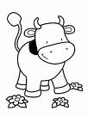 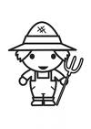

 



 



Nombre

Pega del lado derecho un animal de la granja y de tu lado izquierdo un animal domestico.

Izquierda Derecha



Nombre

Resuelve las sumas.

34 17 30 43

+ + + +

25 32 38 21

____ _____ _____ _____

47 12 53 26

+ + + +

21 52 10 41

____ ____ _____ _____



Nombre

Decora el animal largo y encierra el corto.

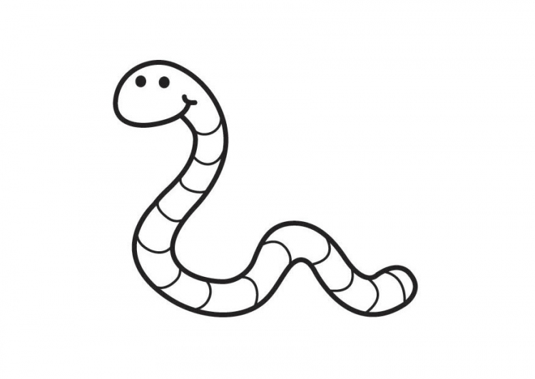





Nombre

Escucha la lectura de “La luna” de tu libro cuenta cuentos y pégale destellos cortos y largos.



Nombre

Decora con material variado la letra Ss.

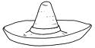

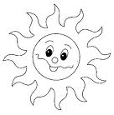



Nombre

Recorta y pega una palabra con cada una de las silabas.

Sa Se Si So Su





Nombre Nombre

Continúa con la plana ubicando el cuadro correctamente.

Ejercicio 1

|  |  |  |  |  |  |  |  |  |  |  |  |  |  |  |  |  |  |  |  |
| --- | --- | --- | --- | --- | --- | --- | --- | --- | --- | --- | --- | --- | --- | --- | --- | --- | --- | --- | --- |
|  |  |  |  |  |  |  |  |  |  |  |  |  |  |  |  |  |  |  |  |
|  |  |  |  |  |  |  |  |  |  |  |  |  |  |  |  |  |  |  |  |
|  |  |  |  |  |  |  |  |  |  |  |  |  |  |  |  |  |  |  |  |
|  |  |  |  |  |  |  |  |  |  |  |  |  |  |  |  |  |  |  |  |
|  |  |  |  |  |  |  |  |  |  |  |  |  |  |  |  |  |  |  |  |
|  |  |  |  |  |  |  |  |  |  |  |  |  |  |  |  |  |  |  |  |

Ejercicio 2

|  |  |  |  |  |  |  |  |  |  |  |  |  |  |  |  |  |  |  |  |
| --- | --- | --- | --- | --- | --- | --- | --- | --- | --- | --- | --- | --- | --- | --- | --- | --- | --- | --- | --- |
|  |  |  |  |  |  |  |  |  |  |  |  |  |  |  |  |  |  |  |  |
|  |  |  |  |  |  |  |  |  |  |  |  |  |  |  |  |  |  |  |  |
|  |  |  |  |  |  |  |  |  |  |  |  |  |  |  |  |  |  |  |  |
|  |  |  |  |  |  |  |  |  |  |  |  |  |  |  |  |  |  |  |  |
|  |  |  |  |  |  |  |  |  |  |  |  |  |  |  |  |  |  |  |  |
|  |  |  |  |  |  |  |  |  |  |  |  |  |  |  |  |  |  |  |  |

Ejercicio 3

|  |  |  |  |  |  |  |  |  |  |  |  |  |  |  |  |  |  |  |  |
| --- | --- | --- | --- | --- | --- | --- | --- | --- | --- | --- | --- | --- | --- | --- | --- | --- | --- | --- | --- |
|  |  |  |  |  |  |  |  |  |  |  |  |  |  |  |  |  |  |  |  |
|  |  |  |  |  |  |  |  |  |  |  |  |  |  |  |  |  |  |  |  |
|  |  |  |  |  |  |  |  |  |  |  |  |  |  |  |  |  |  |  |  |
|  |  |  |  |  |  |  |  |  |  |  |  |  |  |  |  |  |  |  |  |
|  |  |  |  |  |  |  |  |  |  |  |  |  |  |  |  |  |  |  |  |
|  |  |  |  |  |  |  |  |  |  |  |  |  |  |  |  |  |  |  |  |

Ejercicio 4

|  |  |  |  |  |  |  |  |  |  |  |  |  |  |  |  |  |  |  |  |
| --- | --- | --- | --- | --- | --- | --- | --- | --- | --- | --- | --- | --- | --- | --- | --- | --- | --- | --- | --- |
|  |  |  |  |  |  |  |  |  |  |  |  |  |  |  |  |  |  |  |  |
|  |  |  |  |  |  |  |  |  |  |  |  |  |  |  |  |  |  |  |  |
|  |  |  |  |  |  |  |  |  |  |  |  |  |  |  |  |  |  |  |  |
|  |  |  |  |  |  |  |  |  |  |  |  |  |  |  |  |  |  |  |  |
|  |  |  |  |  |  |  |  |  |  |  |  |  |  |  |  |  |  |  |  |
|  |  |  |  |  |  |  |  |  |  |  |  |  |  |  |  |  |  |  |  |

Ejercicio 5

|  |  |  |  |  |  |  |  |  |  |  |  |  |  |  |  |  |  |  |  |
| --- | --- | --- | --- | --- | --- | --- | --- | --- | --- | --- | --- | --- | --- | --- | --- | --- | --- | --- | --- |
|  |  |  |  |  |  |  |  |  |  |  |  |  |  |  |  |  |  |  |  |
|  |  |  |  |  |  |  |  |  |  |  |  |  |  |  |  |  |  |  |  |
|  |  |  |  |  |  |  |  |  |  |  |  |  |  |  |  |  |  |  |  |
|  |  |  |  |  |  |  |  |  |  |  |  |  |  |  |  |  |  |  |  |
|  |  |  |  |  |  |  |  |  |  |  |  |  |  |  |  |  |  |  |  |
|  |  |  |  |  | Scan0005 |  |  |  |  |  |  |  |  |  |  |  |  |  |  |

Nombre

Continúa con la plana ubicando el cuadro correctamente.

Ejercicio 1

|  |  |  |  |  |  |  |  |  |  |  |  |  |  |  |  |  |  |  |  |
| --- | --- | --- | --- | --- | --- | --- | --- | --- | --- | --- | --- | --- | --- | --- | --- | --- | --- | --- | --- |
|  |  |  |  |  |  |  |  |  |  |  |  |  |  |  |  |  |  |  |  |
|  |  |  |  |  |  |  |  |  |  |  |  |  |  |  |  |  |  |  |  |
|  |  |  |  |  |  |  |  |  |  |  |  |  |  |  |  |  |  |  |  |
|  |  |  |  |  |  |  |  |  |  |  |  |  |  |  |  |  |  |  |  |
|  |  |  |  |  |  |  |  |  |  |  |  |  |  |  |  |  |  |  |  |
|  |  |  |  |  |  |  |  |  |  |  |  |  |  |  |  |  |  |  |  |

Ejercicio 2

|  |  |  |  |  |  |  |  |  |  |  |  |  |  |  |  |  |  |  |  |
| --- | --- | --- | --- | --- | --- | --- | --- | --- | --- | --- | --- | --- | --- | --- | --- | --- | --- | --- | --- |
|  |  |  |  |  |  |  |  |  |  |  |  |  |  |  |  |  |  |  |  |
|  |  |  |  |  |  |  |  |  |  |  |  |  |  |  |  |  |  |  |  |
|  |  |  |  |  |  |  |  |  |  |  |  |  |  |  |  |  |  |  |  |
|  |  |  |  |  |  |  |  |  |  |  |  |  |  |  |  |  |  |  |  |
|  |  |  |  |  |  |  |  |  |  |  |  |  |  |  |  |  |  |  |  |
|  |  |  |  |  |  |  |  |  |  |  |  |  |  |  |  |  |  |  |  |

Ejercicio 3

|  |  |  |  |  |  |  |  |  |  |  |  |  |  |  |  |  |  |  |  |
| --- | --- | --- | --- | --- | --- | --- | --- | --- | --- | --- | --- | --- | --- | --- | --- | --- | --- | --- | --- |
|  |  |  |  |  |  |  |  |  |  |  |  |  |  |  |  |  |  |  |  |
|  |  |  |  |  |  |  |  |  |  |  |  |  |  |  |  |  |  |  |  |
|  |  |  |  |  |  |  |  |  |  |  |  |  |  |  |  |  |  |  |  |
|  |  |  |  |  |  |  |  |  |  |  |  |  |  |  |  |  |  |  |  |
|  |  |  |  |  |  |  |  |  |  |  |  |  |  |  |  |  |  |  |  |
|  |  |  |  |  |  |  |  |  |  |  |  |  |  |  |  |  |  |  |  |

Ejercicio 4

|  |  |  |  |  |  |  |  |  |  |  |  |  |  |  |  |  |  |  |  |
| --- | --- | --- | --- | --- | --- | --- | --- | --- | --- | --- | --- | --- | --- | --- | --- | --- | --- | --- | --- |
|  |  |  |  |  |  |  |  |  |  |  |  |  |  |  |  |  |  |  |  |
|  |  |  |  |  |  |  |  |  |  |  |  |  |  |  |  |  |  |  |  |
|  |  |  |  |  |  |  |  |  |  |  |  |  |  |  |  |  |  |  |  |
|  |  |  |  |  |  |  |  |  |  |  |  |  |  |  |  |  |  |  |  |
|  |  |  |  |  |  |  |  |  |  |  |  |  |  |  |  |  |  |  |  |
|  |  |  |  |  |  |  |  |  |  |  |  |  |  |  |  |  |  |  |  |

Ejercicio 5

|  |  |  |  |  |  |  |  |  |  |  |  |  |  |  |  |  |  |  |  |
| --- | --- | --- | --- | --- | --- | --- | --- | --- | --- | --- | --- | --- | --- | --- | --- | --- | --- | --- | --- |
|  |  |  |  |  |  |  |  |  |  |  |  |  |  |  |  |  |  |  |  |
|  |  |  |  |  |  |  |  |  |  |  |  |  |  |  |  |  |  |  |  |
|  |  |  |  |  |  |  |  |  |  |  |  |  |  |  |  |  |  |  |  |
|  |  |  |  |  |  |  |  |  |  |  |  |  |  |  |  |  |  |  |  |
|  |  |  |  |  |  |  |  |  |  |  |  |  |  |  |  |  |  |  |  |
|  |  |  |  |  |  | Scan0005 |  |  |  |  |  |  |  |  |  |  |  |  |  |

Nombre

Escribe cuantas unidades tiene cada grupo y marca una x los grupos que tienen 10 unidades.

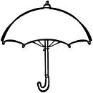   

    

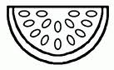  

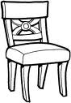     

  

Nombre

Dibuja las unidades que se te pide en cada grupo.

6 4

 7

Nombre

Escucha la lectura de “Saúl y el sapo” y pega aquí tu animal domestico favorito.



Nombre

Con recortes de números completa los números de la familia del 30.

30 __ 32 __ 34

__ 36__ 37 __

39.

Escribe con colores sobre la línea la familia del 30 completa.

__________________________________________



Nombre

Realiza la escritura de la familia del 30.

Ejercicio 1

|  |  |  |  |  |  |  |  |  |  |  |  |  |  |  |  |  |  |  |  |
| --- | --- | --- | --- | --- | --- | --- | --- | --- | --- | --- | --- | --- | --- | --- | --- | --- | --- | --- | --- |
|  |  |  |  |  |  |  |  |  |  |  |  |  |  |  |  |  |  |  |  |
|  |  |  |  |  |  |  |  |  |  |  |  |  |  |  |  |  |  |  |  |
|  |  |  |  |  |  |  |  |  |  |  |  |  |  |  |  |  |  |  |  |
|  |  |  |  |  |  |  |  |  |  |  |  |  |  |  |  |  |  |  |  |
|  |  |  |  |  |  |  |  |  |  |  |  |  |  |  |  |  |  |  |  |
|  |  |  |  |  |  |  |  |  |  |  |  |  |  |  |  |  |  |  |  |

Ejercicio 2

|  |  |  |  |  |  |  |  |  |  |  |  |  |  |  |  |  |  |  |  |
| --- | --- | --- | --- | --- | --- | --- | --- | --- | --- | --- | --- | --- | --- | --- | --- | --- | --- | --- | --- |
|  |  |  |  |  |  |  |  |  |  |  |  |  |  |  |  |  |  |  |  |
|  |  |  |  |  |  |  |  |  |  |  |  |  |  |  |  |  |  |  |  |
|  |  |  |  |  |  |  |  |  |  |  |  |  |  |  |  |  |  |  |  |
|  |  |  |  |  |  |  |  |  |  |  |  |  |  |  |  |  |  |  |  |
|  |  |  |  |  |  |  |  |  |  |  |  |  |  |  |  |  |  |  |  |
|  |  |  |  |  |  |  |  |  |  |  |  |  |  |  |  |  |  |  |  |

Ejercicio 3

|  |  |  |  |  |  |  |  |  |  |  |  |  |  |  |  |  |  |  |  |
| --- | --- | --- | --- | --- | --- | --- | --- | --- | --- | --- | --- | --- | --- | --- | --- | --- | --- | --- | --- |
|  |  |  |  |  |  |  |  |  |  |  |  |  |  |  |  |  |  |  |  |
|  |  |  |  |  |  |  |  |  |  |  |  |  |  |  |  |  |  |  |  |
|  |  |  |  |  |  |  |  |  |  |  |  |  |  |  |  |  |  |  |  |
|  |  |  |  |  |  |  |  |  |  |  |  |  |  |  |  |  |  |  |  |
|  |  |  |  |  |  |  |  |  |  |  |  |  |  |  |  |  |  |  |  |
|  |  |  |  |  |  |  |  |  |  |  |  |  |  |  |  |  |  |  |  |

Ejercicio 4

|  |  |  |  |  |  |  |  |  |  |  |  |  |  |  |  |  |  |  |  |
| --- | --- | --- | --- | --- | --- | --- | --- | --- | --- | --- | --- | --- | --- | --- | --- | --- | --- | --- | --- |
|  |  |  |  |  |  |  |  |  |  |  |  |  |  |  |  |  |  |  |  |
|  |  |  |  |  |  |  |  |  |  |  |  |  |  |  |  |  |  |  |  |
|  |  |  |  |  |  |  |  |  |  |  |  |  |  |  |  |  |  |  |  |
|  |  |  |  |  |  |  |  |  |  |  |  |  |  |  |  |  |  |  |  |
|  |  |  |  |  |  |  |  |  |  |  |  |  |  |  |  |  |  |  |  |
|  |  |  |  |  |  |  |  |  |  |  |  |  |  |  |  |  |  |  |  |

Ejercicio 5

|  |  |  |  |  |  |  |  |  |  |  |  |  |  |  |  |  |  |  |  |
| --- | --- | --- | --- | --- | --- | --- | --- | --- | --- | --- | --- | --- | --- | --- | --- | --- | --- | --- | --- |
|  |  |  |  |  |  |  |  |  |  |  |  |  |  |  |  |  |  |  |  |
|  |  |  |  |  |  |  |  |  |  |  |  |  |  |  |  |  |  |  |  |
|  |  |  |  |  |  |  |  |  |  |  |  |  |  |  |  |  |  |  |  |
|  |  |  |  |  |  |  |  |  |  |  |  |  |  |  |  |  |  |  |  |
|  |  |  |  |  |  |  |  |  |  |  |  |  |  |  |  |  |  |  |  |
|  |  |  |  |  |  | Scan0005 |  |  |  |  |  |  |  |  |  |  |  |  |  |

Nombre

Realiza la plana de tu nombre completo en letra script y cursiva.

Ejercicio 1

|  |  |  |  |  |  |  |  |  |  |  |  |  |  |  |  |  |  |  |  |
| --- | --- | --- | --- | --- | --- | --- | --- | --- | --- | --- | --- | --- | --- | --- | --- | --- | --- | --- | --- |
|  |  |  |  |  |  |  |  |  |  |  |  |  |  |  |  |  |  |  |  |
|  |  |  |  |  |  |  |  |  |  |  |  |  |  |  |  |  |  |  |  |
|  |  |  |  |  |  |  |  |  |  |  |  |  |  |  |  |  |  |  |  |
|  |  |  |  |  |  |  |  |  |  |  |  |  |  |  |  |  |  |  |  |
|  |  |  |  |  |  |  |  |  |  |  |  |  |  |  |  |  |  |  |  |
|  |  |  |  |  |  |  |  |  |  |  |  |  |  |  |  |  |  |  |  |

Ejercicio 2

|  |  |  |  |  |  |  |  |  |  |  |  |  |  |  |  |  |  |  |  |
| --- | --- | --- | --- | --- | --- | --- | --- | --- | --- | --- | --- | --- | --- | --- | --- | --- | --- | --- | --- |
|  |  |  |  |  |  |  |  |  |  |  |  |  |  |  |  |  |  |  |  |
|  |  |  |  |  |  |  |  |  |  |  |  |  |  |  |  |  |  |  |  |
|  |  |  |  |  |  |  |  |  |  |  |  |  |  |  |  |  |  |  |  |
|  |  |  |  |  |  |  |  |  |  |  |  |  |  |  |  |  |  |  |  |
|  |  |  |  |  |  |  |  |  |  |  |  |  |  |  |  |  |  |  |  |
|  |  |  |  |  |  |  |  |  |  |  |  |  |  |  |  |  |  |  |  |

Ejercicio 3

|  |  |  |  |  |  |  |  |  |  |  |  |  |  |  |  |  |  |  |  |
| --- | --- | --- | --- | --- | --- | --- | --- | --- | --- | --- | --- | --- | --- | --- | --- | --- | --- | --- | --- |
|  |  |  |  |  |  |  |  |  |  |  |  |  |  |  |  |  |  |  |  |
|  |  |  |  |  |  |  |  |  |  |  |  |  |  |  |  |  |  |  |  |
|  |  |  |  |  |  |  |  |  |  |  |  |  |  |  |  |  |  |  |  |
|  |  |  |  |  |  |  |  |  |  |  |  |  |  |  |  |  |  |  |  |
|  |  |  |  |  |  |  |  |  |  |  |  |  |  |  |  |  |  |  |  |
|  |  |  |  |  |  |  |  |  |  |  |  |  |  |  |  |  |  |  |  |

Ejercicio 4

|  |  |  |  |  |  |  |  |  |  |  |  |  |  |  |  |  |  |  |  |
| --- | --- | --- | --- | --- | --- | --- | --- | --- | --- | --- | --- | --- | --- | --- | --- | --- | --- | --- | --- |
|  |  |  |  |  |  |  |  |  |  |  |  |  |  |  |  |  |  |  |  |
|  |  |  |  |  |  |  |  |  |  |  |  |  |  |  |  |  |  |  |  |
|  |  |  |  |  |  |  |  |  |  |  |  |  |  |  |  |  |  |  |  |
|  |  |  |  |  |  |  |  |  |  |  |  |  |  |  |  |  |  |  |  |
|  |  |  |  |  |  |  |  |  |  |  |  |  |  |  |  |  |  |  |  |
|  |  |  |  |  |  |  |  |  |  |  |  |  |  |  |  |  |  |  |  |

Ejercicio 5

|  |  |  |  |  |  |  |  |  |  |  |  |  |  |  |  |  |  |  |  |
| --- | --- | --- | --- | --- | --- | --- | --- | --- | --- | --- | --- | --- | --- | --- | --- | --- | --- | --- | --- |
|  |  |  |  |  |  |  |  |  |  |  |  |  |  |  |  |  |  |  |  |
|  |  |  |  |  |  |  |  |  |  |  |  |  |  |  |  |  |  |  |  |
|  |  |  |  |  |  |  |  |  |  |  |  |  |  |  |  |  |  |  |  |
|  |  |  |  |  |  |  |  |  |  |  |  |  |  |  |  |  |  |  |  |
|  |  |  |  |  |  |  |  |  |  |  |  |  |  |  |  |  |  |  |  |
|  |  |  |  |  | Scan0005 |  |  |  |  |  |  |  |  |  |  |  |  |  |  |

Nombre

Decora lo que celebramos en diciembre.

La navidad

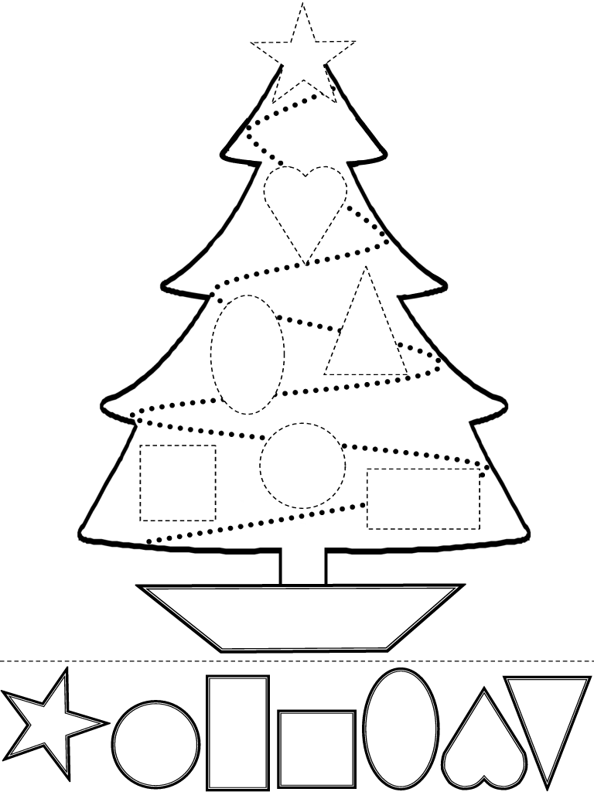

Nombre

Decora con diversidad de materiales la letra C c Ci Ce

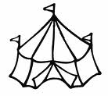

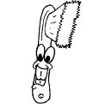



Nombre

De diferentes portadores de texto recorta y pega palabras con

ce y ci.

Ce Ci



Nombre

Continúa con la plana ubicando correctamente los cuadros.

Ejercicio 1

|  |  |  |  |  |  |  |  |  |  |  |  |  |  |  |  |  |  |  |  |
| --- | --- | --- | --- | --- | --- | --- | --- | --- | --- | --- | --- | --- | --- | --- | --- | --- | --- | --- | --- |
|  |  |  |  |  |  |  |  |  |  |  |  |  |  |  |  |  |  |  |  |
|  |  |  |  |  |  |  |  |  |  |  |  |  |  |  |  |  |  |  |  |
|  |  |  |  |  |  |  |  |  |  |  |  |  |  |  |  |  |  |  |  |
|  |  |  |  |  |  |  |  |  |  |  |  |  |  |  |  |  |  |  |  |
|  |  |  |  |  |  |  |  |  |  |  |  |  |  |  |  |  |  |  |  |
|  |  |  |  |  |  |  |  |  |  |  |  |  |  |  |  |  |  |  |  |

Ejercicio 2

|  |  |  |  |  |  |  |  |  |  |  |  |  |  |  |  |  |  |  |  |
| --- | --- | --- | --- | --- | --- | --- | --- | --- | --- | --- | --- | --- | --- | --- | --- | --- | --- | --- | --- |
|  |  |  |  |  |  |  |  |  |  |  |  |  |  |  |  |  |  |  |  |
|  |  |  |  |  |  |  |  |  |  |  |  |  |  |  |  |  |  |  |  |
|  |  |  |  |  |  |  |  |  |  |  |  |  |  |  |  |  |  |  |  |
|  |  |  |  |  |  |  |  |  |  |  |  |  |  |  |  |  |  |  |  |
|  |  |  |  |  |  |  |  |  |  |  |  |  |  |  |  |  |  |  |  |
|  |  |  |  |  |  |  |  |  |  |  |  |  |  |  |  |  |  |  |  |

Ejercicio 3

|  |  |  |  |  |  |  |  |  |  |  |  |  |  |  |  |  |  |  |  |
| --- | --- | --- | --- | --- | --- | --- | --- | --- | --- | --- | --- | --- | --- | --- | --- | --- | --- | --- | --- |
|  |  |  |  |  |  |  |  |  |  |  |  |  |  |  |  |  |  |  |  |
|  |  |  |  |  |  |  |  |  |  |  |  |  |  |  |  |  |  |  |  |
|  |  |  |  |  |  |  |  |  |  |  |  |  |  |  |  |  |  |  |  |
|  |  |  |  |  |  |  |  |  |  |  |  |  |  |  |  |  |  |  |  |
|  |  |  |  |  |  |  |  |  |  |  |  |  |  |  |  |  |  |  |  |
|  |  |  |  |  |  |  |  |  |  |  |  |  |  |  |  |  |  |  |  |

Ejercicio 4

|  |  |  |  |  |  |  |  |  |  |  |  |  |  |  |  |  |  |  |  |
| --- | --- | --- | --- | --- | --- | --- | --- | --- | --- | --- | --- | --- | --- | --- | --- | --- | --- | --- | --- |
|  |  |  |  |  |  |  |  |  |  |  |  |  |  |  |  |  |  |  |  |
|  |  |  |  |  |  |  |  |  |  |  |  |  |  |  |  |  |  |  |  |
|  |  |  |  |  |  |  |  |  |  |  |  |  |  |  |  |  |  |  |  |
|  |  |  |  |  |  |  |  |  |  |  |  |  |  |  |  |  |  |  |  |
|  |  |  |  |  |  |  |  |  |  |  |  |  |  |  |  |  |  |  |  |
|  |  |  |  |  |  |  |  |  |  |  |  |  |  |  |  |  |  |  |  |

Ejercicio 5

|  |  |  |  |  |  |  |  |  |  |  |  |  |  |  |  |  |  |  |  |
| --- | --- | --- | --- | --- | --- | --- | --- | --- | --- | --- | --- | --- | --- | --- | --- | --- | --- | --- | --- |
|  |  |  |  |  |  |  |  |  |  |  |  |  |  |  |  |  |  |  |  |
|  |  |  |  |  |  |  |  |  |  |  |  |  |  |  |  |  |  |  |  |
|  |  |  |  |  |  |  |  |  |  |  |  |  |  |  |  |  |  |  |  |
|  |  |  |  |  |  |  |  |  |  |  |  |  |  |  |  |  |  |  |  |
|  |  |  |  |  |  |  |  |  |  |  |  |  |  |  |  |  |  |  |  |
|  |  |  |  |  |  | Scan0005 |  |  |  |  |  |  |  |  |  |  |  |  |  |

Nombre

Continúa con la plana ubicando el cuadro correcta mente.

Ejercicio 1

|  |  |  |  |  |  |  |  |  |  |  |  |  |  |  |  |  |  |  |  |
| --- | --- | --- | --- | --- | --- | --- | --- | --- | --- | --- | --- | --- | --- | --- | --- | --- | --- | --- | --- |
|  |  |  |  |  |  |  |  |  |  |  |  |  |  |  |  |  |  |  |  |
|  |  |  |  |  |  |  |  |  |  |  |  |  |  |  |  |  |  |  |  |
|  |  |  |  |  |  |  |  |  |  |  |  |  |  |  |  |  |  |  |  |
|  |  |  |  |  |  |  |  |  |  |  |  |  |  |  |  |  |  |  |  |
|  |  |  |  |  |  |  |  |  |  |  |  |  |  |  |  |  |  |  |  |
|  |  |  |  |  |  |  |  |  |  |  |  |  |  |  |  |  |  |  |  |

Ejercicio 2

|  |  |  |  |  |  |  |  |  |  |  |  |  |  |  |  |  |  |  |  |
| --- | --- | --- | --- | --- | --- | --- | --- | --- | --- | --- | --- | --- | --- | --- | --- | --- | --- | --- | --- |
|  |  |  |  |  |  |  |  |  |  |  |  |  |  |  |  |  |  |  |  |
|  |  |  |  |  |  |  |  |  |  |  |  |  |  |  |  |  |  |  |  |
|  |  |  |  |  |  |  |  |  |  |  |  |  |  |  |  |  |  |  |  |
|  |  |  |  |  |  |  |  |  |  |  |  |  |  |  |  |  |  |  |  |
|  |  |  |  |  |  |  |  |  |  |  |  |  |  |  |  |  |  |  |  |
|  |  |  |  |  |  |  |  |  |  |  |  |  |  |  |  |  |  |  |  |

Ejercicio 3

|  |  |  |  |  |  |  |  |  |  |  |  |  |  |  |  |  |  |  |  |
| --- | --- | --- | --- | --- | --- | --- | --- | --- | --- | --- | --- | --- | --- | --- | --- | --- | --- | --- | --- |
|  |  |  |  |  |  |  |  |  |  |  |  |  |  |  |  |  |  |  |  |
|  |  |  |  |  |  |  |  |  |  |  |  |  |  |  |  |  |  |  |  |
|  |  |  |  |  |  |  |  |  |  |  |  |  |  |  |  |  |  |  |  |
|  |  |  |  |  |  |  |  |  |  |  |  |  |  |  |  |  |  |  |  |
|  |  |  |  |  |  |  |  |  |  |  |  |  |  |  |  |  |  |  |  |
|  |  |  |  |  |  |  |  |  |  |  |  |  |  |  |  |  |  |  |  |

Ejercicio 4

|  |  |  |  |  |  |  |  |  |  |  |  |  |  |  |  |  |  |  |  |
| --- | --- | --- | --- | --- | --- | --- | --- | --- | --- | --- | --- | --- | --- | --- | --- | --- | --- | --- | --- |
|  |  |  |  |  |  |  |  |  |  |  |  |  |  |  |  |  |  |  |  |
|  |  |  |  |  |  |  |  |  |  |  |  |  |  |  |  |  |  |  |  |
|  |  |  |  |  |  |  |  |  |  |  |  |  |  |  |  |  |  |  |  |
|  |  |  |  |  |  |  |  |  |  |  |  |  |  |  |  |  |  |  |  |
|  |  |  |  |  |  |  |  |  |  |  |  |  |  |  |  |  |  |  |  |
|  |  |  |  |  |  |  |  |  |  |  |  |  |  |  |  |  |  |  |  |

Ejercicio 5

|  |  |  |  |  |  |  |  |  |  |  |  |  |  |  |  |  |  |  |  |
| --- | --- | --- | --- | --- | --- | --- | --- | --- | --- | --- | --- | --- | --- | --- | --- | --- | --- | --- | --- |
|  |  |  |  |  |  |  |  |  |  |  |  |  |  |  |  |  |  |  |  |
|  |  |  |  |  |  |  |  |  |  |  |  |  |  |  |  |  |  |  |  |
|  |  |  |  |  |  |  |  |  |  |  |  |  |  |  |  |  |  |  |  |
|  |  |  |  |  |  |  |  |  |  |  |  |  |  |  |  |  |  |  |  |
|  |  |  |  |  |  |  |  |  |  |  |  |  |  |  |  |  |  |  |  |
|  |  |  |  |  |  | Scan0005 |  |  |  |  |  |  |  |  |  |  |  |  |  |

Nombre

Continúa con la plana ubicando correctamente el cuadro.

Ejercicio 1

|  |  |  |  |  |  |  |  |  |  |  |  |  |  |  |  |  |  |  |  |
| --- | --- | --- | --- | --- | --- | --- | --- | --- | --- | --- | --- | --- | --- | --- | --- | --- | --- | --- | --- |
|  |  |  |  |  |  |  |  |  |  |  |  |  |  |  |  |  |  |  |  |
|  |  |  |  |  |  |  |  |  |  |  |  |  |  |  |  |  |  |  |  |
|  |  |  |  |  |  |  |  |  |  |  |  |  |  |  |  |  |  |  |  |
|  |  |  |  |  |  |  |  |  |  |  |  |  |  |  |  |  |  |  |  |
|  |  |  |  |  |  |  |  |  |  |  |  |  |  |  |  |  |  |  |  |
|  |  |  |  |  |  |  |  |  |  |  |  |  |  |  |  |  |  |  |  |

Ejercicio 2

|  |  |  |  |  |  |  |  |  |  |  |  |  |  |  |  |  |  |  |  |
| --- | --- | --- | --- | --- | --- | --- | --- | --- | --- | --- | --- | --- | --- | --- | --- | --- | --- | --- | --- |
|  |  |  |  |  |  |  |  |  |  |  |  |  |  |  |  |  |  |  |  |
|  |  |  |  |  |  |  |  |  |  |  |  |  |  |  |  |  |  |  |  |
|  |  |  |  |  |  |  |  |  |  |  |  |  |  |  |  |  |  |  |  |
|  |  |  |  |  |  |  |  |  |  |  |  |  |  |  |  |  |  |  |  |
|  |  |  |  |  |  |  |  |  |  |  |  |  |  |  |  |  |  |  |  |
|  |  |  |  |  |  |  |  |  |  |  |  |  |  |  |  |  |  |  |  |

Ejercicio 3

|  |  |  |  |  |  |  |  |  |  |  |  |  |  |  |  |  |  |  |  |
| --- | --- | --- | --- | --- | --- | --- | --- | --- | --- | --- | --- | --- | --- | --- | --- | --- | --- | --- | --- |
|  |  |  |  |  |  |  |  |  |  |  |  |  |  |  |  |  |  |  |  |
|  |  |  |  |  |  |  |  |  |  |  |  |  |  |  |  |  |  |  |  |
|  |  |  |  |  |  |  |  |  |  |  |  |  |  |  |  |  |  |  |  |
|  |  |  |  |  |  |  |  |  |  |  |  |  |  |  |  |  |  |  |  |
|  |  |  |  |  |  |  |  |  |  |  |  |  |  |  |  |  |  |  |  |
|  |  |  |  |  |  |  |  |  |  |  |  |  |  |  |  |  |  |  |  |

Ejercicio 4

|  |  |  |  |  |  |  |  |  |  |  |  |  |  |  |  |  |  |  |  |
| --- | --- | --- | --- | --- | --- | --- | --- | --- | --- | --- | --- | --- | --- | --- | --- | --- | --- | --- | --- |
|  |  |  |  |  |  |  |  |  |  |  |  |  |  |  |  |  |  |  |  |
|  |  |  |  |  |  |  |  |  |  |  |  |  |  |  |  |  |  |  |  |
|  |  |  |  |  |  |  |  |  |  |  |  |  |  |  |  |  |  |  |  |
|  |  |  |  |  |  |  |  |  |  |  |  |  |  |  |  |  |  |  |  |
|  |  |  |  |  |  |  |  |  |  |  |  |  |  |  |  |  |  |  |  |
|  |  |  |  |  |  |  |  |  |  |  |  |  |  |  |  |  |  |  |  |

Ejercicio 5

|  |  |  |  |  |  |  |  |  |  |  |  |  |  |  |  |  |  |  |  |
| --- | --- | --- | --- | --- | --- | --- | --- | --- | --- | --- | --- | --- | --- | --- | --- | --- | --- | --- | --- |
|  |  |  |  |  |  |  |  |  |  |  |  |  |  |  |  |  |  |  |  |
|  |  |  |  |  |  |  |  |  |  |  |  |  |  |  |  |  |  |  |  |
|  |  |  |  |  |  |  |  |  |  |  |  |  |  |  |  |  |  |  |  |
|  |  |  |  |  |  |  |  |  |  |  |  |  |  |  |  |  |  |  |  |
|  |  |  |  |  |  |  |  |  |  |  |  |  |  |  |  |  |  |  |  |
|  |  |  |  |  |  | Scan0005 |  |  |  |  |  |  |  |  |  |  |  |  |  |

Nombre

# De la lectura de “Cecilia y Cipriana” de tu cuenta cuentos escribe sobre las líneas las palabras que tengan ce ci

____________________ _____________________

____________________ _____________________

____________________ _____________________

____________________ _____________________

____________________ _____________________

____________________ _____________________

____________________ _____________________

____________________ _____________________



Nombre

Copia las sumas y restas del pizarrón y realízalas.



Nombre

Decora con material variado la CL Y CR.

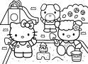 Recreo

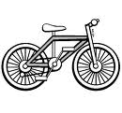

Bicicleta



Nombre

Ejercicio 1 Continúa con la plana de la letra cl, cr.

|  |  |  |  |  |  |  |  |  |  |  |  |  |  |  |  |  |  |  |  |  |  |  |  |  |  |  |  |  |  |
| --- | --- | --- | --- | --- | --- | --- | --- | --- | --- | --- | --- | --- | --- | --- | --- | --- | --- | --- | --- | --- | --- | --- | --- | --- | --- | --- | --- | --- | --- |
|  |  |  |  |  |  |  |  |  |  |  |  |  |  |  |  |  |  |  |  |  |  |  |  |  |  |  |  |  |  |
|  |  |  |  |  |  |  |  |  |  |  |  |  |  |  |  |  |  |  |  |  |  |  |  |  |  |  |  |  |  |
|  |  |  |  |  |  |  |  |  |  |  |  |  |  |  |  |  |  |  |  |  |  |  |  |  |  |  |  |  |  |
|  |  |  |  |  |  |  |  |  |  |  |  |  |  |  |  |  |  |  |  |  |  |  |  |  |  |  |  |  |  |
|  |  |  |  |  |  |  |  |  |  |  |  |  |  |  |  |  |  |  |  |  |  |  |  |  |  |  |  |  |  |
|  |  |  |  |  |  |  |  |  |  |  |  |  |  |  |  |  |  |  |  |  |  |  |  |  |  |  |  |  |  |

Ejercicio 2

|  |  |  |  |  |  |  |  |  |  |  |  |  |  |  |  |  |  |  |  |  |  |  |  |  |  |  |  |  |  |
| --- | --- | --- | --- | --- | --- | --- | --- | --- | --- | --- | --- | --- | --- | --- | --- | --- | --- | --- | --- | --- | --- | --- | --- | --- | --- | --- | --- | --- | --- |
|  |  |  |  |  |  |  |  |  |  |  |  |  |  |  |  |  |  |  |  |  |  |  |  |  |  |  |  |  |  |
|  |  |  |  |  |  |  |  |  |  |  |  |  |  |  |  |  |  |  |  |  |  |  |  |  |  |  |  |  |  |
|  |  |  |  |  |  |  |  |  |  |  |  |  |  |  |  |  |  |  |  |  |  |  |  |  |  |  |  |  |  |
|  |  |  |  |  |  |  |  |  |  |  |  |  |  |  |  |  |  |  |  |  |  |  |  |  |  |  |  |  |  |
|  |  |  |  |  |  |  |  |  |  |  |  |  |  |  |  |  |  |  |  |  |  |  |  |  |  |  |  |  |  |
|  |  |  |  |  |  |  |  |  |  |  |  |  |  |  |  |  |  |  |  |  |  |  |  |  |  |  |  |  |  |

Ejercicio 3

|  |  |  |  |  |  |  |  |  |  |  |  |  |  |  |  |  |  |  |  |  |  |  |  |  |  |  |  |  |  |
| --- | --- | --- | --- | --- | --- | --- | --- | --- | --- | --- | --- | --- | --- | --- | --- | --- | --- | --- | --- | --- | --- | --- | --- | --- | --- | --- | --- | --- | --- |
|  |  |  |  |  |  |  |  |  |  |  |  |  |  |  |  |  |  |  |  |  |  |  |  |  |  |  |  |  |  |
|  |  |  |  |  |  |  |  |  |  |  |  |  |  |  |  |  |  |  |  |  |  |  |  |  |  |  |  |  |  |
|  |  |  |  |  |  |  |  |  |  |  |  |  |  |  |  |  |  |  |  |  |  |  |  |  |  |  |  |  |  |
|  |  |  |  |  |  |  |  |  |  |  |  |  |  |  |  |  |  |  |  |  |  |  |  |  |  |  |  |  |  |
|  |  |  |  |  |  |  |  |  |  |  |  |  |  |  |  |  |  |  |  |  |  |  |  |  |  |  |  |  |  |
|  |  |  |  |  |  |  |  |  |  |  |  |  |  |  |  |  |  |  |  |  |  |  |  |  |  |  |  |  |  |

Ejercicio 4

|  |  |  |  |  |  |  |  |  |  |  |  |  |  |  |  |  |  |  |  |  |  |  |  |  |  |  |  |  |  |
| --- | --- | --- | --- | --- | --- | --- | --- | --- | --- | --- | --- | --- | --- | --- | --- | --- | --- | --- | --- | --- | --- | --- | --- | --- | --- | --- | --- | --- | --- |
|  |  |  |  |  |  |  |  |  |  |  |  |  |  |  |  |  |  |  |  |  |  |  |  |  |  |  |  |  |  |
|  |  |  |  |  |  |  |  |  |  |  |  |  |  |  |  |  |  |  |  |  |  |  |  |  |  |  |  |  |  |
|  |  |  |  |  |  |  |  |  |  |  |  |  |  |  |  |  |  |  |  |  |  |  |  |  |  |  |  |  |  |
|  |  |  |  |  |  |  |  |  |  |  |  |  |  |  |  |  |  |  |  |  |  |  |  |  |  |  |  |  |  |
|  |  |  |  |  |  |  |  |  |  |  |  |  |  |  |  |  |  |  |  |  |  |  |  |  |  |  |  |  |  |
|  |  |  |  |  |  |  |  |  |  |  |  |  |  |  |  |  |  |  |  |  |  |  |  |  |  |  |  |  |  |

Ejercicio 5

|  |  |  |  |  |  |  |  |  |  |  |  |  |  |  |  |  |  |  |  |  |  |  |  |  |  |  |  |  |  |
| --- | --- | --- | --- | --- | --- | --- | --- | --- | --- | --- | --- | --- | --- | --- | --- | --- | --- | --- | --- | --- | --- | --- | --- | --- | --- | --- | --- | --- | --- |
|  |  |  |  |  |  |  |  |  |  |  |  |  |  |  |  |  |  |  |  |  |  |  |  |  |  |  |  |  |  |
|  |  |  |  |  |  |  |  |  |  |  |  |  |  |  |  |  |  |  |  |  |  |  |  |  |  |  |  |  |  |
|  |  |  |  |  |  |  |  |  |  |  |  |  |  |  |  |  |  |  |  |  |  |  |  |  |  |  |  |  |  |
|  |  |  |  |  |  |  |  |  |  |  |  |  |  |  |  |  |  |  |  |  |  |  |  |  |  |  |  |  |  |
|  |  |  |  |  |  |  |  |  |  |  |  |  |  |  |  |  |  |  |  |  |  |  |  |  |  |  |  |  |  |
|  |  |  |  |  |  |  |  |  |  | Scan0005 |  |  |  |  |  |  |  |  |  |  |  |  |  |  |  |  |  |  |  |

Nombre

Busca la página recortable y pega la familia del 40 ordenadamente.

40



Nombre

Ordena la oración correctamente y realiza el dibujo abajo.

de Tomas La pelota es

________________________________________________



Nombre

Copia el texto del pizarrón e ilústralo con recortes o dibujos.

_______________________________________________________________________________________________________________________________________________________________________________________________________________________________________________________________



Nombre

# Colorea como se te indica

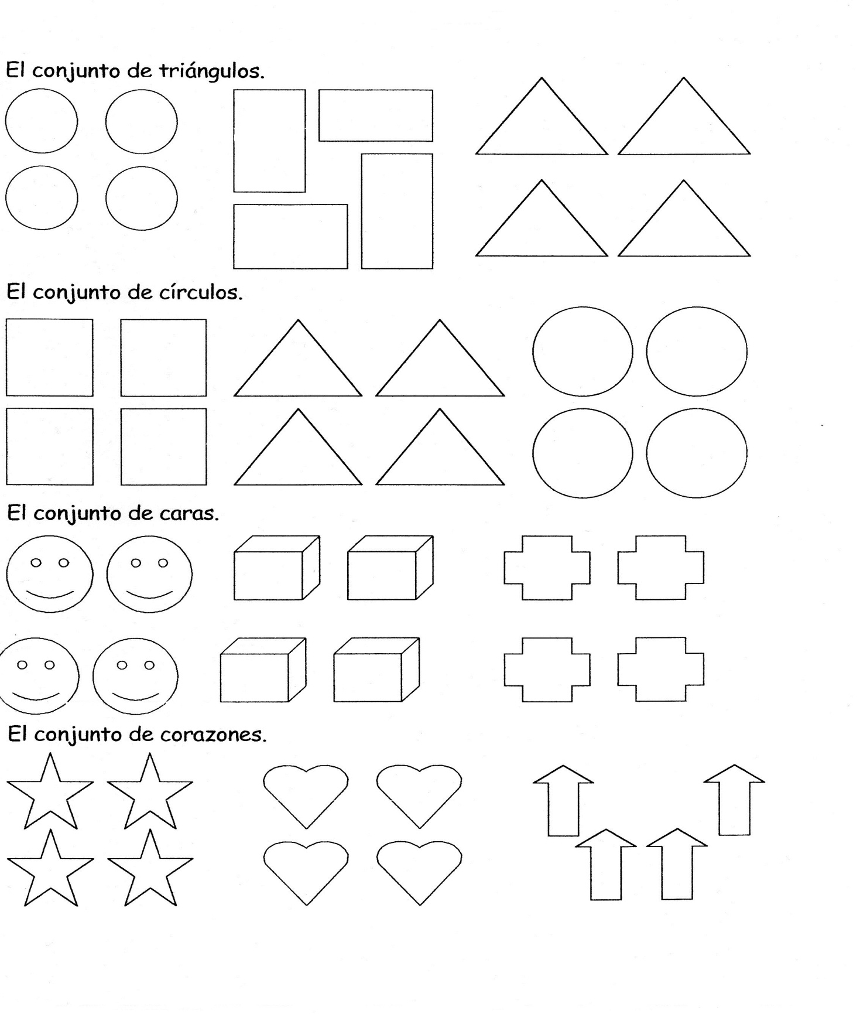



Nombre

Continúa con la plana de la familia del 40 ubicando el cuadro.

Ejercicio 1

|  |  |  |  |  |  |  |  |  |  |  |  |  |  |  |  |  |  |  |  |
| --- | --- | --- | --- | --- | --- | --- | --- | --- | --- | --- | --- | --- | --- | --- | --- | --- | --- | --- | --- |
|  |  |  |  |  |  |  |  |  |  |  |  |  |  |  |  |  |  |  |  |
|  |  |  |  |  |  |  |  |  |  |  |  |  |  |  |  |  |  |  |  |
|  |  |  |  |  |  |  |  |  |  |  |  |  |  |  |  |  |  |  |  |
|  |  |  |  |  |  |  |  |  |  |  |  |  |  |  |  |  |  |  |  |
|  |  |  |  |  |  |  |  |  |  |  |  |  |  |  |  |  |  |  |  |
|  |  |  |  |  |  |  |  |  |  |  |  |  |  |  |  |  |  |  |  |

Ejercicio 2

|  |  |  |  |  |  |  |  |  |  |  |  |  |  |  |  |  |  |  |  |
| --- | --- | --- | --- | --- | --- | --- | --- | --- | --- | --- | --- | --- | --- | --- | --- | --- | --- | --- | --- |
|  |  |  |  |  |  |  |  |  |  |  |  |  |  |  |  |  |  |  |  |
|  |  |  |  |  |  |  |  |  |  |  |  |  |  |  |  |  |  |  |  |
|  |  |  |  |  |  |  |  |  |  |  |  |  |  |  |  |  |  |  |  |
|  |  |  |  |  |  |  |  |  |  |  |  |  |  |  |  |  |  |  |  |
|  |  |  |  |  |  |  |  |  |  |  |  |  |  |  |  |  |  |  |  |
|  |  |  |  |  |  |  |  |  |  |  |  |  |  |  |  |  |  |  |  |

Ejercicio 3

|  |  |  |  |  |  |  |  |  |  |  |  |  |  |  |  |  |  |  |  |
| --- | --- | --- | --- | --- | --- | --- | --- | --- | --- | --- | --- | --- | --- | --- | --- | --- | --- | --- | --- |
|  |  |  |  |  |  |  |  |  |  |  |  |  |  |  |  |  |  |  |  |
|  |  |  |  |  |  |  |  |  |  |  |  |  |  |  |  |  |  |  |  |
|  |  |  |  |  |  |  |  |  |  |  |  |  |  |  |  |  |  |  |  |
|  |  |  |  |  |  |  |  |  |  |  |  |  |  |  |  |  |  |  |  |
|  |  |  |  |  |  |  |  |  |  |  |  |  |  |  |  |  |  |  |  |
|  |  |  |  |  |  |  |  |  |  |  |  |  |  |  |  |  |  |  |  |

Ejercicio 4

|  |  |  |  |  |  |  |  |  |  |  |  |  |  |  |  |  |  |  |  |
| --- | --- | --- | --- | --- | --- | --- | --- | --- | --- | --- | --- | --- | --- | --- | --- | --- | --- | --- | --- |
|  |  |  |  |  |  |  |  |  |  |  |  |  |  |  |  |  |  |  |  |
|  |  |  |  |  |  |  |  |  |  |  |  |  |  |  |  |  |  |  |  |
|  |  |  |  |  |  |  |  |  |  |  |  |  |  |  |  |  |  |  |  |
|  |  |  |  |  |  |  |  |  |  |  |  |  |  |  |  |  |  |  |  |
|  |  |  |  |  |  |  |  |  |  |  |  |  |  |  |  |  |  |  |  |
|  |  |  |  |  |  |  |  |  |  |  |  |  |  |  |  |  |  |  |  |

Ejercicio 5

|  |  |  |  |  |  |  |  |  |  |  |  |  |  |  |  |  |  |  |  |
| --- | --- | --- | --- | --- | --- | --- | --- | --- | --- | --- | --- | --- | --- | --- | --- | --- | --- | --- | --- |
|  |  |  |  |  |  |  |  |  |  |  |  |  |  |  |  |  |  |  |  |
|  |  |  |  |  |  |  |  |  |  |  |  |  |  |  |  |  |  |  |  |
|  |  |  |  |  |  |  |  |  |  |  |  |  |  |  |  |  |  |  |  |
|  |  |  |  |  |  |  |  |  |  |  |  |  |  |  |  |  |  |  |  |
|  |  |  |  |  |  |  |  |  |  |  |  |  |  |  |  |  |  |  |  |
|  |  |  |  |  |  | Scan0005 |  |  |  |  |  |  |  |  |  |  |  |  |  |

Nombre

Con diferentes colores salta la seriaciones del 1, 2,3 como indique la maestra

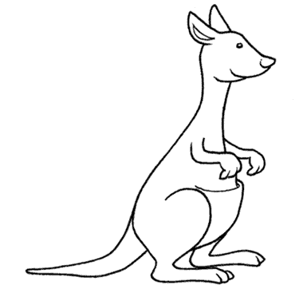

0 1 2 3 4 5 6 7 8 9 10

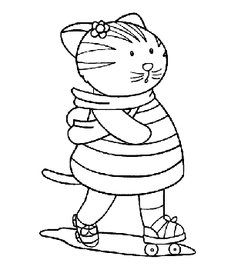

0 1 2 3 4 5 6 7 8 9 10

 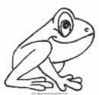0 1 2 3 4 5 6 7 8 9 1

Nombre

Busca la página recortable y pega las manzanas donde correspondan.

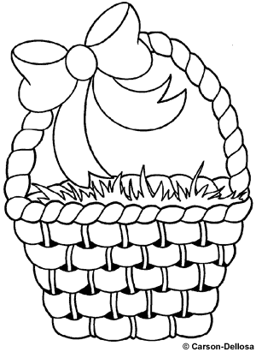

Lleno



 Vació

Nombre

Resuelve los siguientes problemas.

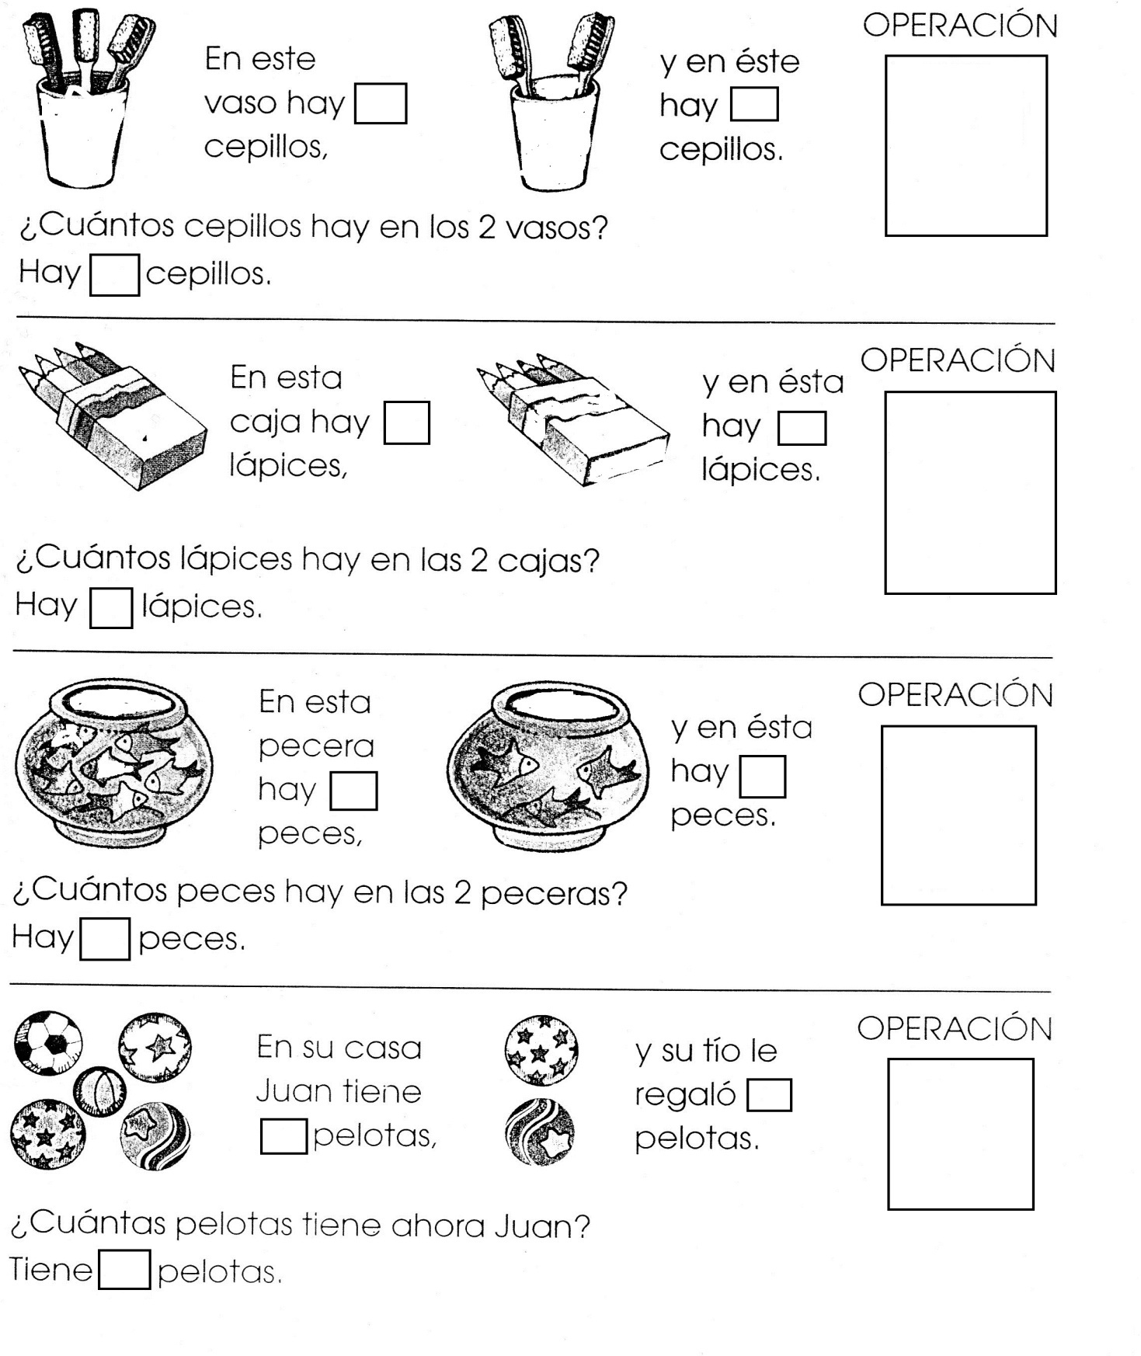

Nombre

Decora con diversidad de materiales la letra Z z.

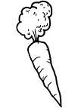





Nombre

Continúa con la plana ubicando el cuadro correctamente.

Ejercicio 1

|  |  |  |  |  |  |  |  |  |  |  |  |  |  |  |  |  |  |  |  |  |  |  |  |  |  |  |  |  |  |
| --- | --- | --- | --- | --- | --- | --- | --- | --- | --- | --- | --- | --- | --- | --- | --- | --- | --- | --- | --- | --- | --- | --- | --- | --- | --- | --- | --- | --- | --- |
|  |  |  |  |  |  |  |  |  |  |  |  |  |  |  |  |  |  |  |  |  |  |  |  |  |  |  |  |  |  |
|  |  |  |  |  |  |  |  |  |  |  |  |  |  |  |  |  |  |  |  |  |  |  |  |  |  |  |  |  |  |
|  |  |  |  |  |  |  |  |  |  |  |  |  |  |  |  |  |  |  |  |  |  |  |  |  |  |  |  |  |  |
|  |  |  |  |  |  |  |  |  |  |  |  |  |  |  |  |  |  |  |  |  |  |  |  |  |  |  |  |  |  |
|  |  |  |  |  |  |  |  |  |  |  |  |  |  |  |  |  |  |  |  |  |  |  |  |  |  |  |  |  |  |
|  |  |  |  |  |  |  |  |  |  |  |  |  |  |  |  |  |  |  |  |  |  |  |  |  |  |  |  |  |  |

Ejercicio 2

|  |  |  |  |  |  |  |  |  |  |  |  |  |  |  |  |  |  |  |  |  |  |  |  |  |  |  |  |  |  |
| --- | --- | --- | --- | --- | --- | --- | --- | --- | --- | --- | --- | --- | --- | --- | --- | --- | --- | --- | --- | --- | --- | --- | --- | --- | --- | --- | --- | --- | --- |
|  |  |  |  |  |  |  |  |  |  |  |  |  |  |  |  |  |  |  |  |  |  |  |  |  |  |  |  |  |  |
|  |  |  |  |  |  |  |  |  |  |  |  |  |  |  |  |  |  |  |  |  |  |  |  |  |  |  |  |  |  |
|  |  |  |  |  |  |  |  |  |  |  |  |  |  |  |  |  |  |  |  |  |  |  |  |  |  |  |  |  |  |
|  |  |  |  |  |  |  |  |  |  |  |  |  |  |  |  |  |  |  |  |  |  |  |  |  |  |  |  |  |  |
|  |  |  |  |  |  |  |  |  |  |  |  |  |  |  |  |  |  |  |  |  |  |  |  |  |  |  |  |  |  |
|  |  |  |  |  |  |  |  |  |  |  |  |  |  |  |  |  |  |  |  |  |  |  |  |  |  |  |  |  |  |

Ejercicio 3

|  |  |  |  |  |  |  |  |  |  |  |  |  |  |  |  |  |  |  |  |  |  |  |  |  |  |  |  |  |  |
| --- | --- | --- | --- | --- | --- | --- | --- | --- | --- | --- | --- | --- | --- | --- | --- | --- | --- | --- | --- | --- | --- | --- | --- | --- | --- | --- | --- | --- | --- |
|  |  |  |  |  |  |  |  |  |  |  |  |  |  |  |  |  |  |  |  |  |  |  |  |  |  |  |  |  |  |
|  |  |  |  |  |  |  |  |  |  |  |  |  |  |  |  |  |  |  |  |  |  |  |  |  |  |  |  |  |  |
|  |  |  |  |  |  |  |  |  |  |  |  |  |  |  |  |  |  |  |  |  |  |  |  |  |  |  |  |  |  |
|  |  |  |  |  |  |  |  |  |  |  |  |  |  |  |  |  |  |  |  |  |  |  |  |  |  |  |  |  |  |
|  |  |  |  |  |  |  |  |  |  |  |  |  |  |  |  |  |  |  |  |  |  |  |  |  |  |  |  |  |  |
|  |  |  |  |  |  |  |  |  |  |  |  |  |  |  |  |  |  |  |  |  |  |  |  |  |  |  |  |  |  |

Ejercicio 4

|  |  |  |  |  |  |  |  |  |  |  |  |  |  |  |  |  |  |  |  |  |  |  |  |  |  |  |  |  |  |
| --- | --- | --- | --- | --- | --- | --- | --- | --- | --- | --- | --- | --- | --- | --- | --- | --- | --- | --- | --- | --- | --- | --- | --- | --- | --- | --- | --- | --- | --- |
|  |  |  |  |  |  |  |  |  |  |  |  |  |  |  |  |  |  |  |  |  |  |  |  |  |  |  |  |  |  |
|  |  |  |  |  |  |  |  |  |  |  |  |  |  |  |  |  |  |  |  |  |  |  |  |  |  |  |  |  |  |
|  |  |  |  |  |  |  |  |  |  |  |  |  |  |  |  |  |  |  |  |  |  |  |  |  |  |  |  |  |  |
|  |  |  |  |  |  |  |  |  |  |  |  |  |  |  |  |  |  |  |  |  |  |  |  |  |  |  |  |  |  |
|  |  |  |  |  |  |  |  |  |  |  |  |  |  |  |  |  |  |  |  |  |  |  |  |  |  |  |  |  |  |
|  |  |  |  |  |  |  |  |  |  |  |  |  |  |  |  |  |  |  |  |  |  |  |  |  |  |  |  |  |  |

Ejercicio 5

|  |  |  |  |  |  |  |  |  |  |  |  |  |  |  |  |  |  |  |  |  |  |  |  |  |  |  |  |  |  |
| --- | --- | --- | --- | --- | --- | --- | --- | --- | --- | --- | --- | --- | --- | --- | --- | --- | --- | --- | --- | --- | --- | --- | --- | --- | --- | --- | --- | --- | --- |
|  |  |  |  |  |  |  |  |  |  |  |  |  |  |  |  |  |  |  |  |  |  |  |  |  |  |  |  |  |  |
|  |  |  |  |  |  |  |  |  |  |  |  |  |  |  |  |  |  |  |  |  |  |  |  |  |  |  |  |  |  |
|  |  |  |  |  |  |  |  |  |  |  |  |  |  |  |  |  |  |  |  |  |  |  |  |  |  |  |  |  |  |
|  |  |  |  |  |  |  |  |  |  |  |  |  |  |  |  |  |  |  |  |  |  |  |  |  |  |  |  |  |  |
|  |  |  |  |  |  |  |  |  |  |  |  |  |  |  |  |  |  |  |  |  |  |  |  |  |  |  |  |  |  |
|  |  |  |  |  |  |  |  |  | Scan0005 |  |  |  |  |  |  |  |  |  |  |  |  |  |  |  |  |  |  |  |  |

Nombre

Continúa con la plana ubicando el cuadro correctamente.

Ejercicio 1

|  |  |  |  |  |  |  |  |  |  |  |  |  |  |  |  |  |  |  |  |  |  |  |  |  |  |  |  |  |  |
| --- | --- | --- | --- | --- | --- | --- | --- | --- | --- | --- | --- | --- | --- | --- | --- | --- | --- | --- | --- | --- | --- | --- | --- | --- | --- | --- | --- | --- | --- |
|  |  |  |  |  |  |  |  |  |  |  |  |  |  |  |  |  |  |  |  |  |  |  |  |  |  |  |  |  |  |
|  |  |  |  |  |  |  |  |  |  |  |  |  |  |  |  |  |  |  |  |  |  |  |  |  |  |  |  |  |  |
|  |  |  |  |  |  |  |  |  |  |  |  |  |  |  |  |  |  |  |  |  |  |  |  |  |  |  |  |  |  |
|  |  |  |  |  |  |  |  |  |  |  |  |  |  |  |  |  |  |  |  |  |  |  |  |  |  |  |  |  |  |
|  |  |  |  |  |  |  |  |  |  |  |  |  |  |  |  |  |  |  |  |  |  |  |  |  |  |  |  |  |  |
|  |  |  |  |  |  |  |  |  |  |  |  |  |  |  |  |  |  |  |  |  |  |  |  |  |  |  |  |  |  |

Ejercicio 2

|  |  |  |  |  |  |  |  |  |  |  |  |  |  |  |  |  |  |  |  |  |  |  |  |  |  |  |  |  |  |
| --- | --- | --- | --- | --- | --- | --- | --- | --- | --- | --- | --- | --- | --- | --- | --- | --- | --- | --- | --- | --- | --- | --- | --- | --- | --- | --- | --- | --- | --- |
|  |  |  |  |  |  |  |  |  |  |  |  |  |  |  |  |  |  |  |  |  |  |  |  |  |  |  |  |  |  |
|  |  |  |  |  |  |  |  |  |  |  |  |  |  |  |  |  |  |  |  |  |  |  |  |  |  |  |  |  |  |
|  |  |  |  |  |  |  |  |  |  |  |  |  |  |  |  |  |  |  |  |  |  |  |  |  |  |  |  |  |  |
|  |  |  |  |  |  |  |  |  |  |  |  |  |  |  |  |  |  |  |  |  |  |  |  |  |  |  |  |  |  |
|  |  |  |  |  |  |  |  |  |  |  |  |  |  |  |  |  |  |  |  |  |  |  |  |  |  |  |  |  |  |
|  |  |  |  |  |  |  |  |  |  |  |  |  |  |  |  |  |  |  |  |  |  |  |  |  |  |  |  |  |  |

Ejercicio 3

|  |  |  |  |  |  |  |  |  |  |  |  |  |  |  |  |  |  |  |  |  |  |  |  |  |  |  |  |  |  |
| --- | --- | --- | --- | --- | --- | --- | --- | --- | --- | --- | --- | --- | --- | --- | --- | --- | --- | --- | --- | --- | --- | --- | --- | --- | --- | --- | --- | --- | --- |
|  |  |  |  |  |  |  |  |  |  |  |  |  |  |  |  |  |  |  |  |  |  |  |  |  |  |  |  |  |  |
|  |  |  |  |  |  |  |  |  |  |  |  |  |  |  |  |  |  |  |  |  |  |  |  |  |  |  |  |  |  |
|  |  |  |  |  |  |  |  |  |  |  |  |  |  |  |  |  |  |  |  |  |  |  |  |  |  |  |  |  |  |
|  |  |  |  |  |  |  |  |  |  |  |  |  |  |  |  |  |  |  |  |  |  |  |  |  |  |  |  |  |  |
|  |  |  |  |  |  |  |  |  |  |  |  |  |  |  |  |  |  |  |  |  |  |  |  |  |  |  |  |  |  |
|  |  |  |  |  |  |  |  |  |  |  |  |  |  |  |  |  |  |  |  |  |  |  |  |  |  |  |  |  |  |

Ejercicio 4

|  |  |  |  |  |  |  |  |  |  |  |  |  |  |  |  |  |  |  |  |  |  |  |  |  |  |  |  |  |  |
| --- | --- | --- | --- | --- | --- | --- | --- | --- | --- | --- | --- | --- | --- | --- | --- | --- | --- | --- | --- | --- | --- | --- | --- | --- | --- | --- | --- | --- | --- |
|  |  |  |  |  |  |  |  |  |  |  |  |  |  |  |  |  |  |  |  |  |  |  |  |  |  |  |  |  |  |
|  |  |  |  |  |  |  |  |  |  |  |  |  |  |  |  |  |  |  |  |  |  |  |  |  |  |  |  |  |  |
|  |  |  |  |  |  |  |  |  |  |  |  |  |  |  |  |  |  |  |  |  |  |  |  |  |  |  |  |  |  |
|  |  |  |  |  |  |  |  |  |  |  |  |  |  |  |  |  |  |  |  |  |  |  |  |  |  |  |  |  |  |
|  |  |  |  |  |  |  |  |  |  |  |  |  |  |  |  |  |  |  |  |  |  |  |  |  |  |  |  |  |  |
|  |  |  |  |  |  |  |  |  |  |  |  |  |  |  |  |  |  |  |  |  |  |  |  |  |  |  |  |  |  |

Ejercicio 5

|  |  |  |  |  |  |  |  |  |  |  |  |  |  |  |  |  |  |  |  |  |  |  |  |  |  |  |  |  |  |
| --- | --- | --- | --- | --- | --- | --- | --- | --- | --- | --- | --- | --- | --- | --- | --- | --- | --- | --- | --- | --- | --- | --- | --- | --- | --- | --- | --- | --- | --- |
|  |  |  |  |  |  |  |  |  |  |  |  |  |  |  |  |  |  |  |  |  |  |  |  |  |  |  |  |  |  |
|  |  |  |  |  |  |  |  |  |  |  |  |  |  |  |  |  |  |  |  |  |  |  |  |  |  |  |  |  |  |
|  |  |  |  |  |  |  |  |  |  |  |  |  |  |  |  |  |  |  |  |  |  |  |  |  |  |  |  |  |  |
|  |  |  |  |  |  |  |  |  |  |  |  |  |  |  |  |  |  |  |  |  |  |  |  |  |  |  |  |  |  |
|  |  |  |  |  |  |  |  |  |  |  |  |  |  |  |  |  |  |  |  |  |  |  |  |  |  |  |  |  |  |
|  |  |  |  |  |  |  |  |  |  | Scan0005 |  |  |  |  |  |  |  |  |  |  |  |  |  |  |  |  |  |  |  |

Nombre

Completa la familia del 50.

50

__

__

53

__

__

__

57

__

__



Nombre

Realiza la escritura de la familia del 50 ubicando bien el cuadro.

Ejercicio 1

|  |  |  |  |  |  |  |  |  |  |  |  |  |  |  |  |  |  |  |  |  |  |  |  |  |  |  |  |  |  |
| --- | --- | --- | --- | --- | --- | --- | --- | --- | --- | --- | --- | --- | --- | --- | --- | --- | --- | --- | --- | --- | --- | --- | --- | --- | --- | --- | --- | --- | --- |
|  |  |  |  |  |  |  |  |  |  |  |  |  |  |  |  |  |  |  |  |  |  |  |  |  |  |  |  |  |  |
|  |  |  |  |  |  |  |  |  |  |  |  |  |  |  |  |  |  |  |  |  |  |  |  |  |  |  |  |  |  |
|  |  |  |  |  |  |  |  |  |  |  |  |  |  |  |  |  |  |  |  |  |  |  |  |  |  |  |  |  |  |
|  |  |  |  |  |  |  |  |  |  |  |  |  |  |  |  |  |  |  |  |  |  |  |  |  |  |  |  |  |  |
|  |  |  |  |  |  |  |  |  |  |  |  |  |  |  |  |  |  |  |  |  |  |  |  |  |  |  |  |  |  |
|  |  |  |  |  |  |  |  |  |  |  |  |  |  |  |  |  |  |  |  |  |  |  |  |  |  |  |  |  |  |

Ejercicio 2

|  |  |  |  |  |  |  |  |  |  |  |  |  |  |  |  |  |  |  |  |  |  |  |  |  |  |  |  |  |  |
| --- | --- | --- | --- | --- | --- | --- | --- | --- | --- | --- | --- | --- | --- | --- | --- | --- | --- | --- | --- | --- | --- | --- | --- | --- | --- | --- | --- | --- | --- |
|  |  |  |  |  |  |  |  |  |  |  |  |  |  |  |  |  |  |  |  |  |  |  |  |  |  |  |  |  |  |
|  |  |  |  |  |  |  |  |  |  |  |  |  |  |  |  |  |  |  |  |  |  |  |  |  |  |  |  |  |  |
|  |  |  |  |  |  |  |  |  |  |  |  |  |  |  |  |  |  |  |  |  |  |  |  |  |  |  |  |  |  |
|  |  |  |  |  |  |  |  |  |  |  |  |  |  |  |  |  |  |  |  |  |  |  |  |  |  |  |  |  |  |
|  |  |  |  |  |  |  |  |  |  |  |  |  |  |  |  |  |  |  |  |  |  |  |  |  |  |  |  |  |  |
|  |  |  |  |  |  |  |  |  |  |  |  |  |  |  |  |  |  |  |  |  |  |  |  |  |  |  |  |  |  |

Ejercicio 3

|  |  |  |  |  |  |  |  |  |  |  |  |  |  |  |  |  |  |  |  |  |  |  |  |  |  |  |  |  |  |
| --- | --- | --- | --- | --- | --- | --- | --- | --- | --- | --- | --- | --- | --- | --- | --- | --- | --- | --- | --- | --- | --- | --- | --- | --- | --- | --- | --- | --- | --- |
|  |  |  |  |  |  |  |  |  |  |  |  |  |  |  |  |  |  |  |  |  |  |  |  |  |  |  |  |  |  |
|  |  |  |  |  |  |  |  |  |  |  |  |  |  |  |  |  |  |  |  |  |  |  |  |  |  |  |  |  |  |
|  |  |  |  |  |  |  |  |  |  |  |  |  |  |  |  |  |  |  |  |  |  |  |  |  |  |  |  |  |  |
|  |  |  |  |  |  |  |  |  |  |  |  |  |  |  |  |  |  |  |  |  |  |  |  |  |  |  |  |  |  |
|  |  |  |  |  |  |  |  |  |  |  |  |  |  |  |  |  |  |  |  |  |  |  |  |  |  |  |  |  |  |
|  |  |  |  |  |  |  |  |  |  |  |  |  |  |  |  |  |  |  |  |  |  |  |  |  |  |  |  |  |  |

Ejercicio 4

|  |  |  |  |  |  |  |  |  |  |  |  |  |  |  |  |  |  |  |  |  |  |  |  |  |  |  |  |  |  |
| --- | --- | --- | --- | --- | --- | --- | --- | --- | --- | --- | --- | --- | --- | --- | --- | --- | --- | --- | --- | --- | --- | --- | --- | --- | --- | --- | --- | --- | --- |
|  |  |  |  |  |  |  |  |  |  |  |  |  |  |  |  |  |  |  |  |  |  |  |  |  |  |  |  |  |  |
|  |  |  |  |  |  |  |  |  |  |  |  |  |  |  |  |  |  |  |  |  |  |  |  |  |  |  |  |  |  |
|  |  |  |  |  |  |  |  |  |  |  |  |  |  |  |  |  |  |  |  |  |  |  |  |  |  |  |  |  |  |
|  |  |  |  |  |  |  |  |  |  |  |  |  |  |  |  |  |  |  |  |  |  |  |  |  |  |  |  |  |  |
|  |  |  |  |  |  |  |  |  |  |  |  |  |  |  |  |  |  |  |  |  |  |  |  |  |  |  |  |  |  |
|  |  |  |  |  |  |  |  |  |  |  |  |  |  |  |  |  |  |  |  |  |  |  |  |  |  |  |  |  |  |

Ejercicio 5

|  |  |  |  |  |  |  |  |  |  |  |  |  |  |  |  |  |  |  |  |  |  |  |  |  |  |  |  |  |  |
| --- | --- | --- | --- | --- | --- | --- | --- | --- | --- | --- | --- | --- | --- | --- | --- | --- | --- | --- | --- | --- | --- | --- | --- | --- | --- | --- | --- | --- | --- |
|  |  |  |  |  |  |  |  |  |  |  |  |  |  |  |  |  |  |  |  |  |  |  |  |  |  |  |  |  |  |
|  |  |  |  |  |  |  |  |  |  |  |  |  |  |  |  |  |  |  |  |  |  |  |  |  |  |  |  |  |  |
|  |  |  |  |  |  |  |  |  |  |  |  |  |  |  |  |  |  |  |  |  |  |  |  |  |  |  |  |  |  |
|  |  |  |  |  |  |  |  |  |  |  |  |  |  |  |  |  |  |  |  |  |  |  |  |  |  |  |  |  |  |
|  |  |  |  |  |  |  |  |  |  |  |  |  |  |  |  |  |  |  |  |  |  |  |  |  |  |  |  |  |  |
|  |  |  |  |  |  |  |  | Scan0005 |  |  |  |  |  |  |  |  |  |  |  |  |  |  |  |  |  |  |  |  |  |

Nombre

Copia las sumas y restas del pizarrón y realízalas.



Nombre

Observa los dibujos y encierra la palabra correcta.

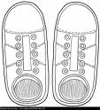 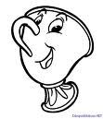

Zapote toze

Zapato tiza

Zapota taza

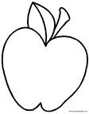

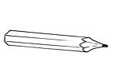

Manzina lipiz

Minzina lápiz

Manzana lepiz



Nombre

Escucha la lectura de “Los zapatos nuevos” de tu libro de cuenta cuentos ¿Qué le falta al cien pies? pégale lo que le falta.

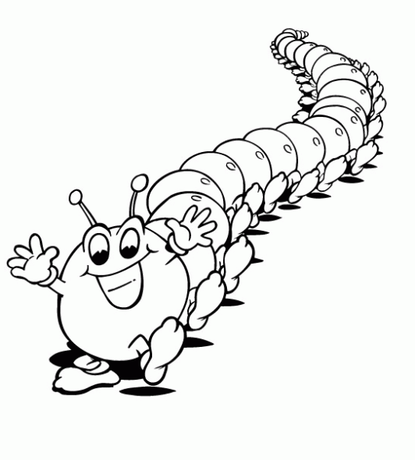



Nombre

Decora lo que celebramos en febrero.

DIA DEL AMOR Y DE LA AMISTAD.

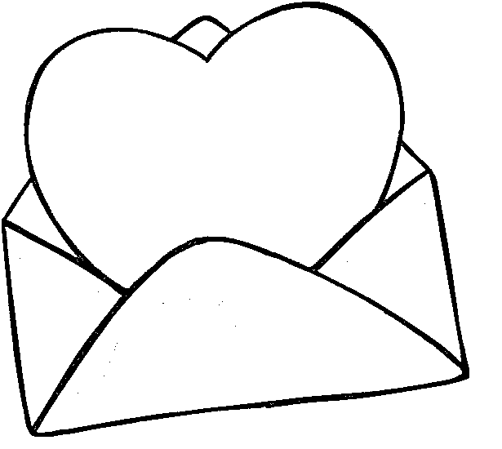



Nombre

Decora con material variado la letra LL ll.

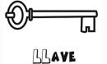

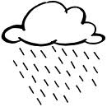



Nombre

Continúa con la plana ubicando correctamente el cuadro.

Ejercicio 1

|  |  |  |  |  |  |  |  |  |  |  |  |  |  |  |  |  |  |  |  |  |  |  |  |  |  |  |  |  |  |
| --- | --- | --- | --- | --- | --- | --- | --- | --- | --- | --- | --- | --- | --- | --- | --- | --- | --- | --- | --- | --- | --- | --- | --- | --- | --- | --- | --- | --- | --- |
|  |  |  |  |  |  |  |  |  |  |  |  |  |  |  |  |  |  |  |  |  |  |  |  |  |  |  |  |  |  |
|  |  |  |  |  |  |  |  |  |  |  |  |  |  |  |  |  |  |  |  |  |  |  |  |  |  |  |  |  |  |
|  |  |  |  |  |  |  |  |  |  |  |  |  |  |  |  |  |  |  |  |  |  |  |  |  |  |  |  |  |  |
|  |  |  |  |  |  |  |  |  |  |  |  |  |  |  |  |  |  |  |  |  |  |  |  |  |  |  |  |  |  |
|  |  |  |  |  |  |  |  |  |  |  |  |  |  |  |  |  |  |  |  |  |  |  |  |  |  |  |  |  |  |
|  |  |  |  |  |  |  |  |  |  |  |  |  |  |  |  |  |  |  |  |  |  |  |  |  |  |  |  |  |  |

Ejercicio 2

|  |  |  |  |  |  |  |  |  |  |  |  |  |  |  |  |  |  |  |  |  |  |  |  |  |  |  |  |  |  |
| --- | --- | --- | --- | --- | --- | --- | --- | --- | --- | --- | --- | --- | --- | --- | --- | --- | --- | --- | --- | --- | --- | --- | --- | --- | --- | --- | --- | --- | --- |
|  |  |  |  |  |  |  |  |  |  |  |  |  |  |  |  |  |  |  |  |  |  |  |  |  |  |  |  |  |  |
|  |  |  |  |  |  |  |  |  |  |  |  |  |  |  |  |  |  |  |  |  |  |  |  |  |  |  |  |  |  |
|  |  |  |  |  |  |  |  |  |  |  |  |  |  |  |  |  |  |  |  |  |  |  |  |  |  |  |  |  |  |
|  |  |  |  |  |  |  |  |  |  |  |  |  |  |  |  |  |  |  |  |  |  |  |  |  |  |  |  |  |  |
|  |  |  |  |  |  |  |  |  |  |  |  |  |  |  |  |  |  |  |  |  |  |  |  |  |  |  |  |  |  |
|  |  |  |  |  |  |  |  |  |  |  |  |  |  |  |  |  |  |  |  |  |  |  |  |  |  |  |  |  |  |

Ejercicio 3

|  |  |  |  |  |  |  |  |  |  |  |  |  |  |  |  |  |  |  |  |  |  |  |  |  |  |  |  |  |  |
| --- | --- | --- | --- | --- | --- | --- | --- | --- | --- | --- | --- | --- | --- | --- | --- | --- | --- | --- | --- | --- | --- | --- | --- | --- | --- | --- | --- | --- | --- |
|  |  |  |  |  |  |  |  |  |  |  |  |  |  |  |  |  |  |  |  |  |  |  |  |  |  |  |  |  |  |
|  |  |  |  |  |  |  |  |  |  |  |  |  |  |  |  |  |  |  |  |  |  |  |  |  |  |  |  |  |  |
|  |  |  |  |  |  |  |  |  |  |  |  |  |  |  |  |  |  |  |  |  |  |  |  |  |  |  |  |  |  |
|  |  |  |  |  |  |  |  |  |  |  |  |  |  |  |  |  |  |  |  |  |  |  |  |  |  |  |  |  |  |
|  |  |  |  |  |  |  |  |  |  |  |  |  |  |  |  |  |  |  |  |  |  |  |  |  |  |  |  |  |  |
|  |  |  |  |  |  |  |  |  |  |  |  |  |  |  |  |  |  |  |  |  |  |  |  |  |  |  |  |  |  |

Ejercicio 4

|  |  |  |  |  |  |  |  |  |  |  |  |  |  |  |  |  |  |  |  |  |  |  |  |  |  |  |  |  |  |
| --- | --- | --- | --- | --- | --- | --- | --- | --- | --- | --- | --- | --- | --- | --- | --- | --- | --- | --- | --- | --- | --- | --- | --- | --- | --- | --- | --- | --- | --- |
|  |  |  |  |  |  |  |  |  |  |  |  |  |  |  |  |  |  |  |  |  |  |  |  |  |  |  |  |  |  |
|  |  |  |  |  |  |  |  |  |  |  |  |  |  |  |  |  |  |  |  |  |  |  |  |  |  |  |  |  |  |
|  |  |  |  |  |  |  |  |  |  |  |  |  |  |  |  |  |  |  |  |  |  |  |  |  |  |  |  |  |  |
|  |  |  |  |  |  |  |  |  |  |  |  |  |  |  |  |  |  |  |  |  |  |  |  |  |  |  |  |  |  |
|  |  |  |  |  |  |  |  |  |  |  |  |  |  |  |  |  |  |  |  |  |  |  |  |  |  |  |  |  |  |
|  |  |  |  |  |  |  |  |  |  |  |  |  |  |  |  |  |  |  |  |  |  |  |  |  |  |  |  |  |  |

Ejercicio 5

|  |  |  |  |  |  |  |  |  |  |  |  |  |  |  |  |  |  |  |  |  |  |  |  |  |  |  |  |  |  |
| --- | --- | --- | --- | --- | --- | --- | --- | --- | --- | --- | --- | --- | --- | --- | --- | --- | --- | --- | --- | --- | --- | --- | --- | --- | --- | --- | --- | --- | --- |
|  |  |  |  |  |  |  |  |  |  |  |  |  |  |  |  |  |  |  |  |  |  |  |  |  |  |  |  |  |  |
|  |  |  |  |  |  |  |  |  |  |  |  |  |  |  |  |  |  |  |  |  |  |  |  |  |  |  |  |  |  |
|  |  |  |  |  |  |  |  |  |  |  |  |  |  |  |  |  |  |  |  |  |  |  |  |  |  |  |  |  |  |
|  |  |  |  |  |  |  |  |  |  |  |  |  |  |  |  |  |  |  |  |  |  |  |  |  |  |  |  |  |  |
|  |  |  |  |  |  |  |  |  |  |  |  |  |  |  |  |  |  |  |  |  |  |  |  |  |  |  |  |  |  |
|  |  |  |  |  |  |  |  |  |  | Scan0005 |  |  |  |  |  |  |  |  |  |  |  |  |  |  |  |  |  |  |  |

Nombre

Continúa con la plana ubicando el cuadro correctamente.

Ejercicio 1

|  |  |  |  |  |  |  |  |  |  |  |  |  |  |  |  |  |  |  |  |  |  |  |  |  |  |  |  |  |  |
| --- | --- | --- | --- | --- | --- | --- | --- | --- | --- | --- | --- | --- | --- | --- | --- | --- | --- | --- | --- | --- | --- | --- | --- | --- | --- | --- | --- | --- | --- |
|  |  |  |  |  |  |  |  |  |  |  |  |  |  |  |  |  |  |  |  |  |  |  |  |  |  |  |  |  |  |
|  |  |  |  |  |  |  |  |  |  |  |  |  |  |  |  |  |  |  |  |  |  |  |  |  |  |  |  |  |  |
|  |  |  |  |  |  |  |  |  |  |  |  |  |  |  |  |  |  |  |  |  |  |  |  |  |  |  |  |  |  |
|  |  |  |  |  |  |  |  |  |  |  |  |  |  |  |  |  |  |  |  |  |  |  |  |  |  |  |  |  |  |
|  |  |  |  |  |  |  |  |  |  |  |  |  |  |  |  |  |  |  |  |  |  |  |  |  |  |  |  |  |  |
|  |  |  |  |  |  |  |  |  |  |  |  |  |  |  |  |  |  |  |  |  |  |  |  |  |  |  |  |  |  |

Ejercicio 2

|  |  |  |  |  |  |  |  |  |  |  |  |  |  |  |  |  |  |  |  |  |  |  |  |  |  |  |  |  |  |
| --- | --- | --- | --- | --- | --- | --- | --- | --- | --- | --- | --- | --- | --- | --- | --- | --- | --- | --- | --- | --- | --- | --- | --- | --- | --- | --- | --- | --- | --- |
|  |  |  |  |  |  |  |  |  |  |  |  |  |  |  |  |  |  |  |  |  |  |  |  |  |  |  |  |  |  |
|  |  |  |  |  |  |  |  |  |  |  |  |  |  |  |  |  |  |  |  |  |  |  |  |  |  |  |  |  |  |
|  |  |  |  |  |  |  |  |  |  |  |  |  |  |  |  |  |  |  |  |  |  |  |  |  |  |  |  |  |  |
|  |  |  |  |  |  |  |  |  |  |  |  |  |  |  |  |  |  |  |  |  |  |  |  |  |  |  |  |  |  |
|  |  |  |  |  |  |  |  |  |  |  |  |  |  |  |  |  |  |  |  |  |  |  |  |  |  |  |  |  |  |
|  |  |  |  |  |  |  |  |  |  |  |  |  |  |  |  |  |  |  |  |  |  |  |  |  |  |  |  |  |  |

Ejercicio 3

|  |  |  |  |  |  |  |  |  |  |  |  |  |  |  |  |  |  |  |  |  |  |  |  |  |  |  |  |  |  |
| --- | --- | --- | --- | --- | --- | --- | --- | --- | --- | --- | --- | --- | --- | --- | --- | --- | --- | --- | --- | --- | --- | --- | --- | --- | --- | --- | --- | --- | --- |
|  |  |  |  |  |  |  |  |  |  |  |  |  |  |  |  |  |  |  |  |  |  |  |  |  |  |  |  |  |  |
|  |  |  |  |  |  |  |  |  |  |  |  |  |  |  |  |  |  |  |  |  |  |  |  |  |  |  |  |  |  |
|  |  |  |  |  |  |  |  |  |  |  |  |  |  |  |  |  |  |  |  |  |  |  |  |  |  |  |  |  |  |
|  |  |  |  |  |  |  |  |  |  |  |  |  |  |  |  |  |  |  |  |  |  |  |  |  |  |  |  |  |  |
|  |  |  |  |  |  |  |  |  |  |  |  |  |  |  |  |  |  |  |  |  |  |  |  |  |  |  |  |  |  |
|  |  |  |  |  |  |  |  |  |  |  |  |  |  |  |  |  |  |  |  |  |  |  |  |  |  |  |  |  |  |

Ejercicio 4

|  |  |  |  |  |  |  |  |  |  |  |  |  |  |  |  |  |  |  |  |  |  |  |  |  |  |  |  |  |  |
| --- | --- | --- | --- | --- | --- | --- | --- | --- | --- | --- | --- | --- | --- | --- | --- | --- | --- | --- | --- | --- | --- | --- | --- | --- | --- | --- | --- | --- | --- |
|  |  |  |  |  |  |  |  |  |  |  |  |  |  |  |  |  |  |  |  |  |  |  |  |  |  |  |  |  |  |
|  |  |  |  |  |  |  |  |  |  |  |  |  |  |  |  |  |  |  |  |  |  |  |  |  |  |  |  |  |  |
|  |  |  |  |  |  |  |  |  |  |  |  |  |  |  |  |  |  |  |  |  |  |  |  |  |  |  |  |  |  |
|  |  |  |  |  |  |  |  |  |  |  |  |  |  |  |  |  |  |  |  |  |  |  |  |  |  |  |  |  |  |
|  |  |  |  |  |  |  |  |  |  |  |  |  |  |  |  |  |  |  |  |  |  |  |  |  |  |  |  |  |  |
|  |  |  |  |  |  |  |  |  |  |  |  |  |  |  |  |  |  |  |  |  |  |  |  |  |  |  |  |  |  |

Ejercicio 5

|  |  |  |  |  |  |  |  |  |  |  |  |  |  |  |  |  |  |  |  |  |  |  |  |  |  |  |  |  |  |
| --- | --- | --- | --- | --- | --- | --- | --- | --- | --- | --- | --- | --- | --- | --- | --- | --- | --- | --- | --- | --- | --- | --- | --- | --- | --- | --- | --- | --- | --- |
|  |  |  |  |  |  |  |  |  |  |  |  |  |  |  |  |  |  |  |  |  |  |  |  |  |  |  |  |  |  |
|  |  |  |  |  |  |  |  |  |  |  |  |  |  |  |  |  |  |  |  |  |  |  |  |  |  |  |  |  |  |
|  |  |  |  |  |  |  |  |  |  |  |  |  |  |  |  |  |  |  |  |  |  |  |  |  |  |  |  |  |  |
|  |  |  |  |  |  |  |  |  |  |  |  |  |  |  |  |  |  |  |  |  |  |  |  |  |  |  |  |  |  |
|  |  |  |  |  |  |  |  |  |  |  |  |  |  |  |  |  |  |  |  |  |  |  |  |  |  |  |  |  |  |
|  |  |  |  |  |  |  |  |  |  | Scan0005 |  |  |  |  |  |  |  |  |  |  |  |  |  |  |  |  |  |  |  |

Nombre

Observa los dibujos y únelos correctamente con la palabra.

Pollo

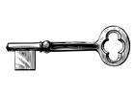 Caballo 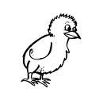

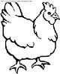 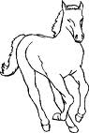

Camello

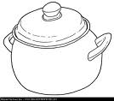

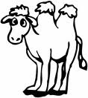

Cuchillo

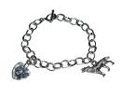 Olla 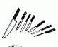

Collar

 

Gallina



Nombre

Representa las unidades y decenas.

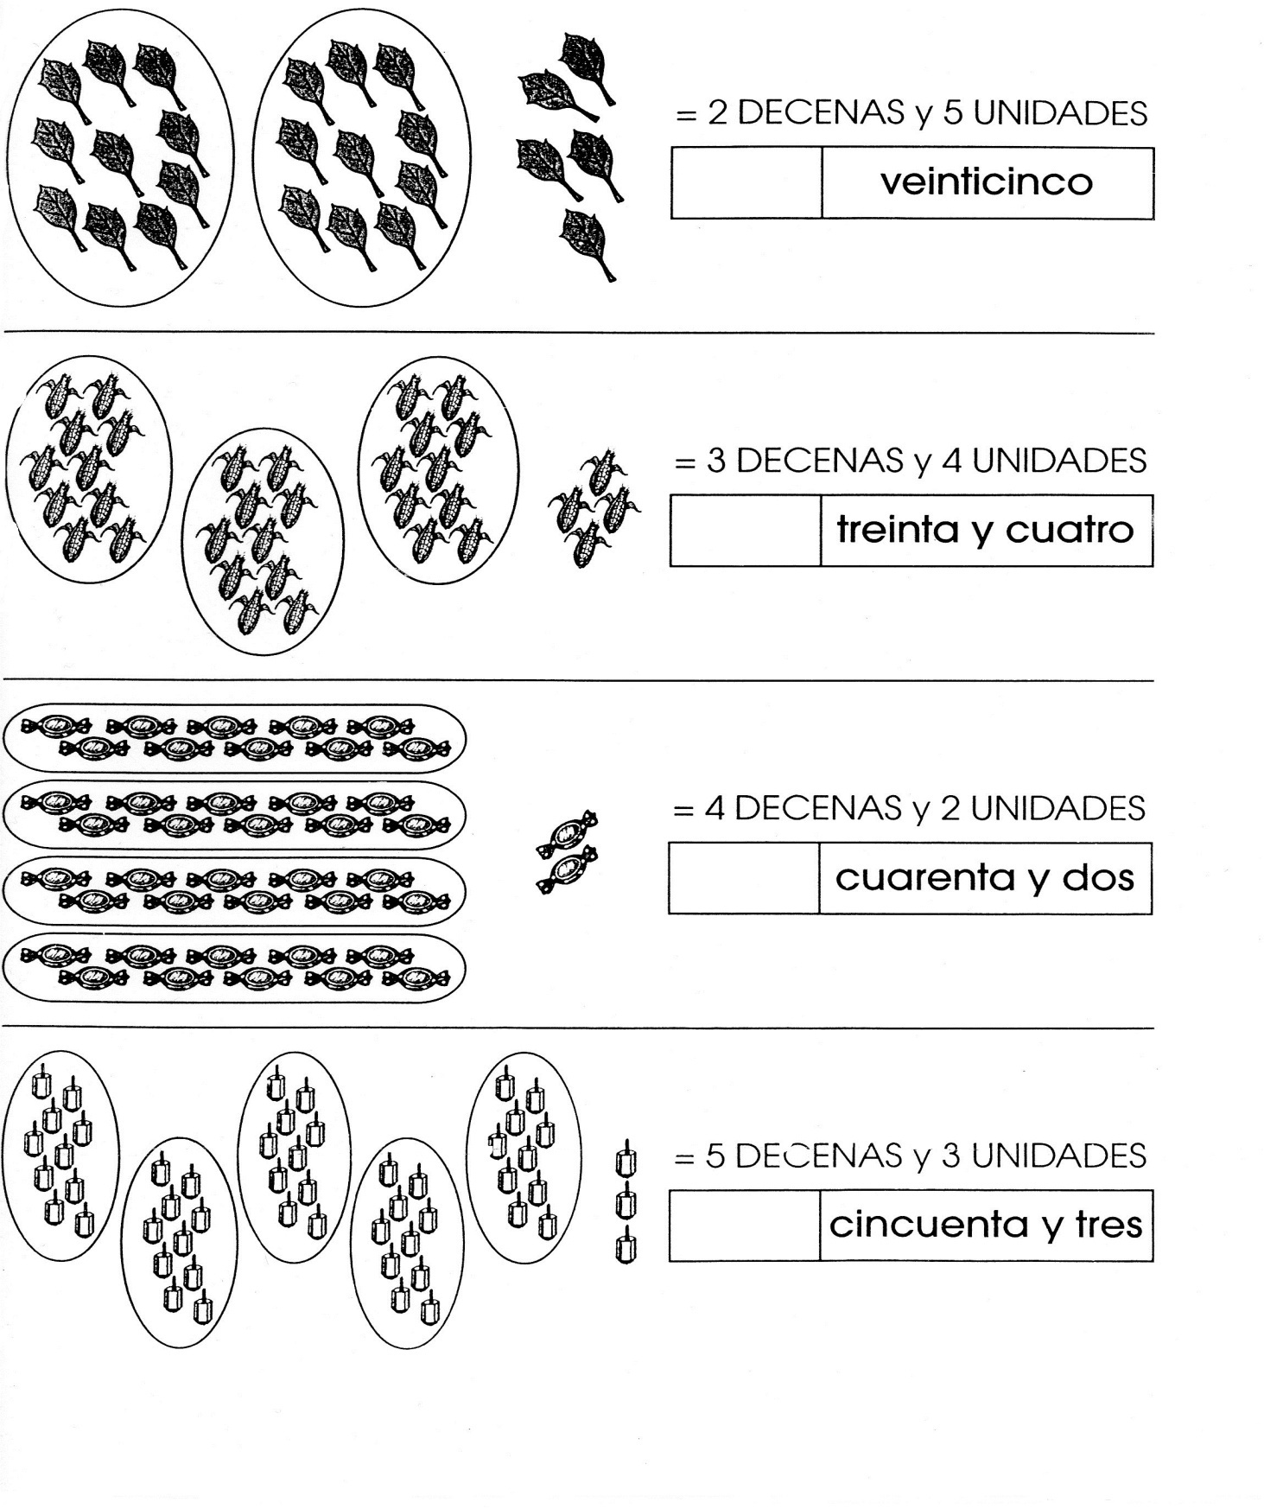



Nombre

Decora tu nombre completo en cursiva con material variado.



Nombre

Decora lo que celebramos en el mes de febrero.

24 DE FEBRERO DIA DE LA BANDERA.

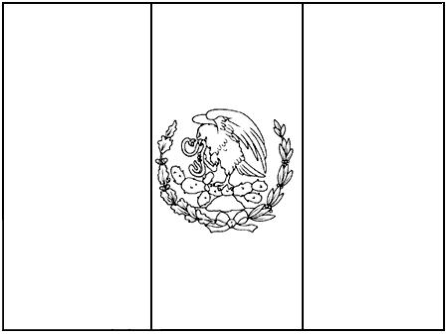



Nombre

Decora con material variado.

Plural

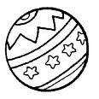   
  

  



 

Muchos

Nombre

Decora con material variado.

Singular

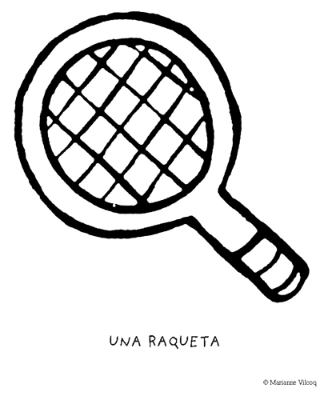

Único

Nombre

Escribe los números por familias en los círculos y podrás ver a donde llega Camila.

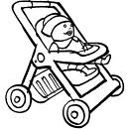

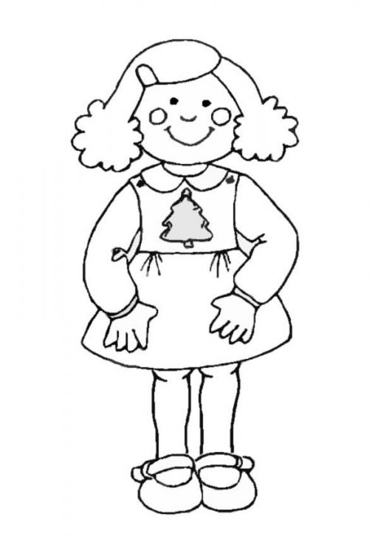 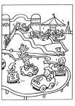

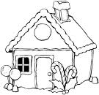

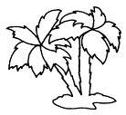

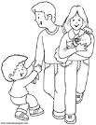



Nombre

Decora con material variado la letra C c.

 Ca Co Cu

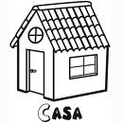



Nombre

De diferentes portadores de texto pega palabras con ca, co, cu.

ca co cu



Nombre

Continúa con la plana ubicando correctamente el cuadro.

Ejercicio 1

|  |  |  |  |  |  |  |  |  |  |  |  |  |  |  |  |  |  |  |  |  |  |  |  |  |  |  |  |  |  |
| --- | --- | --- | --- | --- | --- | --- | --- | --- | --- | --- | --- | --- | --- | --- | --- | --- | --- | --- | --- | --- | --- | --- | --- | --- | --- | --- | --- | --- | --- |
|  |  |  |  |  |  |  |  |  |  |  |  |  |  |  |  |  |  |  |  |  |  |  |  |  |  |  |  |  |  |
|  |  |  |  |  |  |  |  |  |  |  |  |  |  |  |  |  |  |  |  |  |  |  |  |  |  |  |  |  |  |
|  |  |  |  |  |  |  |  |  |  |  |  |  |  |  |  |  |  |  |  |  |  |  |  |  |  |  |  |  |  |
|  |  |  |  |  |  |  |  |  |  |  |  |  |  |  |  |  |  |  |  |  |  |  |  |  |  |  |  |  |  |
|  |  |  |  |  |  |  |  |  |  |  |  |  |  |  |  |  |  |  |  |  |  |  |  |  |  |  |  |  |  |
|  |  |  |  |  |  |  |  |  |  |  |  |  |  |  |  |  |  |  |  |  |  |  |  |  |  |  |  |  |  |

Ejercicio 2

|  |  |  |  |  |  |  |  |  |  |  |  |  |  |  |  |  |  |  |  |  |  |  |  |  |  |  |  |  |  |
| --- | --- | --- | --- | --- | --- | --- | --- | --- | --- | --- | --- | --- | --- | --- | --- | --- | --- | --- | --- | --- | --- | --- | --- | --- | --- | --- | --- | --- | --- |
|  |  |  |  |  |  |  |  |  |  |  |  |  |  |  |  |  |  |  |  |  |  |  |  |  |  |  |  |  |  |
|  |  |  |  |  |  |  |  |  |  |  |  |  |  |  |  |  |  |  |  |  |  |  |  |  |  |  |  |  |  |
|  |  |  |  |  |  |  |  |  |  |  |  |  |  |  |  |  |  |  |  |  |  |  |  |  |  |  |  |  |  |
|  |  |  |  |  |  |  |  |  |  |  |  |  |  |  |  |  |  |  |  |  |  |  |  |  |  |  |  |  |  |
|  |  |  |  |  |  |  |  |  |  |  |  |  |  |  |  |  |  |  |  |  |  |  |  |  |  |  |  |  |  |
|  |  |  |  |  |  |  |  |  |  |  |  |  |  |  |  |  |  |  |  |  |  |  |  |  |  |  |  |  |  |

Ejercicio 3

|  |  |  |  |  |  |  |  |  |  |  |  |  |  |  |  |  |  |  |  |  |  |  |  |  |  |  |  |  |  |
| --- | --- | --- | --- | --- | --- | --- | --- | --- | --- | --- | --- | --- | --- | --- | --- | --- | --- | --- | --- | --- | --- | --- | --- | --- | --- | --- | --- | --- | --- |
|  |  |  |  |  |  |  |  |  |  |  |  |  |  |  |  |  |  |  |  |  |  |  |  |  |  |  |  |  |  |
|  |  |  |  |  |  |  |  |  |  |  |  |  |  |  |  |  |  |  |  |  |  |  |  |  |  |  |  |  |  |
|  |  |  |  |  |  |  |  |  |  |  |  |  |  |  |  |  |  |  |  |  |  |  |  |  |  |  |  |  |  |
|  |  |  |  |  |  |  |  |  |  |  |  |  |  |  |  |  |  |  |  |  |  |  |  |  |  |  |  |  |  |
|  |  |  |  |  |  |  |  |  |  |  |  |  |  |  |  |  |  |  |  |  |  |  |  |  |  |  |  |  |  |
|  |  |  |  |  |  |  |  |  |  |  |  |  |  |  |  |  |  |  |  |  |  |  |  |  |  |  |  |  |  |

Ejercicio 4

|  |  |  |  |  |  |  |  |  |  |  |  |  |  |  |  |  |  |  |  |  |  |  |  |  |  |  |  |  |  |
| --- | --- | --- | --- | --- | --- | --- | --- | --- | --- | --- | --- | --- | --- | --- | --- | --- | --- | --- | --- | --- | --- | --- | --- | --- | --- | --- | --- | --- | --- |
|  |  |  |  |  |  |  |  |  |  |  |  |  |  |  |  |  |  |  |  |  |  |  |  |  |  |  |  |  |  |
|  |  |  |  |  |  |  |  |  |  |  |  |  |  |  |  |  |  |  |  |  |  |  |  |  |  |  |  |  |  |
|  |  |  |  |  |  |  |  |  |  |  |  |  |  |  |  |  |  |  |  |  |  |  |  |  |  |  |  |  |  |
|  |  |  |  |  |  |  |  |  |  |  |  |  |  |  |  |  |  |  |  |  |  |  |  |  |  |  |  |  |  |
|  |  |  |  |  |  |  |  |  |  |  |  |  |  |  |  |  |  |  |  |  |  |  |  |  |  |  |  |  |  |
|  |  |  |  |  |  |  |  |  |  |  |  |  |  |  |  |  |  |  |  |  |  |  |  |  |  |  |  |  |  |

Ejercicio 5

|  |  |  |  |  |  |  |  |  |  |  |  |  |  |  |  |  |  |  |  |  |  |  |  |  |  |  |  |  |  |
| --- | --- | --- | --- | --- | --- | --- | --- | --- | --- | --- | --- | --- | --- | --- | --- | --- | --- | --- | --- | --- | --- | --- | --- | --- | --- | --- | --- | --- | --- |
|  |  |  |  |  |  |  |  |  |  |  |  |  |  |  |  |  |  |  |  |  |  |  |  |  |  |  |  |  |  |
|  |  |  |  |  |  |  |  |  |  |  |  |  |  |  |  |  |  |  |  |  |  |  |  |  |  |  |  |  |  |
|  |  |  |  |  |  |  |  |  |  |  |  |  |  |  |  |  |  |  |  |  |  |  |  |  |  |  |  |  |  |
|  |  |  |  |  |  |  |  |  |  |  |  |  |  |  |  |  |  |  |  |  |  |  |  |  |  |  |  |  |  |
|  |  |  |  |  |  |  |  |  |  |  |  |  |  |  |  |  |  |  |  |  |  |  |  |  |  |  |  |  |  |
|  |  |  |  |  |  |  |  | Scan0005 |  |  |  |  |  |  |  |  |  |  |  |  |  |  |  |  |  |  |  |  |  |

Nombre

Continúa con la plana ubicando correctamente el cuadro.

Ejercicio 1

|  |  |  |  |  |  |  |  |  |  |  |  |  |  |  |  |  |  |  |  |  |  |  |  |  |  |  |  |  |  |
| --- | --- | --- | --- | --- | --- | --- | --- | --- | --- | --- | --- | --- | --- | --- | --- | --- | --- | --- | --- | --- | --- | --- | --- | --- | --- | --- | --- | --- | --- |
|  |  |  |  |  |  |  |  |  |  |  |  |  |  |  |  |  |  |  |  |  |  |  |  |  |  |  |  |  |  |
|  |  |  |  |  |  |  |  |  |  |  |  |  |  |  |  |  |  |  |  |  |  |  |  |  |  |  |  |  |  |
|  |  |  |  |  |  |  |  |  |  |  |  |  |  |  |  |  |  |  |  |  |  |  |  |  |  |  |  |  |  |
|  |  |  |  |  |  |  |  |  |  |  |  |  |  |  |  |  |  |  |  |  |  |  |  |  |  |  |  |  |  |
|  |  |  |  |  |  |  |  |  |  |  |  |  |  |  |  |  |  |  |  |  |  |  |  |  |  |  |  |  |  |
|  |  |  |  |  |  |  |  |  |  |  |  |  |  |  |  |  |  |  |  |  |  |  |  |  |  |  |  |  |  |

Ejercicio 2

|  |  |  |  |  |  |  |  |  |  |  |  |  |  |  |  |  |  |  |  |  |  |  |  |  |  |  |  |  |  |
| --- | --- | --- | --- | --- | --- | --- | --- | --- | --- | --- | --- | --- | --- | --- | --- | --- | --- | --- | --- | --- | --- | --- | --- | --- | --- | --- | --- | --- | --- |
|  |  |  |  |  |  |  |  |  |  |  |  |  |  |  |  |  |  |  |  |  |  |  |  |  |  |  |  |  |  |
|  |  |  |  |  |  |  |  |  |  |  |  |  |  |  |  |  |  |  |  |  |  |  |  |  |  |  |  |  |  |
|  |  |  |  |  |  |  |  |  |  |  |  |  |  |  |  |  |  |  |  |  |  |  |  |  |  |  |  |  |  |
|  |  |  |  |  |  |  |  |  |  |  |  |  |  |  |  |  |  |  |  |  |  |  |  |  |  |  |  |  |  |
|  |  |  |  |  |  |  |  |  |  |  |  |  |  |  |  |  |  |  |  |  |  |  |  |  |  |  |  |  |  |
|  |  |  |  |  |  |  |  |  |  |  |  |  |  |  |  |  |  |  |  |  |  |  |  |  |  |  |  |  |  |

Ejercicio 3

|  |  |  |  |  |  |  |  |  |  |  |  |  |  |  |  |  |  |  |  |  |  |  |  |  |  |  |  |  |  |
| --- | --- | --- | --- | --- | --- | --- | --- | --- | --- | --- | --- | --- | --- | --- | --- | --- | --- | --- | --- | --- | --- | --- | --- | --- | --- | --- | --- | --- | --- |
|  |  |  |  |  |  |  |  |  |  |  |  |  |  |  |  |  |  |  |  |  |  |  |  |  |  |  |  |  |  |
|  |  |  |  |  |  |  |  |  |  |  |  |  |  |  |  |  |  |  |  |  |  |  |  |  |  |  |  |  |  |
|  |  |  |  |  |  |  |  |  |  |  |  |  |  |  |  |  |  |  |  |  |  |  |  |  |  |  |  |  |  |
|  |  |  |  |  |  |  |  |  |  |  |  |  |  |  |  |  |  |  |  |  |  |  |  |  |  |  |  |  |  |
|  |  |  |  |  |  |  |  |  |  |  |  |  |  |  |  |  |  |  |  |  |  |  |  |  |  |  |  |  |  |
|  |  |  |  |  |  |  |  |  |  |  |  |  |  |  |  |  |  |  |  |  |  |  |  |  |  |  |  |  |  |

Ejercicio 4

|  |  |  |  |  |  |  |  |  |  |  |  |  |  |  |  |  |  |  |  |  |  |  |  |  |  |  |  |  |  |
| --- | --- | --- | --- | --- | --- | --- | --- | --- | --- | --- | --- | --- | --- | --- | --- | --- | --- | --- | --- | --- | --- | --- | --- | --- | --- | --- | --- | --- | --- |
|  |  |  |  |  |  |  |  |  |  |  |  |  |  |  |  |  |  |  |  |  |  |  |  |  |  |  |  |  |  |
|  |  |  |  |  |  |  |  |  |  |  |  |  |  |  |  |  |  |  |  |  |  |  |  |  |  |  |  |  |  |
|  |  |  |  |  |  |  |  |  |  |  |  |  |  |  |  |  |  |  |  |  |  |  |  |  |  |  |  |  |  |
|  |  |  |  |  |  |  |  |  |  |  |  |  |  |  |  |  |  |  |  |  |  |  |  |  |  |  |  |  |  |
|  |  |  |  |  |  |  |  |  |  |  |  |  |  |  |  |  |  |  |  |  |  |  |  |  |  |  |  |  |  |
|  |  |  |  |  |  |  |  |  |  |  |  |  |  |  |  |  |  |  |  |  |  |  |  |  |  |  |  |  |  |

Ejercicio 5

|  |  |  |  |  |  |  |  |  |  |  |  |  |  |  |  |  |  |  |  |  |  |  |  |  |  |  |  |  |  |
| --- | --- | --- | --- | --- | --- | --- | --- | --- | --- | --- | --- | --- | --- | --- | --- | --- | --- | --- | --- | --- | --- | --- | --- | --- | --- | --- | --- | --- | --- |
|  |  |  |  |  |  |  |  |  |  |  |  |  |  |  |  |  |  |  |  |  |  |  |  |  |  |  |  |  |  |
|  |  |  |  |  |  |  |  |  |  |  |  |  |  |  |  |  |  |  |  |  |  |  |  |  |  |  |  |  |  |
|  |  |  |  |  |  |  |  |  |  |  |  |  |  |  |  |  |  |  |  |  |  |  |  |  |  |  |  |  |  |
|  |  |  |  |  |  |  |  |  |  |  |  |  |  |  |  |  |  |  |  |  |  |  |  |  |  |  |  |  |  |
|  |  |  |  |  |  |  |  |  |  |  |  |  |  |  |  |  |  |  |  |  |  |  |  |  |  |  |  |  |  |
|  |  |  |  |  |  |  |  | Scan0005 |  |  |  |  |  |  |  |  |  |  |  |  |  |  |  |  |  |  |  |  |  |

Nombre

Decora con material variado el siguiente signo.

Mayor que



Nombre

Decora el signo con material variado.

Menor que



Nombre

Decora el signo con material variado.

Igual



Nombre

Anota el signo que corresponda a cada pareja de conjuntos y a cada pareja de números.

  

 

 

7 2

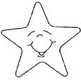    

 

3 4

 

 4 4

Nombre

Escucha la lectura de “El poema de cristina” y “Una historia misteriosa” de tu libro cuenta cuentos y pega palabras con cl, cr.

CR CL



Nombre

Resuelve el siguiente problema matemático.

Piensa y contesta:

1- Sergio tiene 3 carritos, y Toño tiene 4 carritos ¿Cuántos carritos tienen en total?

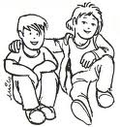 Operación

Tienen________carritos

2- Rosita tiene 4 muñecas de papel y su mamá le regalo 5 mas ¿Cuántas muñecas tiene en total?

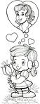

Tiene_________muñecas.

 Operación

Nombre

Busca la pagina recortable y pega en orden la familia del 60.

60



Nombre

Continúa con la escritura de la familia del 60 ubicando el cuadro.

Ejercicio 1

|  |  |  |  |  |  |  |  |  |  |  |  |  |  |  |  |  |  |  |  |  |  |  |  |  |  |  |  |  |  |
| --- | --- | --- | --- | --- | --- | --- | --- | --- | --- | --- | --- | --- | --- | --- | --- | --- | --- | --- | --- | --- | --- | --- | --- | --- | --- | --- | --- | --- | --- |
|  |  |  |  |  |  |  |  |  |  |  |  |  |  |  |  |  |  |  |  |  |  |  |  |  |  |  |  |  |  |
|  |  |  |  |  |  |  |  |  |  |  |  |  |  |  |  |  |  |  |  |  |  |  |  |  |  |  |  |  |  |
|  |  |  |  |  |  |  |  |  |  |  |  |  |  |  |  |  |  |  |  |  |  |  |  |  |  |  |  |  |  |
|  |  |  |  |  |  |  |  |  |  |  |  |  |  |  |  |  |  |  |  |  |  |  |  |  |  |  |  |  |  |
|  |  |  |  |  |  |  |  |  |  |  |  |  |  |  |  |  |  |  |  |  |  |  |  |  |  |  |  |  |  |
|  |  |  |  |  |  |  |  |  |  |  |  |  |  |  |  |  |  |  |  |  |  |  |  |  |  |  |  |  |  |

Ejercicio 2

|  |  |  |  |  |  |  |  |  |  |  |  |  |  |  |  |  |  |  |  |  |  |  |  |  |  |  |  |  |  |
| --- | --- | --- | --- | --- | --- | --- | --- | --- | --- | --- | --- | --- | --- | --- | --- | --- | --- | --- | --- | --- | --- | --- | --- | --- | --- | --- | --- | --- | --- |
|  |  |  |  |  |  |  |  |  |  |  |  |  |  |  |  |  |  |  |  |  |  |  |  |  |  |  |  |  |  |
|  |  |  |  |  |  |  |  |  |  |  |  |  |  |  |  |  |  |  |  |  |  |  |  |  |  |  |  |  |  |
|  |  |  |  |  |  |  |  |  |  |  |  |  |  |  |  |  |  |  |  |  |  |  |  |  |  |  |  |  |  |
|  |  |  |  |  |  |  |  |  |  |  |  |  |  |  |  |  |  |  |  |  |  |  |  |  |  |  |  |  |  |
|  |  |  |  |  |  |  |  |  |  |  |  |  |  |  |  |  |  |  |  |  |  |  |  |  |  |  |  |  |  |
|  |  |  |  |  |  |  |  |  |  |  |  |  |  |  |  |  |  |  |  |  |  |  |  |  |  |  |  |  |  |

Ejercicio 3

|  |  |  |  |  |  |  |  |  |  |  |  |  |  |  |  |  |  |  |  |  |  |  |  |  |  |  |  |  |  |
| --- | --- | --- | --- | --- | --- | --- | --- | --- | --- | --- | --- | --- | --- | --- | --- | --- | --- | --- | --- | --- | --- | --- | --- | --- | --- | --- | --- | --- | --- |
|  |  |  |  |  |  |  |  |  |  |  |  |  |  |  |  |  |  |  |  |  |  |  |  |  |  |  |  |  |  |
|  |  |  |  |  |  |  |  |  |  |  |  |  |  |  |  |  |  |  |  |  |  |  |  |  |  |  |  |  |  |
|  |  |  |  |  |  |  |  |  |  |  |  |  |  |  |  |  |  |  |  |  |  |  |  |  |  |  |  |  |  |
|  |  |  |  |  |  |  |  |  |  |  |  |  |  |  |  |  |  |  |  |  |  |  |  |  |  |  |  |  |  |
|  |  |  |  |  |  |  |  |  |  |  |  |  |  |  |  |  |  |  |  |  |  |  |  |  |  |  |  |  |  |
|  |  |  |  |  |  |  |  |  |  |  |  |  |  |  |  |  |  |  |  |  |  |  |  |  |  |  |  |  |  |

Ejercicio 4

|  |  |  |  |  |  |  |  |  |  |  |  |  |  |  |  |  |  |  |  |  |  |  |  |  |  |  |  |  |  |
| --- | --- | --- | --- | --- | --- | --- | --- | --- | --- | --- | --- | --- | --- | --- | --- | --- | --- | --- | --- | --- | --- | --- | --- | --- | --- | --- | --- | --- | --- |
|  |  |  |  |  |  |  |  |  |  |  |  |  |  |  |  |  |  |  |  |  |  |  |  |  |  |  |  |  |  |
|  |  |  |  |  |  |  |  |  |  |  |  |  |  |  |  |  |  |  |  |  |  |  |  |  |  |  |  |  |  |
|  |  |  |  |  |  |  |  |  |  |  |  |  |  |  |  |  |  |  |  |  |  |  |  |  |  |  |  |  |  |
|  |  |  |  |  |  |  |  |  |  |  |  |  |  |  |  |  |  |  |  |  |  |  |  |  |  |  |  |  |  |
|  |  |  |  |  |  |  |  |  |  |  |  |  |  |  |  |  |  |  |  |  |  |  |  |  |  |  |  |  |  |
|  |  |  |  |  |  |  |  |  |  |  |  |  |  |  |  |  |  |  |  |  |  |  |  |  |  |  |  |  |  |

Ejercicio 5

|  |  |  |  |  |  |  |  |  |  |  |  |  |  |  |  |  |  |  |  |  |  |  |  |  |  |  |  |  |  |
| --- | --- | --- | --- | --- | --- | --- | --- | --- | --- | --- | --- | --- | --- | --- | --- | --- | --- | --- | --- | --- | --- | --- | --- | --- | --- | --- | --- | --- | --- |
|  |  |  |  |  |  |  |  |  |  |  |  |  |  |  |  |  |  |  |  |  |  |  |  |  |  |  |  |  |  |
|  |  |  |  |  |  |  |  |  |  |  |  |  |  |  |  |  |  |  |  |  |  |  |  |  |  |  |  |  |  |
|  |  |  |  |  |  |  |  |  |  |  |  |  |  |  |  |  |  |  |  |  |  |  |  |  |  |  |  |  |  |
|  |  |  |  |  |  |  |  |  |  |  |  |  |  |  |  |  |  |  |  |  |  |  |  |  |  |  |  |  |  |
|  |  |  |  |  |  |  |  |  |  |  |  |  |  |  |  |  |  |  |  |  |  |  |  |  |  |  |  |  |  |
|  |  |  |  |  |  |  |  |  |  |  | Scan0005 |  |  |  |  |  |  |  |  |  |  |  |  |  |  |  |  |  |  |

Nombre

Con recortes de diferentes portadores de texto pega la familia del 40, 50, 60.



Nombre

Decora con material variado la letra Q q.

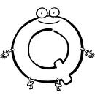

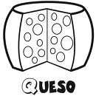



Nombre

Escucha la lectura de “Quinqué” y pega aquí palabras con Q q.



Nombre

Realiza los ejercicios de caligrafía.

Ejercicio 1

|  |  |  |  |  |  |  |  |  |  |  |  |  |  |  |  |  |  |  |  |  |  |  |  |  |  |  |  |  |  |
| --- | --- | --- | --- | --- | --- | --- | --- | --- | --- | --- | --- | --- | --- | --- | --- | --- | --- | --- | --- | --- | --- | --- | --- | --- | --- | --- | --- | --- | --- |
|  |  |  |  |  |  |  |  |  |  |  |  |  |  |  |  |  |  |  |  |  |  |  |  |  |  |  |  |  |  |
|  |  |  |  |  |  |  |  |  |  |  |  |  |  |  |  |  |  |  |  |  |  |  |  |  |  |  |  |  |  |
|  |  |  |  |  |  |  |  |  |  |  |  |  |  |  |  |  |  |  |  |  |  |  |  |  |  |  |  |  |  |
|  |  |  |  |  |  |  |  |  |  |  |  |  |  |  |  |  |  |  |  |  |  |  |  |  |  |  |  |  |  |
|  |  |  |  |  |  |  |  |  |  |  |  |  |  |  |  |  |  |  |  |  |  |  |  |  |  |  |  |  |  |
|  |  |  |  |  |  |  |  |  |  |  |  |  |  |  |  |  |  |  |  |  |  |  |  |  |  |  |  |  |  |

Ejercicio 2

|  |  |  |  |  |  |  |  |  |  |  |  |  |  |  |  |  |  |  |  |  |  |  |  |  |  |  |  |  |  |
| --- | --- | --- | --- | --- | --- | --- | --- | --- | --- | --- | --- | --- | --- | --- | --- | --- | --- | --- | --- | --- | --- | --- | --- | --- | --- | --- | --- | --- | --- |
|  |  |  |  |  |  |  |  |  |  |  |  |  |  |  |  |  |  |  |  |  |  |  |  |  |  |  |  |  |  |
|  |  |  |  |  |  |  |  |  |  |  |  |  |  |  |  |  |  |  |  |  |  |  |  |  |  |  |  |  |  |
|  |  |  |  |  |  |  |  |  |  |  |  |  |  |  |  |  |  |  |  |  |  |  |  |  |  |  |  |  |  |
|  |  |  |  |  |  |  |  |  |  |  |  |  |  |  |  |  |  |  |  |  |  |  |  |  |  |  |  |  |  |
|  |  |  |  |  |  |  |  |  |  |  |  |  |  |  |  |  |  |  |  |  |  |  |  |  |  |  |  |  |  |
|  |  |  |  |  |  |  |  |  |  |  |  |  |  |  |  |  |  |  |  |  |  |  |  |  |  |  |  |  |  |

Ejercicio 3

|  |  |  |  |  |  |  |  |  |  |  |  |  |  |  |  |  |  |  |  |  |  |  |  |  |  |  |  |  |  |
| --- | --- | --- | --- | --- | --- | --- | --- | --- | --- | --- | --- | --- | --- | --- | --- | --- | --- | --- | --- | --- | --- | --- | --- | --- | --- | --- | --- | --- | --- |
|  |  |  |  |  |  |  |  |  |  |  |  |  |  |  |  |  |  |  |  |  |  |  |  |  |  |  |  |  |  |
|  |  |  |  |  |  |  |  |  |  |  |  |  |  |  |  |  |  |  |  |  |  |  |  |  |  |  |  |  |  |
|  |  |  |  |  |  |  |  |  |  |  |  |  |  |  |  |  |  |  |  |  |  |  |  |  |  |  |  |  |  |
|  |  |  |  |  |  |  |  |  |  |  |  |  |  |  |  |  |  |  |  |  |  |  |  |  |  |  |  |  |  |
|  |  |  |  |  |  |  |  |  |  |  |  |  |  |  |  |  |  |  |  |  |  |  |  |  |  |  |  |  |  |
|  |  |  |  |  |  |  |  |  |  |  |  |  |  |  |  |  |  |  |  |  |  |  |  |  |  |  |  |  |  |

Ejercicio 4

|  |  |  |  |  |  |  |  |  |  |  |  |  |  |  |  |  |  |  |  |  |  |  |  |  |  |  |  |  |  |
| --- | --- | --- | --- | --- | --- | --- | --- | --- | --- | --- | --- | --- | --- | --- | --- | --- | --- | --- | --- | --- | --- | --- | --- | --- | --- | --- | --- | --- | --- |
|  |  |  |  |  |  |  |  |  |  |  |  |  |  |  |  |  |  |  |  |  |  |  |  |  |  |  |  |  |  |
|  |  |  |  |  |  |  |  |  |  |  |  |  |  |  |  |  |  |  |  |  |  |  |  |  |  |  |  |  |  |
|  |  |  |  |  |  |  |  |  |  |  |  |  |  |  |  |  |  |  |  |  |  |  |  |  |  |  |  |  |  |
|  |  |  |  |  |  |  |  |  |  |  |  |  |  |  |  |  |  |  |  |  |  |  |  |  |  |  |  |  |  |
|  |  |  |  |  |  |  |  |  |  |  |  |  |  |  |  |  |  |  |  |  |  |  |  |  |  |  |  |  |  |
|  |  |  |  |  |  |  |  |  |  |  |  |  |  |  |  |  |  |  |  |  |  |  |  |  |  |  |  |  |  |

Ejercicio 5

|  |  |  |  |  |  |  |  |  |  |  |  |  |  |  |  |  |  |  |  |  |  |  |  |  |  |  |  |  |  |
| --- | --- | --- | --- | --- | --- | --- | --- | --- | --- | --- | --- | --- | --- | --- | --- | --- | --- | --- | --- | --- | --- | --- | --- | --- | --- | --- | --- | --- | --- |
|  |  |  |  |  |  |  |  |  |  |  |  |  |  |  |  |  |  |  |  |  |  |  |  |  |  |  |  |  |  |
|  |  |  |  |  |  |  |  |  |  |  |  |  |  |  |  |  |  |  |  |  |  |  |  |  |  |  |  |  |  |
|  |  |  |  |  |  |  |  |  |  |  |  |  |  |  |  |  |  |  |  |  |  |  |  |  |  |  |  |  |  |
|  |  |  |  |  |  |  |  |  |  |  |  |  |  |  |  |  |  |  |  |  |  |  |  |  |  |  |  |  |  |
|  |  |  |  |  |  |  |  |  |  |  |  |  |  |  |  |  |  |  |  |  |  |  |  |  |  |  |  |  |  |
|  |  |  |  |  |  |  |  |  | Scan0005 |  |  |  |  |  |  |  |  |  |  |  |  |  |  |  |  |  |  |  |  |

Nombre

Ejercicio 1 Continúa con la plana ubicando el cuadro correctamente.

|  |  |  |  |  |  |  |  |  |  |  |  |  |  |  |  |  |  |  |  |  |  |  |  |  |  |  |  |  |  |
| --- | --- | --- | --- | --- | --- | --- | --- | --- | --- | --- | --- | --- | --- | --- | --- | --- | --- | --- | --- | --- | --- | --- | --- | --- | --- | --- | --- | --- | --- |
|  |  |  |  |  |  |  |  |  |  |  |  |  |  |  |  |  |  |  |  |  |  |  |  |  |  |  |  |  |  |
|  |  |  |  |  |  |  |  |  |  |  |  |  |  |  |  |  |  |  |  |  |  |  |  |  |  |  |  |  |  |
|  |  |  |  |  |  |  |  |  |  |  |  |  |  |  |  |  |  |  |  |  |  |  |  |  |  |  |  |  |  |
|  |  |  |  |  |  |  |  |  |  |  |  |  |  |  |  |  |  |  |  |  |  |  |  |  |  |  |  |  |  |
|  |  |  |  |  |  |  |  |  |  |  |  |  |  |  |  |  |  |  |  |  |  |  |  |  |  |  |  |  |  |
|  |  |  |  |  |  |  |  |  |  |  |  |  |  |  |  |  |  |  |  |  |  |  |  |  |  |  |  |  |  |

Ejercicio 2

|  |  |  |  |  |  |  |  |  |  |  |  |  |  |  |  |  |  |  |  |  |  |  |  |  |  |  |  |  |  |
| --- | --- | --- | --- | --- | --- | --- | --- | --- | --- | --- | --- | --- | --- | --- | --- | --- | --- | --- | --- | --- | --- | --- | --- | --- | --- | --- | --- | --- | --- |
|  |  |  |  |  |  |  |  |  |  |  |  |  |  |  |  |  |  |  |  |  |  |  |  |  |  |  |  |  |  |
|  |  |  |  |  |  |  |  |  |  |  |  |  |  |  |  |  |  |  |  |  |  |  |  |  |  |  |  |  |  |
|  |  |  |  |  |  |  |  |  |  |  |  |  |  |  |  |  |  |  |  |  |  |  |  |  |  |  |  |  |  |
|  |  |  |  |  |  |  |  |  |  |  |  |  |  |  |  |  |  |  |  |  |  |  |  |  |  |  |  |  |  |
|  |  |  |  |  |  |  |  |  |  |  |  |  |  |  |  |  |  |  |  |  |  |  |  |  |  |  |  |  |  |
|  |  |  |  |  |  |  |  |  |  |  |  |  |  |  |  |  |  |  |  |  |  |  |  |  |  |  |  |  |  |

Ejercicio 3

|  |  |  |  |  |  |  |  |  |  |  |  |  |  |  |  |  |  |  |  |  |  |  |  |  |  |  |  |  |  |
| --- | --- | --- | --- | --- | --- | --- | --- | --- | --- | --- | --- | --- | --- | --- | --- | --- | --- | --- | --- | --- | --- | --- | --- | --- | --- | --- | --- | --- | --- |
|  |  |  |  |  |  |  |  |  |  |  |  |  |  |  |  |  |  |  |  |  |  |  |  |  |  |  |  |  |  |
|  |  |  |  |  |  |  |  |  |  |  |  |  |  |  |  |  |  |  |  |  |  |  |  |  |  |  |  |  |  |
|  |  |  |  |  |  |  |  |  |  |  |  |  |  |  |  |  |  |  |  |  |  |  |  |  |  |  |  |  |  |
|  |  |  |  |  |  |  |  |  |  |  |  |  |  |  |  |  |  |  |  |  |  |  |  |  |  |  |  |  |  |
|  |  |  |  |  |  |  |  |  |  |  |  |  |  |  |  |  |  |  |  |  |  |  |  |  |  |  |  |  |  |
|  |  |  |  |  |  |  |  |  |  |  |  |  |  |  |  |  |  |  |  |  |  |  |  |  |  |  |  |  |  |

Ejercicio 4

|  |  |  |  |  |  |  |  |  |  |  |  |  |  |  |  |  |  |  |  |  |  |  |  |  |  |  |  |  |  |
| --- | --- | --- | --- | --- | --- | --- | --- | --- | --- | --- | --- | --- | --- | --- | --- | --- | --- | --- | --- | --- | --- | --- | --- | --- | --- | --- | --- | --- | --- |
|  |  |  |  |  |  |  |  |  |  |  |  |  |  |  |  |  |  |  |  |  |  |  |  |  |  |  |  |  |  |
|  |  |  |  |  |  |  |  |  |  |  |  |  |  |  |  |  |  |  |  |  |  |  |  |  |  |  |  |  |  |
|  |  |  |  |  |  |  |  |  |  |  |  |  |  |  |  |  |  |  |  |  |  |  |  |  |  |  |  |  |  |
|  |  |  |  |  |  |  |  |  |  |  |  |  |  |  |  |  |  |  |  |  |  |  |  |  |  |  |  |  |  |
|  |  |  |  |  |  |  |  |  |  |  |  |  |  |  |  |  |  |  |  |  |  |  |  |  |  |  |  |  |  |
|  |  |  |  |  |  |  |  |  |  |  |  |  |  |  |  |  |  |  |  |  |  |  |  |  |  |  |  |  |  |

Ejercicio 5

|  |  |  |  |  |  |  |  |  |  |  |  |  |  |  |  |  |  |  |  |  |  |  |  |  |  |  |  |  |  |
| --- | --- | --- | --- | --- | --- | --- | --- | --- | --- | --- | --- | --- | --- | --- | --- | --- | --- | --- | --- | --- | --- | --- | --- | --- | --- | --- | --- | --- | --- |
|  |  |  |  |  |  |  |  |  |  |  |  |  |  |  |  |  |  |  |  |  |  |  |  |  |  |  |  |  |  |
|  |  |  |  |  |  |  |  |  |  |  |  |  |  |  |  |  |  |  |  |  |  |  |  |  |  |  |  |  |  |
|  |  |  |  |  |  |  |  |  |  |  |  |  |  |  |  |  |  |  |  |  |  |  |  |  |  |  |  |  |  |
|  |  |  |  |  |  |  |  |  |  |  |  |  |  |  |  |  |  |  |  |  |  |  |  |  |  |  |  |  |  |
|  |  |  |  |  |  |  |  |  |  |  |  |  |  |  |  |  |  |  |  |  |  |  |  |  |  |  |  |  |  |
|  |  |  |  |  |  |  |  |  |  | Scan0005 |  |  |  |  |  |  |  |  |  |  |  |  |  |  |  |  |  |  |  |

Nombre

De tu nombre completo encierra con colores las letras que has visto.



Nombre

Decora con material variado la letra CH ch.

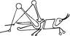

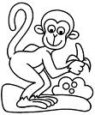



Nombre

Ejercicio 1 Realiza los ejercicios de caligrafía con distintos colores.

|  |  |  |  |  |  |  |  |  |  |  |  |  |  |  |  |  |  |  |  |  |  |  |  |  |  |  |  |  |  |
| --- | --- | --- | --- | --- | --- | --- | --- | --- | --- | --- | --- | --- | --- | --- | --- | --- | --- | --- | --- | --- | --- | --- | --- | --- | --- | --- | --- | --- | --- |
|  |  |  |  |  |  |  |  |  |  |  |  |  |  |  |  |  |  |  |  |  |  |  |  |  |  |  |  |  |  |
|  |  |  |  |  |  |  |  |  |  |  |  |  |  |  |  |  |  |  |  |  |  |  |  |  |  |  |  |  |  |
|  |  |  |  |  |  |  |  |  |  |  |  |  |  |  |  |  |  |  |  |  |  |  |  |  |  |  |  |  |  |
|  |  |  |  |  |  |  |  |  |  |  |  |  |  |  |  |  |  |  |  |  |  |  |  |  |  |  |  |  |  |
|  |  |  |  |  |  |  |  |  |  |  |  |  |  |  |  |  |  |  |  |  |  |  |  |  |  |  |  |  |  |
|  |  |  |  |  |  |  |  |  |  |  |  |  |  |  |  |  |  |  |  |  |  |  |  |  |  |  |  |  |  |

Ejercicio 2

|  |  |  |  |  |  |  |  |  |  |  |  |  |  |  |  |  |  |  |  |  |  |  |  |  |  |  |  |  |  |
| --- | --- | --- | --- | --- | --- | --- | --- | --- | --- | --- | --- | --- | --- | --- | --- | --- | --- | --- | --- | --- | --- | --- | --- | --- | --- | --- | --- | --- | --- |
|  |  |  |  |  |  |  |  |  |  |  |  |  |  |  |  |  |  |  |  |  |  |  |  |  |  |  |  |  |  |
|  |  |  |  |  |  |  |  |  |  |  |  |  |  |  |  |  |  |  |  |  |  |  |  |  |  |  |  |  |  |
|  |  |  |  |  |  |  |  |  |  |  |  |  |  |  |  |  |  |  |  |  |  |  |  |  |  |  |  |  |  |
|  |  |  |  |  |  |  |  |  |  |  |  |  |  |  |  |  |  |  |  |  |  |  |  |  |  |  |  |  |  |
|  |  |  |  |  |  |  |  |  |  |  |  |  |  |  |  |  |  |  |  |  |  |  |  |  |  |  |  |  |  |
|  |  |  |  |  |  |  |  |  |  |  |  |  |  |  |  |  |  |  |  |  |  |  |  |  |  |  |  |  |  |

Ejercicio 3

|  |  |  |  |  |  |  |  |  |  |  |  |  |  |  |  |  |  |  |  |  |  |  |  |  |  |  |  |  |  |
| --- | --- | --- | --- | --- | --- | --- | --- | --- | --- | --- | --- | --- | --- | --- | --- | --- | --- | --- | --- | --- | --- | --- | --- | --- | --- | --- | --- | --- | --- |
|  |  |  |  |  |  |  |  |  |  |  |  |  |  |  |  |  |  |  |  |  |  |  |  |  |  |  |  |  |  |
|  |  |  |  |  |  |  |  |  |  |  |  |  |  |  |  |  |  |  |  |  |  |  |  |  |  |  |  |  |  |
|  |  |  |  |  |  |  |  |  |  |  |  |  |  |  |  |  |  |  |  |  |  |  |  |  |  |  |  |  |  |
|  |  |  |  |  |  |  |  |  |  |  |  |  |  |  |  |  |  |  |  |  |  |  |  |  |  |  |  |  |  |
|  |  |  |  |  |  |  |  |  |  |  |  |  |  |  |  |  |  |  |  |  |  |  |  |  |  |  |  |  |  |
|  |  |  |  |  |  |  |  |  |  |  |  |  |  |  |  |  |  |  |  |  |  |  |  |  |  |  |  |  |  |

Ejercicio 4

|  |  |  |  |  |  |  |  |  |  |  |  |  |  |  |  |  |  |  |  |  |  |  |  |  |  |  |  |  |  |
| --- | --- | --- | --- | --- | --- | --- | --- | --- | --- | --- | --- | --- | --- | --- | --- | --- | --- | --- | --- | --- | --- | --- | --- | --- | --- | --- | --- | --- | --- |
|  |  |  |  |  |  |  |  |  |  |  |  |  |  |  |  |  |  |  |  |  |  |  |  |  |  |  |  |  |  |
|  |  |  |  |  |  |  |  |  |  |  |  |  |  |  |  |  |  |  |  |  |  |  |  |  |  |  |  |  |  |
|  |  |  |  |  |  |  |  |  |  |  |  |  |  |  |  |  |  |  |  |  |  |  |  |  |  |  |  |  |  |
|  |  |  |  |  |  |  |  |  |  |  |  |  |  |  |  |  |  |  |  |  |  |  |  |  |  |  |  |  |  |
|  |  |  |  |  |  |  |  |  |  |  |  |  |  |  |  |  |  |  |  |  |  |  |  |  |  |  |  |  |  |
|  |  |  |  |  |  |  |  |  |  |  |  |  |  |  |  |  |  |  |  |  |  |  |  |  |  |  |  |  |  |

Ejercicio 5

|  |  |  |  |  |  |  |  |  |  |  |  |  |  |  |  |  |  |  |  |  |  |  |  |  |  |  |  |  |  |
| --- | --- | --- | --- | --- | --- | --- | --- | --- | --- | --- | --- | --- | --- | --- | --- | --- | --- | --- | --- | --- | --- | --- | --- | --- | --- | --- | --- | --- | --- |
|  |  |  |  |  |  |  |  |  |  |  |  |  |  |  |  |  |  |  |  |  |  |  |  |  |  |  |  |  |  |
|  |  |  |  |  |  |  |  |  |  |  |  |  |  |  |  |  |  |  |  |  |  |  |  |  |  |  |  |  |  |
|  |  |  |  |  |  |  |  |  |  |  |  |  |  |  |  |  |  |  |  |  |  |  |  |  |  |  |  |  |  |
|  |  |  |  |  |  |  |  |  |  |  |  |  |  |  |  |  |  |  |  |  |  |  |  |  |  |  |  |  |  |
|  |  |  |  |  |  |  |  |  |  |  |  |  |  |  |  |  |  |  |  |  |  |  |  |  |  |  |  |  |  |
|  |  |  |  |  |  |  |  |  | Scan0005 |  |  |  |  |  |  |  |  |  |  |  |  |  |  |  |  |  |  |  |  |

Nombre

Ejercicio 1 Continúa con la plana ubicando el cuadro correctamente.

|  |  |  |  |  |  |  |  |  |  |  |  |  |  |  |  |  |  |  |  |  |  |  |  |  |  |  |  |  |  |
| --- | --- | --- | --- | --- | --- | --- | --- | --- | --- | --- | --- | --- | --- | --- | --- | --- | --- | --- | --- | --- | --- | --- | --- | --- | --- | --- | --- | --- | --- |
|  |  |  |  |  |  |  |  |  |  |  |  |  |  |  |  |  |  |  |  |  |  |  |  |  |  |  |  |  |  |
|  |  |  |  |  |  |  |  |  |  |  |  |  |  |  |  |  |  |  |  |  |  |  |  |  |  |  |  |  |  |
|  |  |  |  |  |  |  |  |  |  |  |  |  |  |  |  |  |  |  |  |  |  |  |  |  |  |  |  |  |  |
|  |  |  |  |  |  |  |  |  |  |  |  |  |  |  |  |  |  |  |  |  |  |  |  |  |  |  |  |  |  |
|  |  |  |  |  |  |  |  |  |  |  |  |  |  |  |  |  |  |  |  |  |  |  |  |  |  |  |  |  |  |
|  |  |  |  |  |  |  |  |  |  |  |  |  |  |  |  |  |  |  |  |  |  |  |  |  |  |  |  |  |  |

Ejercicio 2

|  |  |  |  |  |  |  |  |  |  |  |  |  |  |  |  |  |  |  |  |  |  |  |  |  |  |  |  |  |  |
| --- | --- | --- | --- | --- | --- | --- | --- | --- | --- | --- | --- | --- | --- | --- | --- | --- | --- | --- | --- | --- | --- | --- | --- | --- | --- | --- | --- | --- | --- |
|  |  |  |  |  |  |  |  |  |  |  |  |  |  |  |  |  |  |  |  |  |  |  |  |  |  |  |  |  |  |
|  |  |  |  |  |  |  |  |  |  |  |  |  |  |  |  |  |  |  |  |  |  |  |  |  |  |  |  |  |  |
|  |  |  |  |  |  |  |  |  |  |  |  |  |  |  |  |  |  |  |  |  |  |  |  |  |  |  |  |  |  |
|  |  |  |  |  |  |  |  |  |  |  |  |  |  |  |  |  |  |  |  |  |  |  |  |  |  |  |  |  |  |
|  |  |  |  |  |  |  |  |  |  |  |  |  |  |  |  |  |  |  |  |  |  |  |  |  |  |  |  |  |  |
|  |  |  |  |  |  |  |  |  |  |  |  |  |  |  |  |  |  |  |  |  |  |  |  |  |  |  |  |  |  |

Ejercicio 3

|  |  |  |  |  |  |  |  |  |  |  |  |  |  |  |  |  |  |  |  |  |  |  |  |  |  |  |  |  |  |
| --- | --- | --- | --- | --- | --- | --- | --- | --- | --- | --- | --- | --- | --- | --- | --- | --- | --- | --- | --- | --- | --- | --- | --- | --- | --- | --- | --- | --- | --- |
|  |  |  |  |  |  |  |  |  |  |  |  |  |  |  |  |  |  |  |  |  |  |  |  |  |  |  |  |  |  |
|  |  |  |  |  |  |  |  |  |  |  |  |  |  |  |  |  |  |  |  |  |  |  |  |  |  |  |  |  |  |
|  |  |  |  |  |  |  |  |  |  |  |  |  |  |  |  |  |  |  |  |  |  |  |  |  |  |  |  |  |  |
|  |  |  |  |  |  |  |  |  |  |  |  |  |  |  |  |  |  |  |  |  |  |  |  |  |  |  |  |  |  |
|  |  |  |  |  |  |  |  |  |  |  |  |  |  |  |  |  |  |  |  |  |  |  |  |  |  |  |  |  |  |
|  |  |  |  |  |  |  |  |  |  |  |  |  |  |  |  |  |  |  |  |  |  |  |  |  |  |  |  |  |  |

Ejercicio 4

|  |  |  |  |  |  |  |  |  |  |  |  |  |  |  |  |  |  |  |  |  |  |  |  |  |  |  |  |  |  |
| --- | --- | --- | --- | --- | --- | --- | --- | --- | --- | --- | --- | --- | --- | --- | --- | --- | --- | --- | --- | --- | --- | --- | --- | --- | --- | --- | --- | --- | --- |
|  |  |  |  |  |  |  |  |  |  |  |  |  |  |  |  |  |  |  |  |  |  |  |  |  |  |  |  |  |  |
|  |  |  |  |  |  |  |  |  |  |  |  |  |  |  |  |  |  |  |  |  |  |  |  |  |  |  |  |  |  |
|  |  |  |  |  |  |  |  |  |  |  |  |  |  |  |  |  |  |  |  |  |  |  |  |  |  |  |  |  |  |
|  |  |  |  |  |  |  |  |  |  |  |  |  |  |  |  |  |  |  |  |  |  |  |  |  |  |  |  |  |  |
|  |  |  |  |  |  |  |  |  |  |  |  |  |  |  |  |  |  |  |  |  |  |  |  |  |  |  |  |  |  |
|  |  |  |  |  |  |  |  |  |  |  |  |  |  |  |  |  |  |  |  |  |  |  |  |  |  |  |  |  |  |

Ejercicio 5

|  |  |  |  |  |  |  |  |  |  |  |  |  |  |  |  |  |  |  |  |  |  |  |  |  |  |  |  |  |  |
| --- | --- | --- | --- | --- | --- | --- | --- | --- | --- | --- | --- | --- | --- | --- | --- | --- | --- | --- | --- | --- | --- | --- | --- | --- | --- | --- | --- | --- | --- |
|  |  |  |  |  |  |  |  |  |  |  |  |  |  |  |  |  |  |  |  |  |  |  |  |  |  |  |  |  |  |
|  |  |  |  |  |  |  |  |  |  |  |  |  |  |  |  |  |  |  |  |  |  |  |  |  |  |  |  |  |  |
|  |  |  |  |  |  |  |  |  |  |  |  |  |  |  |  |  |  |  |  |  |  |  |  |  |  |  |  |  |  |
|  |  |  |  |  |  |  |  |  |  |  |  |  |  |  |  |  |  |  |  |  |  |  |  |  |  |  |  |  |  |
|  |  |  |  |  |  |  |  |  |  |  |  |  |  |  |  |  |  |  |  |  |  |  |  |  |  |  |  |  |  |
|  |  |  |  |  |  |  |  |  |  | Scan0005 |  |  |  |  |  |  |  |  |  |  |  |  |  |  |  |  |  |  |  |

Nombre

Observa los dibujos y únelos correctamente.

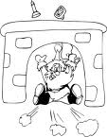 Chapulín 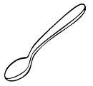

Chango

Ocho

Chimenea 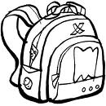

Mochila

 Cuchara 

Nombre

Representa las unidades y decenas.

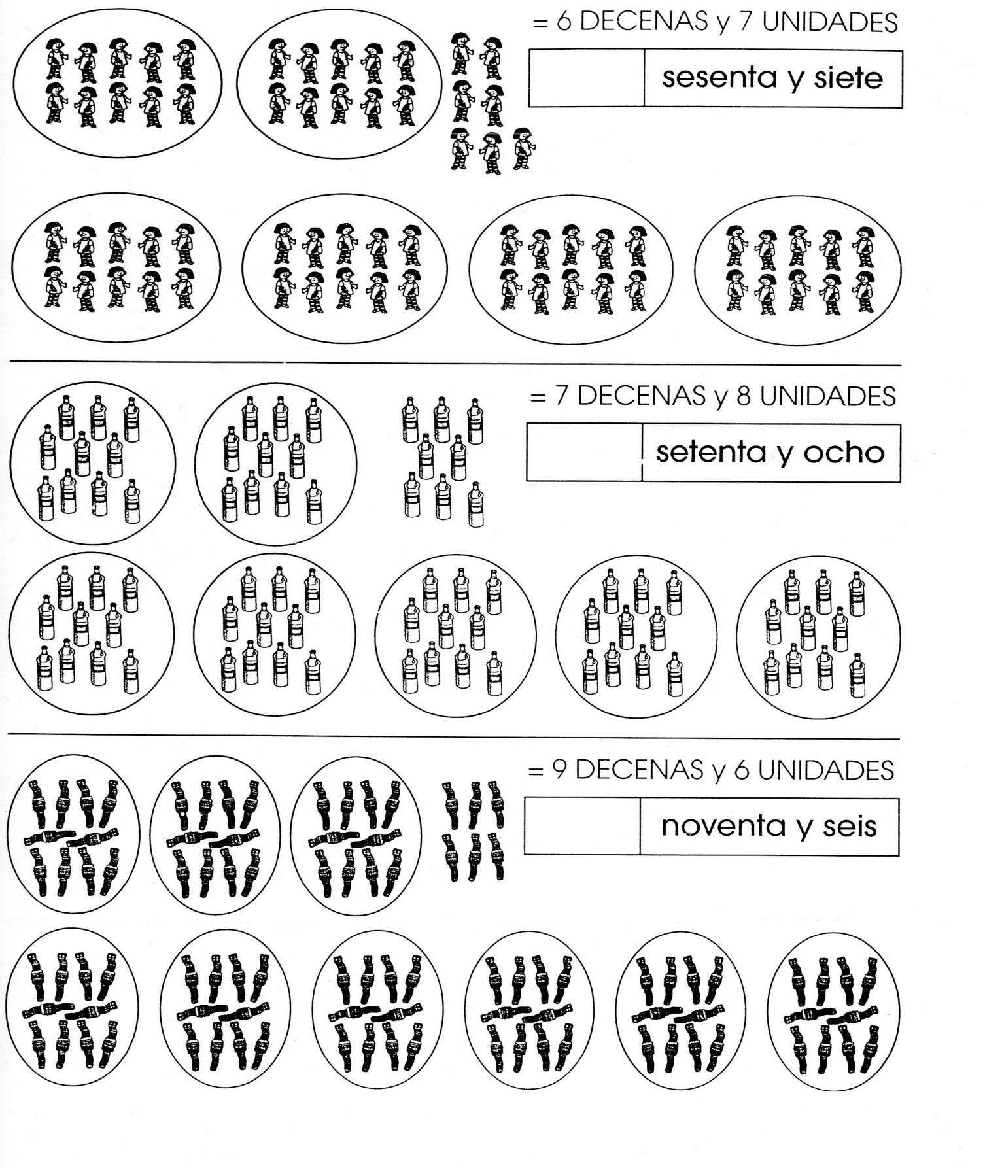

Nombre

Decora con material variado la letra H h.

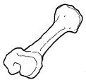





Nombre

Continúa con la plana ubicando el cuadro correctamente.

Ejercicio 1

|  |  |  |  |  |  |  |  |  |  |  |  |  |  |  |  |  |  |  |  |  |  |  |  |  |  |  |  |  |  |
| --- | --- | --- | --- | --- | --- | --- | --- | --- | --- | --- | --- | --- | --- | --- | --- | --- | --- | --- | --- | --- | --- | --- | --- | --- | --- | --- | --- | --- | --- |
|  |  |  |  |  |  |  |  |  |  |  |  |  |  |  |  |  |  |  |  |  |  |  |  |  |  |  |  |  |  |
|  |  |  |  |  |  |  |  |  |  |  |  |  |  |  |  |  |  |  |  |  |  |  |  |  |  |  |  |  |  |
|  |  |  |  |  |  |  |  |  |  |  |  |  |  |  |  |  |  |  |  |  |  |  |  |  |  |  |  |  |  |
|  |  |  |  |  |  |  |  |  |  |  |  |  |  |  |  |  |  |  |  |  |  |  |  |  |  |  |  |  |  |
|  |  |  |  |  |  |  |  |  |  |  |  |  |  |  |  |  |  |  |  |  |  |  |  |  |  |  |  |  |  |
|  |  |  |  |  |  |  |  |  |  |  |  |  |  |  |  |  |  |  |  |  |  |  |  |  |  |  |  |  |  |

Ejercicio 2

|  |  |  |  |  |  |  |  |  |  |  |  |  |  |  |  |  |  |  |  |  |  |  |  |  |  |  |  |  |  |
| --- | --- | --- | --- | --- | --- | --- | --- | --- | --- | --- | --- | --- | --- | --- | --- | --- | --- | --- | --- | --- | --- | --- | --- | --- | --- | --- | --- | --- | --- |
|  |  |  |  |  |  |  |  |  |  |  |  |  |  |  |  |  |  |  |  |  |  |  |  |  |  |  |  |  |  |
|  |  |  |  |  |  |  |  |  |  |  |  |  |  |  |  |  |  |  |  |  |  |  |  |  |  |  |  |  |  |
|  |  |  |  |  |  |  |  |  |  |  |  |  |  |  |  |  |  |  |  |  |  |  |  |  |  |  |  |  |  |
|  |  |  |  |  |  |  |  |  |  |  |  |  |  |  |  |  |  |  |  |  |  |  |  |  |  |  |  |  |  |
|  |  |  |  |  |  |  |  |  |  |  |  |  |  |  |  |  |  |  |  |  |  |  |  |  |  |  |  |  |  |
|  |  |  |  |  |  |  |  |  |  |  |  |  |  |  |  |  |  |  |  |  |  |  |  |  |  |  |  |  |  |

Ejercicio 3

|  |  |  |  |  |  |  |  |  |  |  |  |  |  |  |  |  |  |  |  |  |  |  |  |  |  |  |  |  |  |
| --- | --- | --- | --- | --- | --- | --- | --- | --- | --- | --- | --- | --- | --- | --- | --- | --- | --- | --- | --- | --- | --- | --- | --- | --- | --- | --- | --- | --- | --- |
|  |  |  |  |  |  |  |  |  |  |  |  |  |  |  |  |  |  |  |  |  |  |  |  |  |  |  |  |  |  |
|  |  |  |  |  |  |  |  |  |  |  |  |  |  |  |  |  |  |  |  |  |  |  |  |  |  |  |  |  |  |
|  |  |  |  |  |  |  |  |  |  |  |  |  |  |  |  |  |  |  |  |  |  |  |  |  |  |  |  |  |  |
|  |  |  |  |  |  |  |  |  |  |  |  |  |  |  |  |  |  |  |  |  |  |  |  |  |  |  |  |  |  |
|  |  |  |  |  |  |  |  |  |  |  |  |  |  |  |  |  |  |  |  |  |  |  |  |  |  |  |  |  |  |
|  |  |  |  |  |  |  |  |  |  |  |  |  |  |  |  |  |  |  |  |  |  |  |  |  |  |  |  |  |  |

Ejercicio 4

|  |  |  |  |  |  |  |  |  |  |  |  |  |  |  |  |  |  |  |  |  |  |  |  |  |  |  |  |  |  |
| --- | --- | --- | --- | --- | --- | --- | --- | --- | --- | --- | --- | --- | --- | --- | --- | --- | --- | --- | --- | --- | --- | --- | --- | --- | --- | --- | --- | --- | --- |
|  |  |  |  |  |  |  |  |  |  |  |  |  |  |  |  |  |  |  |  |  |  |  |  |  |  |  |  |  |  |
|  |  |  |  |  |  |  |  |  |  |  |  |  |  |  |  |  |  |  |  |  |  |  |  |  |  |  |  |  |  |
|  |  |  |  |  |  |  |  |  |  |  |  |  |  |  |  |  |  |  |  |  |  |  |  |  |  |  |  |  |  |
|  |  |  |  |  |  |  |  |  |  |  |  |  |  |  |  |  |  |  |  |  |  |  |  |  |  |  |  |  |  |
|  |  |  |  |  |  |  |  |  |  |  |  |  |  |  |  |  |  |  |  |  |  |  |  |  |  |  |  |  |  |
|  |  |  |  |  |  |  |  |  |  |  |  |  |  |  |  |  |  |  |  |  |  |  |  |  |  |  |  |  |  |

Ejercicio 5

|  |  |  |  |  |  |  |  |  |  |  |  |  |  |  |  |  |  |  |  |  |  |  |  |  |  |  |  |  |  |
| --- | --- | --- | --- | --- | --- | --- | --- | --- | --- | --- | --- | --- | --- | --- | --- | --- | --- | --- | --- | --- | --- | --- | --- | --- | --- | --- | --- | --- | --- |
|  |  |  |  |  |  |  |  |  |  |  |  |  |  |  |  |  |  |  |  |  |  |  |  |  |  |  |  |  |  |
|  |  |  |  |  |  |  |  |  |  |  |  |  |  |  |  |  |  |  |  |  |  |  |  |  |  |  |  |  |  |
|  |  |  |  |  |  |  |  |  |  |  |  |  |  |  |  |  |  |  |  |  |  |  |  |  |  |  |  |  |  |
|  |  |  |  |  |  |  |  |  |  |  |  |  |  |  |  |  |  |  |  |  |  |  |  |  |  |  |  |  |  |
|  |  |  |  |  |  |  |  |  |  |  |  |  |  |  |  |  |  |  |  |  |  |  |  |  |  |  |  |  |  |
|  |  |  |  |  |  |  |  |  | Scan0005 |  |  |  |  |  |  |  |  |  |  |  |  |  |  |  |  |  |  |  |  |

Nombre

Continúa con la plana correctamente ubicando el cuadro.

Ejercicio 1

|  |  |  |  |  |  |  |  |  |  |  |  |  |  |  |  |  |  |  |  |  |  |  |  |  |  |  |  |  |  |
| --- | --- | --- | --- | --- | --- | --- | --- | --- | --- | --- | --- | --- | --- | --- | --- | --- | --- | --- | --- | --- | --- | --- | --- | --- | --- | --- | --- | --- | --- |
|  |  |  |  |  |  |  |  |  |  |  |  |  |  |  |  |  |  |  |  |  |  |  |  |  |  |  |  |  |  |
|  |  |  |  |  |  |  |  |  |  |  |  |  |  |  |  |  |  |  |  |  |  |  |  |  |  |  |  |  |  |
|  |  |  |  |  |  |  |  |  |  |  |  |  |  |  |  |  |  |  |  |  |  |  |  |  |  |  |  |  |  |
|  |  |  |  |  |  |  |  |  |  |  |  |  |  |  |  |  |  |  |  |  |  |  |  |  |  |  |  |  |  |
|  |  |  |  |  |  |  |  |  |  |  |  |  |  |  |  |  |  |  |  |  |  |  |  |  |  |  |  |  |  |
|  |  |  |  |  |  |  |  |  |  |  |  |  |  |  |  |  |  |  |  |  |  |  |  |  |  |  |  |  |  |

Ejercicio 2

|  |  |  |  |  |  |  |  |  |  |  |  |  |  |  |  |  |  |  |  |  |  |  |  |  |  |  |  |  |  |
| --- | --- | --- | --- | --- | --- | --- | --- | --- | --- | --- | --- | --- | --- | --- | --- | --- | --- | --- | --- | --- | --- | --- | --- | --- | --- | --- | --- | --- | --- |
|  |  |  |  |  |  |  |  |  |  |  |  |  |  |  |  |  |  |  |  |  |  |  |  |  |  |  |  |  |  |
|  |  |  |  |  |  |  |  |  |  |  |  |  |  |  |  |  |  |  |  |  |  |  |  |  |  |  |  |  |  |
|  |  |  |  |  |  |  |  |  |  |  |  |  |  |  |  |  |  |  |  |  |  |  |  |  |  |  |  |  |  |
|  |  |  |  |  |  |  |  |  |  |  |  |  |  |  |  |  |  |  |  |  |  |  |  |  |  |  |  |  |  |
|  |  |  |  |  |  |  |  |  |  |  |  |  |  |  |  |  |  |  |  |  |  |  |  |  |  |  |  |  |  |
|  |  |  |  |  |  |  |  |  |  |  |  |  |  |  |  |  |  |  |  |  |  |  |  |  |  |  |  |  |  |

Ejercicio 3

|  |  |  |  |  |  |  |  |  |  |  |  |  |  |  |  |  |  |  |  |  |  |  |  |  |  |  |  |  |  |
| --- | --- | --- | --- | --- | --- | --- | --- | --- | --- | --- | --- | --- | --- | --- | --- | --- | --- | --- | --- | --- | --- | --- | --- | --- | --- | --- | --- | --- | --- |
|  |  |  |  |  |  |  |  |  |  |  |  |  |  |  |  |  |  |  |  |  |  |  |  |  |  |  |  |  |  |
|  |  |  |  |  |  |  |  |  |  |  |  |  |  |  |  |  |  |  |  |  |  |  |  |  |  |  |  |  |  |
|  |  |  |  |  |  |  |  |  |  |  |  |  |  |  |  |  |  |  |  |  |  |  |  |  |  |  |  |  |  |
|  |  |  |  |  |  |  |  |  |  |  |  |  |  |  |  |  |  |  |  |  |  |  |  |  |  |  |  |  |  |
|  |  |  |  |  |  |  |  |  |  |  |  |  |  |  |  |  |  |  |  |  |  |  |  |  |  |  |  |  |  |
|  |  |  |  |  |  |  |  |  |  |  |  |  |  |  |  |  |  |  |  |  |  |  |  |  |  |  |  |  |  |

Ejercicio 4

|  |  |  |  |  |  |  |  |  |  |  |  |  |  |  |  |  |  |  |  |  |  |  |  |  |  |  |  |  |  |
| --- | --- | --- | --- | --- | --- | --- | --- | --- | --- | --- | --- | --- | --- | --- | --- | --- | --- | --- | --- | --- | --- | --- | --- | --- | --- | --- | --- | --- | --- |
|  |  |  |  |  |  |  |  |  |  |  |  |  |  |  |  |  |  |  |  |  |  |  |  |  |  |  |  |  |  |
|  |  |  |  |  |  |  |  |  |  |  |  |  |  |  |  |  |  |  |  |  |  |  |  |  |  |  |  |  |  |
|  |  |  |  |  |  |  |  |  |  |  |  |  |  |  |  |  |  |  |  |  |  |  |  |  |  |  |  |  |  |
|  |  |  |  |  |  |  |  |  |  |  |  |  |  |  |  |  |  |  |  |  |  |  |  |  |  |  |  |  |  |
|  |  |  |  |  |  |  |  |  |  |  |  |  |  |  |  |  |  |  |  |  |  |  |  |  |  |  |  |  |  |
|  |  |  |  |  |  |  |  |  |  |  |  |  |  |  |  |  |  |  |  |  |  |  |  |  |  |  |  |  |  |

Ejercicio 5

|  |  |  |  |  |  |  |  |  |  |  |  |  |  |  |  |  |  |  |  |  |  |  |  |  |  |  |  |  |  |
| --- | --- | --- | --- | --- | --- | --- | --- | --- | --- | --- | --- | --- | --- | --- | --- | --- | --- | --- | --- | --- | --- | --- | --- | --- | --- | --- | --- | --- | --- |
|  |  |  |  |  |  |  |  |  |  |  |  |  |  |  |  |  |  |  |  |  |  |  |  |  |  |  |  |  |  |
|  |  |  |  |  |  |  |  |  |  |  |  |  |  |  |  |  |  |  |  |  |  |  |  |  |  |  |  |  |  |
|  |  |  |  |  |  |  |  |  |  |  |  |  |  |  |  |  |  |  |  |  |  |  |  |  |  |  |  |  |  |
|  |  |  |  |  |  |  |  |  |  |  |  |  |  |  |  |  |  |  |  |  |  |  |  |  |  |  |  |  |  |
|  |  |  |  |  |  |  |  |  |  |  |  |  |  |  |  |  |  |  |  |  |  |  |  |  |  |  |  |  |  |
|  |  |  |  |  |  |  |  |  |  |  | Scan0005 |  |  |  |  |  |  |  |  |  |  |  |  |  |  |  |  |  |  |

Nombre

Resuelve los siguientes problemas.

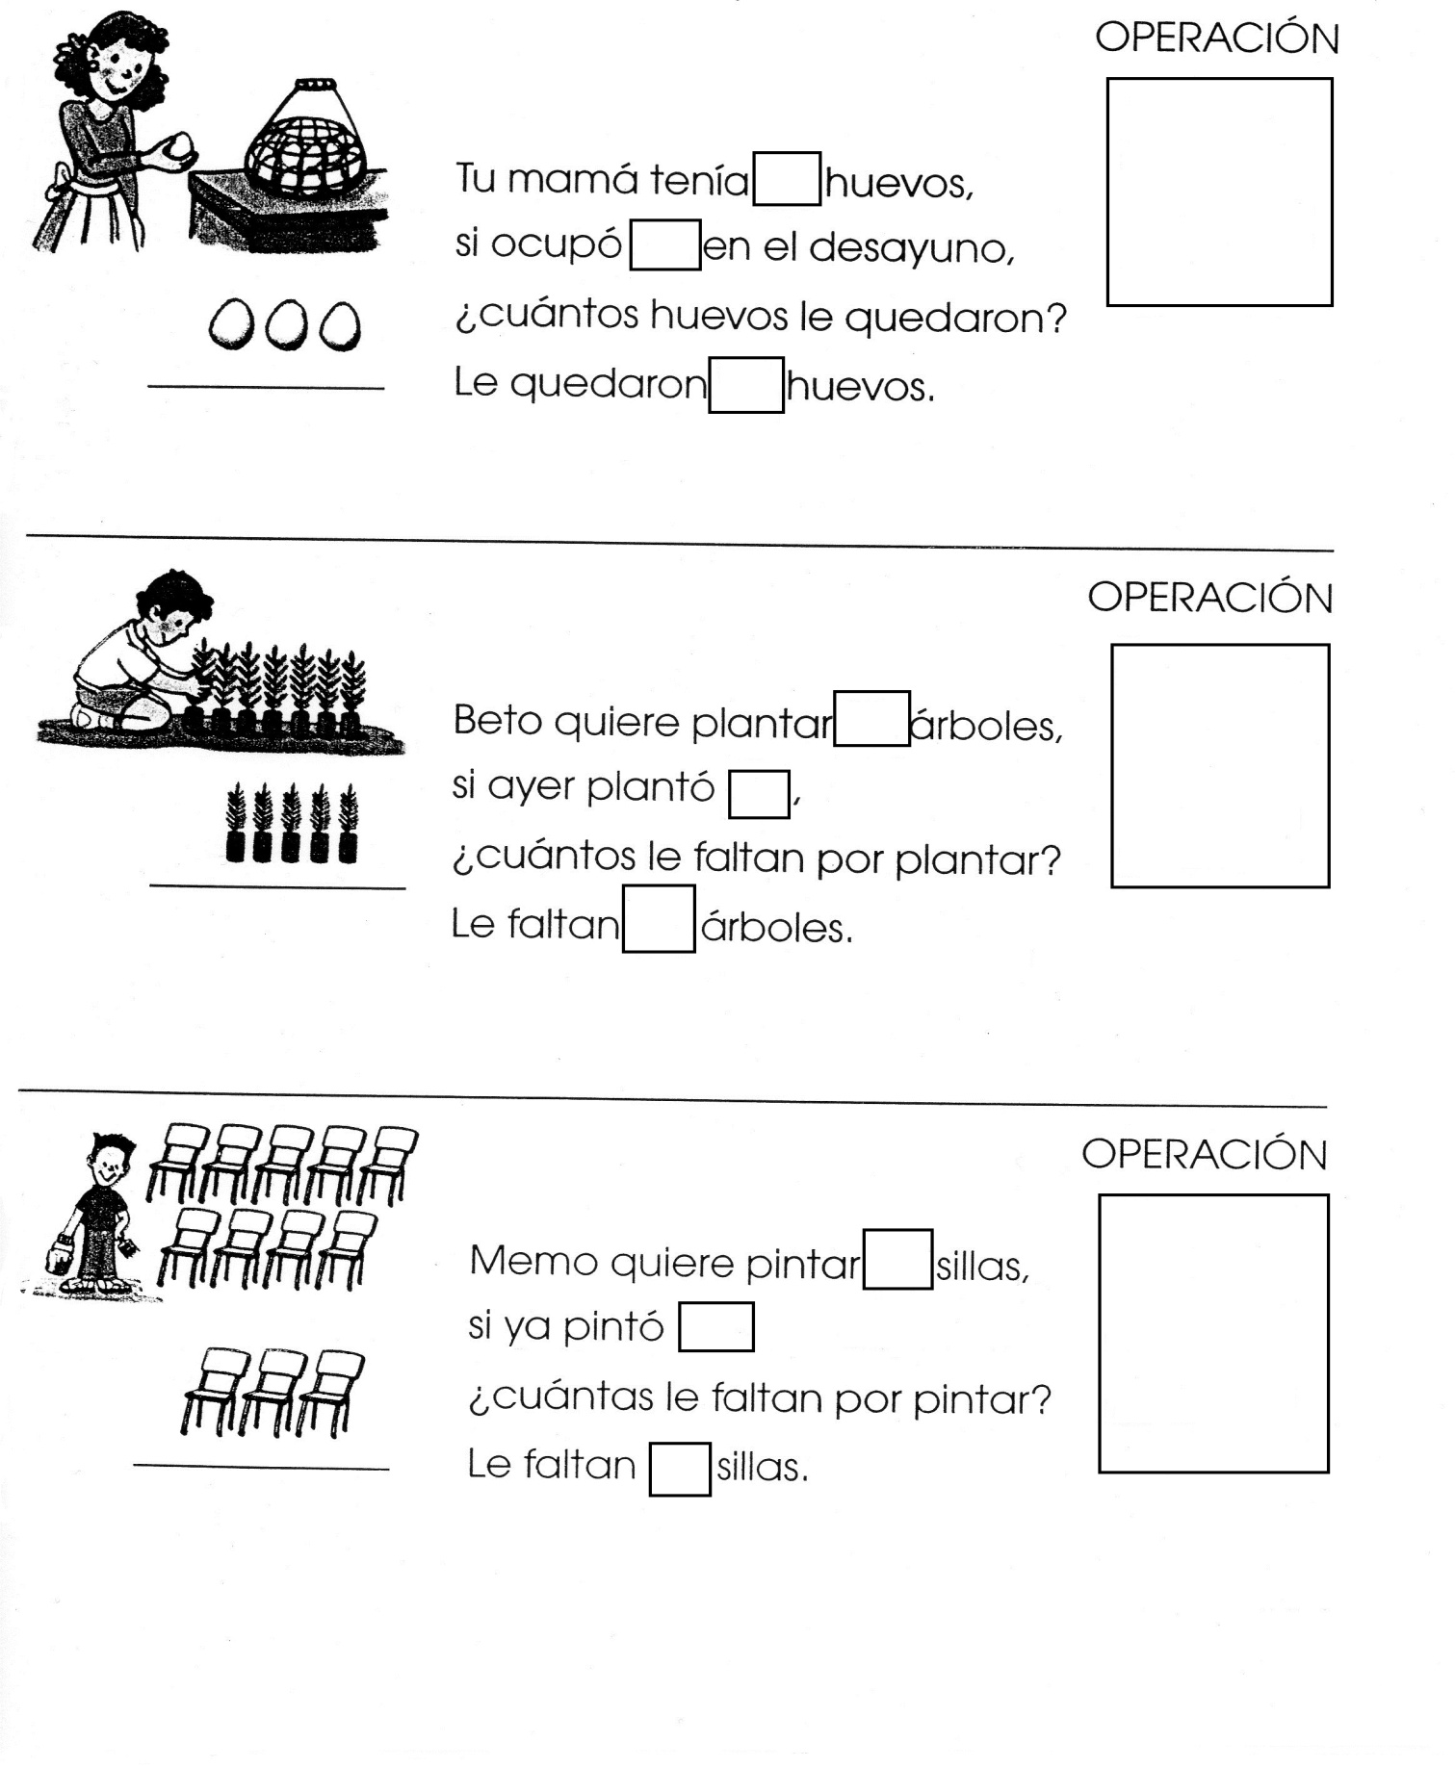

Nombre

Escucha la lectura de “La h” de tu libro cuenta cuentos y haci como la lectura pega palabras con h.



Nombre

Realiza las siguientes rectas numéricas.

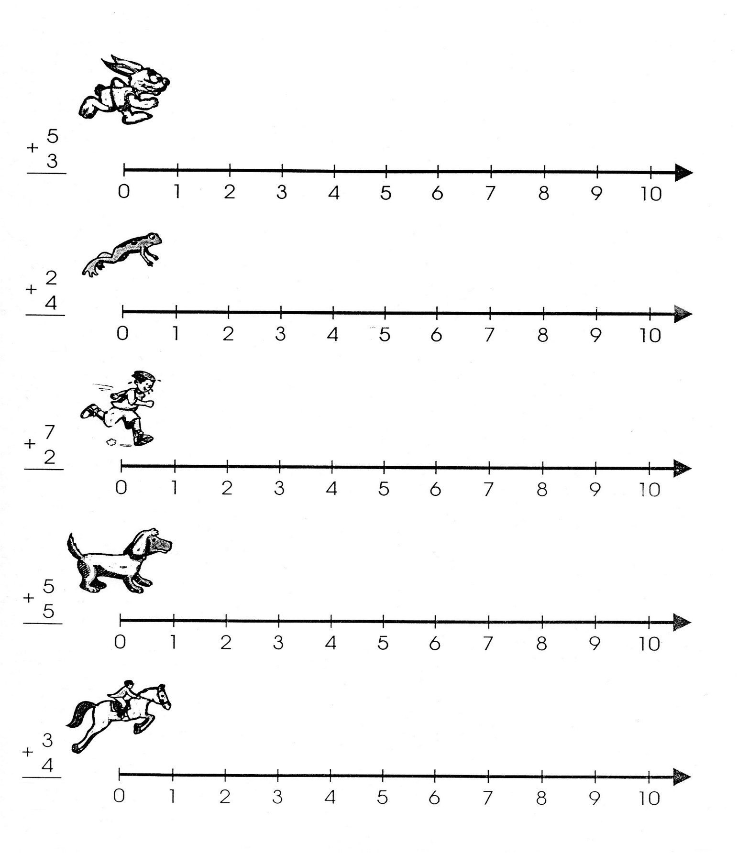

Nombre

Decora con material variado el siguiente dibujo de la primavera.

Primavera

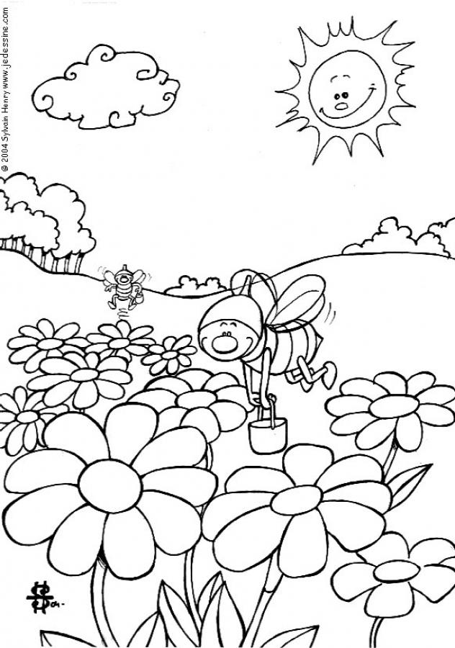

Nombre

Decora con material variado la letra Y y.

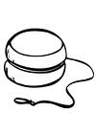



Nombre

Escucha la lectura de “El cocuyo Cayetano” de tu libro cuenta cuentos e ilustra con recortes o dibujos lo que más te gusto.



Nombre

Ejercicio 1 Continúa con la plana ubicando correctamente el cuadro.

|  |  |  |  |  |  |  |  |  |  |  |  |  |  |  |  |  |  |  |  |  |  |  |  |  |  |  |  |  |  |
| --- | --- | --- | --- | --- | --- | --- | --- | --- | --- | --- | --- | --- | --- | --- | --- | --- | --- | --- | --- | --- | --- | --- | --- | --- | --- | --- | --- | --- | --- |
|  |  |  |  |  |  |  |  |  |  |  |  |  |  |  |  |  |  |  |  |  |  |  |  |  |  |  |  |  |  |
|  |  |  |  |  |  |  |  |  |  |  |  |  |  |  |  |  |  |  |  |  |  |  |  |  |  |  |  |  |  |
|  |  |  |  |  |  |  |  |  |  |  |  |  |  |  |  |  |  |  |  |  |  |  |  |  |  |  |  |  |  |
|  |  |  |  |  |  |  |  |  |  |  |  |  |  |  |  |  |  |  |  |  |  |  |  |  |  |  |  |  |  |
|  |  |  |  |  |  |  |  |  |  |  |  |  |  |  |  |  |  |  |  |  |  |  |  |  |  |  |  |  |  |
|  |  |  |  |  |  |  |  |  |  |  |  |  |  |  |  |  |  |  |  |  |  |  |  |  |  |  |  |  |  |

Ejercicio 2

|  |  |  |  |  |  |  |  |  |  |  |  |  |  |  |  |  |  |  |  |  |  |  |  |  |  |  |  |  |  |
| --- | --- | --- | --- | --- | --- | --- | --- | --- | --- | --- | --- | --- | --- | --- | --- | --- | --- | --- | --- | --- | --- | --- | --- | --- | --- | --- | --- | --- | --- |
|  |  |  |  |  |  |  |  |  |  |  |  |  |  |  |  |  |  |  |  |  |  |  |  |  |  |  |  |  |  |
|  |  |  |  |  |  |  |  |  |  |  |  |  |  |  |  |  |  |  |  |  |  |  |  |  |  |  |  |  |  |
|  |  |  |  |  |  |  |  |  |  |  |  |  |  |  |  |  |  |  |  |  |  |  |  |  |  |  |  |  |  |
|  |  |  |  |  |  |  |  |  |  |  |  |  |  |  |  |  |  |  |  |  |  |  |  |  |  |  |  |  |  |
|  |  |  |  |  |  |  |  |  |  |  |  |  |  |  |  |  |  |  |  |  |  |  |  |  |  |  |  |  |  |
|  |  |  |  |  |  |  |  |  |  |  |  |  |  |  |  |  |  |  |  |  |  |  |  |  |  |  |  |  |  |

Ejercicio 3

|  |  |  |  |  |  |  |  |  |  |  |  |  |  |  |  |  |  |  |  |  |  |  |  |  |  |  |  |  |  |
| --- | --- | --- | --- | --- | --- | --- | --- | --- | --- | --- | --- | --- | --- | --- | --- | --- | --- | --- | --- | --- | --- | --- | --- | --- | --- | --- | --- | --- | --- |
|  |  |  |  |  |  |  |  |  |  |  |  |  |  |  |  |  |  |  |  |  |  |  |  |  |  |  |  |  |  |
|  |  |  |  |  |  |  |  |  |  |  |  |  |  |  |  |  |  |  |  |  |  |  |  |  |  |  |  |  |  |
|  |  |  |  |  |  |  |  |  |  |  |  |  |  |  |  |  |  |  |  |  |  |  |  |  |  |  |  |  |  |
|  |  |  |  |  |  |  |  |  |  |  |  |  |  |  |  |  |  |  |  |  |  |  |  |  |  |  |  |  |  |
|  |  |  |  |  |  |  |  |  |  |  |  |  |  |  |  |  |  |  |  |  |  |  |  |  |  |  |  |  |  |
|  |  |  |  |  |  |  |  |  |  |  |  |  |  |  |  |  |  |  |  |  |  |  |  |  |  |  |  |  |  |

Ejercicio 4

|  |  |  |  |  |  |  |  |  |  |  |  |  |  |  |  |  |  |  |  |  |  |  |  |  |  |  |  |  |  |
| --- | --- | --- | --- | --- | --- | --- | --- | --- | --- | --- | --- | --- | --- | --- | --- | --- | --- | --- | --- | --- | --- | --- | --- | --- | --- | --- | --- | --- | --- |
|  |  |  |  |  |  |  |  |  |  |  |  |  |  |  |  |  |  |  |  |  |  |  |  |  |  |  |  |  |  |
|  |  |  |  |  |  |  |  |  |  |  |  |  |  |  |  |  |  |  |  |  |  |  |  |  |  |  |  |  |  |
|  |  |  |  |  |  |  |  |  |  |  |  |  |  |  |  |  |  |  |  |  |  |  |  |  |  |  |  |  |  |
|  |  |  |  |  |  |  |  |  |  |  |  |  |  |  |  |  |  |  |  |  |  |  |  |  |  |  |  |  |  |
|  |  |  |  |  |  |  |  |  |  |  |  |  |  |  |  |  |  |  |  |  |  |  |  |  |  |  |  |  |  |
|  |  |  |  |  |  |  |  |  |  |  |  |  |  |  |  |  |  |  |  |  |  |  |  |  |  |  |  |  |  |

Ejercicio 5

|  |  |  |  |  |  |  |  |  |  |  |  |  |  |  |  |  |  |  |  |  |  |  |  |  |  |  |  |  |  |
| --- | --- | --- | --- | --- | --- | --- | --- | --- | --- | --- | --- | --- | --- | --- | --- | --- | --- | --- | --- | --- | --- | --- | --- | --- | --- | --- | --- | --- | --- |
|  |  |  |  |  |  |  |  |  |  |  |  |  |  |  |  |  |  |  |  |  |  |  |  |  |  |  |  |  |  |
|  |  |  |  |  |  |  |  |  |  |  |  |  |  |  |  |  |  |  |  |  |  |  |  |  |  |  |  |  |  |
|  |  |  |  |  |  |  |  |  |  |  |  |  |  |  |  |  |  |  |  |  |  |  |  |  |  |  |  |  |  |
|  |  |  |  |  |  |  |  |  |  |  |  |  |  |  |  |  |  |  |  |  |  |  |  |  |  |  |  |  |  |
|  |  |  |  |  |  |  |  |  |  |  |  |  |  |  |  |  |  |  |  |  |  |  |  |  |  |  |  |  |  |
|  |  |  |  |  |  |  |  |  | Scan0005 |  |  |  |  |  |  |  |  |  |  |  |  |  |  |  |  |  |  |  |  |

Nombre

Ejercicio 1 Continúa con la plana ubicando correctamente el cuadro.

|  |  |  |  |  |  |  |  |  |  |  |  |  |  |  |  |  |  |  |  |  |  |  |  |  |  |  |  |  |  |
| --- | --- | --- | --- | --- | --- | --- | --- | --- | --- | --- | --- | --- | --- | --- | --- | --- | --- | --- | --- | --- | --- | --- | --- | --- | --- | --- | --- | --- | --- |
|  |  |  |  |  |  |  |  |  |  |  |  |  |  |  |  |  |  |  |  |  |  |  |  |  |  |  |  |  |  |
|  |  |  |  |  |  |  |  |  |  |  |  |  |  |  |  |  |  |  |  |  |  |  |  |  |  |  |  |  |  |
|  |  |  |  |  |  |  |  |  |  |  |  |  |  |  |  |  |  |  |  |  |  |  |  |  |  |  |  |  |  |
|  |  |  |  |  |  |  |  |  |  |  |  |  |  |  |  |  |  |  |  |  |  |  |  |  |  |  |  |  |  |
|  |  |  |  |  |  |  |  |  |  |  |  |  |  |  |  |  |  |  |  |  |  |  |  |  |  |  |  |  |  |
|  |  |  |  |  |  |  |  |  |  |  |  |  |  |  |  |  |  |  |  |  |  |  |  |  |  |  |  |  |  |

Ejercicio 2

|  |  |  |  |  |  |  |  |  |  |  |  |  |  |  |  |  |  |  |  |  |  |  |  |  |  |  |  |  |  |
| --- | --- | --- | --- | --- | --- | --- | --- | --- | --- | --- | --- | --- | --- | --- | --- | --- | --- | --- | --- | --- | --- | --- | --- | --- | --- | --- | --- | --- | --- |
|  |  |  |  |  |  |  |  |  |  |  |  |  |  |  |  |  |  |  |  |  |  |  |  |  |  |  |  |  |  |
|  |  |  |  |  |  |  |  |  |  |  |  |  |  |  |  |  |  |  |  |  |  |  |  |  |  |  |  |  |  |
|  |  |  |  |  |  |  |  |  |  |  |  |  |  |  |  |  |  |  |  |  |  |  |  |  |  |  |  |  |  |
|  |  |  |  |  |  |  |  |  |  |  |  |  |  |  |  |  |  |  |  |  |  |  |  |  |  |  |  |  |  |
|  |  |  |  |  |  |  |  |  |  |  |  |  |  |  |  |  |  |  |  |  |  |  |  |  |  |  |  |  |  |
|  |  |  |  |  |  |  |  |  |  |  |  |  |  |  |  |  |  |  |  |  |  |  |  |  |  |  |  |  |  |

Ejercicio 3

|  |  |  |  |  |  |  |  |  |  |  |  |  |  |  |  |  |  |  |  |  |  |  |  |  |  |  |  |  |  |
| --- | --- | --- | --- | --- | --- | --- | --- | --- | --- | --- | --- | --- | --- | --- | --- | --- | --- | --- | --- | --- | --- | --- | --- | --- | --- | --- | --- | --- | --- |
|  |  |  |  |  |  |  |  |  |  |  |  |  |  |  |  |  |  |  |  |  |  |  |  |  |  |  |  |  |  |
|  |  |  |  |  |  |  |  |  |  |  |  |  |  |  |  |  |  |  |  |  |  |  |  |  |  |  |  |  |  |
|  |  |  |  |  |  |  |  |  |  |  |  |  |  |  |  |  |  |  |  |  |  |  |  |  |  |  |  |  |  |
|  |  |  |  |  |  |  |  |  |  |  |  |  |  |  |  |  |  |  |  |  |  |  |  |  |  |  |  |  |  |
|  |  |  |  |  |  |  |  |  |  |  |  |  |  |  |  |  |  |  |  |  |  |  |  |  |  |  |  |  |  |
|  |  |  |  |  |  |  |  |  |  |  |  |  |  |  |  |  |  |  |  |  |  |  |  |  |  |  |  |  |  |

Ejercicio 4

|  |  |  |  |  |  |  |  |  |  |  |  |  |  |  |  |  |  |  |  |  |  |  |  |  |  |  |  |  |  |
| --- | --- | --- | --- | --- | --- | --- | --- | --- | --- | --- | --- | --- | --- | --- | --- | --- | --- | --- | --- | --- | --- | --- | --- | --- | --- | --- | --- | --- | --- |
|  |  |  |  |  |  |  |  |  |  |  |  |  |  |  |  |  |  |  |  |  |  |  |  |  |  |  |  |  |  |
|  |  |  |  |  |  |  |  |  |  |  |  |  |  |  |  |  |  |  |  |  |  |  |  |  |  |  |  |  |  |
|  |  |  |  |  |  |  |  |  |  |  |  |  |  |  |  |  |  |  |  |  |  |  |  |  |  |  |  |  |  |
|  |  |  |  |  |  |  |  |  |  |  |  |  |  |  |  |  |  |  |  |  |  |  |  |  |  |  |  |  |  |
|  |  |  |  |  |  |  |  |  |  |  |  |  |  |  |  |  |  |  |  |  |  |  |  |  |  |  |  |  |  |
|  |  |  |  |  |  |  |  |  |  |  |  |  |  |  |  |  |  |  |  |  |  |  |  |  |  |  |  |  |  |

Ejercicio 5

|  |  |  |  |  |  |  |  |  |  |  |  |  |  |  |  |  |  |  |  |  |  |  |  |  |  |  |  |  |  |
| --- | --- | --- | --- | --- | --- | --- | --- | --- | --- | --- | --- | --- | --- | --- | --- | --- | --- | --- | --- | --- | --- | --- | --- | --- | --- | --- | --- | --- | --- |
|  |  |  |  |  |  |  |  |  |  |  |  |  |  |  |  |  |  |  |  |  |  |  |  |  |  |  |  |  |  |
|  |  |  |  |  |  |  |  |  |  |  |  |  |  |  |  |  |  |  |  |  |  |  |  |  |  |  |  |  |  |
|  |  |  |  |  |  |  |  |  |  |  |  |  |  |  |  |  |  |  |  |  |  |  |  |  |  |  |  |  |  |
|  |  |  |  |  |  |  |  |  |  |  |  |  |  |  |  |  |  |  |  |  |  |  |  |  |  |  |  |  |  |
|  |  |  |  |  |  |  |  |  |  |  |  |  |  |  |  |  |  |  |  |  |  |  |  |  |  |  |  |  |  |
|  |  |  |  |  |  |  |  |  | Scan0005 |  |  |  |  |  |  |  |  |  |  |  |  |  |  |  |  |  |  |  |  |

Nombre

De las siguientes palabras encierra todas las silabas que encuentres.

Ya Ye Yi Yo Yu

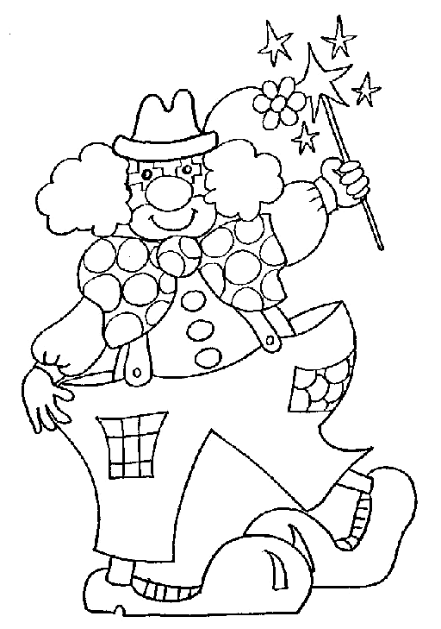

El payaso juega con un yoyo

Yegua yate rey

Yoyo ayer buey

Yema guayaba rayo

Nombre

Realiza los ejercicios de recta numérica.

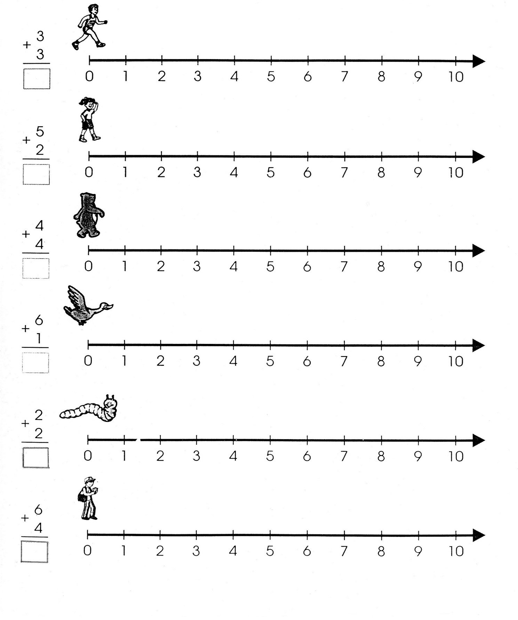

Nombre

Pega dentro de los círculos las unidades que se te piden.

10 10

10

10

10

10

Cuantas decenas hay en total:

 10

Nombre

Ejercicio 1 Realiza la escritura de la familia del 70 ubicando el cuadro.

|  |  |  |  |  |  |  |  |  |  |  |  |  |  |  |  |  |  |  |  |  |  |  |  |  |  |  |  |  |  |
| --- | --- | --- | --- | --- | --- | --- | --- | --- | --- | --- | --- | --- | --- | --- | --- | --- | --- | --- | --- | --- | --- | --- | --- | --- | --- | --- | --- | --- | --- |
|  |  |  |  |  |  |  |  |  |  |  |  |  |  |  |  |  |  |  |  |  |  |  |  |  |  |  |  |  |  |
|  |  |  |  |  |  |  |  |  |  |  |  |  |  |  |  |  |  |  |  |  |  |  |  |  |  |  |  |  |  |
|  |  |  |  |  |  |  |  |  |  |  |  |  |  |  |  |  |  |  |  |  |  |  |  |  |  |  |  |  |  |
|  |  |  |  |  |  |  |  |  |  |  |  |  |  |  |  |  |  |  |  |  |  |  |  |  |  |  |  |  |  |
|  |  |  |  |  |  |  |  |  |  |  |  |  |  |  |  |  |  |  |  |  |  |  |  |  |  |  |  |  |  |
|  |  |  |  |  |  |  |  |  |  |  |  |  |  |  |  |  |  |  |  |  |  |  |  |  |  |  |  |  |  |

Ejercicio 2

|  |  |  |  |  |  |  |  |  |  |  |  |  |  |  |  |  |  |  |  |  |  |  |  |  |  |  |  |  |  |
| --- | --- | --- | --- | --- | --- | --- | --- | --- | --- | --- | --- | --- | --- | --- | --- | --- | --- | --- | --- | --- | --- | --- | --- | --- | --- | --- | --- | --- | --- |
|  |  |  |  |  |  |  |  |  |  |  |  |  |  |  |  |  |  |  |  |  |  |  |  |  |  |  |  |  |  |
|  |  |  |  |  |  |  |  |  |  |  |  |  |  |  |  |  |  |  |  |  |  |  |  |  |  |  |  |  |  |
|  |  |  |  |  |  |  |  |  |  |  |  |  |  |  |  |  |  |  |  |  |  |  |  |  |  |  |  |  |  |
|  |  |  |  |  |  |  |  |  |  |  |  |  |  |  |  |  |  |  |  |  |  |  |  |  |  |  |  |  |  |
|  |  |  |  |  |  |  |  |  |  |  |  |  |  |  |  |  |  |  |  |  |  |  |  |  |  |  |  |  |  |
|  |  |  |  |  |  |  |  |  |  |  |  |  |  |  |  |  |  |  |  |  |  |  |  |  |  |  |  |  |  |

Ejercicio 3

|  |  |  |  |  |  |  |  |  |  |  |  |  |  |  |  |  |  |  |  |  |  |  |  |  |  |  |  |  |  |
| --- | --- | --- | --- | --- | --- | --- | --- | --- | --- | --- | --- | --- | --- | --- | --- | --- | --- | --- | --- | --- | --- | --- | --- | --- | --- | --- | --- | --- | --- |
|  |  |  |  |  |  |  |  |  |  |  |  |  |  |  |  |  |  |  |  |  |  |  |  |  |  |  |  |  |  |
|  |  |  |  |  |  |  |  |  |  |  |  |  |  |  |  |  |  |  |  |  |  |  |  |  |  |  |  |  |  |
|  |  |  |  |  |  |  |  |  |  |  |  |  |  |  |  |  |  |  |  |  |  |  |  |  |  |  |  |  |  |
|  |  |  |  |  |  |  |  |  |  |  |  |  |  |  |  |  |  |  |  |  |  |  |  |  |  |  |  |  |  |
|  |  |  |  |  |  |  |  |  |  |  |  |  |  |  |  |  |  |  |  |  |  |  |  |  |  |  |  |  |  |
|  |  |  |  |  |  |  |  |  |  |  |  |  |  |  |  |  |  |  |  |  |  |  |  |  |  |  |  |  |  |

Ejercicio 4

|  |  |  |  |  |  |  |  |  |  |  |  |  |  |  |  |  |  |  |  |  |  |  |  |  |  |  |  |  |  |
| --- | --- | --- | --- | --- | --- | --- | --- | --- | --- | --- | --- | --- | --- | --- | --- | --- | --- | --- | --- | --- | --- | --- | --- | --- | --- | --- | --- | --- | --- |
|  |  |  |  |  |  |  |  |  |  |  |  |  |  |  |  |  |  |  |  |  |  |  |  |  |  |  |  |  |  |
|  |  |  |  |  |  |  |  |  |  |  |  |  |  |  |  |  |  |  |  |  |  |  |  |  |  |  |  |  |  |
|  |  |  |  |  |  |  |  |  |  |  |  |  |  |  |  |  |  |  |  |  |  |  |  |  |  |  |  |  |  |
|  |  |  |  |  |  |  |  |  |  |  |  |  |  |  |  |  |  |  |  |  |  |  |  |  |  |  |  |  |  |
|  |  |  |  |  |  |  |  |  |  |  |  |  |  |  |  |  |  |  |  |  |  |  |  |  |  |  |  |  |  |
|  |  |  |  |  |  |  |  |  |  |  |  |  |  |  |  |  |  |  |  |  |  |  |  |  |  |  |  |  |  |

Ejercicio 5

|  |  |  |  |  |  |  |  |  |  |  |  |  |  |  |  |  |  |  |  |  |  |  |  |  |  |  |  |  |  |
| --- | --- | --- | --- | --- | --- | --- | --- | --- | --- | --- | --- | --- | --- | --- | --- | --- | --- | --- | --- | --- | --- | --- | --- | --- | --- | --- | --- | --- | --- |
|  |  |  |  |  |  |  |  |  |  |  |  |  |  |  |  |  |  |  |  |  |  |  |  |  |  |  |  |  |  |
|  |  |  |  |  |  |  |  |  |  |  |  |  |  |  |  |  |  |  |  |  |  |  |  |  |  |  |  |  |  |
|  |  |  |  |  |  |  |  |  |  |  |  |  |  |  |  |  |  |  |  |  |  |  |  |  |  |  |  |  |  |
|  |  |  |  |  |  |  |  |  |  |  |  |  |  |  |  |  |  |  |  |  |  |  |  |  |  |  |  |  |  |
|  |  |  |  |  |  |  |  |  |  |  |  |  |  |  |  |  |  |  |  |  |  |  |  |  |  |  |  |  |  |
|  |  |  |  |  |  |  |  |  | Scan0005 |  |  |  |  |  |  |  |  |  |  |  |  |  |  |  |  |  |  |  |  |

Nombre

Ejercicio 1 Realiza la plana de tu nombre ubicando el cuadro.

|  |  |  |  |  |  |  |  |  |  |  |  |  |  |  |  |  |  |  |  |  |  |  |  |  |  |  |  |  |  |
| --- | --- | --- | --- | --- | --- | --- | --- | --- | --- | --- | --- | --- | --- | --- | --- | --- | --- | --- | --- | --- | --- | --- | --- | --- | --- | --- | --- | --- | --- |
|  |  |  |  |  |  |  |  |  |  |  |  |  |  |  |  |  |  |  |  |  |  |  |  |  |  |  |  |  |  |
|  |  |  |  |  |  |  |  |  |  |  |  |  |  |  |  |  |  |  |  |  |  |  |  |  |  |  |  |  |  |
|  |  |  |  |  |  |  |  |  |  |  |  |  |  |  |  |  |  |  |  |  |  |  |  |  |  |  |  |  |  |
|  |  |  |  |  |  |  |  |  |  |  |  |  |  |  |  |  |  |  |  |  |  |  |  |  |  |  |  |  |  |
|  |  |  |  |  |  |  |  |  |  |  |  |  |  |  |  |  |  |  |  |  |  |  |  |  |  |  |  |  |  |
|  |  |  |  |  |  |  |  |  |  |  |  |  |  |  |  |  |  |  |  |  |  |  |  |  |  |  |  |  |  |

Ejercicio 2

|  |  |  |  |  |  |  |  |  |  |  |  |  |  |  |  |  |  |  |  |  |  |  |  |  |  |  |  |  |  |
| --- | --- | --- | --- | --- | --- | --- | --- | --- | --- | --- | --- | --- | --- | --- | --- | --- | --- | --- | --- | --- | --- | --- | --- | --- | --- | --- | --- | --- | --- |
|  |  |  |  |  |  |  |  |  |  |  |  |  |  |  |  |  |  |  |  |  |  |  |  |  |  |  |  |  |  |
|  |  |  |  |  |  |  |  |  |  |  |  |  |  |  |  |  |  |  |  |  |  |  |  |  |  |  |  |  |  |
|  |  |  |  |  |  |  |  |  |  |  |  |  |  |  |  |  |  |  |  |  |  |  |  |  |  |  |  |  |  |
|  |  |  |  |  |  |  |  |  |  |  |  |  |  |  |  |  |  |  |  |  |  |  |  |  |  |  |  |  |  |
|  |  |  |  |  |  |  |  |  |  |  |  |  |  |  |  |  |  |  |  |  |  |  |  |  |  |  |  |  |  |
|  |  |  |  |  |  |  |  |  |  |  |  |  |  |  |  |  |  |  |  |  |  |  |  |  |  |  |  |  |  |

Ejercicio 3

|  |  |  |  |  |  |  |  |  |  |  |  |  |  |  |  |  |  |  |  |  |  |  |  |  |  |  |  |  |  |
| --- | --- | --- | --- | --- | --- | --- | --- | --- | --- | --- | --- | --- | --- | --- | --- | --- | --- | --- | --- | --- | --- | --- | --- | --- | --- | --- | --- | --- | --- |
|  |  |  |  |  |  |  |  |  |  |  |  |  |  |  |  |  |  |  |  |  |  |  |  |  |  |  |  |  |  |
|  |  |  |  |  |  |  |  |  |  |  |  |  |  |  |  |  |  |  |  |  |  |  |  |  |  |  |  |  |  |
|  |  |  |  |  |  |  |  |  |  |  |  |  |  |  |  |  |  |  |  |  |  |  |  |  |  |  |  |  |  |
|  |  |  |  |  |  |  |  |  |  |  |  |  |  |  |  |  |  |  |  |  |  |  |  |  |  |  |  |  |  |
|  |  |  |  |  |  |  |  |  |  |  |  |  |  |  |  |  |  |  |  |  |  |  |  |  |  |  |  |  |  |
|  |  |  |  |  |  |  |  |  |  |  |  |  |  |  |  |  |  |  |  |  |  |  |  |  |  |  |  |  |  |

Ejercicio 4

|  |  |  |  |  |  |  |  |  |  |  |  |  |  |  |  |  |  |  |  |  |  |  |  |  |  |  |  |  |  |
| --- | --- | --- | --- | --- | --- | --- | --- | --- | --- | --- | --- | --- | --- | --- | --- | --- | --- | --- | --- | --- | --- | --- | --- | --- | --- | --- | --- | --- | --- |
|  |  |  |  |  |  |  |  |  |  |  |  |  |  |  |  |  |  |  |  |  |  |  |  |  |  |  |  |  |  |
|  |  |  |  |  |  |  |  |  |  |  |  |  |  |  |  |  |  |  |  |  |  |  |  |  |  |  |  |  |  |
|  |  |  |  |  |  |  |  |  |  |  |  |  |  |  |  |  |  |  |  |  |  |  |  |  |  |  |  |  |  |
|  |  |  |  |  |  |  |  |  |  |  |  |  |  |  |  |  |  |  |  |  |  |  |  |  |  |  |  |  |  |
|  |  |  |  |  |  |  |  |  |  |  |  |  |  |  |  |  |  |  |  |  |  |  |  |  |  |  |  |  |  |
|  |  |  |  |  |  |  |  |  |  |  |  |  |  |  |  |  |  |  |  |  |  |  |  |  |  |  |  |  |  |

Ejercicio 5

|  |  |  |  |  |  |  |  |  |  |  |  |  |  |  |  |  |  |  |  |  |  |  |  |  |  |  |  |  |  |
| --- | --- | --- | --- | --- | --- | --- | --- | --- | --- | --- | --- | --- | --- | --- | --- | --- | --- | --- | --- | --- | --- | --- | --- | --- | --- | --- | --- | --- | --- |
|  |  |  |  |  |  |  |  |  |  |  |  |  |  |  |  |  |  |  |  |  |  |  |  |  |  |  |  |  |  |
|  |  |  |  |  |  |  |  |  |  |  |  |  |  |  |  |  |  |  |  |  |  |  |  |  |  |  |  |  |  |
|  |  |  |  |  |  |  |  |  |  |  |  |  |  |  |  |  |  |  |  |  |  |  |  |  |  |  |  |  |  |
|  |  |  |  |  |  |  |  |  |  |  |  |  |  |  |  |  |  |  |  |  |  |  |  |  |  |  |  |  |  |
|  |  |  |  |  |  |  |  |  |  |  |  |  |  |  |  |  |  |  |  |  |  |  |  |  |  |  |  |  |  |
|  |  |  |  |  |  |  |  |  |  | Scan0005 |  |  |  |  |  |  |  |  |  |  |  |  |  |  |  |  |  |  |  |

Nombre

Decora con material variado la letra K k.





Nombre

Escucha la lectura de “El koala” de tu libro de cuenta cuentos y decora con material variado el dibujo y pégale palabras con k alrededor.

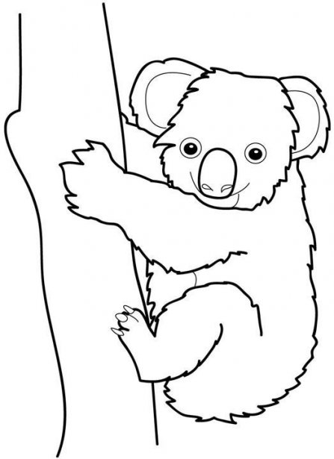



Nombre

Ejercicio 1 Continúa con la plana ubicando correctamente el cuadro.

|  |  |  |  |  |  |  |  |  |  |  |  |  |  |  |  |  |  |  |  |  |  |  |  |  |  |  |  |  |  |
| --- | --- | --- | --- | --- | --- | --- | --- | --- | --- | --- | --- | --- | --- | --- | --- | --- | --- | --- | --- | --- | --- | --- | --- | --- | --- | --- | --- | --- | --- |
|  |  |  |  |  |  |  |  |  |  |  |  |  |  |  |  |  |  |  |  |  |  |  |  |  |  |  |  |  |  |
|  |  |  |  |  |  |  |  |  |  |  |  |  |  |  |  |  |  |  |  |  |  |  |  |  |  |  |  |  |  |
|  |  |  |  |  |  |  |  |  |  |  |  |  |  |  |  |  |  |  |  |  |  |  |  |  |  |  |  |  |  |
|  |  |  |  |  |  |  |  |  |  |  |  |  |  |  |  |  |  |  |  |  |  |  |  |  |  |  |  |  |  |
|  |  |  |  |  |  |  |  |  |  |  |  |  |  |  |  |  |  |  |  |  |  |  |  |  |  |  |  |  |  |
|  |  |  |  |  |  |  |  |  |  |  |  |  |  |  |  |  |  |  |  |  |  |  |  |  |  |  |  |  |  |

Ejercicio 2

|  |  |  |  |  |  |  |  |  |  |  |  |  |  |  |  |  |  |  |  |  |  |  |  |  |  |  |  |  |  |
| --- | --- | --- | --- | --- | --- | --- | --- | --- | --- | --- | --- | --- | --- | --- | --- | --- | --- | --- | --- | --- | --- | --- | --- | --- | --- | --- | --- | --- | --- |
|  |  |  |  |  |  |  |  |  |  |  |  |  |  |  |  |  |  |  |  |  |  |  |  |  |  |  |  |  |  |
|  |  |  |  |  |  |  |  |  |  |  |  |  |  |  |  |  |  |  |  |  |  |  |  |  |  |  |  |  |  |
|  |  |  |  |  |  |  |  |  |  |  |  |  |  |  |  |  |  |  |  |  |  |  |  |  |  |  |  |  |  |
|  |  |  |  |  |  |  |  |  |  |  |  |  |  |  |  |  |  |  |  |  |  |  |  |  |  |  |  |  |  |
|  |  |  |  |  |  |  |  |  |  |  |  |  |  |  |  |  |  |  |  |  |  |  |  |  |  |  |  |  |  |
|  |  |  |  |  |  |  |  |  |  |  |  |  |  |  |  |  |  |  |  |  |  |  |  |  |  |  |  |  |  |

Ejercicio 3

|  |  |  |  |  |  |  |  |  |  |  |  |  |  |  |  |  |  |  |  |  |  |  |  |  |  |  |  |  |  |
| --- | --- | --- | --- | --- | --- | --- | --- | --- | --- | --- | --- | --- | --- | --- | --- | --- | --- | --- | --- | --- | --- | --- | --- | --- | --- | --- | --- | --- | --- |
|  |  |  |  |  |  |  |  |  |  |  |  |  |  |  |  |  |  |  |  |  |  |  |  |  |  |  |  |  |  |
|  |  |  |  |  |  |  |  |  |  |  |  |  |  |  |  |  |  |  |  |  |  |  |  |  |  |  |  |  |  |
|  |  |  |  |  |  |  |  |  |  |  |  |  |  |  |  |  |  |  |  |  |  |  |  |  |  |  |  |  |  |
|  |  |  |  |  |  |  |  |  |  |  |  |  |  |  |  |  |  |  |  |  |  |  |  |  |  |  |  |  |  |
|  |  |  |  |  |  |  |  |  |  |  |  |  |  |  |  |  |  |  |  |  |  |  |  |  |  |  |  |  |  |
|  |  |  |  |  |  |  |  |  |  |  |  |  |  |  |  |  |  |  |  |  |  |  |  |  |  |  |  |  |  |

Ejercicio 4

|  |  |  |  |  |  |  |  |  |  |  |  |  |  |  |  |  |  |  |  |  |  |  |  |  |  |  |  |  |  |
| --- | --- | --- | --- | --- | --- | --- | --- | --- | --- | --- | --- | --- | --- | --- | --- | --- | --- | --- | --- | --- | --- | --- | --- | --- | --- | --- | --- | --- | --- |
|  |  |  |  |  |  |  |  |  |  |  |  |  |  |  |  |  |  |  |  |  |  |  |  |  |  |  |  |  |  |
|  |  |  |  |  |  |  |  |  |  |  |  |  |  |  |  |  |  |  |  |  |  |  |  |  |  |  |  |  |  |
|  |  |  |  |  |  |  |  |  |  |  |  |  |  |  |  |  |  |  |  |  |  |  |  |  |  |  |  |  |  |
|  |  |  |  |  |  |  |  |  |  |  |  |  |  |  |  |  |  |  |  |  |  |  |  |  |  |  |  |  |  |
|  |  |  |  |  |  |  |  |  |  |  |  |  |  |  |  |  |  |  |  |  |  |  |  |  |  |  |  |  |  |
|  |  |  |  |  |  |  |  |  |  |  |  |  |  |  |  |  |  |  |  |  |  |  |  |  |  |  |  |  |  |

Ejercicio 5

|  |  |  |  |  |  |  |  |  |  |  |  |  |  |  |  |  |  |  |  |  |  |  |  |  |  |  |  |  |  |
| --- | --- | --- | --- | --- | --- | --- | --- | --- | --- | --- | --- | --- | --- | --- | --- | --- | --- | --- | --- | --- | --- | --- | --- | --- | --- | --- | --- | --- | --- |
|  |  |  |  |  |  |  |  |  |  |  |  |  |  |  |  |  |  |  |  |  |  |  |  |  |  |  |  |  |  |
|  |  |  |  |  |  |  |  |  |  |  |  |  |  |  |  |  |  |  |  |  |  |  |  |  |  |  |  |  |  |
|  |  |  |  |  |  |  |  |  |  |  |  |  |  |  |  |  |  |  |  |  |  |  |  |  |  |  |  |  |  |
|  |  |  |  |  |  |  |  |  |  |  |  |  |  |  |  |  |  |  |  |  |  |  |  |  |  |  |  |  |  |
|  |  |  |  |  |  |  |  |  |  |  |  |  |  |  |  |  |  |  |  |  |  |  |  |  |  |  |  |  |  |
|  |  |  |  |  |  |  |  |  |  | Scan0005 |  |  |  |  |  |  |  |  |  |  |  |  |  |  |  |  |  |  |  |

Nombre

Ejercicio 1 Continúa con la plana ubicando correctamente el cuadro.

|  |  |  |  |  |  |  |  |  |  |  |  |  |  |  |  |  |  |  |  |  |  |  |  |  |  |  |  |  |  |
| --- | --- | --- | --- | --- | --- | --- | --- | --- | --- | --- | --- | --- | --- | --- | --- | --- | --- | --- | --- | --- | --- | --- | --- | --- | --- | --- | --- | --- | --- |
|  |  |  |  |  |  |  |  |  |  |  |  |  |  |  |  |  |  |  |  |  |  |  |  |  |  |  |  |  |  |
|  |  |  |  |  |  |  |  |  |  |  |  |  |  |  |  |  |  |  |  |  |  |  |  |  |  |  |  |  |  |
|  |  |  |  |  |  |  |  |  |  |  |  |  |  |  |  |  |  |  |  |  |  |  |  |  |  |  |  |  |  |
|  |  |  |  |  |  |  |  |  |  |  |  |  |  |  |  |  |  |  |  |  |  |  |  |  |  |  |  |  |  |
|  |  |  |  |  |  |  |  |  |  |  |  |  |  |  |  |  |  |  |  |  |  |  |  |  |  |  |  |  |  |
|  |  |  |  |  |  |  |  |  |  |  |  |  |  |  |  |  |  |  |  |  |  |  |  |  |  |  |  |  |  |

Ejercicio 2

|  |  |  |  |  |  |  |  |  |  |  |  |  |  |  |  |  |  |  |  |  |  |  |  |  |  |  |  |  |  |
| --- | --- | --- | --- | --- | --- | --- | --- | --- | --- | --- | --- | --- | --- | --- | --- | --- | --- | --- | --- | --- | --- | --- | --- | --- | --- | --- | --- | --- | --- |
|  |  |  |  |  |  |  |  |  |  |  |  |  |  |  |  |  |  |  |  |  |  |  |  |  |  |  |  |  |  |
|  |  |  |  |  |  |  |  |  |  |  |  |  |  |  |  |  |  |  |  |  |  |  |  |  |  |  |  |  |  |
|  |  |  |  |  |  |  |  |  |  |  |  |  |  |  |  |  |  |  |  |  |  |  |  |  |  |  |  |  |  |
|  |  |  |  |  |  |  |  |  |  |  |  |  |  |  |  |  |  |  |  |  |  |  |  |  |  |  |  |  |  |
|  |  |  |  |  |  |  |  |  |  |  |  |  |  |  |  |  |  |  |  |  |  |  |  |  |  |  |  |  |  |
|  |  |  |  |  |  |  |  |  |  |  |  |  |  |  |  |  |  |  |  |  |  |  |  |  |  |  |  |  |  |

Ejercicio 3

|  |  |  |  |  |  |  |  |  |  |  |  |  |  |  |  |  |  |  |  |  |  |  |  |  |  |  |  |  |  |
| --- | --- | --- | --- | --- | --- | --- | --- | --- | --- | --- | --- | --- | --- | --- | --- | --- | --- | --- | --- | --- | --- | --- | --- | --- | --- | --- | --- | --- | --- |
|  |  |  |  |  |  |  |  |  |  |  |  |  |  |  |  |  |  |  |  |  |  |  |  |  |  |  |  |  |  |
|  |  |  |  |  |  |  |  |  |  |  |  |  |  |  |  |  |  |  |  |  |  |  |  |  |  |  |  |  |  |
|  |  |  |  |  |  |  |  |  |  |  |  |  |  |  |  |  |  |  |  |  |  |  |  |  |  |  |  |  |  |
|  |  |  |  |  |  |  |  |  |  |  |  |  |  |  |  |  |  |  |  |  |  |  |  |  |  |  |  |  |  |
|  |  |  |  |  |  |  |  |  |  |  |  |  |  |  |  |  |  |  |  |  |  |  |  |  |  |  |  |  |  |
|  |  |  |  |  |  |  |  |  |  |  |  |  |  |  |  |  |  |  |  |  |  |  |  |  |  |  |  |  |  |

Ejercicio 4

|  |  |  |  |  |  |  |  |  |  |  |  |  |  |  |  |  |  |  |  |  |  |  |  |  |  |  |  |  |  |
| --- | --- | --- | --- | --- | --- | --- | --- | --- | --- | --- | --- | --- | --- | --- | --- | --- | --- | --- | --- | --- | --- | --- | --- | --- | --- | --- | --- | --- | --- |
|  |  |  |  |  |  |  |  |  |  |  |  |  |  |  |  |  |  |  |  |  |  |  |  |  |  |  |  |  |  |
|  |  |  |  |  |  |  |  |  |  |  |  |  |  |  |  |  |  |  |  |  |  |  |  |  |  |  |  |  |  |
|  |  |  |  |  |  |  |  |  |  |  |  |  |  |  |  |  |  |  |  |  |  |  |  |  |  |  |  |  |  |
|  |  |  |  |  |  |  |  |  |  |  |  |  |  |  |  |  |  |  |  |  |  |  |  |  |  |  |  |  |  |
|  |  |  |  |  |  |  |  |  |  |  |  |  |  |  |  |  |  |  |  |  |  |  |  |  |  |  |  |  |  |
|  |  |  |  |  |  |  |  |  |  |  |  |  |  |  |  |  |  |  |  |  |  |  |  |  |  |  |  |  |  |

Ejercicio 5

|  |  |  |  |  |  |  |  |  |  |  |  |  |  |  |  |  |  |  |  |  |  |  |  |  |  |  |  |  |  |
| --- | --- | --- | --- | --- | --- | --- | --- | --- | --- | --- | --- | --- | --- | --- | --- | --- | --- | --- | --- | --- | --- | --- | --- | --- | --- | --- | --- | --- | --- |
|  |  |  |  |  |  |  |  |  |  |  |  |  |  |  |  |  |  |  |  |  |  |  |  |  |  |  |  |  |  |
|  |  |  |  |  |  |  |  |  |  |  |  |  |  |  |  |  |  |  |  |  |  |  |  |  |  |  |  |  |  |
|  |  |  |  |  |  |  |  |  |  |  |  |  |  |  |  |  |  |  |  |  |  |  |  |  |  |  |  |  |  |
|  |  |  |  |  |  |  |  |  |  |  |  |  |  |  |  |  |  |  |  |  |  |  |  |  |  |  |  |  |  |
|  |  |  |  |  |  |  |  |  |  |  |  |  |  |  |  |  |  |  |  |  |  |  |  |  |  |  |  |  |  |
|  |  |  |  |  |  |  |  |  | Scan0005 |  |  |  |  |  |  |  |  |  |  |  |  |  |  |  |  |  |  |  |  |

Nombre

Observa los dibujos y únelos correctamente con cada palabra.

Kiosco

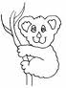 Kity 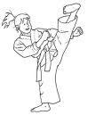

Karina

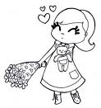 Koala 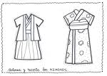

Karateca

 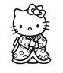 Kimono 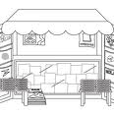

Nombre

Realiza el siguiente problema.

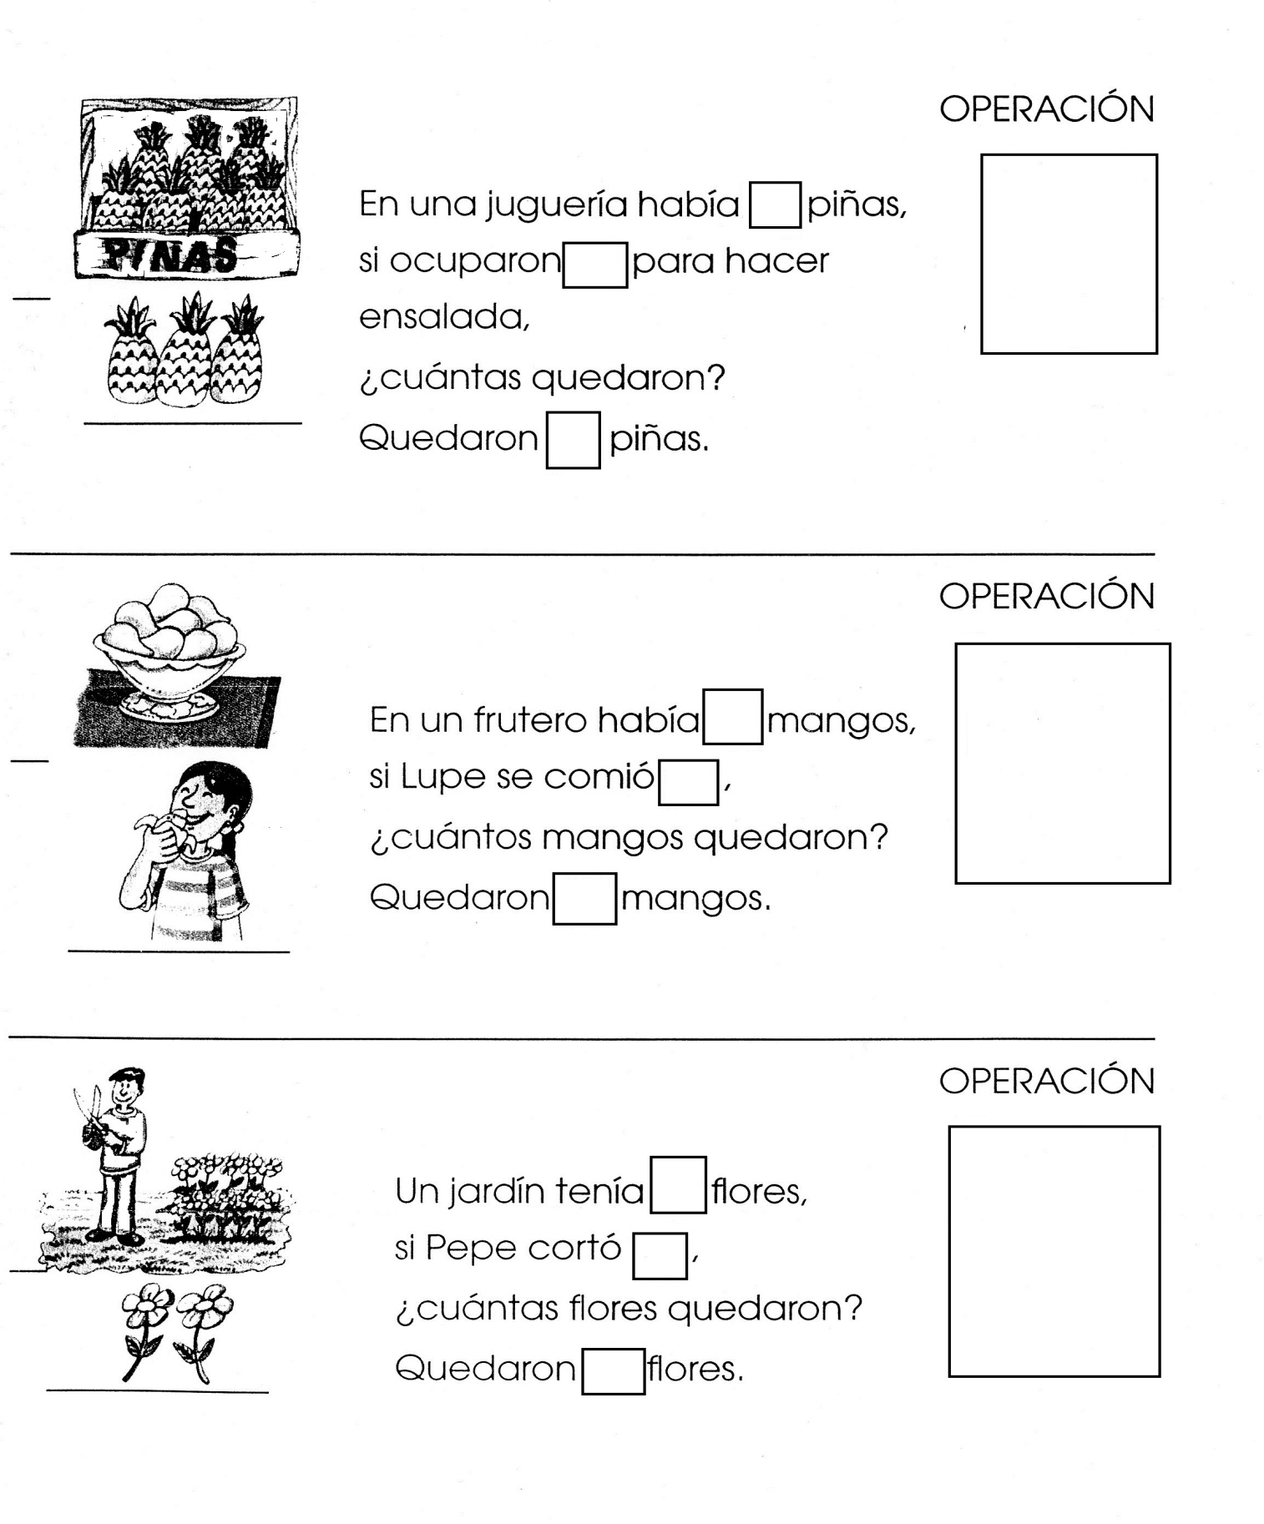



Nombre

Decora con diversidad de materiales.

Entero

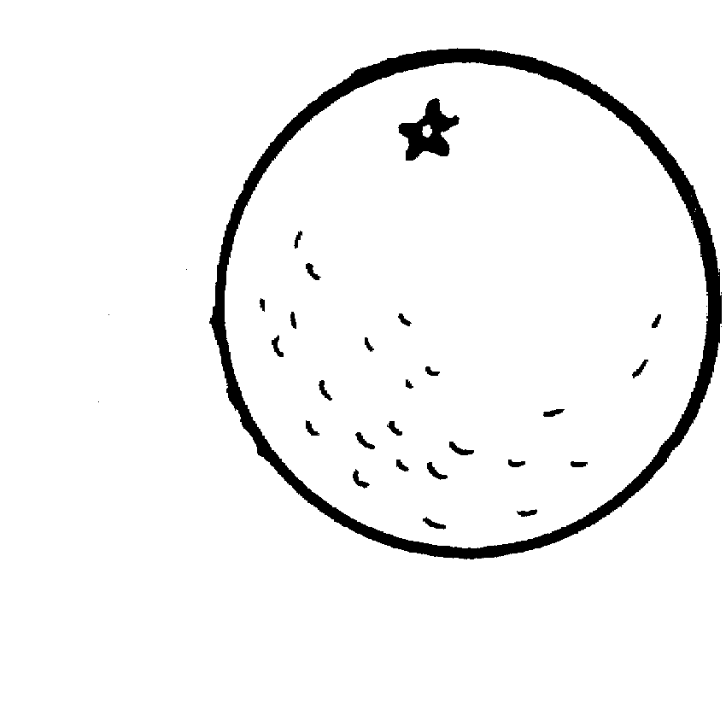



Nombre

Decora con material variado el dibujo.

Mitad

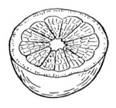



Nombre

Decora con material variado el dibujo.

Cuarto

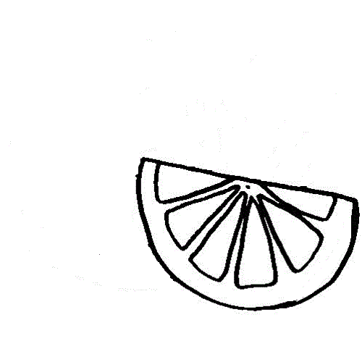



Nombre

Encierra de café los objetos que estén enteros, de color morado los que estén a la mitad y de naranja los que estén en cuarto.

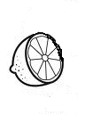 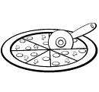 

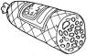 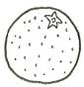

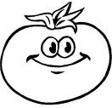

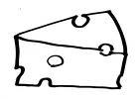 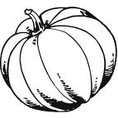



Nombre

Con recortes pega aquí la familia del 70.



Nombre

Observa los tipos de flores que hay. Encierra lo dos tipos que más te gusten.

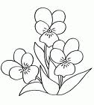

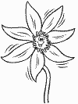

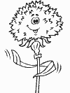 

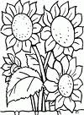

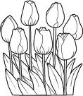

 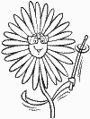

Nombre

Comenta con tus compañeros cual flor eligieron. Colorea los cuadros según los votos de tus compañeros.

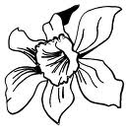      

|  |  |  |  |  |  |  |  |  |
| --- | --- | --- | --- | --- | --- | --- | --- | --- |
|  |  |  |  |  |  |  |  |  |
|  |  |  |  |  |  |  |
|  |
|  |  |  |  |  |  |  |
|  |  |  |  |  |  |  |
|  |  |  |  |  |  |  |
|  |  |  |  |  |  |  |
|  |  |  |  |  |  |  |
|  |  |  |  |  |  |  |
|  |  |  |  |  |  |  |

¿Cuál es la flor

favorita del grupo?

Nombre

Decora con material variado la letra N n.

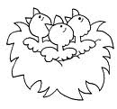



Nombre

Escribe las silabas que faltan.

na ne ni no nu

 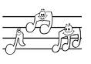

____do _____tas

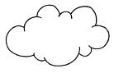

______be

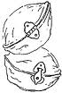 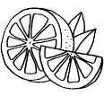

_____ez _____ranja



Nombre

Escucha la lectura de “Nora” de tu libro cuenta cuentos y escribe las palabras con n sobre las líneas.

________________________________________________________________________________________________________________________________________________________________________________________________________________________________________________________________________________________________________________



Nombre

Ejercicio 1 Continúa con la plana ubicando correctamente el cuadro.

|  |  |  |  |  |  |  |  |  |  |  |  |  |  |  |  |  |  |  |  |  |  |  |  |  |  |  |  |  |  |
| --- | --- | --- | --- | --- | --- | --- | --- | --- | --- | --- | --- | --- | --- | --- | --- | --- | --- | --- | --- | --- | --- | --- | --- | --- | --- | --- | --- | --- | --- |
|  |  |  |  |  |  |  |  |  |  |  |  |  |  |  |  |  |  |  |  |  |  |  |  |  |  |  |  |  |  |
|  |  |  |  |  |  |  |  |  |  |  |  |  |  |  |  |  |  |  |  |  |  |  |  |  |  |  |  |  |  |
|  |  |  |  |  |  |  |  |  |  |  |  |  |  |  |  |  |  |  |  |  |  |  |  |  |  |  |  |  |  |
|  |  |  |  |  |  |  |  |  |  |  |  |  |  |  |  |  |  |  |  |  |  |  |  |  |  |  |  |  |  |
|  |  |  |  |  |  |  |  |  |  |  |  |  |  |  |  |  |  |  |  |  |  |  |  |  |  |  |  |  |  |
|  |  |  |  |  |  |  |  |  |  |  |  |  |  |  |  |  |  |  |  |  |  |  |  |  |  |  |  |  |  |

Ejercicio 2

|  |  |  |  |  |  |  |  |  |  |  |  |  |  |  |  |  |  |  |  |  |  |  |  |  |  |  |  |  |  |
| --- | --- | --- | --- | --- | --- | --- | --- | --- | --- | --- | --- | --- | --- | --- | --- | --- | --- | --- | --- | --- | --- | --- | --- | --- | --- | --- | --- | --- | --- |
|  |  |  |  |  |  |  |  |  |  |  |  |  |  |  |  |  |  |  |  |  |  |  |  |  |  |  |  |  |  |
|  |  |  |  |  |  |  |  |  |  |  |  |  |  |  |  |  |  |  |  |  |  |  |  |  |  |  |  |  |  |
|  |  |  |  |  |  |  |  |  |  |  |  |  |  |  |  |  |  |  |  |  |  |  |  |  |  |  |  |  |  |
|  |  |  |  |  |  |  |  |  |  |  |  |  |  |  |  |  |  |  |  |  |  |  |  |  |  |  |  |  |  |
|  |  |  |  |  |  |  |  |  |  |  |  |  |  |  |  |  |  |  |  |  |  |  |  |  |  |  |  |  |  |
|  |  |  |  |  |  |  |  |  |  |  |  |  |  |  |  |  |  |  |  |  |  |  |  |  |  |  |  |  |  |

Ejercicio 3

|  |  |  |  |  |  |  |  |  |  |  |  |  |  |  |  |  |  |  |  |  |  |  |  |  |  |  |  |  |  |
| --- | --- | --- | --- | --- | --- | --- | --- | --- | --- | --- | --- | --- | --- | --- | --- | --- | --- | --- | --- | --- | --- | --- | --- | --- | --- | --- | --- | --- | --- |
|  |  |  |  |  |  |  |  |  |  |  |  |  |  |  |  |  |  |  |  |  |  |  |  |  |  |  |  |  |  |
|  |  |  |  |  |  |  |  |  |  |  |  |  |  |  |  |  |  |  |  |  |  |  |  |  |  |  |  |  |  |
|  |  |  |  |  |  |  |  |  |  |  |  |  |  |  |  |  |  |  |  |  |  |  |  |  |  |  |  |  |  |
|  |  |  |  |  |  |  |  |  |  |  |  |  |  |  |  |  |  |  |  |  |  |  |  |  |  |  |  |  |  |
|  |  |  |  |  |  |  |  |  |  |  |  |  |  |  |  |  |  |  |  |  |  |  |  |  |  |  |  |  |  |
|  |  |  |  |  |  |  |  |  |  |  |  |  |  |  |  |  |  |  |  |  |  |  |  |  |  |  |  |  |  |

Ejercicio 4

|  |  |  |  |  |  |  |  |  |  |  |  |  |  |  |  |  |  |  |  |  |  |  |  |  |  |  |  |  |  |
| --- | --- | --- | --- | --- | --- | --- | --- | --- | --- | --- | --- | --- | --- | --- | --- | --- | --- | --- | --- | --- | --- | --- | --- | --- | --- | --- | --- | --- | --- |
|  |  |  |  |  |  |  |  |  |  |  |  |  |  |  |  |  |  |  |  |  |  |  |  |  |  |  |  |  |  |
|  |  |  |  |  |  |  |  |  |  |  |  |  |  |  |  |  |  |  |  |  |  |  |  |  |  |  |  |  |  |
|  |  |  |  |  |  |  |  |  |  |  |  |  |  |  |  |  |  |  |  |  |  |  |  |  |  |  |  |  |  |
|  |  |  |  |  |  |  |  |  |  |  |  |  |  |  |  |  |  |  |  |  |  |  |  |  |  |  |  |  |  |
|  |  |  |  |  |  |  |  |  |  |  |  |  |  |  |  |  |  |  |  |  |  |  |  |  |  |  |  |  |  |
|  |  |  |  |  |  |  |  |  |  |  |  |  |  |  |  |  |  |  |  |  |  |  |  |  |  |  |  |  |  |

Ejercicio 5

|  |  |  |  |  |  |  |  |  |  |  |  |  |  |  |  |  |  |  |  |  |  |  |  |  |  |  |  |  |  |
| --- | --- | --- | --- | --- | --- | --- | --- | --- | --- | --- | --- | --- | --- | --- | --- | --- | --- | --- | --- | --- | --- | --- | --- | --- | --- | --- | --- | --- | --- |
|  |  |  |  |  |  |  |  |  |  |  |  |  |  |  |  |  |  |  |  |  |  |  |  |  |  |  |  |  |  |
|  |  |  |  |  |  |  |  |  |  |  |  |  |  |  |  |  |  |  |  |  |  |  |  |  |  |  |  |  |  |
|  |  |  |  |  |  |  |  |  |  |  |  |  |  |  |  |  |  |  |  |  |  |  |  |  |  |  |  |  |  |
|  |  |  |  |  |  |  |  |  |  |  |  |  |  |  |  |  |  |  |  |  |  |  |  |  |  |  |  |  |  |
|  |  |  |  |  |  |  |  |  |  |  |  |  |  |  |  |  |  |  |  |  |  |  |  |  |  |  |  |  |  |
|  |  |  |  |  |  |  |  |  |  | Scan0005 |  |  |  |  |  |  |  |  |  |  |  |  |  |  |  |  |  |  |  |

Nombre

Ejercicio 1 Continúa con la plana ubicando el cuadro correctamente.

|  |  |  |  |  |  |  |  |  |  |  |  |  |  |  |  |  |  |  |  |  |  |  |  |  |  |  |  |  |  |
| --- | --- | --- | --- | --- | --- | --- | --- | --- | --- | --- | --- | --- | --- | --- | --- | --- | --- | --- | --- | --- | --- | --- | --- | --- | --- | --- | --- | --- | --- |
|  |  |  |  |  |  |  |  |  |  |  |  |  |  |  |  |  |  |  |  |  |  |  |  |  |  |  |  |  |  |
|  |  |  |  |  |  |  |  |  |  |  |  |  |  |  |  |  |  |  |  |  |  |  |  |  |  |  |  |  |  |
|  |  |  |  |  |  |  |  |  |  |  |  |  |  |  |  |  |  |  |  |  |  |  |  |  |  |  |  |  |  |
|  |  |  |  |  |  |  |  |  |  |  |  |  |  |  |  |  |  |  |  |  |  |  |  |  |  |  |  |  |  |
|  |  |  |  |  |  |  |  |  |  |  |  |  |  |  |  |  |  |  |  |  |  |  |  |  |  |  |  |  |  |
|  |  |  |  |  |  |  |  |  |  |  |  |  |  |  |  |  |  |  |  |  |  |  |  |  |  |  |  |  |  |

Ejercicio 2

|  |  |  |  |  |  |  |  |  |  |  |  |  |  |  |  |  |  |  |  |  |  |  |  |  |  |  |  |  |  |
| --- | --- | --- | --- | --- | --- | --- | --- | --- | --- | --- | --- | --- | --- | --- | --- | --- | --- | --- | --- | --- | --- | --- | --- | --- | --- | --- | --- | --- | --- |
|  |  |  |  |  |  |  |  |  |  |  |  |  |  |  |  |  |  |  |  |  |  |  |  |  |  |  |  |  |  |
|  |  |  |  |  |  |  |  |  |  |  |  |  |  |  |  |  |  |  |  |  |  |  |  |  |  |  |  |  |  |
|  |  |  |  |  |  |  |  |  |  |  |  |  |  |  |  |  |  |  |  |  |  |  |  |  |  |  |  |  |  |
|  |  |  |  |  |  |  |  |  |  |  |  |  |  |  |  |  |  |  |  |  |  |  |  |  |  |  |  |  |  |
|  |  |  |  |  |  |  |  |  |  |  |  |  |  |  |  |  |  |  |  |  |  |  |  |  |  |  |  |  |  |
|  |  |  |  |  |  |  |  |  |  |  |  |  |  |  |  |  |  |  |  |  |  |  |  |  |  |  |  |  |  |

Ejercicio 3

|  |  |  |  |  |  |  |  |  |  |  |  |  |  |  |  |  |  |  |  |  |  |  |  |  |  |  |  |  |  |
| --- | --- | --- | --- | --- | --- | --- | --- | --- | --- | --- | --- | --- | --- | --- | --- | --- | --- | --- | --- | --- | --- | --- | --- | --- | --- | --- | --- | --- | --- |
|  |  |  |  |  |  |  |  |  |  |  |  |  |  |  |  |  |  |  |  |  |  |  |  |  |  |  |  |  |  |
|  |  |  |  |  |  |  |  |  |  |  |  |  |  |  |  |  |  |  |  |  |  |  |  |  |  |  |  |  |  |
|  |  |  |  |  |  |  |  |  |  |  |  |  |  |  |  |  |  |  |  |  |  |  |  |  |  |  |  |  |  |
|  |  |  |  |  |  |  |  |  |  |  |  |  |  |  |  |  |  |  |  |  |  |  |  |  |  |  |  |  |  |
|  |  |  |  |  |  |  |  |  |  |  |  |  |  |  |  |  |  |  |  |  |  |  |  |  |  |  |  |  |  |
|  |  |  |  |  |  |  |  |  |  |  |  |  |  |  |  |  |  |  |  |  |  |  |  |  |  |  |  |  |  |

Ejercicio 4

|  |  |  |  |  |  |  |  |  |  |  |  |  |  |  |  |  |  |  |  |  |  |  |  |  |  |  |  |  |  |
| --- | --- | --- | --- | --- | --- | --- | --- | --- | --- | --- | --- | --- | --- | --- | --- | --- | --- | --- | --- | --- | --- | --- | --- | --- | --- | --- | --- | --- | --- |
|  |  |  |  |  |  |  |  |  |  |  |  |  |  |  |  |  |  |  |  |  |  |  |  |  |  |  |  |  |  |
|  |  |  |  |  |  |  |  |  |  |  |  |  |  |  |  |  |  |  |  |  |  |  |  |  |  |  |  |  |  |
|  |  |  |  |  |  |  |  |  |  |  |  |  |  |  |  |  |  |  |  |  |  |  |  |  |  |  |  |  |  |
|  |  |  |  |  |  |  |  |  |  |  |  |  |  |  |  |  |  |  |  |  |  |  |  |  |  |  |  |  |  |
|  |  |  |  |  |  |  |  |  |  |  |  |  |  |  |  |  |  |  |  |  |  |  |  |  |  |  |  |  |  |
|  |  |  |  |  |  |  |  |  |  |  |  |  |  |  |  |  |  |  |  |  |  |  |  |  |  |  |  |  |  |

Ejercicio 5

|  |  |  |  |  |  |  |  |  |  |  |  |  |  |  |  |  |  |  |  |  |  |  |  |  |  |  |  |  |  |
| --- | --- | --- | --- | --- | --- | --- | --- | --- | --- | --- | --- | --- | --- | --- | --- | --- | --- | --- | --- | --- | --- | --- | --- | --- | --- | --- | --- | --- | --- |
|  |  |  |  |  |  |  |  |  |  |  |  |  |  |  |  |  |  |  |  |  |  |  |  |  |  |  |  |  |  |
|  |  |  |  |  |  |  |  |  |  |  |  |  |  |  |  |  |  |  |  |  |  |  |  |  |  |  |  |  |  |
|  |  |  |  |  |  |  |  |  |  |  |  |  |  |  |  |  |  |  |  |  |  |  |  |  |  |  |  |  |  |
|  |  |  |  |  |  |  |  |  |  |  |  |  |  |  |  |  |  |  |  |  |  |  |  |  |  |  |  |  |  |
|  |  |  |  |  |  |  |  |  |  |  |  |  |  |  |  |  |  |  |  |  |  |  |  |  |  |  |  |  |  |
|  |  |  |  |  |  |  |  |  | Scan0005 |  |  |  |  |  |  |  |  |  |  |  |  |  |  |  |  |  |  |  |  |

Nombre

Resuelve la recta numérica.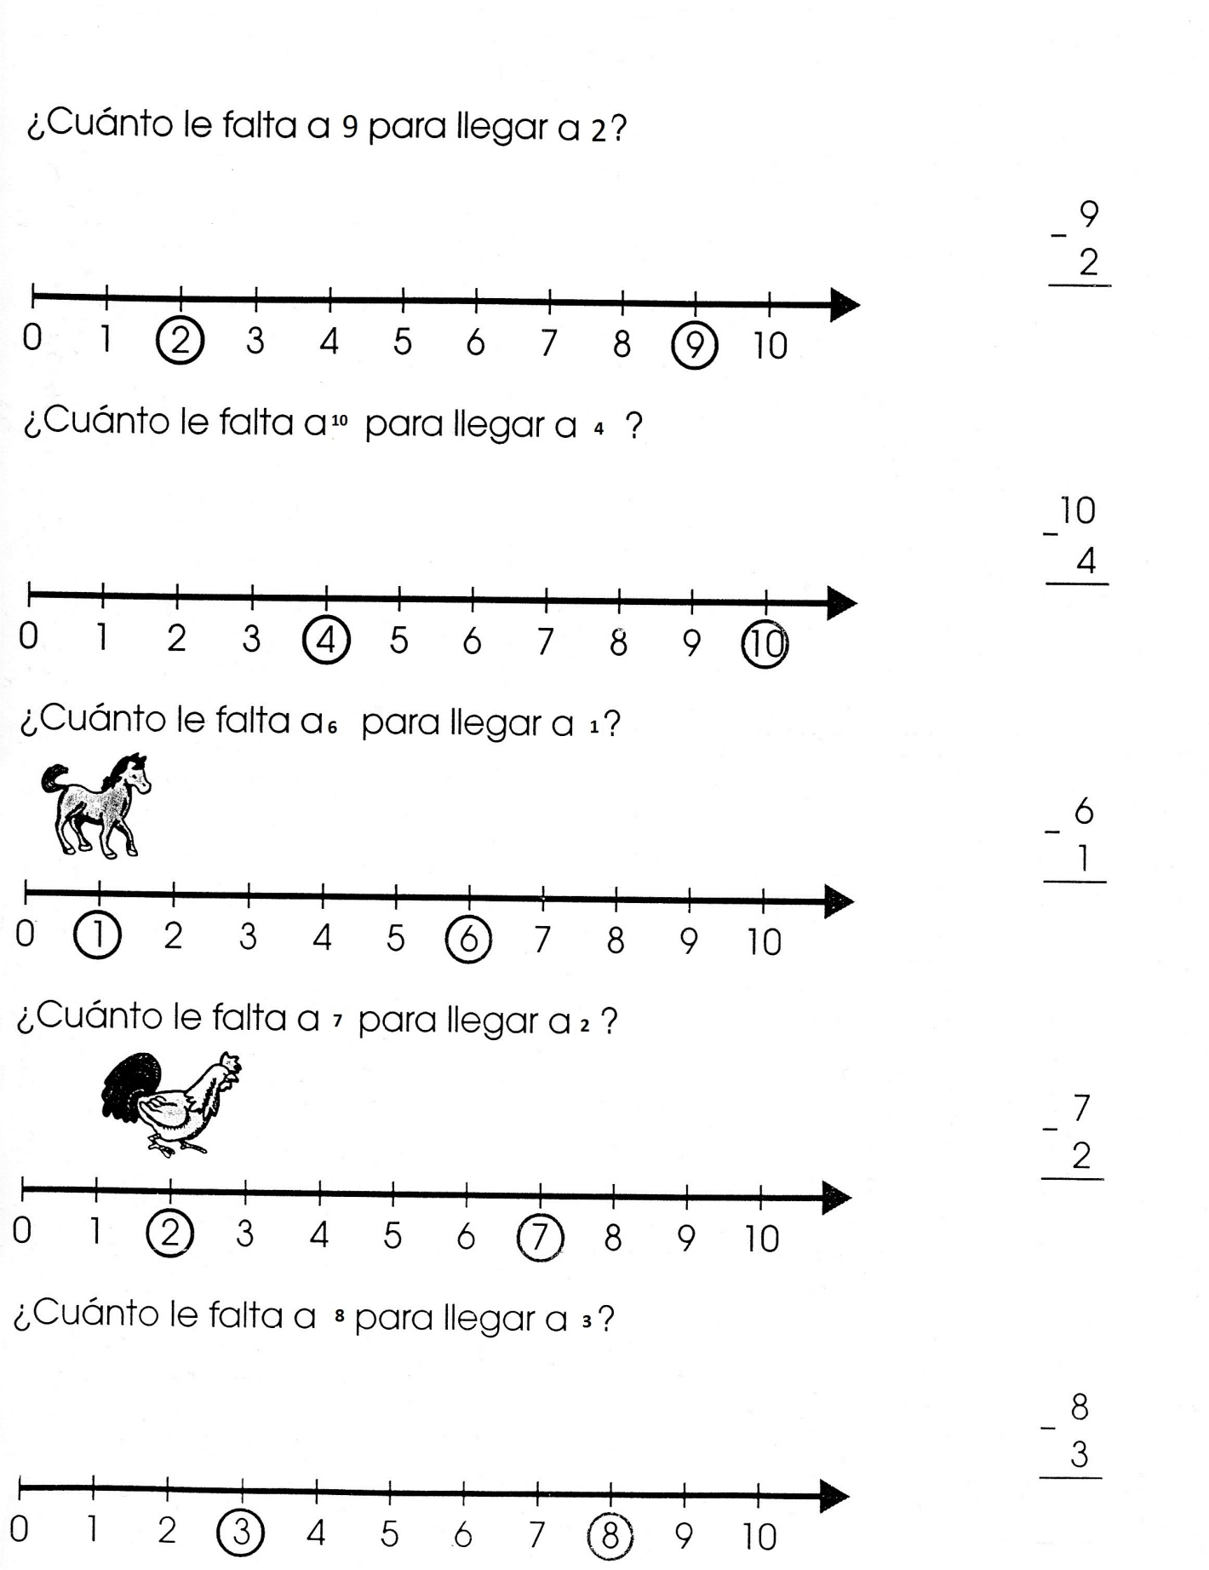

Nombre

Resuelve las siguientes operaciones.

20 33 51

+ + +

4 5 27

________ ________ ______

79 68 54

* - -

33 27 43

_______ ______ ______

7 9 3

* - -

4 8 2

_____ ______ ______



Nombre

Decora con material la letra Ñ ñ

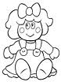



Nombre

Recorta y pega palabras con las silabas correspondientes.

ña ñe

ñi ño

ñu



Nombre

Observa los dibujos y une la respuesta correcta.

Araña  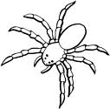 

Piña  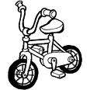 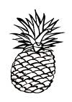

 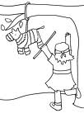 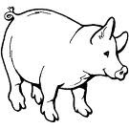

Piñata

Nombre

Ejercicio 1 Continúa con la plana ubicando el cuadro correctamente.

|  |  |  |  |  |  |  |  |  |  |  |  |  |  |  |  |  |  |  |  |  |  |  |  |  |  |  |  |  |  |
| --- | --- | --- | --- | --- | --- | --- | --- | --- | --- | --- | --- | --- | --- | --- | --- | --- | --- | --- | --- | --- | --- | --- | --- | --- | --- | --- | --- | --- | --- |
|  |  |  |  |  |  |  |  |  |  |  |  |  |  |  |  |  |  |  |  |  |  |  |  |  |  |  |  |  |  |
|  |  |  |  |  |  |  |  |  |  |  |  |  |  |  |  |  |  |  |  |  |  |  |  |  |  |  |  |  |  |
|  |  |  |  |  |  |  |  |  |  |  |  |  |  |  |  |  |  |  |  |  |  |  |  |  |  |  |  |  |  |
|  |  |  |  |  |  |  |  |  |  |  |  |  |  |  |  |  |  |  |  |  |  |  |  |  |  |  |  |  |  |
|  |  |  |  |  |  |  |  |  |  |  |  |  |  |  |  |  |  |  |  |  |  |  |  |  |  |  |  |  |  |
|  |  |  |  |  |  |  |  |  |  |  |  |  |  |  |  |  |  |  |  |  |  |  |  |  |  |  |  |  |  |

Ejercicio 2

|  |  |  |  |  |  |  |  |  |  |  |  |  |  |  |  |  |  |  |  |  |  |  |  |  |  |  |  |  |  |
| --- | --- | --- | --- | --- | --- | --- | --- | --- | --- | --- | --- | --- | --- | --- | --- | --- | --- | --- | --- | --- | --- | --- | --- | --- | --- | --- | --- | --- | --- |
|  |  |  |  |  |  |  |  |  |  |  |  |  |  |  |  |  |  |  |  |  |  |  |  |  |  |  |  |  |  |
|  |  |  |  |  |  |  |  |  |  |  |  |  |  |  |  |  |  |  |  |  |  |  |  |  |  |  |  |  |  |
|  |  |  |  |  |  |  |  |  |  |  |  |  |  |  |  |  |  |  |  |  |  |  |  |  |  |  |  |  |  |
|  |  |  |  |  |  |  |  |  |  |  |  |  |  |  |  |  |  |  |  |  |  |  |  |  |  |  |  |  |  |
|  |  |  |  |  |  |  |  |  |  |  |  |  |  |  |  |  |  |  |  |  |  |  |  |  |  |  |  |  |  |
|  |  |  |  |  |  |  |  |  |  |  |  |  |  |  |  |  |  |  |  |  |  |  |  |  |  |  |  |  |  |

Ejercicio 3

|  |  |  |  |  |  |  |  |  |  |  |  |  |  |  |  |  |  |  |  |  |  |  |  |  |  |  |  |  |  |
| --- | --- | --- | --- | --- | --- | --- | --- | --- | --- | --- | --- | --- | --- | --- | --- | --- | --- | --- | --- | --- | --- | --- | --- | --- | --- | --- | --- | --- | --- |
|  |  |  |  |  |  |  |  |  |  |  |  |  |  |  |  |  |  |  |  |  |  |  |  |  |  |  |  |  |  |
|  |  |  |  |  |  |  |  |  |  |  |  |  |  |  |  |  |  |  |  |  |  |  |  |  |  |  |  |  |  |
|  |  |  |  |  |  |  |  |  |  |  |  |  |  |  |  |  |  |  |  |  |  |  |  |  |  |  |  |  |  |
|  |  |  |  |  |  |  |  |  |  |  |  |  |  |  |  |  |  |  |  |  |  |  |  |  |  |  |  |  |  |
|  |  |  |  |  |  |  |  |  |  |  |  |  |  |  |  |  |  |  |  |  |  |  |  |  |  |  |  |  |  |
|  |  |  |  |  |  |  |  |  |  |  |  |  |  |  |  |  |  |  |  |  |  |  |  |  |  |  |  |  |  |

Ejercicio 4

|  |  |  |  |  |  |  |  |  |  |  |  |  |  |  |  |  |  |  |  |  |  |  |  |  |  |  |  |  |  |
| --- | --- | --- | --- | --- | --- | --- | --- | --- | --- | --- | --- | --- | --- | --- | --- | --- | --- | --- | --- | --- | --- | --- | --- | --- | --- | --- | --- | --- | --- |
|  |  |  |  |  |  |  |  |  |  |  |  |  |  |  |  |  |  |  |  |  |  |  |  |  |  |  |  |  |  |
|  |  |  |  |  |  |  |  |  |  |  |  |  |  |  |  |  |  |  |  |  |  |  |  |  |  |  |  |  |  |
|  |  |  |  |  |  |  |  |  |  |  |  |  |  |  |  |  |  |  |  |  |  |  |  |  |  |  |  |  |  |
|  |  |  |  |  |  |  |  |  |  |  |  |  |  |  |  |  |  |  |  |  |  |  |  |  |  |  |  |  |  |
|  |  |  |  |  |  |  |  |  |  |  |  |  |  |  |  |  |  |  |  |  |  |  |  |  |  |  |  |  |  |
|  |  |  |  |  |  |  |  |  |  |  |  |  |  |  |  |  |  |  |  |  |  |  |  |  |  |  |  |  |  |

Ejercicio 5

|  |  |  |  |  |  |  |  |  |  |  |  |  |  |  |  |  |  |  |  |  |  |  |  |  |  |  |  |  |  |
| --- | --- | --- | --- | --- | --- | --- | --- | --- | --- | --- | --- | --- | --- | --- | --- | --- | --- | --- | --- | --- | --- | --- | --- | --- | --- | --- | --- | --- | --- |
|  |  |  |  |  |  |  |  |  |  |  |  |  |  |  |  |  |  |  |  |  |  |  |  |  |  |  |  |  |  |
|  |  |  |  |  |  |  |  |  |  |  |  |  |  |  |  |  |  |  |  |  |  |  |  |  |  |  |  |  |  |
|  |  |  |  |  |  |  |  |  |  |  |  |  |  |  |  |  |  |  |  |  |  |  |  |  |  |  |  |  |  |
|  |  |  |  |  |  |  |  |  |  |  |  |  |  |  |  |  |  |  |  |  |  |  |  |  |  |  |  |  |  |
|  |  |  |  |  |  |  |  |  |  |  |  |  |  |  |  |  |  |  |  |  |  |  |  |  |  |  |  |  |  |
|  |  |  |  |  |  |  |  |  |  |  | Scan0005 |  |  |  |  |  |  |  |  |  |  |  |  |  |  |  |  |  |  |

Nombre

Ejercicio 1 Continúa con la plana ubicando el cuadro correctamente.

|  |  |  |  |  |  |  |  |  |  |  |  |  |  |  |  |  |  |  |  |  |  |  |  |  |  |  |  |  |  |
| --- | --- | --- | --- | --- | --- | --- | --- | --- | --- | --- | --- | --- | --- | --- | --- | --- | --- | --- | --- | --- | --- | --- | --- | --- | --- | --- | --- | --- | --- |
|  |  |  |  |  |  |  |  |  |  |  |  |  |  |  |  |  |  |  |  |  |  |  |  |  |  |  |  |  |  |
|  |  |  |  |  |  |  |  |  |  |  |  |  |  |  |  |  |  |  |  |  |  |  |  |  |  |  |  |  |  |
|  |  |  |  |  |  |  |  |  |  |  |  |  |  |  |  |  |  |  |  |  |  |  |  |  |  |  |  |  |  |
|  |  |  |  |  |  |  |  |  |  |  |  |  |  |  |  |  |  |  |  |  |  |  |  |  |  |  |  |  |  |
|  |  |  |  |  |  |  |  |  |  |  |  |  |  |  |  |  |  |  |  |  |  |  |  |  |  |  |  |  |  |
|  |  |  |  |  |  |  |  |  |  |  |  |  |  |  |  |  |  |  |  |  |  |  |  |  |  |  |  |  |  |

Ejercicio 2

|  |  |  |  |  |  |  |  |  |  |  |  |  |  |  |  |  |  |  |  |  |  |  |  |  |  |  |  |  |  |
| --- | --- | --- | --- | --- | --- | --- | --- | --- | --- | --- | --- | --- | --- | --- | --- | --- | --- | --- | --- | --- | --- | --- | --- | --- | --- | --- | --- | --- | --- |
|  |  |  |  |  |  |  |  |  |  |  |  |  |  |  |  |  |  |  |  |  |  |  |  |  |  |  |  |  |  |
|  |  |  |  |  |  |  |  |  |  |  |  |  |  |  |  |  |  |  |  |  |  |  |  |  |  |  |  |  |  |
|  |  |  |  |  |  |  |  |  |  |  |  |  |  |  |  |  |  |  |  |  |  |  |  |  |  |  |  |  |  |
|  |  |  |  |  |  |  |  |  |  |  |  |  |  |  |  |  |  |  |  |  |  |  |  |  |  |  |  |  |  |
|  |  |  |  |  |  |  |  |  |  |  |  |  |  |  |  |  |  |  |  |  |  |  |  |  |  |  |  |  |  |
|  |  |  |  |  |  |  |  |  |  |  |  |  |  |  |  |  |  |  |  |  |  |  |  |  |  |  |  |  |  |

Ejercicio 3

|  |  |  |  |  |  |  |  |  |  |  |  |  |  |  |  |  |  |  |  |  |  |  |  |  |  |  |  |  |  |
| --- | --- | --- | --- | --- | --- | --- | --- | --- | --- | --- | --- | --- | --- | --- | --- | --- | --- | --- | --- | --- | --- | --- | --- | --- | --- | --- | --- | --- | --- |
|  |  |  |  |  |  |  |  |  |  |  |  |  |  |  |  |  |  |  |  |  |  |  |  |  |  |  |  |  |  |
|  |  |  |  |  |  |  |  |  |  |  |  |  |  |  |  |  |  |  |  |  |  |  |  |  |  |  |  |  |  |
|  |  |  |  |  |  |  |  |  |  |  |  |  |  |  |  |  |  |  |  |  |  |  |  |  |  |  |  |  |  |
|  |  |  |  |  |  |  |  |  |  |  |  |  |  |  |  |  |  |  |  |  |  |  |  |  |  |  |  |  |  |
|  |  |  |  |  |  |  |  |  |  |  |  |  |  |  |  |  |  |  |  |  |  |  |  |  |  |  |  |  |  |
|  |  |  |  |  |  |  |  |  |  |  |  |  |  |  |  |  |  |  |  |  |  |  |  |  |  |  |  |  |  |

Ejercicio 4

|  |  |  |  |  |  |  |  |  |  |  |  |  |  |  |  |  |  |  |  |  |  |  |  |  |  |  |  |  |  |
| --- | --- | --- | --- | --- | --- | --- | --- | --- | --- | --- | --- | --- | --- | --- | --- | --- | --- | --- | --- | --- | --- | --- | --- | --- | --- | --- | --- | --- | --- |
|  |  |  |  |  |  |  |  |  |  |  |  |  |  |  |  |  |  |  |  |  |  |  |  |  |  |  |  |  |  |
|  |  |  |  |  |  |  |  |  |  |  |  |  |  |  |  |  |  |  |  |  |  |  |  |  |  |  |  |  |  |
|  |  |  |  |  |  |  |  |  |  |  |  |  |  |  |  |  |  |  |  |  |  |  |  |  |  |  |  |  |  |
|  |  |  |  |  |  |  |  |  |  |  |  |  |  |  |  |  |  |  |  |  |  |  |  |  |  |  |  |  |  |
|  |  |  |  |  |  |  |  |  |  |  |  |  |  |  |  |  |  |  |  |  |  |  |  |  |  |  |  |  |  |
|  |  |  |  |  |  |  |  |  |  |  |  |  |  |  |  |  |  |  |  |  |  |  |  |  |  |  |  |  |  |

Ejercicio 5

|  |  |  |  |  |  |  |  |  |  |  |  |  |  |  |  |  |  |  |  |  |  |  |  |  |  |  |  |  |  |
| --- | --- | --- | --- | --- | --- | --- | --- | --- | --- | --- | --- | --- | --- | --- | --- | --- | --- | --- | --- | --- | --- | --- | --- | --- | --- | --- | --- | --- | --- |
|  |  |  |  |  |  |  |  |  |  |  |  |  |  |  |  |  |  |  |  |  |  |  |  |  |  |  |  |  |  |
|  |  |  |  |  |  |  |  |  |  |  |  |  |  |  |  |  |  |  |  |  |  |  |  |  |  |  |  |  |  |
|  |  |  |  |  |  |  |  |  |  |  |  |  |  |  |  |  |  |  |  |  |  |  |  |  |  |  |  |  |  |
|  |  |  |  |  |  |  |  |  |  |  |  |  |  |  |  |  |  |  |  |  |  |  |  |  |  |  |  |  |  |
|  |  |  |  |  |  |  |  |  |  |  |  |  |  |  |  |  |  |  |  |  |  |  |  |  |  |  |  |  |  |
|  |  |  |  |  |  |  |  |  |  |  |  | Scan0005 |  |  |  |  |  |  |  |  |  |  |  |  |  |  |  |  |  |

Nombre

Realiza los siguientes ejercicios de decenas.

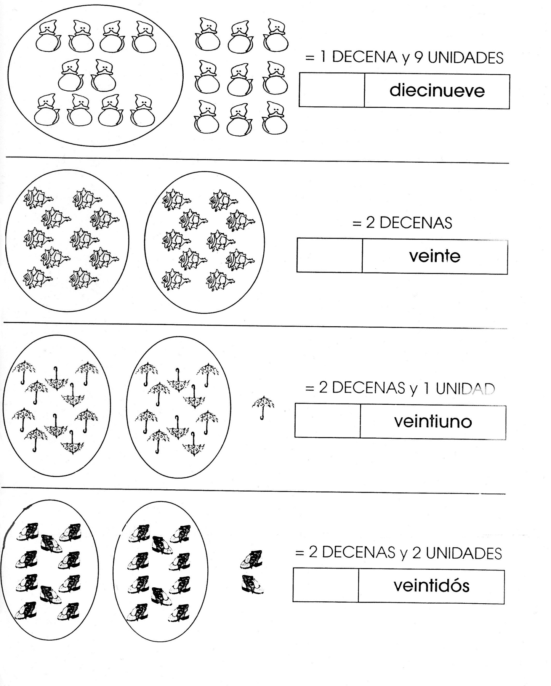



Nombre

Realiza el siguiente ejercicio:

Colorea de rojo los cuadros según las decenas.

= 10 = decena

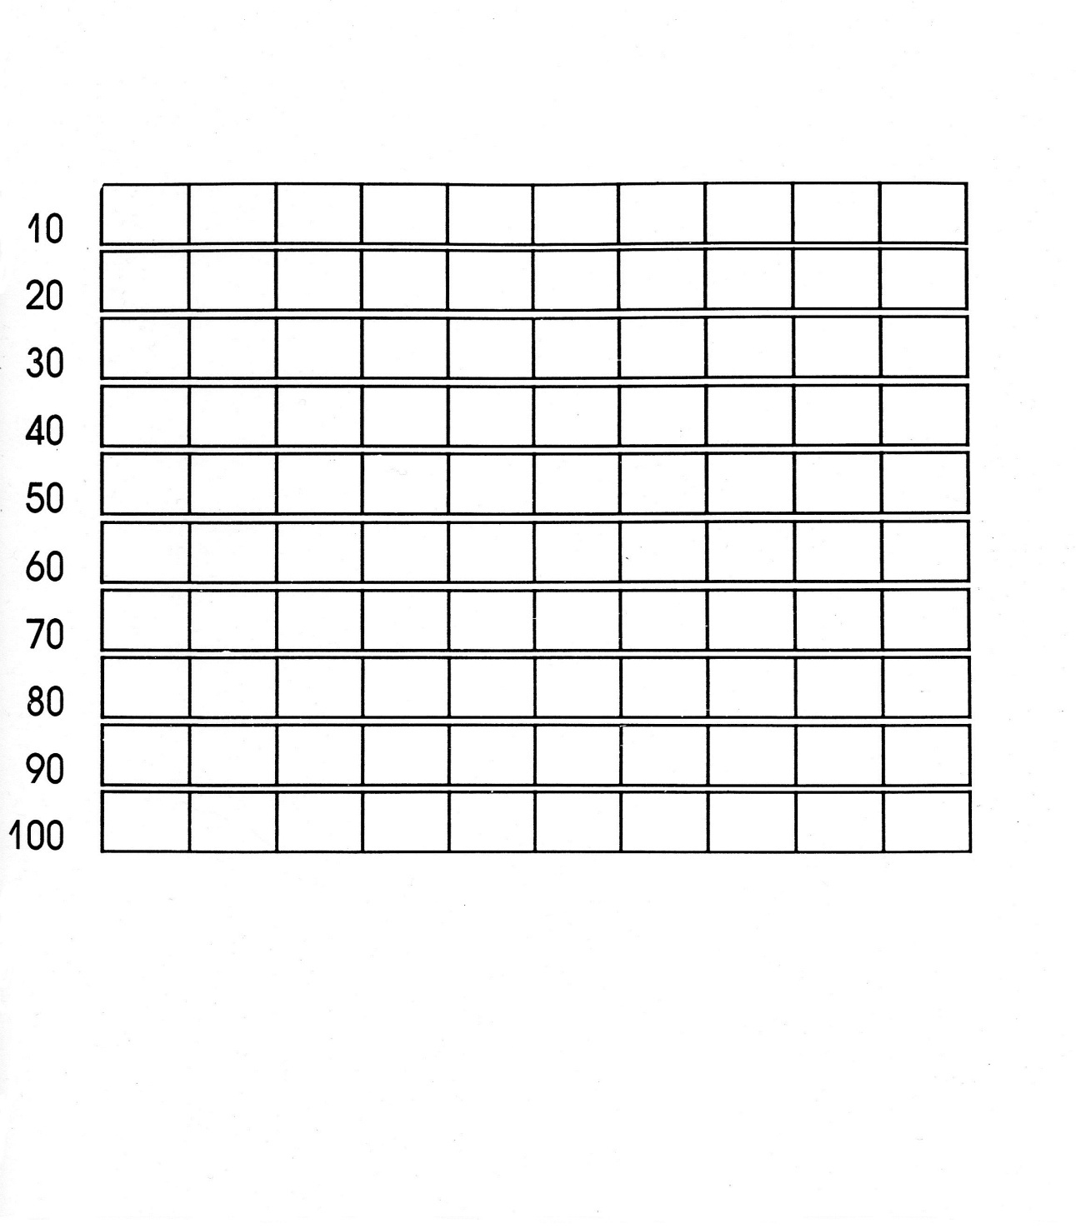

Nombre

Ejercicio 1 Realiza la familia del 80 ubicando el cuadro.

|  |  |  |  |  |  |  |  |  |  |  |  |  |  |  |  |  |  |  |  |  |  |  |  |  |  |  |  |  |  |
| --- | --- | --- | --- | --- | --- | --- | --- | --- | --- | --- | --- | --- | --- | --- | --- | --- | --- | --- | --- | --- | --- | --- | --- | --- | --- | --- | --- | --- | --- |
|  |  |  |  |  |  |  |  |  |  |  |  |  |  |  |  |  |  |  |  |  |  |  |  |  |  |  |  |  |  |
|  |  |  |  |  |  |  |  |  |  |  |  |  |  |  |  |  |  |  |  |  |  |  |  |  |  |  |  |  |  |
|  |  |  |  |  |  |  |  |  |  |  |  |  |  |  |  |  |  |  |  |  |  |  |  |  |  |  |  |  |  |
|  |  |  |  |  |  |  |  |  |  |  |  |  |  |  |  |  |  |  |  |  |  |  |  |  |  |  |  |  |  |
|  |  |  |  |  |  |  |  |  |  |  |  |  |  |  |  |  |  |  |  |  |  |  |  |  |  |  |  |  |  |
|  |  |  |  |  |  |  |  |  |  |  |  |  |  |  |  |  |  |  |  |  |  |  |  |  |  |  |  |  |  |

Ejercicio 2

|  |  |  |  |  |  |  |  |  |  |  |  |  |  |  |  |  |  |  |  |  |  |  |  |  |  |  |  |  |  |
| --- | --- | --- | --- | --- | --- | --- | --- | --- | --- | --- | --- | --- | --- | --- | --- | --- | --- | --- | --- | --- | --- | --- | --- | --- | --- | --- | --- | --- | --- |
|  |  |  |  |  |  |  |  |  |  |  |  |  |  |  |  |  |  |  |  |  |  |  |  |  |  |  |  |  |  |
|  |  |  |  |  |  |  |  |  |  |  |  |  |  |  |  |  |  |  |  |  |  |  |  |  |  |  |  |  |  |
|  |  |  |  |  |  |  |  |  |  |  |  |  |  |  |  |  |  |  |  |  |  |  |  |  |  |  |  |  |  |
|  |  |  |  |  |  |  |  |  |  |  |  |  |  |  |  |  |  |  |  |  |  |  |  |  |  |  |  |  |  |
|  |  |  |  |  |  |  |  |  |  |  |  |  |  |  |  |  |  |  |  |  |  |  |  |  |  |  |  |  |  |
|  |  |  |  |  |  |  |  |  |  |  |  |  |  |  |  |  |  |  |  |  |  |  |  |  |  |  |  |  |  |

Ejercicio 3

|  |  |  |  |  |  |  |  |  |  |  |  |  |  |  |  |  |  |  |  |  |  |  |  |  |  |  |  |  |  |
| --- | --- | --- | --- | --- | --- | --- | --- | --- | --- | --- | --- | --- | --- | --- | --- | --- | --- | --- | --- | --- | --- | --- | --- | --- | --- | --- | --- | --- | --- |
|  |  |  |  |  |  |  |  |  |  |  |  |  |  |  |  |  |  |  |  |  |  |  |  |  |  |  |  |  |  |
|  |  |  |  |  |  |  |  |  |  |  |  |  |  |  |  |  |  |  |  |  |  |  |  |  |  |  |  |  |  |
|  |  |  |  |  |  |  |  |  |  |  |  |  |  |  |  |  |  |  |  |  |  |  |  |  |  |  |  |  |  |
|  |  |  |  |  |  |  |  |  |  |  |  |  |  |  |  |  |  |  |  |  |  |  |  |  |  |  |  |  |  |
|  |  |  |  |  |  |  |  |  |  |  |  |  |  |  |  |  |  |  |  |  |  |  |  |  |  |  |  |  |  |
|  |  |  |  |  |  |  |  |  |  |  |  |  |  |  |  |  |  |  |  |  |  |  |  |  |  |  |  |  |  |

Ejercicio 4

|  |  |  |  |  |  |  |  |  |  |  |  |  |  |  |  |  |  |  |  |  |  |  |  |  |  |  |  |  |  |
| --- | --- | --- | --- | --- | --- | --- | --- | --- | --- | --- | --- | --- | --- | --- | --- | --- | --- | --- | --- | --- | --- | --- | --- | --- | --- | --- | --- | --- | --- |
|  |  |  |  |  |  |  |  |  |  |  |  |  |  |  |  |  |  |  |  |  |  |  |  |  |  |  |  |  |  |
|  |  |  |  |  |  |  |  |  |  |  |  |  |  |  |  |  |  |  |  |  |  |  |  |  |  |  |  |  |  |
|  |  |  |  |  |  |  |  |  |  |  |  |  |  |  |  |  |  |  |  |  |  |  |  |  |  |  |  |  |  |
|  |  |  |  |  |  |  |  |  |  |  |  |  |  |  |  |  |  |  |  |  |  |  |  |  |  |  |  |  |  |
|  |  |  |  |  |  |  |  |  |  |  |  |  |  |  |  |  |  |  |  |  |  |  |  |  |  |  |  |  |  |
|  |  |  |  |  |  |  |  |  |  |  |  |  |  |  |  |  |  |  |  |  |  |  |  |  |  |  |  |  |  |

Ejercicio 5

|  |  |  |  |  |  |  |  |  |  |  |  |  |  |  |  |  |  |  |  |  |  |  |  |  |  |  |  |  |  |
| --- | --- | --- | --- | --- | --- | --- | --- | --- | --- | --- | --- | --- | --- | --- | --- | --- | --- | --- | --- | --- | --- | --- | --- | --- | --- | --- | --- | --- | --- |
|  |  |  |  |  |  |  |  |  |  |  |  |  |  |  |  |  |  |  |  |  |  |  |  |  |  |  |  |  |  |
|  |  |  |  |  |  |  |  |  |  |  |  |  |  |  |  |  |  |  |  |  |  |  |  |  |  |  |  |  |  |
|  |  |  |  |  |  |  |  |  |  |  |  |  |  |  |  |  |  |  |  |  |  |  |  |  |  |  |  |  |  |
|  |  |  |  |  |  |  |  |  |  |  |  |  |  |  |  |  |  |  |  |  |  |  |  |  |  |  |  |  |  |
|  |  |  |  |  |  |  |  |  |  |  |  |  |  |  |  |  |  |  |  |  |  |  |  |  |  |  |  |  |  |
|  |  |  |  |  |  |  |  |  | Scan0005 |  |  |  |  |  |  |  |  |  |  |  |  |  |  |  |  |  |  |  |  |

Nombre

Con recortes de números la familia del 80.

80



Nombre

Decora lo que celebramos en abril.

Día de los niños

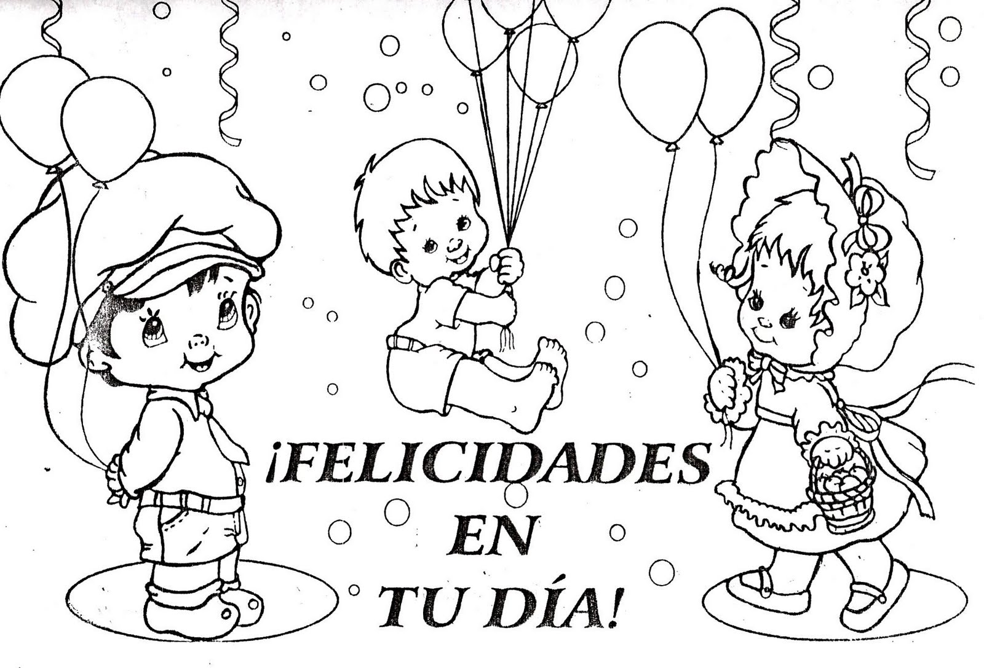



Nombre

Decora con diversidad de materiales.

Isósceles



Nombre

Decora con material variado.

Equilátero



Nombre

Ejercicio 1 Continúa con la plana de triángulos ubicando el cuadro.

|  |  |  |  |  |  |  |  |  |  |  |  |  |  |  |  |  |  |  |  |  |  |  |  |  |  |  |  |  |  |
| --- | --- | --- | --- | --- | --- | --- | --- | --- | --- | --- | --- | --- | --- | --- | --- | --- | --- | --- | --- | --- | --- | --- | --- | --- | --- | --- | --- | --- | --- |
|  |  |  |  |  |  |  |  |  |  |  |  |  |  |  |  |  |  |  |  |  |  |  |  |  |  |  |  |  |  |
|  |  |  |  |  |  |  |  |  |  |  |  |  |  |  |  |  |  |  |  |  |  |  |  |  |  |  |  |  |  |
|  |  |  |  |  |  |  |  |  |  |  |  |  |  |  |  |  |  |  |  |  |  |  |  |  |  |  |  |  |  |
|  |  |  |  |  |  |  |  |  |  |  |  |  |  |  |  |  |  |  |  |  |  |  |  |  |  |  |  |  |  |
|  |  |  |  |  |  |  |  |  |  |  |  |  |  |  |  |  |  |  |  |  |  |  |  |  |  |  |  |  |  |
|  |  |  |  |  |  |  |  |  |  |  |  |  |  |  |  |  |  |  |  |  |  |  |  |  |  |  |  |  |  |

Ejercicio 2

|  |  |  |  |  |  |  |  |  |  |  |  |  |  |  |  |  |  |  |  |  |  |  |  |  |  |  |  |  |  |
| --- | --- | --- | --- | --- | --- | --- | --- | --- | --- | --- | --- | --- | --- | --- | --- | --- | --- | --- | --- | --- | --- | --- | --- | --- | --- | --- | --- | --- | --- |
|  |  |  |  |  |  |  |  |  |  |  |  |  |  |  |  |  |  |  |  |  |  |  |  |  |  |  |  |  |  |
|  |  |  |  |  |  |  |  |  |  |  |  |  |  |  |  |  |  |  |  |  |  |  |  |  |  |  |  |  |  |
|  |  |  |  |  |  |  |  |  |  |  |  |  |  |  |  |  |  |  |  |  |  |  |  |  |  |  |  |  |  |
|  |  |  |  |  |  |  |  |  |  |  |  |  |  |  |  |  |  |  |  |  |  |  |  |  |  |  |  |  |  |
|  |  |  |  |  |  |  |  |  |  |  |  |  |  |  |  |  |  |  |  |  |  |  |  |  |  |  |  |  |  |
|  |  |  |  |  |  |  |  |  |  |  |  |  |  |  |  |  |  |  |  |  |  |  |  |  |  |  |  |  |  |

Ejercicio 3

|  |  |  |  |  |  |  |  |  |  |  |  |  |  |  |  |  |  |  |  |  |  |  |  |  |  |  |  |  |  |
| --- | --- | --- | --- | --- | --- | --- | --- | --- | --- | --- | --- | --- | --- | --- | --- | --- | --- | --- | --- | --- | --- | --- | --- | --- | --- | --- | --- | --- | --- |
|  |  |  |  |  |  |  |  |  |  |  |  |  |  |  |  |  |  |  |  |  |  |  |  |  |  |  |  |  |  |
|  |  |  |  |  |  |  |  |  |  |  |  |  |  |  |  |  |  |  |  |  |  |  |  |  |  |  |  |  |  |
|  |  |  |  |  |  |  |  |  |  |  |  |  |  |  |  |  |  |  |  |  |  |  |  |  |  |  |  |  |  |
|  |  |  |  |  |  |  |  |  |  |  |  |  |  |  |  |  |  |  |  |  |  |  |  |  |  |  |  |  |  |
|  |  |  |  |  |  |  |  |  |  |  |  |  |  |  |  |  |  |  |  |  |  |  |  |  |  |  |  |  |  |
|  |  |  |  |  |  |  |  |  |  |  |  |  |  |  |  |  |  |  |  |  |  |  |  |  |  |  |  |  |  |

Ejercicio 4

|  |  |  |  |  |  |  |  |  |  |  |  |  |  |  |  |  |  |  |  |  |  |  |  |  |  |  |  |  |  |
| --- | --- | --- | --- | --- | --- | --- | --- | --- | --- | --- | --- | --- | --- | --- | --- | --- | --- | --- | --- | --- | --- | --- | --- | --- | --- | --- | --- | --- | --- |
|  |  |  |  |  |  |  |  |  |  |  |  |  |  |  |  |  |  |  |  |  |  |  |  |  |  |  |  |  |  |
|  |  |  |  |  |  |  |  |  |  |  |  |  |  |  |  |  |  |  |  |  |  |  |  |  |  |  |  |  |  |
|  |  |  |  |  |  |  |  |  |  |  |  |  |  |  |  |  |  |  |  |  |  |  |  |  |  |  |  |  |  |
|  |  |  |  |  |  |  |  |  |  |  |  |  |  |  |  |  |  |  |  |  |  |  |  |  |  |  |  |  |  |
|  |  |  |  |  |  |  |  |  |  |  |  |  |  |  |  |  |  |  |  |  |  |  |  |  |  |  |  |  |  |
|  |  |  |  |  |  |  |  |  |  |  |  |  |  |  |  |  |  |  |  |  |  |  |  |  |  |  |  |  |  |

Ejercicio 5

|  |  |  |  |  |  |  |  |  |  |  |  |  |  |  |  |  |  |  |  |  |  |  |  |  |  |  |  |  |  |
| --- | --- | --- | --- | --- | --- | --- | --- | --- | --- | --- | --- | --- | --- | --- | --- | --- | --- | --- | --- | --- | --- | --- | --- | --- | --- | --- | --- | --- | --- |
|  |  |  |  |  |  |  |  |  |  |  |  |  |  |  |  |  |  |  |  |  |  |  |  |  |  |  |  |  |  |
|  |  |  |  |  |  |  |  |  |  |  |  |  |  |  |  |  |  |  |  |  |  |  |  |  |  |  |  |  |  |
|  |  |  |  |  |  |  |  |  |  |  |  |  |  |  |  |  |  |  |  |  |  |  |  |  |  |  |  |  |  |
|  |  |  |  |  |  |  |  |  |  |  |  |  |  |  |  |  |  |  |  |  |  |  |  |  |  |  |  |  |  |
|  |  |  |  |  |  |  |  |  |  |  |  |  |  |  |  |  |  |  |  |  |  |  |  |  |  |  |  |  |  |
|  |  |  |  |  |  |  |  |  |  |  | Scan0005 |  |  |  |  |  |  |  |  |  |  |  |  |  |  |  |  |  |  |

Nombre

Decora con material variado.

Escaleno

Nombre

Encierra los objetos pesados y tacha los ligeros.

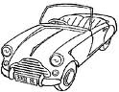 



 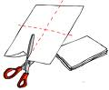

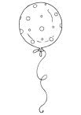



Nombre

Realiza las siguientes operaciones.

7 - 5 = _______ 9 - 9 = ________

4 + 4 = _______ 4 – 3 = ________

9 – 7 = _______ 2 + 6 = ________

3 + 6 = _______ 5 + 4 = ________

1 + 0 = _______ 8 – 7 = _________



Nombre

Decora con material variado la letra F f

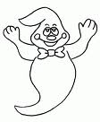



Nombre

Escucha la lectura de la “La foca Fifú” de tu libro cuenta cuentos, decora el dibujo y pega palabras con F f alrededor.

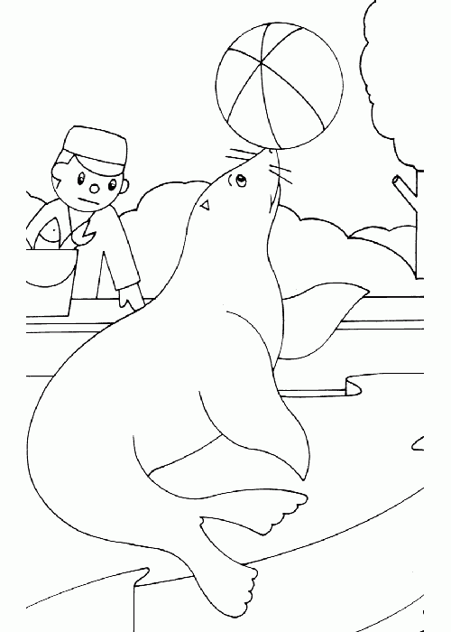



Nombre

Ejercicio 1 Continúa con la plana ubicando el cuadro correctamente.

|  |  |  |  |  |  |  |  |  |  |  |  |  |  |  |  |  |  |  |  |  |  |  |  |  |  |  |  |  |  |
| --- | --- | --- | --- | --- | --- | --- | --- | --- | --- | --- | --- | --- | --- | --- | --- | --- | --- | --- | --- | --- | --- | --- | --- | --- | --- | --- | --- | --- | --- |
|  |  |  |  |  |  |  |  |  |  |  |  |  |  |  |  |  |  |  |  |  |  |  |  |  |  |  |  |  |  |
|  |  |  |  |  |  |  |  |  |  |  |  |  |  |  |  |  |  |  |  |  |  |  |  |  |  |  |  |  |  |
|  |  |  |  |  |  |  |  |  |  |  |  |  |  |  |  |  |  |  |  |  |  |  |  |  |  |  |  |  |  |
|  |  |  |  |  |  |  |  |  |  |  |  |  |  |  |  |  |  |  |  |  |  |  |  |  |  |  |  |  |  |
|  |  |  |  |  |  |  |  |  |  |  |  |  |  |  |  |  |  |  |  |  |  |  |  |  |  |  |  |  |  |
|  |  |  |  |  |  |  |  |  |  |  |  |  |  |  |  |  |  |  |  |  |  |  |  |  |  |  |  |  |  |

Ejercicio 2

|  |  |  |  |  |  |  |  |  |  |  |  |  |  |  |  |  |  |  |  |  |  |  |  |  |  |  |  |  |  |
| --- | --- | --- | --- | --- | --- | --- | --- | --- | --- | --- | --- | --- | --- | --- | --- | --- | --- | --- | --- | --- | --- | --- | --- | --- | --- | --- | --- | --- | --- |
|  |  |  |  |  |  |  |  |  |  |  |  |  |  |  |  |  |  |  |  |  |  |  |  |  |  |  |  |  |  |
|  |  |  |  |  |  |  |  |  |  |  |  |  |  |  |  |  |  |  |  |  |  |  |  |  |  |  |  |  |  |
|  |  |  |  |  |  |  |  |  |  |  |  |  |  |  |  |  |  |  |  |  |  |  |  |  |  |  |  |  |  |
|  |  |  |  |  |  |  |  |  |  |  |  |  |  |  |  |  |  |  |  |  |  |  |  |  |  |  |  |  |  |
|  |  |  |  |  |  |  |  |  |  |  |  |  |  |  |  |  |  |  |  |  |  |  |  |  |  |  |  |  |  |
|  |  |  |  |  |  |  |  |  |  |  |  |  |  |  |  |  |  |  |  |  |  |  |  |  |  |  |  |  |  |

Ejercicio 3

|  |  |  |  |  |  |  |  |  |  |  |  |  |  |  |  |  |  |  |  |  |  |  |  |  |  |  |  |  |  |
| --- | --- | --- | --- | --- | --- | --- | --- | --- | --- | --- | --- | --- | --- | --- | --- | --- | --- | --- | --- | --- | --- | --- | --- | --- | --- | --- | --- | --- | --- |
|  |  |  |  |  |  |  |  |  |  |  |  |  |  |  |  |  |  |  |  |  |  |  |  |  |  |  |  |  |  |
|  |  |  |  |  |  |  |  |  |  |  |  |  |  |  |  |  |  |  |  |  |  |  |  |  |  |  |  |  |  |
|  |  |  |  |  |  |  |  |  |  |  |  |  |  |  |  |  |  |  |  |  |  |  |  |  |  |  |  |  |  |
|  |  |  |  |  |  |  |  |  |  |  |  |  |  |  |  |  |  |  |  |  |  |  |  |  |  |  |  |  |  |
|  |  |  |  |  |  |  |  |  |  |  |  |  |  |  |  |  |  |  |  |  |  |  |  |  |  |  |  |  |  |
|  |  |  |  |  |  |  |  |  |  |  |  |  |  |  |  |  |  |  |  |  |  |  |  |  |  |  |  |  |  |

Ejercicio 4

|  |  |  |  |  |  |  |  |  |  |  |  |  |  |  |  |  |  |  |  |  |  |  |  |  |  |  |  |  |  |
| --- | --- | --- | --- | --- | --- | --- | --- | --- | --- | --- | --- | --- | --- | --- | --- | --- | --- | --- | --- | --- | --- | --- | --- | --- | --- | --- | --- | --- | --- |
|  |  |  |  |  |  |  |  |  |  |  |  |  |  |  |  |  |  |  |  |  |  |  |  |  |  |  |  |  |  |
|  |  |  |  |  |  |  |  |  |  |  |  |  |  |  |  |  |  |  |  |  |  |  |  |  |  |  |  |  |  |
|  |  |  |  |  |  |  |  |  |  |  |  |  |  |  |  |  |  |  |  |  |  |  |  |  |  |  |  |  |  |
|  |  |  |  |  |  |  |  |  |  |  |  |  |  |  |  |  |  |  |  |  |  |  |  |  |  |  |  |  |  |
|  |  |  |  |  |  |  |  |  |  |  |  |  |  |  |  |  |  |  |  |  |  |  |  |  |  |  |  |  |  |
|  |  |  |  |  |  |  |  |  |  |  |  |  |  |  |  |  |  |  |  |  |  |  |  |  |  |  |  |  |  |

Ejercicio 5

|  |  |  |  |  |  |  |  |  |  |  |  |  |  |  |  |  |  |  |  |  |  |  |  |  |  |  |  |  |  |
| --- | --- | --- | --- | --- | --- | --- | --- | --- | --- | --- | --- | --- | --- | --- | --- | --- | --- | --- | --- | --- | --- | --- | --- | --- | --- | --- | --- | --- | --- |
|  |  |  |  |  |  |  |  |  |  |  |  |  |  |  |  |  |  |  |  |  |  |  |  |  |  |  |  |  |  |
|  |  |  |  |  |  |  |  |  |  |  |  |  |  |  |  |  |  |  |  |  |  |  |  |  |  |  |  |  |  |
|  |  |  |  |  |  |  |  |  |  |  |  |  |  |  |  |  |  |  |  |  |  |  |  |  |  |  |  |  |  |
|  |  |  |  |  |  |  |  |  |  |  |  |  |  |  |  |  |  |  |  |  |  |  |  |  |  |  |  |  |  |
|  |  |  |  |  |  |  |  |  |  |  |  |  |  |  |  |  |  |  |  |  |  |  |  |  |  |  |  |  |  |
|  |  |  |  |  |  |  |  |  |  | Scan0005 |  |  |  |  |  |  |  |  |  |  |  |  |  |  |  |  |  |  |  |

Nombre

Ejercicio 1 Continúa con la plana ubicando el cuadro correctamente.

|  |  |  |  |  |  |  |  |  |  |  |  |  |  |  |  |  |  |  |  |  |  |  |  |  |  |  |  |  |  |
| --- | --- | --- | --- | --- | --- | --- | --- | --- | --- | --- | --- | --- | --- | --- | --- | --- | --- | --- | --- | --- | --- | --- | --- | --- | --- | --- | --- | --- | --- |
|  |  |  |  |  |  |  |  |  |  |  |  |  |  |  |  |  |  |  |  |  |  |  |  |  |  |  |  |  |  |
|  |  |  |  |  |  |  |  |  |  |  |  |  |  |  |  |  |  |  |  |  |  |  |  |  |  |  |  |  |  |
|  |  |  |  |  |  |  |  |  |  |  |  |  |  |  |  |  |  |  |  |  |  |  |  |  |  |  |  |  |  |
|  |  |  |  |  |  |  |  |  |  |  |  |  |  |  |  |  |  |  |  |  |  |  |  |  |  |  |  |  |  |
|  |  |  |  |  |  |  |  |  |  |  |  |  |  |  |  |  |  |  |  |  |  |  |  |  |  |  |  |  |  |
|  |  |  |  |  |  |  |  |  |  |  |  |  |  |  |  |  |  |  |  |  |  |  |  |  |  |  |  |  |  |

Ejercicio 2

|  |  |  |  |  |  |  |  |  |  |  |  |  |  |  |  |  |  |  |  |  |  |  |  |  |  |  |  |  |  |
| --- | --- | --- | --- | --- | --- | --- | --- | --- | --- | --- | --- | --- | --- | --- | --- | --- | --- | --- | --- | --- | --- | --- | --- | --- | --- | --- | --- | --- | --- |
|  |  |  |  |  |  |  |  |  |  |  |  |  |  |  |  |  |  |  |  |  |  |  |  |  |  |  |  |  |  |
|  |  |  |  |  |  |  |  |  |  |  |  |  |  |  |  |  |  |  |  |  |  |  |  |  |  |  |  |  |  |
|  |  |  |  |  |  |  |  |  |  |  |  |  |  |  |  |  |  |  |  |  |  |  |  |  |  |  |  |  |  |
|  |  |  |  |  |  |  |  |  |  |  |  |  |  |  |  |  |  |  |  |  |  |  |  |  |  |  |  |  |  |
|  |  |  |  |  |  |  |  |  |  |  |  |  |  |  |  |  |  |  |  |  |  |  |  |  |  |  |  |  |  |
|  |  |  |  |  |  |  |  |  |  |  |  |  |  |  |  |  |  |  |  |  |  |  |  |  |  |  |  |  |  |

Ejercicio 3

|  |  |  |  |  |  |  |  |  |  |  |  |  |  |  |  |  |  |  |  |  |  |  |  |  |  |  |  |  |  |
| --- | --- | --- | --- | --- | --- | --- | --- | --- | --- | --- | --- | --- | --- | --- | --- | --- | --- | --- | --- | --- | --- | --- | --- | --- | --- | --- | --- | --- | --- |
|  |  |  |  |  |  |  |  |  |  |  |  |  |  |  |  |  |  |  |  |  |  |  |  |  |  |  |  |  |  |
|  |  |  |  |  |  |  |  |  |  |  |  |  |  |  |  |  |  |  |  |  |  |  |  |  |  |  |  |  |  |
|  |  |  |  |  |  |  |  |  |  |  |  |  |  |  |  |  |  |  |  |  |  |  |  |  |  |  |  |  |  |
|  |  |  |  |  |  |  |  |  |  |  |  |  |  |  |  |  |  |  |  |  |  |  |  |  |  |  |  |  |  |
|  |  |  |  |  |  |  |  |  |  |  |  |  |  |  |  |  |  |  |  |  |  |  |  |  |  |  |  |  |  |
|  |  |  |  |  |  |  |  |  |  |  |  |  |  |  |  |  |  |  |  |  |  |  |  |  |  |  |  |  |  |

Ejercicio 4

|  |  |  |  |  |  |  |  |  |  |  |  |  |  |  |  |  |  |  |  |  |  |  |  |  |  |  |  |  |  |
| --- | --- | --- | --- | --- | --- | --- | --- | --- | --- | --- | --- | --- | --- | --- | --- | --- | --- | --- | --- | --- | --- | --- | --- | --- | --- | --- | --- | --- | --- |
|  |  |  |  |  |  |  |  |  |  |  |  |  |  |  |  |  |  |  |  |  |  |  |  |  |  |  |  |  |  |
|  |  |  |  |  |  |  |  |  |  |  |  |  |  |  |  |  |  |  |  |  |  |  |  |  |  |  |  |  |  |
|  |  |  |  |  |  |  |  |  |  |  |  |  |  |  |  |  |  |  |  |  |  |  |  |  |  |  |  |  |  |
|  |  |  |  |  |  |  |  |  |  |  |  |  |  |  |  |  |  |  |  |  |  |  |  |  |  |  |  |  |  |
|  |  |  |  |  |  |  |  |  |  |  |  |  |  |  |  |  |  |  |  |  |  |  |  |  |  |  |  |  |  |
|  |  |  |  |  |  |  |  |  |  |  |  |  |  |  |  |  |  |  |  |  |  |  |  |  |  |  |  |  |  |

Ejercicio 5

|  |  |  |  |  |  |  |  |  |  |  |  |  |  |  |  |  |  |  |  |  |  |  |  |  |  |  |  |  |  |
| --- | --- | --- | --- | --- | --- | --- | --- | --- | --- | --- | --- | --- | --- | --- | --- | --- | --- | --- | --- | --- | --- | --- | --- | --- | --- | --- | --- | --- | --- |
|  |  |  |  |  |  |  |  |  |  |  |  |  |  |  |  |  |  |  |  |  |  |  |  |  |  |  |  |  |  |
|  |  |  |  |  |  |  |  |  |  |  |  |  |  |  |  |  |  |  |  |  |  |  |  |  |  |  |  |  |  |
|  |  |  |  |  |  |  |  |  |  |  |  |  |  |  |  |  |  |  |  |  |  |  |  |  |  |  |  |  |  |
|  |  |  |  |  |  |  |  |  |  |  |  |  |  |  |  |  |  |  |  |  |  |  |  |  |  |  |  |  |  |
|  |  |  |  |  |  |  |  |  |  |  |  |  |  |  |  |  |  |  |  |  |  |  |  |  |  |  |  |  |  |
|  |  |  |  |  |  |  |  |  |  |  | Scan0005 |  |  |  |  |  |  |  |  |  |  |  |  |  |  |  |  |  |  |

Nombre

Decora con material variado la letra FR, FL.



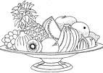



Nombre

Ejercicio 1 Continúa con la plana de la fl, fr ubicando el cuadro correctamente.

|  |  |  |  |  |  |  |  |  |  |  |  |  |  |  |  |  |  |  |  |  |  |  |  |  |  |  |  |  |  |
| --- | --- | --- | --- | --- | --- | --- | --- | --- | --- | --- | --- | --- | --- | --- | --- | --- | --- | --- | --- | --- | --- | --- | --- | --- | --- | --- | --- | --- | --- |
|  |  |  |  |  |  |  |  |  |  |  |  |  |  |  |  |  |  |  |  |  |  |  |  |  |  |  |  |  |  |
|  |  |  |  |  |  |  |  |  |  |  |  |  |  |  |  |  |  |  |  |  |  |  |  |  |  |  |  |  |  |
|  |  |  |  |  |  |  |  |  |  |  |  |  |  |  |  |  |  |  |  |  |  |  |  |  |  |  |  |  |  |
|  |  |  |  |  |  |  |  |  |  |  |  |  |  |  |  |  |  |  |  |  |  |  |  |  |  |  |  |  |  |
|  |  |  |  |  |  |  |  |  |  |  |  |  |  |  |  |  |  |  |  |  |  |  |  |  |  |  |  |  |  |
|  |  |  |  |  |  |  |  |  |  |  |  |  |  |  |  |  |  |  |  |  |  |  |  |  |  |  |  |  |  |

Ejercicio 2

|  |  |  |  |  |  |  |  |  |  |  |  |  |  |  |  |  |  |  |  |  |  |  |  |  |  |  |  |  |  |
| --- | --- | --- | --- | --- | --- | --- | --- | --- | --- | --- | --- | --- | --- | --- | --- | --- | --- | --- | --- | --- | --- | --- | --- | --- | --- | --- | --- | --- | --- |
|  |  |  |  |  |  |  |  |  |  |  |  |  |  |  |  |  |  |  |  |  |  |  |  |  |  |  |  |  |  |
|  |  |  |  |  |  |  |  |  |  |  |  |  |  |  |  |  |  |  |  |  |  |  |  |  |  |  |  |  |  |
|  |  |  |  |  |  |  |  |  |  |  |  |  |  |  |  |  |  |  |  |  |  |  |  |  |  |  |  |  |  |
|  |  |  |  |  |  |  |  |  |  |  |  |  |  |  |  |  |  |  |  |  |  |  |  |  |  |  |  |  |  |
|  |  |  |  |  |  |  |  |  |  |  |  |  |  |  |  |  |  |  |  |  |  |  |  |  |  |  |  |  |  |
|  |  |  |  |  |  |  |  |  |  |  |  |  |  |  |  |  |  |  |  |  |  |  |  |  |  |  |  |  |  |

Ejercicio 3

|  |  |  |  |  |  |  |  |  |  |  |  |  |  |  |  |  |  |  |  |  |  |  |  |  |  |  |  |  |  |
| --- | --- | --- | --- | --- | --- | --- | --- | --- | --- | --- | --- | --- | --- | --- | --- | --- | --- | --- | --- | --- | --- | --- | --- | --- | --- | --- | --- | --- | --- |
|  |  |  |  |  |  |  |  |  |  |  |  |  |  |  |  |  |  |  |  |  |  |  |  |  |  |  |  |  |  |
|  |  |  |  |  |  |  |  |  |  |  |  |  |  |  |  |  |  |  |  |  |  |  |  |  |  |  |  |  |  |
|  |  |  |  |  |  |  |  |  |  |  |  |  |  |  |  |  |  |  |  |  |  |  |  |  |  |  |  |  |  |
|  |  |  |  |  |  |  |  |  |  |  |  |  |  |  |  |  |  |  |  |  |  |  |  |  |  |  |  |  |  |
|  |  |  |  |  |  |  |  |  |  |  |  |  |  |  |  |  |  |  |  |  |  |  |  |  |  |  |  |  |  |
|  |  |  |  |  |  |  |  |  |  |  |  |  |  |  |  |  |  |  |  |  |  |  |  |  |  |  |  |  |  |

Ejercicio 4

|  |  |  |  |  |  |  |  |  |  |  |  |  |  |  |  |  |  |  |  |  |  |  |  |  |  |  |  |  |  |
| --- | --- | --- | --- | --- | --- | --- | --- | --- | --- | --- | --- | --- | --- | --- | --- | --- | --- | --- | --- | --- | --- | --- | --- | --- | --- | --- | --- | --- | --- |
|  |  |  |  |  |  |  |  |  |  |  |  |  |  |  |  |  |  |  |  |  |  |  |  |  |  |  |  |  |  |
|  |  |  |  |  |  |  |  |  |  |  |  |  |  |  |  |  |  |  |  |  |  |  |  |  |  |  |  |  |  |
|  |  |  |  |  |  |  |  |  |  |  |  |  |  |  |  |  |  |  |  |  |  |  |  |  |  |  |  |  |  |
|  |  |  |  |  |  |  |  |  |  |  |  |  |  |  |  |  |  |  |  |  |  |  |  |  |  |  |  |  |  |
|  |  |  |  |  |  |  |  |  |  |  |  |  |  |  |  |  |  |  |  |  |  |  |  |  |  |  |  |  |  |
|  |  |  |  |  |  |  |  |  |  |  |  |  |  |  |  |  |  |  |  |  |  |  |  |  |  |  |  |  |  |

Ejercicio 5

|  |  |  |  |  |  |  |  |  |  |  |  |  |  |  |  |  |  |  |  |  |  |  |  |  |  |  |  |  |  |
| --- | --- | --- | --- | --- | --- | --- | --- | --- | --- | --- | --- | --- | --- | --- | --- | --- | --- | --- | --- | --- | --- | --- | --- | --- | --- | --- | --- | --- | --- |
|  |  |  |  |  |  |  |  |  |  |  |  |  |  |  |  |  |  |  |  |  |  |  |  |  |  |  |  |  |  |
|  |  |  |  |  |  |  |  |  |  |  |  |  |  |  |  |  |  |  |  |  |  |  |  |  |  |  |  |  |  |
|  |  |  |  |  |  |  |  |  |  |  |  |  |  |  |  |  |  |  |  |  |  |  |  |  |  |  |  |  |  |
|  |  |  |  |  |  |  |  |  |  |  |  |  |  |  |  |  |  |  |  |  |  |  |  |  |  |  |  |  |  |
|  |  |  |  |  |  |  |  |  |  |  |  |  |  |  |  |  |  |  |  |  |  |  |  |  |  |  |  |  |  |
|  |  |  |  |  |  |  |  |  | Scan0005 |  |  |  |  |  |  |  |  |  |  |  |  |  |  |  |  |  |  |  |  |

Nombre

Cuenta los dibujos y pon el número en el recuadro.

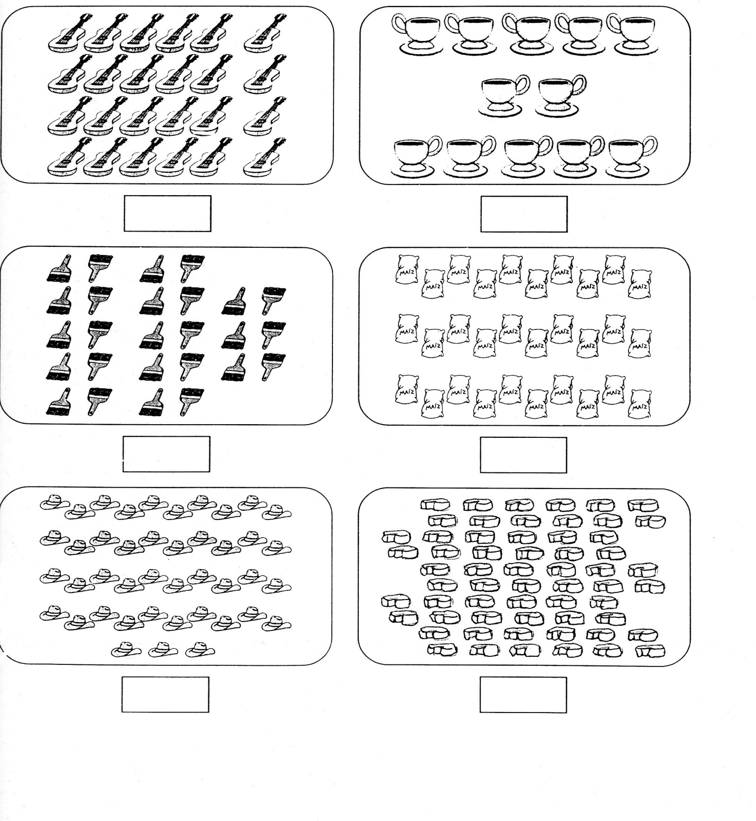



Nombre

Con recortes de números pega la familia del 90

90



Nombre

Copia el siguiente problema del pizarrón y realízalo.

________________________________________________________________________________________________________________________________________________________________________

Operación.

Resultado.



Nombre

Decora lo que celebramos en mayo.

10 de mayo día de las madres.

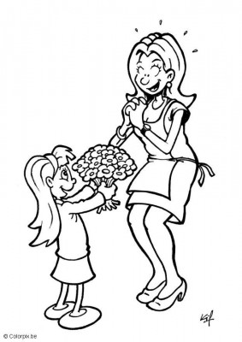



Nombre

Decora con material variado la letra J j

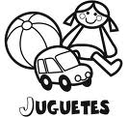

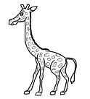



Nombre

Escucha la lectura de “La jirafita Jazmín” de tu libro cuenta cuentos, decora el dibujo y alrededor pégale palabras con j.

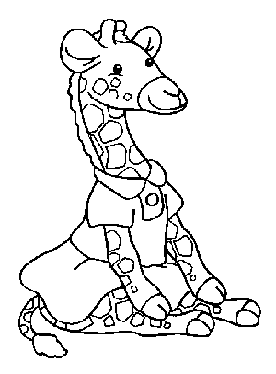



Nombre

Ejercicio 1 Continúa con la plana ubicando el cuadro correctamente.

|  |  |  |  |  |  |  |  |  |  |  |  |  |  |  |  |  |  |  |  |  |  |  |  |  |  |  |  |  |  |
| --- | --- | --- | --- | --- | --- | --- | --- | --- | --- | --- | --- | --- | --- | --- | --- | --- | --- | --- | --- | --- | --- | --- | --- | --- | --- | --- | --- | --- | --- |
|  |  |  |  |  |  |  |  |  |  |  |  |  |  |  |  |  |  |  |  |  |  |  |  |  |  |  |  |  |  |
|  |  |  |  |  |  |  |  |  |  |  |  |  |  |  |  |  |  |  |  |  |  |  |  |  |  |  |  |  |  |
|  |  |  |  |  |  |  |  |  |  |  |  |  |  |  |  |  |  |  |  |  |  |  |  |  |  |  |  |  |  |
|  |  |  |  |  |  |  |  |  |  |  |  |  |  |  |  |  |  |  |  |  |  |  |  |  |  |  |  |  |  |
|  |  |  |  |  |  |  |  |  |  |  |  |  |  |  |  |  |  |  |  |  |  |  |  |  |  |  |  |  |  |
|  |  |  |  |  |  |  |  |  |  |  |  |  |  |  |  |  |  |  |  |  |  |  |  |  |  |  |  |  |  |

Ejercicio 2

|  |  |  |  |  |  |  |  |  |  |  |  |  |  |  |  |  |  |  |  |  |  |  |  |  |  |  |  |  |  |
| --- | --- | --- | --- | --- | --- | --- | --- | --- | --- | --- | --- | --- | --- | --- | --- | --- | --- | --- | --- | --- | --- | --- | --- | --- | --- | --- | --- | --- | --- |
|  |  |  |  |  |  |  |  |  |  |  |  |  |  |  |  |  |  |  |  |  |  |  |  |  |  |  |  |  |  |
|  |  |  |  |  |  |  |  |  |  |  |  |  |  |  |  |  |  |  |  |  |  |  |  |  |  |  |  |  |  |
|  |  |  |  |  |  |  |  |  |  |  |  |  |  |  |  |  |  |  |  |  |  |  |  |  |  |  |  |  |  |
|  |  |  |  |  |  |  |  |  |  |  |  |  |  |  |  |  |  |  |  |  |  |  |  |  |  |  |  |  |  |
|  |  |  |  |  |  |  |  |  |  |  |  |  |  |  |  |  |  |  |  |  |  |  |  |  |  |  |  |  |  |
|  |  |  |  |  |  |  |  |  |  |  |  |  |  |  |  |  |  |  |  |  |  |  |  |  |  |  |  |  |  |

Ejercicio 3

|  |  |  |  |  |  |  |  |  |  |  |  |  |  |  |  |  |  |  |  |  |  |  |  |  |  |  |  |  |  |
| --- | --- | --- | --- | --- | --- | --- | --- | --- | --- | --- | --- | --- | --- | --- | --- | --- | --- | --- | --- | --- | --- | --- | --- | --- | --- | --- | --- | --- | --- |
|  |  |  |  |  |  |  |  |  |  |  |  |  |  |  |  |  |  |  |  |  |  |  |  |  |  |  |  |  |  |
|  |  |  |  |  |  |  |  |  |  |  |  |  |  |  |  |  |  |  |  |  |  |  |  |  |  |  |  |  |  |
|  |  |  |  |  |  |  |  |  |  |  |  |  |  |  |  |  |  |  |  |  |  |  |  |  |  |  |  |  |  |
|  |  |  |  |  |  |  |  |  |  |  |  |  |  |  |  |  |  |  |  |  |  |  |  |  |  |  |  |  |  |
|  |  |  |  |  |  |  |  |  |  |  |  |  |  |  |  |  |  |  |  |  |  |  |  |  |  |  |  |  |  |
|  |  |  |  |  |  |  |  |  |  |  |  |  |  |  |  |  |  |  |  |  |  |  |  |  |  |  |  |  |  |

Ejercicio 4

|  |  |  |  |  |  |  |  |  |  |  |  |  |  |  |  |  |  |  |  |  |  |  |  |  |  |  |  |  |  |
| --- | --- | --- | --- | --- | --- | --- | --- | --- | --- | --- | --- | --- | --- | --- | --- | --- | --- | --- | --- | --- | --- | --- | --- | --- | --- | --- | --- | --- | --- |
|  |  |  |  |  |  |  |  |  |  |  |  |  |  |  |  |  |  |  |  |  |  |  |  |  |  |  |  |  |  |
|  |  |  |  |  |  |  |  |  |  |  |  |  |  |  |  |  |  |  |  |  |  |  |  |  |  |  |  |  |  |
|  |  |  |  |  |  |  |  |  |  |  |  |  |  |  |  |  |  |  |  |  |  |  |  |  |  |  |  |  |  |
|  |  |  |  |  |  |  |  |  |  |  |  |  |  |  |  |  |  |  |  |  |  |  |  |  |  |  |  |  |  |
|  |  |  |  |  |  |  |  |  |  |  |  |  |  |  |  |  |  |  |  |  |  |  |  |  |  |  |  |  |  |
|  |  |  |  |  |  |  |  |  |  |  |  |  |  |  |  |  |  |  |  |  |  |  |  |  |  |  |  |  |  |

Ejercicio 5

|  |  |  |  |  |  |  |  |  |  |  |  |  |  |  |  |  |  |  |  |  |  |  |  |  |  |  |  |  |  |
| --- | --- | --- | --- | --- | --- | --- | --- | --- | --- | --- | --- | --- | --- | --- | --- | --- | --- | --- | --- | --- | --- | --- | --- | --- | --- | --- | --- | --- | --- |
|  |  |  |  |  |  |  |  |  |  |  |  |  |  |  |  |  |  |  |  |  |  |  |  |  |  |  |  |  |  |
|  |  |  |  |  |  |  |  |  |  |  |  |  |  |  |  |  |  |  |  |  |  |  |  |  |  |  |  |  |  |
|  |  |  |  |  |  |  |  |  |  |  |  |  |  |  |  |  |  |  |  |  |  |  |  |  |  |  |  |  |  |
|  |  |  |  |  |  |  |  |  |  |  |  |  |  |  |  |  |  |  |  |  |  |  |  |  |  |  |  |  |  |
|  |  |  |  |  |  |  |  |  |  |  |  |  |  |  |  |  |  |  |  |  |  |  |  |  |  |  |  |  |  |
|  |  |  |  |  |  |  |  |  |  | Scan0005 |  |  |  |  |  |  |  |  |  |  |  |  |  |  |  |  |  |  |  |

Nombre

Ejercicio 1 Continúa con la plana ubicando el cuadro correctamente.

|  |  |  |  |  |  |  |  |  |  |  |  |  |  |  |  |  |  |  |  |  |  |  |  |  |  |  |  |  |  |
| --- | --- | --- | --- | --- | --- | --- | --- | --- | --- | --- | --- | --- | --- | --- | --- | --- | --- | --- | --- | --- | --- | --- | --- | --- | --- | --- | --- | --- | --- |
|  |  |  |  |  |  |  |  |  |  |  |  |  |  |  |  |  |  |  |  |  |  |  |  |  |  |  |  |  |  |
|  |  |  |  |  |  |  |  |  |  |  |  |  |  |  |  |  |  |  |  |  |  |  |  |  |  |  |  |  |  |
|  |  |  |  |  |  |  |  |  |  |  |  |  |  |  |  |  |  |  |  |  |  |  |  |  |  |  |  |  |  |
|  |  |  |  |  |  |  |  |  |  |  |  |  |  |  |  |  |  |  |  |  |  |  |  |  |  |  |  |  |  |
|  |  |  |  |  |  |  |  |  |  |  |  |  |  |  |  |  |  |  |  |  |  |  |  |  |  |  |  |  |  |
|  |  |  |  |  |  |  |  |  |  |  |  |  |  |  |  |  |  |  |  |  |  |  |  |  |  |  |  |  |  |

Ejercicio 2

|  |  |  |  |  |  |  |  |  |  |  |  |  |  |  |  |  |  |  |  |  |  |  |  |  |  |  |  |  |  |
| --- | --- | --- | --- | --- | --- | --- | --- | --- | --- | --- | --- | --- | --- | --- | --- | --- | --- | --- | --- | --- | --- | --- | --- | --- | --- | --- | --- | --- | --- |
|  |  |  |  |  |  |  |  |  |  |  |  |  |  |  |  |  |  |  |  |  |  |  |  |  |  |  |  |  |  |
|  |  |  |  |  |  |  |  |  |  |  |  |  |  |  |  |  |  |  |  |  |  |  |  |  |  |  |  |  |  |
|  |  |  |  |  |  |  |  |  |  |  |  |  |  |  |  |  |  |  |  |  |  |  |  |  |  |  |  |  |  |
|  |  |  |  |  |  |  |  |  |  |  |  |  |  |  |  |  |  |  |  |  |  |  |  |  |  |  |  |  |  |
|  |  |  |  |  |  |  |  |  |  |  |  |  |  |  |  |  |  |  |  |  |  |  |  |  |  |  |  |  |  |
|  |  |  |  |  |  |  |  |  |  |  |  |  |  |  |  |  |  |  |  |  |  |  |  |  |  |  |  |  |  |

Ejercicio 3

|  |  |  |  |  |  |  |  |  |  |  |  |  |  |  |  |  |  |  |  |  |  |  |  |  |  |  |  |  |  |
| --- | --- | --- | --- | --- | --- | --- | --- | --- | --- | --- | --- | --- | --- | --- | --- | --- | --- | --- | --- | --- | --- | --- | --- | --- | --- | --- | --- | --- | --- |
|  |  |  |  |  |  |  |  |  |  |  |  |  |  |  |  |  |  |  |  |  |  |  |  |  |  |  |  |  |  |
|  |  |  |  |  |  |  |  |  |  |  |  |  |  |  |  |  |  |  |  |  |  |  |  |  |  |  |  |  |  |
|  |  |  |  |  |  |  |  |  |  |  |  |  |  |  |  |  |  |  |  |  |  |  |  |  |  |  |  |  |  |
|  |  |  |  |  |  |  |  |  |  |  |  |  |  |  |  |  |  |  |  |  |  |  |  |  |  |  |  |  |  |
|  |  |  |  |  |  |  |  |  |  |  |  |  |  |  |  |  |  |  |  |  |  |  |  |  |  |  |  |  |  |
|  |  |  |  |  |  |  |  |  |  |  |  |  |  |  |  |  |  |  |  |  |  |  |  |  |  |  |  |  |  |

Ejercicio 4

|  |  |  |  |  |  |  |  |  |  |  |  |  |  |  |  |  |  |  |  |  |  |  |  |  |  |  |  |  |  |
| --- | --- | --- | --- | --- | --- | --- | --- | --- | --- | --- | --- | --- | --- | --- | --- | --- | --- | --- | --- | --- | --- | --- | --- | --- | --- | --- | --- | --- | --- |
|  |  |  |  |  |  |  |  |  |  |  |  |  |  |  |  |  |  |  |  |  |  |  |  |  |  |  |  |  |  |
|  |  |  |  |  |  |  |  |  |  |  |  |  |  |  |  |  |  |  |  |  |  |  |  |  |  |  |  |  |  |
|  |  |  |  |  |  |  |  |  |  |  |  |  |  |  |  |  |  |  |  |  |  |  |  |  |  |  |  |  |  |
|  |  |  |  |  |  |  |  |  |  |  |  |  |  |  |  |  |  |  |  |  |  |  |  |  |  |  |  |  |  |
|  |  |  |  |  |  |  |  |  |  |  |  |  |  |  |  |  |  |  |  |  |  |  |  |  |  |  |  |  |  |
|  |  |  |  |  |  |  |  |  |  |  |  |  |  |  |  |  |  |  |  |  |  |  |  |  |  |  |  |  |  |

Ejercicio 5

|  |  |  |  |  |  |  |  |  |  |  |  |  |  |  |  |  |  |  |  |  |  |  |  |  |  |  |  |  |  |
| --- | --- | --- | --- | --- | --- | --- | --- | --- | --- | --- | --- | --- | --- | --- | --- | --- | --- | --- | --- | --- | --- | --- | --- | --- | --- | --- | --- | --- | --- |
|  |  |  |  |  |  |  |  |  |  |  |  |  |  |  |  |  |  |  |  |  |  |  |  |  |  |  |  |  |  |
|  |  |  |  |  |  |  |  |  |  |  |  |  |  |  |  |  |  |  |  |  |  |  |  |  |  |  |  |  |  |
|  |  |  |  |  |  |  |  |  |  |  |  |  |  |  |  |  |  |  |  |  |  |  |  |  |  |  |  |  |  |
|  |  |  |  |  |  |  |  |  |  |  |  |  |  |  |  |  |  |  |  |  |  |  |  |  |  |  |  |  |  |
|  |  |  |  |  |  |  |  |  |  |  |  |  |  |  |  |  |  |  |  |  |  |  |  |  |  |  |  |  |  |
|  |  |  |  |  |  |  |  |  |  | Scan0005 |  |  |  |  |  |  |  |  |  |  |  |  |  |  |  |  |  |  |  |

Nombre

Observa el dibujo y únelo con la palabra correcta.

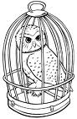 Jardinera 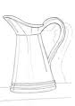

Jabón

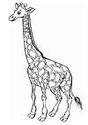 Jarra 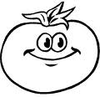

Jirafa

Jaula 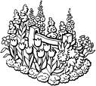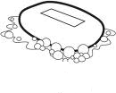

 Jitomate

Nombre

Con diferentes colores encierra los dibujos por decenas y pon en el recuadro cuantas decenas y unidades formaste.

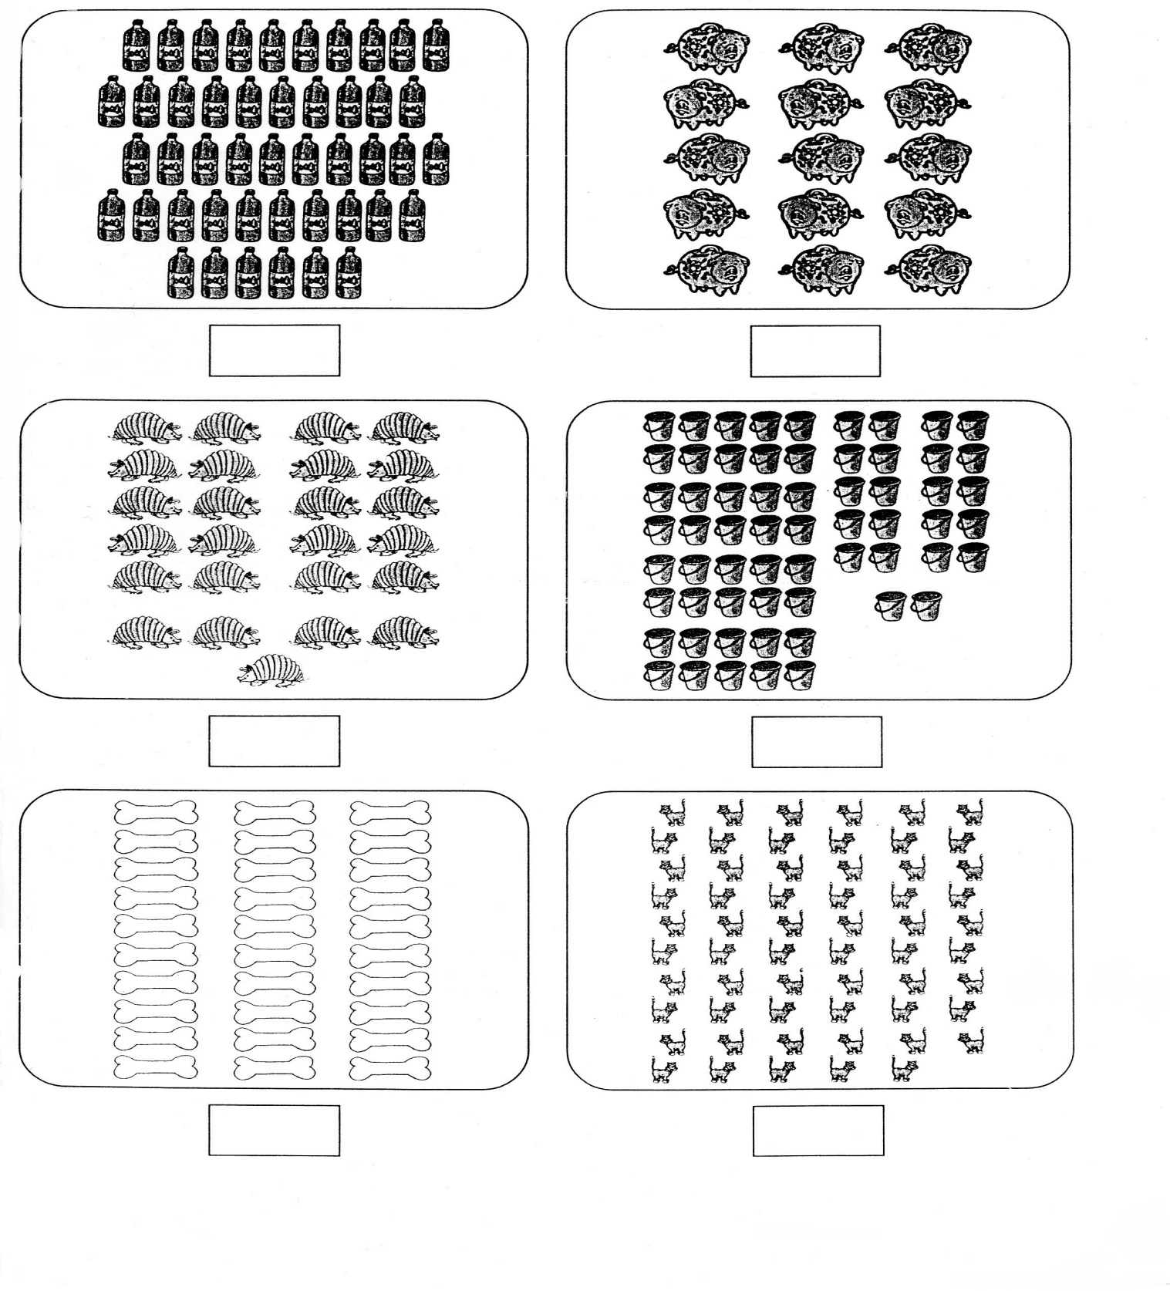

Nombre

Decora lo que celebramos en mayo.

Día del maestro.

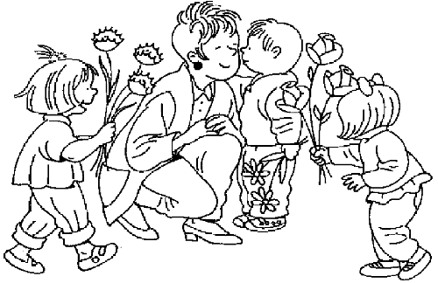



Nombre

Colorea las figuras según el color.

Rojo Morado

Azul verde

Café Naranja



Nombre

Decora con material variado la letra X x.

México

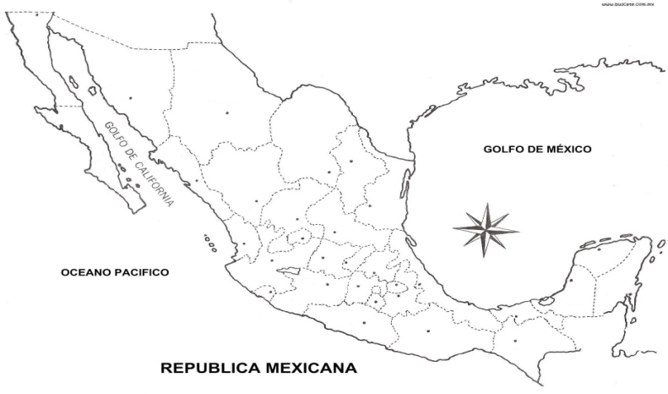



Nombre

Ejercicio 1 Realiza los siguientes ejercicios de caligrafía.

|  |  |  |  |  |  |  |  |  |  |  |  |  |  |  |  |  |  |  |  |  |  |  |  |  |  |  |  |  |  |
| --- | --- | --- | --- | --- | --- | --- | --- | --- | --- | --- | --- | --- | --- | --- | --- | --- | --- | --- | --- | --- | --- | --- | --- | --- | --- | --- | --- | --- | --- |
|  |  |  |  |  |  |  |  |  |  |  |  |  |  |  |  |  |  |  |  |  |  |  |  |  |  |  |  |  |  |
|  |  |  |  |  |  |  |  |  |  |  |  |  |  |  |  |  |  |  |  |  |  |  |  |  |  |  |  |  |  |
|  |  |  |  |  |  |  |  |  |  |  |  |  |  |  |  |  |  |  |  |  |  |  |  |  |  |  |  |  |  |
|  |  |  |  |  |  |  |  |  |  |  |  |  |  |  |  |  |  |  |  |  |  |  |  |  |  |  |  |  |  |
|  |  |  |  |  |  |  |  |  |  |  |  |  |  |  |  |  |  |  |  |  |  |  |  |  |  |  |  |  |  |
|  |  |  |  |  |  |  |  |  |  |  |  |  |  |  |  |  |  |  |  |  |  |  |  |  |  |  |  |  |  |

Ejercicio 2

|  |  |  |  |  |  |  |  |  |  |  |  |  |  |  |  |  |  |  |  |  |  |  |  |  |  |  |  |  |  |
| --- | --- | --- | --- | --- | --- | --- | --- | --- | --- | --- | --- | --- | --- | --- | --- | --- | --- | --- | --- | --- | --- | --- | --- | --- | --- | --- | --- | --- | --- |
|  |  |  |  |  |  |  |  |  |  |  |  |  |  |  |  |  |  |  |  |  |  |  |  |  |  |  |  |  |  |
|  |  |  |  |  |  |  |  |  |  |  |  |  |  |  |  |  |  |  |  |  |  |  |  |  |  |  |  |  |  |
|  |  |  |  |  |  |  |  |  |  |  |  |  |  |  |  |  |  |  |  |  |  |  |  |  |  |  |  |  |  |
|  |  |  |  |  |  |  |  |  |  |  |  |  |  |  |  |  |  |  |  |  |  |  |  |  |  |  |  |  |  |
|  |  |  |  |  |  |  |  |  |  |  |  |  |  |  |  |  |  |  |  |  |  |  |  |  |  |  |  |  |  |
|  |  |  |  |  |  |  |  |  |  |  |  |  |  |  |  |  |  |  |  |  |  |  |  |  |  |  |  |  |  |

Ejercicio 3

|  |  |  |  |  |  |  |  |  |  |  |  |  |  |  |  |  |  |  |  |  |  |  |  |  |  |  |  |  |  |
| --- | --- | --- | --- | --- | --- | --- | --- | --- | --- | --- | --- | --- | --- | --- | --- | --- | --- | --- | --- | --- | --- | --- | --- | --- | --- | --- | --- | --- | --- |
|  |  |  |  |  |  |  |  |  |  |  |  |  |  |  |  |  |  |  |  |  |  |  |  |  |  |  |  |  |  |
|  |  |  |  |  |  |  |  |  |  |  |  |  |  |  |  |  |  |  |  |  |  |  |  |  |  |  |  |  |  |
|  |  |  |  |  |  |  |  |  |  |  |  |  |  |  |  |  |  |  |  |  |  |  |  |  |  |  |  |  |  |
|  |  |  |  |  |  |  |  |  |  |  |  |  |  |  |  |  |  |  |  |  |  |  |  |  |  |  |  |  |  |
|  |  |  |  |  |  |  |  |  |  |  |  |  |  |  |  |  |  |  |  |  |  |  |  |  |  |  |  |  |  |
|  |  |  |  |  |  |  |  |  |  |  |  |  |  |  |  |  |  |  |  |  |  |  |  |  |  |  |  |  |  |

Ejercicio 4

|  |  |  |  |  |  |  |  |  |  |  |  |  |  |  |  |  |  |  |  |  |  |  |  |  |  |  |  |  |  |
| --- | --- | --- | --- | --- | --- | --- | --- | --- | --- | --- | --- | --- | --- | --- | --- | --- | --- | --- | --- | --- | --- | --- | --- | --- | --- | --- | --- | --- | --- |
|  |  |  |  |  |  |  |  |  |  |  |  |  |  |  |  |  |  |  |  |  |  |  |  |  |  |  |  |  |  |
|  |  |  |  |  |  |  |  |  |  |  |  |  |  |  |  |  |  |  |  |  |  |  |  |  |  |  |  |  |  |
|  |  |  |  |  |  |  |  |  |  |  |  |  |  |  |  |  |  |  |  |  |  |  |  |  |  |  |  |  |  |
|  |  |  |  |  |  |  |  |  |  |  |  |  |  |  |  |  |  |  |  |  |  |  |  |  |  |  |  |  |  |
|  |  |  |  |  |  |  |  |  |  |  |  |  |  |  |  |  |  |  |  |  |  |  |  |  |  |  |  |  |  |
|  |  |  |  |  |  |  |  |  |  |  |  |  |  |  |  |  |  |  |  |  |  |  |  |  |  |  |  |  |  |

Ejercicio 5

|  |  |  |  |  |  |  |  |  |  |  |  |  |  |  |  |  |  |  |  |  |  |  |  |  |  |  |  |  |  |
| --- | --- | --- | --- | --- | --- | --- | --- | --- | --- | --- | --- | --- | --- | --- | --- | --- | --- | --- | --- | --- | --- | --- | --- | --- | --- | --- | --- | --- | --- |
|  |  |  |  |  |  |  |  |  |  |  |  |  |  |  |  |  |  |  |  |  |  |  |  |  |  |  |  |  |  |
|  |  |  |  |  |  |  |  |  |  |  |  |  |  |  |  |  |  |  |  |  |  |  |  |  |  |  |  |  |  |
|  |  |  |  |  |  |  |  |  |  |  |  |  |  |  |  |  |  |  |  |  |  |  |  |  |  |  |  |  |  |
|  |  |  |  |  |  |  |  |  |  |  |  |  |  |  |  |  |  |  |  |  |  |  |  |  |  |  |  |  |  |
|  |  |  |  |  |  |  |  |  |  |  |  |  |  |  |  |  |  |  |  |  |  |  |  |  |  |  |  |  |  |
|  |  |  |  |  |  |  |  |  |  | Scan0005 |  |  |  |  |  |  |  |  |  |  |  |  |  |  |  |  |  |  |  |

Nombre

Escucha la lectura de “México” de tu libro cuenta cuentos e ilustra con recortes que mas hay aquí en nuestro país.



Nombre

Ejercicio 1 Continúa con la plana ubicando el cuadro correctamente.

|  |  |  |  |  |  |  |  |  |  |  |  |  |  |  |  |  |  |  |  |  |  |  |  |  |  |  |  |  |  |
| --- | --- | --- | --- | --- | --- | --- | --- | --- | --- | --- | --- | --- | --- | --- | --- | --- | --- | --- | --- | --- | --- | --- | --- | --- | --- | --- | --- | --- | --- |
|  |  |  |  |  |  |  |  |  |  |  |  |  |  |  |  |  |  |  |  |  |  |  |  |  |  |  |  |  |  |
|  |  |  |  |  |  |  |  |  |  |  |  |  |  |  |  |  |  |  |  |  |  |  |  |  |  |  |  |  |  |
|  |  |  |  |  |  |  |  |  |  |  |  |  |  |  |  |  |  |  |  |  |  |  |  |  |  |  |  |  |  |
|  |  |  |  |  |  |  |  |  |  |  |  |  |  |  |  |  |  |  |  |  |  |  |  |  |  |  |  |  |  |
|  |  |  |  |  |  |  |  |  |  |  |  |  |  |  |  |  |  |  |  |  |  |  |  |  |  |  |  |  |  |
|  |  |  |  |  |  |  |  |  |  |  |  |  |  |  |  |  |  |  |  |  |  |  |  |  |  |  |  |  |  |

Ejercicio 2

|  |  |  |  |  |  |  |  |  |  |  |  |  |  |  |  |  |  |  |  |  |  |  |  |  |  |  |  |  |  |
| --- | --- | --- | --- | --- | --- | --- | --- | --- | --- | --- | --- | --- | --- | --- | --- | --- | --- | --- | --- | --- | --- | --- | --- | --- | --- | --- | --- | --- | --- |
|  |  |  |  |  |  |  |  |  |  |  |  |  |  |  |  |  |  |  |  |  |  |  |  |  |  |  |  |  |  |
|  |  |  |  |  |  |  |  |  |  |  |  |  |  |  |  |  |  |  |  |  |  |  |  |  |  |  |  |  |  |
|  |  |  |  |  |  |  |  |  |  |  |  |  |  |  |  |  |  |  |  |  |  |  |  |  |  |  |  |  |  |
|  |  |  |  |  |  |  |  |  |  |  |  |  |  |  |  |  |  |  |  |  |  |  |  |  |  |  |  |  |  |
|  |  |  |  |  |  |  |  |  |  |  |  |  |  |  |  |  |  |  |  |  |  |  |  |  |  |  |  |  |  |
|  |  |  |  |  |  |  |  |  |  |  |  |  |  |  |  |  |  |  |  |  |  |  |  |  |  |  |  |  |  |

Ejercicio 3

|  |  |  |  |  |  |  |  |  |  |  |  |  |  |  |  |  |  |  |  |  |  |  |  |  |  |  |  |  |  |
| --- | --- | --- | --- | --- | --- | --- | --- | --- | --- | --- | --- | --- | --- | --- | --- | --- | --- | --- | --- | --- | --- | --- | --- | --- | --- | --- | --- | --- | --- |
|  |  |  |  |  |  |  |  |  |  |  |  |  |  |  |  |  |  |  |  |  |  |  |  |  |  |  |  |  |  |
|  |  |  |  |  |  |  |  |  |  |  |  |  |  |  |  |  |  |  |  |  |  |  |  |  |  |  |  |  |  |
|  |  |  |  |  |  |  |  |  |  |  |  |  |  |  |  |  |  |  |  |  |  |  |  |  |  |  |  |  |  |
|  |  |  |  |  |  |  |  |  |  |  |  |  |  |  |  |  |  |  |  |  |  |  |  |  |  |  |  |  |  |
|  |  |  |  |  |  |  |  |  |  |  |  |  |  |  |  |  |  |  |  |  |  |  |  |  |  |  |  |  |  |
|  |  |  |  |  |  |  |  |  |  |  |  |  |  |  |  |  |  |  |  |  |  |  |  |  |  |  |  |  |  |

Ejercicio 4

|  |  |  |  |  |  |  |  |  |  |  |  |  |  |  |  |  |  |  |  |  |  |  |  |  |  |  |  |  |  |
| --- | --- | --- | --- | --- | --- | --- | --- | --- | --- | --- | --- | --- | --- | --- | --- | --- | --- | --- | --- | --- | --- | --- | --- | --- | --- | --- | --- | --- | --- |
|  |  |  |  |  |  |  |  |  |  |  |  |  |  |  |  |  |  |  |  |  |  |  |  |  |  |  |  |  |  |
|  |  |  |  |  |  |  |  |  |  |  |  |  |  |  |  |  |  |  |  |  |  |  |  |  |  |  |  |  |  |
|  |  |  |  |  |  |  |  |  |  |  |  |  |  |  |  |  |  |  |  |  |  |  |  |  |  |  |  |  |  |
|  |  |  |  |  |  |  |  |  |  |  |  |  |  |  |  |  |  |  |  |  |  |  |  |  |  |  |  |  |  |
|  |  |  |  |  |  |  |  |  |  |  |  |  |  |  |  |  |  |  |  |  |  |  |  |  |  |  |  |  |  |
|  |  |  |  |  |  |  |  |  |  |  |  |  |  |  |  |  |  |  |  |  |  |  |  |  |  |  |  |  |  |

Ejercicio 5

|  |  |  |  |  |  |  |  |  |  |  |  |  |  |  |  |  |  |  |  |  |  |  |  |  |  |  |  |  |  |
| --- | --- | --- | --- | --- | --- | --- | --- | --- | --- | --- | --- | --- | --- | --- | --- | --- | --- | --- | --- | --- | --- | --- | --- | --- | --- | --- | --- | --- | --- |
|  |  |  |  |  |  |  |  |  |  |  |  |  |  |  |  |  |  |  |  |  |  |  |  |  |  |  |  |  |  |
|  |  |  |  |  |  |  |  |  |  |  |  |  |  |  |  |  |  |  |  |  |  |  |  |  |  |  |  |  |  |
|  |  |  |  |  |  |  |  |  |  |  |  |  |  |  |  |  |  |  |  |  |  |  |  |  |  |  |  |  |  |
|  |  |  |  |  |  |  |  |  |  |  |  |  |  |  |  |  |  |  |  |  |  |  |  |  |  |  |  |  |  |
|  |  |  |  |  |  |  |  |  |  |  |  |  |  |  |  |  |  |  |  |  |  |  |  |  |  |  |  |  |  |
|  |  |  |  |  |  |  |  |  | Scan0005 |  |  |  |  |  |  |  |  |  |  |  |  |  |  |  |  |  |  |  |  |

Nombre

Decora con material variado de color amarillo.

Centena

Centena = 100



Nombre

Representa con cuadritos de papel de colores correspondientes las unidades, decenas, centenas.

c d u cdu cdu cdu

124 137 100 152



Nombre

Resuelve los siguientes problemas.

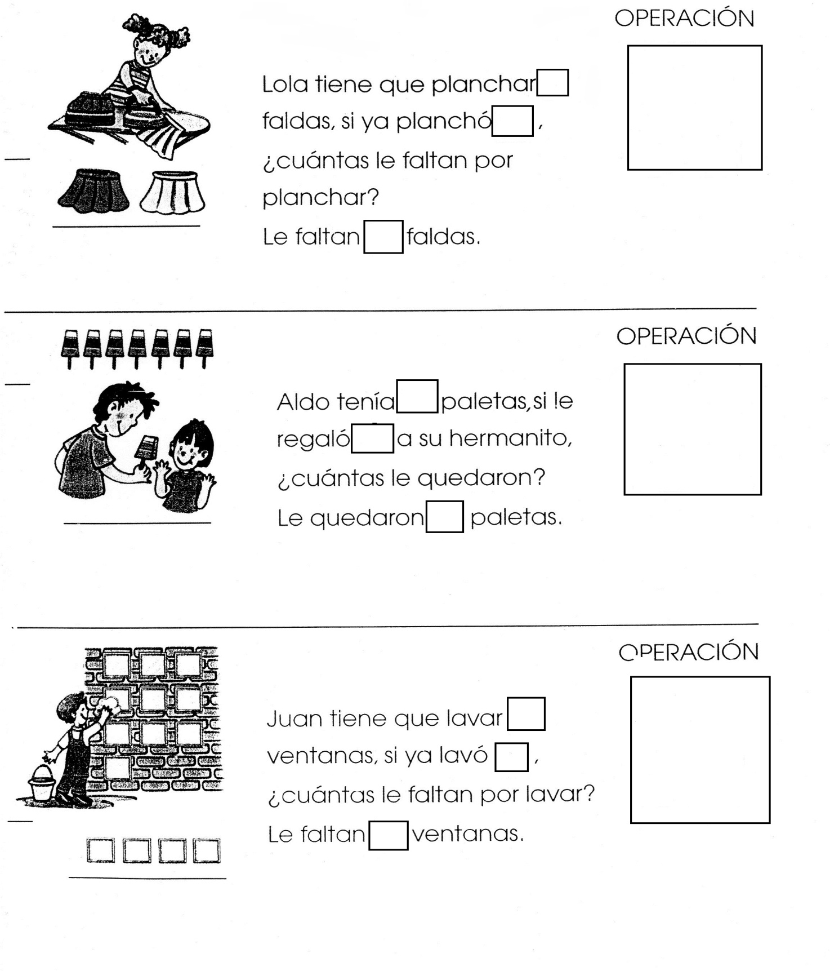

Nombre

Con recortes de números pega la familia del 100.



Nombre

Ejercicio 1 Continúa con la plana de la familia del 100.

|  |  |  |  |  |  |  |  |  |  |  |  |  |  |  |  |  |  |  |  |  |  |  |  |  |  |  |  |  |  |
| --- | --- | --- | --- | --- | --- | --- | --- | --- | --- | --- | --- | --- | --- | --- | --- | --- | --- | --- | --- | --- | --- | --- | --- | --- | --- | --- | --- | --- | --- |
|  |  |  |  |  |  |  |  |  |  |  |  |  |  |  |  |  |  |  |  |  |  |  |  |  |  |  |  |  |  |
|  |  |  |  |  |  |  |  |  |  |  |  |  |  |  |  |  |  |  |  |  |  |  |  |  |  |  |  |  |  |
|  |  |  |  |  |  |  |  |  |  |  |  |  |  |  |  |  |  |  |  |  |  |  |  |  |  |  |  |  |  |
|  |  |  |  |  |  |  |  |  |  |  |  |  |  |  |  |  |  |  |  |  |  |  |  |  |  |  |  |  |  |
|  |  |  |  |  |  |  |  |  |  |  |  |  |  |  |  |  |  |  |  |  |  |  |  |  |  |  |  |  |  |
|  |  |  |  |  |  |  |  |  |  |  |  |  |  |  |  |  |  |  |  |  |  |  |  |  |  |  |  |  |  |

Ejercicio 2

|  |  |  |  |  |  |  |  |  |  |  |  |  |  |  |  |  |  |  |  |  |  |  |  |  |  |  |  |  |  |
| --- | --- | --- | --- | --- | --- | --- | --- | --- | --- | --- | --- | --- | --- | --- | --- | --- | --- | --- | --- | --- | --- | --- | --- | --- | --- | --- | --- | --- | --- |
|  |  |  |  |  |  |  |  |  |  |  |  |  |  |  |  |  |  |  |  |  |  |  |  |  |  |  |  |  |  |
|  |  |  |  |  |  |  |  |  |  |  |  |  |  |  |  |  |  |  |  |  |  |  |  |  |  |  |  |  |  |
|  |  |  |  |  |  |  |  |  |  |  |  |  |  |  |  |  |  |  |  |  |  |  |  |  |  |  |  |  |  |
|  |  |  |  |  |  |  |  |  |  |  |  |  |  |  |  |  |  |  |  |  |  |  |  |  |  |  |  |  |  |
|  |  |  |  |  |  |  |  |  |  |  |  |  |  |  |  |  |  |  |  |  |  |  |  |  |  |  |  |  |  |
|  |  |  |  |  |  |  |  |  |  |  |  |  |  |  |  |  |  |  |  |  |  |  |  |  |  |  |  |  |  |

Ejercicio 3

|  |  |  |  |  |  |  |  |  |  |  |  |  |  |  |  |  |  |  |  |  |  |  |  |  |  |  |  |  |  |
| --- | --- | --- | --- | --- | --- | --- | --- | --- | --- | --- | --- | --- | --- | --- | --- | --- | --- | --- | --- | --- | --- | --- | --- | --- | --- | --- | --- | --- | --- |
|  |  |  |  |  |  |  |  |  |  |  |  |  |  |  |  |  |  |  |  |  |  |  |  |  |  |  |  |  |  |
|  |  |  |  |  |  |  |  |  |  |  |  |  |  |  |  |  |  |  |  |  |  |  |  |  |  |  |  |  |  |
|  |  |  |  |  |  |  |  |  |  |  |  |  |  |  |  |  |  |  |  |  |  |  |  |  |  |  |  |  |  |
|  |  |  |  |  |  |  |  |  |  |  |  |  |  |  |  |  |  |  |  |  |  |  |  |  |  |  |  |  |  |
|  |  |  |  |  |  |  |  |  |  |  |  |  |  |  |  |  |  |  |  |  |  |  |  |  |  |  |  |  |  |
|  |  |  |  |  |  |  |  |  |  |  |  |  |  |  |  |  |  |  |  |  |  |  |  |  |  |  |  |  |  |

Ejercicio 4

|  |  |  |  |  |  |  |  |  |  |  |  |  |  |  |  |  |  |  |  |  |  |  |  |  |  |  |  |  |  |
| --- | --- | --- | --- | --- | --- | --- | --- | --- | --- | --- | --- | --- | --- | --- | --- | --- | --- | --- | --- | --- | --- | --- | --- | --- | --- | --- | --- | --- | --- |
|  |  |  |  |  |  |  |  |  |  |  |  |  |  |  |  |  |  |  |  |  |  |  |  |  |  |  |  |  |  |
|  |  |  |  |  |  |  |  |  |  |  |  |  |  |  |  |  |  |  |  |  |  |  |  |  |  |  |  |  |  |
|  |  |  |  |  |  |  |  |  |  |  |  |  |  |  |  |  |  |  |  |  |  |  |  |  |  |  |  |  |  |
|  |  |  |  |  |  |  |  |  |  |  |  |  |  |  |  |  |  |  |  |  |  |  |  |  |  |  |  |  |  |
|  |  |  |  |  |  |  |  |  |  |  |  |  |  |  |  |  |  |  |  |  |  |  |  |  |  |  |  |  |  |
|  |  |  |  |  |  |  |  |  |  |  |  |  |  |  |  |  |  |  |  |  |  |  |  |  |  |  |  |  |  |

Ejercicio 5

|  |  |  |  |  |  |  |  |  |  |  |  |  |  |  |  |  |  |  |  |  |  |  |  |  |  |  |  |  |  |
| --- | --- | --- | --- | --- | --- | --- | --- | --- | --- | --- | --- | --- | --- | --- | --- | --- | --- | --- | --- | --- | --- | --- | --- | --- | --- | --- | --- | --- | --- |
|  |  |  |  |  |  |  |  |  |  |  |  |  |  |  |  |  |  |  |  |  |  |  |  |  |  |  |  |  |  |
|  |  |  |  |  |  |  |  |  |  |  |  |  |  |  |  |  |  |  |  |  |  |  |  |  |  |  |  |  |  |
|  |  |  |  |  |  |  |  |  |  |  |  |  |  |  |  |  |  |  |  |  |  |  |  |  |  |  |  |  |  |
|  |  |  |  |  |  |  |  |  |  |  |  |  |  |  |  |  |  |  |  |  |  |  |  |  |  |  |  |  |  |
|  |  |  |  |  |  |  | Scan0005 |  |  |  |  |  |  |  |  |  |  |  |  |  |  |  |  |  |  |  |  |  |  |
|  |  |  |  |  |  |  |  |  |  |  |  |  |  |  |  |  |  |  |  |  |  |  |  |  |  |  |  |  |  |

Nombre

Decora con material variado la letra G g

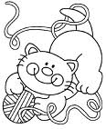



Nombre

Escucha la lectura de “Gatilda” de tu libro cuenta cuentos, decora el dibujo y pega silabas ga, go, gu alrededor.

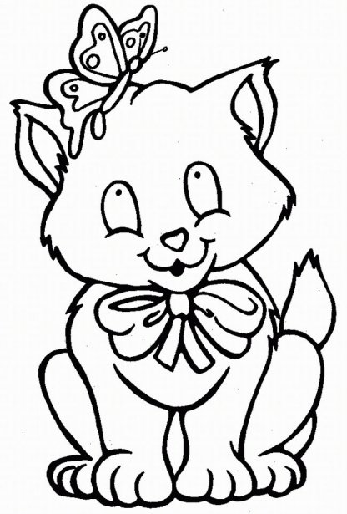



Nombre

Decora el dibujo, observa las palabras y encierra las silabas

ga, go, gu.

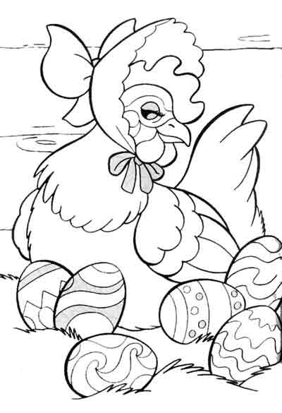

Gallina gusano bigote



Nombre

Ejercicio 1 Continúa con la plana ubicando el cuadro correctamente.

|  |  |  |  |  |  |  |  |  |  |  |  |  |  |  |  |  |  |  |  |  |  |  |  |  |  |  |  |  |  |
| --- | --- | --- | --- | --- | --- | --- | --- | --- | --- | --- | --- | --- | --- | --- | --- | --- | --- | --- | --- | --- | --- | --- | --- | --- | --- | --- | --- | --- | --- |
|  |  |  |  |  |  |  |  |  |  |  |  |  |  |  |  |  |  |  |  |  |  |  |  |  |  |  |  |  |  |
|  |  |  |  |  |  |  |  |  |  |  |  |  |  |  |  |  |  |  |  |  |  |  |  |  |  |  |  |  |  |
|  |  |  |  |  |  |  |  |  |  |  |  |  |  |  |  |  |  |  |  |  |  |  |  |  |  |  |  |  |  |
|  |  |  |  |  |  |  |  |  |  |  |  |  |  |  |  |  |  |  |  |  |  |  |  |  |  |  |  |  |  |
|  |  |  |  |  |  |  |  |  |  |  |  |  |  |  |  |  |  |  |  |  |  |  |  |  |  |  |  |  |  |
|  |  |  |  |  |  |  |  |  |  |  |  |  |  |  |  |  |  |  |  |  |  |  |  |  |  |  |  |  |  |

Ejercicio 2

|  |  |  |  |  |  |  |  |  |  |  |  |  |  |  |  |  |  |  |  |  |  |  |  |  |  |  |  |  |  |
| --- | --- | --- | --- | --- | --- | --- | --- | --- | --- | --- | --- | --- | --- | --- | --- | --- | --- | --- | --- | --- | --- | --- | --- | --- | --- | --- | --- | --- | --- |
|  |  |  |  |  |  |  |  |  |  |  |  |  |  |  |  |  |  |  |  |  |  |  |  |  |  |  |  |  |  |
|  |  |  |  |  |  |  |  |  |  |  |  |  |  |  |  |  |  |  |  |  |  |  |  |  |  |  |  |  |  |
|  |  |  |  |  |  |  |  |  |  |  |  |  |  |  |  |  |  |  |  |  |  |  |  |  |  |  |  |  |  |
|  |  |  |  |  |  |  |  |  |  |  |  |  |  |  |  |  |  |  |  |  |  |  |  |  |  |  |  |  |  |
|  |  |  |  |  |  |  |  |  |  |  |  |  |  |  |  |  |  |  |  |  |  |  |  |  |  |  |  |  |  |
|  |  |  |  |  |  |  |  |  |  |  |  |  |  |  |  |  |  |  |  |  |  |  |  |  |  |  |  |  |  |

Ejercicio 3

|  |  |  |  |  |  |  |  |  |  |  |  |  |  |  |  |  |  |  |  |  |  |  |  |  |  |  |  |  |  |
| --- | --- | --- | --- | --- | --- | --- | --- | --- | --- | --- | --- | --- | --- | --- | --- | --- | --- | --- | --- | --- | --- | --- | --- | --- | --- | --- | --- | --- | --- |
|  |  |  |  |  |  |  |  |  |  |  |  |  |  |  |  |  |  |  |  |  |  |  |  |  |  |  |  |  |  |
|  |  |  |  |  |  |  |  |  |  |  |  |  |  |  |  |  |  |  |  |  |  |  |  |  |  |  |  |  |  |
|  |  |  |  |  |  |  |  |  |  |  |  |  |  |  |  |  |  |  |  |  |  |  |  |  |  |  |  |  |  |
|  |  |  |  |  |  |  |  |  |  |  |  |  |  |  |  |  |  |  |  |  |  |  |  |  |  |  |  |  |  |
|  |  |  |  |  |  |  |  |  |  |  |  |  |  |  |  |  |  |  |  |  |  |  |  |  |  |  |  |  |  |
|  |  |  |  |  |  |  |  |  |  |  |  |  |  |  |  |  |  |  |  |  |  |  |  |  |  |  |  |  |  |

Ejercicio 4

|  |  |  |  |  |  |  |  |  |  |  |  |  |  |  |  |  |  |  |  |  |  |  |  |  |  |  |  |  |  |
| --- | --- | --- | --- | --- | --- | --- | --- | --- | --- | --- | --- | --- | --- | --- | --- | --- | --- | --- | --- | --- | --- | --- | --- | --- | --- | --- | --- | --- | --- |
|  |  |  |  |  |  |  |  |  |  |  |  |  |  |  |  |  |  |  |  |  |  |  |  |  |  |  |  |  |  |
|  |  |  |  |  |  |  |  |  |  |  |  |  |  |  |  |  |  |  |  |  |  |  |  |  |  |  |  |  |  |
|  |  |  |  |  |  |  |  |  |  |  |  |  |  |  |  |  |  |  |  |  |  |  |  |  |  |  |  |  |  |
|  |  |  |  |  |  |  |  |  |  |  |  |  |  |  |  |  |  |  |  |  |  |  |  |  |  |  |  |  |  |
|  |  |  |  |  |  |  |  |  |  |  |  |  |  |  |  |  |  |  |  |  |  |  |  |  |  |  |  |  |  |
|  |  |  |  |  |  |  |  |  |  |  |  |  |  |  |  |  |  |  |  |  |  |  |  |  |  |  |  |  |  |

Ejercicio 5

|  |  |  |  |  |  |  |  |  |  |  |  |  |  |  |  |  |  |  |  |  |  |  |  |  |  |  |  |  |  |
| --- | --- | --- | --- | --- | --- | --- | --- | --- | --- | --- | --- | --- | --- | --- | --- | --- | --- | --- | --- | --- | --- | --- | --- | --- | --- | --- | --- | --- | --- |
|  |  |  |  |  |  |  |  |  |  |  |  |  |  |  |  |  |  |  |  |  |  |  |  |  |  |  |  |  |  |
|  |  |  |  |  |  |  |  |  |  |  |  |  |  |  |  |  |  |  |  |  |  |  |  |  |  |  |  |  |  |
|  |  |  |  |  |  |  |  |  |  |  |  |  |  |  |  |  |  |  |  |  |  |  |  |  |  |  |  |  |  |
|  |  |  |  |  |  |  |  |  |  |  |  |  |  |  |  |  |  |  |  |  |  |  |  |  |  |  |  |  |  |
|  |  |  |  |  |  |  |  |  |  |  |  |  |  |  |  |  |  |  |  |  |  |  |  |  |  |  |  |  |  |
|  |  |  |  |  |  |  |  | Scan0005 |  |  |  |  |  |  |  |  |  |  |  |  |  |  |  |  |  |  |  |  |  |

Nombre

Ejercicio 1 Continúa con la plana ubicando el cuadro correctamente.

|  |  |  |  |  |  |  |  |  |  |  |  |  |  |  |  |  |  |  |  |  |  |  |  |  |  |  |  |  |  |
| --- | --- | --- | --- | --- | --- | --- | --- | --- | --- | --- | --- | --- | --- | --- | --- | --- | --- | --- | --- | --- | --- | --- | --- | --- | --- | --- | --- | --- | --- |
|  |  |  |  |  |  |  |  |  |  |  |  |  |  |  |  |  |  |  |  |  |  |  |  |  |  |  |  |  |  |
|  |  |  |  |  |  |  |  |  |  |  |  |  |  |  |  |  |  |  |  |  |  |  |  |  |  |  |  |  |  |
|  |  |  |  |  |  |  |  |  |  |  |  |  |  |  |  |  |  |  |  |  |  |  |  |  |  |  |  |  |  |
|  |  |  |  |  |  |  |  |  |  |  |  |  |  |  |  |  |  |  |  |  |  |  |  |  |  |  |  |  |  |
|  |  |  |  |  |  |  |  |  |  |  |  |  |  |  |  |  |  |  |  |  |  |  |  |  |  |  |  |  |  |
|  |  |  |  |  |  |  |  |  |  |  |  |  |  |  |  |  |  |  |  |  |  |  |  |  |  |  |  |  |  |

Ejercicio 2

|  |  |  |  |  |  |  |  |  |  |  |  |  |  |  |  |  |  |  |  |  |  |  |  |  |  |  |  |  |  |
| --- | --- | --- | --- | --- | --- | --- | --- | --- | --- | --- | --- | --- | --- | --- | --- | --- | --- | --- | --- | --- | --- | --- | --- | --- | --- | --- | --- | --- | --- |
|  |  |  |  |  |  |  |  |  |  |  |  |  |  |  |  |  |  |  |  |  |  |  |  |  |  |  |  |  |  |
|  |  |  |  |  |  |  |  |  |  |  |  |  |  |  |  |  |  |  |  |  |  |  |  |  |  |  |  |  |  |
|  |  |  |  |  |  |  |  |  |  |  |  |  |  |  |  |  |  |  |  |  |  |  |  |  |  |  |  |  |  |
|  |  |  |  |  |  |  |  |  |  |  |  |  |  |  |  |  |  |  |  |  |  |  |  |  |  |  |  |  |  |
|  |  |  |  |  |  |  |  |  |  |  |  |  |  |  |  |  |  |  |  |  |  |  |  |  |  |  |  |  |  |
|  |  |  |  |  |  |  |  |  |  |  |  |  |  |  |  |  |  |  |  |  |  |  |  |  |  |  |  |  |  |

Ejercicio 3

|  |  |  |  |  |  |  |  |  |  |  |  |  |  |  |  |  |  |  |  |  |  |  |  |  |  |  |  |  |  |
| --- | --- | --- | --- | --- | --- | --- | --- | --- | --- | --- | --- | --- | --- | --- | --- | --- | --- | --- | --- | --- | --- | --- | --- | --- | --- | --- | --- | --- | --- |
|  |  |  |  |  |  |  |  |  |  |  |  |  |  |  |  |  |  |  |  |  |  |  |  |  |  |  |  |  |  |
|  |  |  |  |  |  |  |  |  |  |  |  |  |  |  |  |  |  |  |  |  |  |  |  |  |  |  |  |  |  |
|  |  |  |  |  |  |  |  |  |  |  |  |  |  |  |  |  |  |  |  |  |  |  |  |  |  |  |  |  |  |
|  |  |  |  |  |  |  |  |  |  |  |  |  |  |  |  |  |  |  |  |  |  |  |  |  |  |  |  |  |  |
|  |  |  |  |  |  |  |  |  |  |  |  |  |  |  |  |  |  |  |  |  |  |  |  |  |  |  |  |  |  |
|  |  |  |  |  |  |  |  |  |  |  |  |  |  |  |  |  |  |  |  |  |  |  |  |  |  |  |  |  |  |

Ejercicio 4

|  |  |  |  |  |  |  |  |  |  |  |  |  |  |  |  |  |  |  |  |  |  |  |  |  |  |  |  |  |  |
| --- | --- | --- | --- | --- | --- | --- | --- | --- | --- | --- | --- | --- | --- | --- | --- | --- | --- | --- | --- | --- | --- | --- | --- | --- | --- | --- | --- | --- | --- |
|  |  |  |  |  |  |  |  |  |  |  |  |  |  |  |  |  |  |  |  |  |  |  |  |  |  |  |  |  |  |
|  |  |  |  |  |  |  |  |  |  |  |  |  |  |  |  |  |  |  |  |  |  |  |  |  |  |  |  |  |  |
|  |  |  |  |  |  |  |  |  |  |  |  |  |  |  |  |  |  |  |  |  |  |  |  |  |  |  |  |  |  |
|  |  |  |  |  |  |  |  |  |  |  |  |  |  |  |  |  |  |  |  |  |  |  |  |  |  |  |  |  |  |
|  |  |  |  |  |  |  |  |  |  |  |  |  |  |  |  |  |  |  |  |  |  |  |  |  |  |  |  |  |  |
|  |  |  |  |  |  |  |  |  |  |  |  |  |  |  |  |  |  |  |  |  |  |  |  |  |  |  |  |  |  |

Ejercicio 5

|  |  |  |  |  |  |  |  |  |  |  |  |  |  |  |  |  |  |  |  |  |  |  |  |  |  |  |  |  |  |
| --- | --- | --- | --- | --- | --- | --- | --- | --- | --- | --- | --- | --- | --- | --- | --- | --- | --- | --- | --- | --- | --- | --- | --- | --- | --- | --- | --- | --- | --- |
|  |  |  |  |  |  |  |  |  |  |  |  |  |  |  |  |  |  |  |  |  |  |  |  |  |  |  |  |  |  |
|  |  |  |  |  |  |  |  |  |  |  |  |  |  |  |  |  |  |  |  |  |  |  |  |  |  |  |  |  |  |
|  |  |  |  |  |  |  |  |  |  |  |  |  |  |  |  |  |  |  |  |  |  |  |  |  |  |  |  |  |  |
|  |  |  |  |  |  |  |  |  |  |  |  |  |  |  |  |  |  |  |  |  |  |  |  |  |  |  |  |  |  |
|  |  |  |  |  |  |  |  |  |  |  |  |  |  |  |  |  |  |  |  |  |  |  |  |  |  |  |  |  |  |
|  |  |  |  |  |  |  |  |  | Scan0005 |  |  |  |  |  |  |  |  |  |  |  |  |  |  |  |  |  |  |  |  |

Nombre

Observa las monedas que Gonzalo tiene en su alcancía.

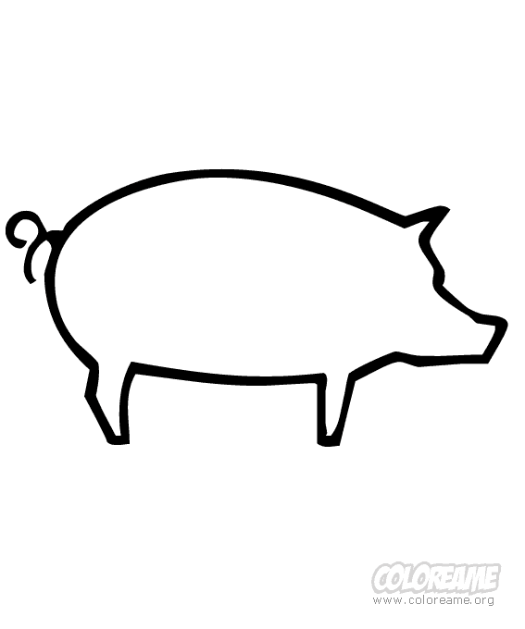

Las monedas sirven para comprar o pagar.

Nuestra unidad de monedas es el peso.

El peso se representa así: $



Nombre

0bserva y completa el sistema monetario.

$_______

$________

$_______

$_______



Nombre

Piensa y contesta

Tengo $36 y quiero comprar juguetes para mi muñeca Lulú.

Cuestan:

$10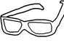 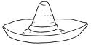  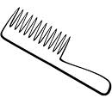 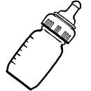

$8 $5 $4 $7

-si compre unos  y un 

- pague_______

-compre también un  y un 

-pague_______

-después de hacer las compras ¿Cuánto dinero me sobro?

-me sobro’________

Dibuja lo que no compraste.



Nombre

Escucha la lectura de “El girasol de Gertrudis” de tu libro de cuenta cuentos. Decora el dibujo y pégale palabras con ge, gi alrededor.

Ge Gi ge gi

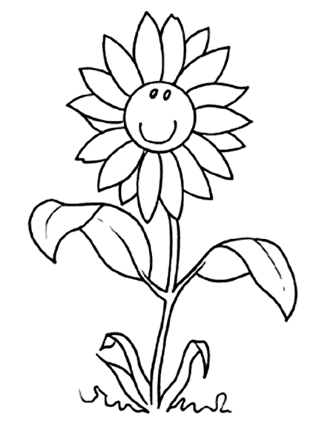



Nombre

Decora con material variado la letra GR, GL, gr, gl.

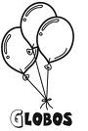

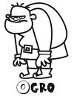



Nombre

Escucha la lectura de “Greta y Gracián” y “Gladis y Gloria” de tu cuenta cuentos y pega palabras con gl, gr donde correspondan.

Gr Gl



Nombre

Ejercicio 1 Continúa con la plana ubicando correctamente el cuadro.

|  |  |  |  |  |  |  |  |  |  |  |  |  |  |  |  |  |  |  |  |  |  |  |  |  |  |  |  |  |  |
| --- | --- | --- | --- | --- | --- | --- | --- | --- | --- | --- | --- | --- | --- | --- | --- | --- | --- | --- | --- | --- | --- | --- | --- | --- | --- | --- | --- | --- | --- |
|  |  |  |  |  |  |  |  |  |  |  |  |  |  |  |  |  |  |  |  |  |  |  |  |  |  |  |  |  |  |
|  |  |  |  |  |  |  |  |  |  |  |  |  |  |  |  |  |  |  |  |  |  |  |  |  |  |  |  |  |  |
|  |  |  |  |  |  |  |  |  |  |  |  |  |  |  |  |  |  |  |  |  |  |  |  |  |  |  |  |  |  |
|  |  |  |  |  |  |  |  |  |  |  |  |  |  |  |  |  |  |  |  |  |  |  |  |  |  |  |  |  |  |
|  |  |  |  |  |  |  |  |  |  |  |  |  |  |  |  |  |  |  |  |  |  |  |  |  |  |  |  |  |  |
|  |  |  |  |  |  |  |  |  |  |  |  |  |  |  |  |  |  |  |  |  |  |  |  |  |  |  |  |  |  |

Ejercicio 2

|  |  |  |  |  |  |  |  |  |  |  |  |  |  |  |  |  |  |  |  |  |  |  |  |  |  |  |  |  |  |
| --- | --- | --- | --- | --- | --- | --- | --- | --- | --- | --- | --- | --- | --- | --- | --- | --- | --- | --- | --- | --- | --- | --- | --- | --- | --- | --- | --- | --- | --- |
|  |  |  |  |  |  |  |  |  |  |  |  |  |  |  |  |  |  |  |  |  |  |  |  |  |  |  |  |  |  |
|  |  |  |  |  |  |  |  |  |  |  |  |  |  |  |  |  |  |  |  |  |  |  |  |  |  |  |  |  |  |
|  |  |  |  |  |  |  |  |  |  |  |  |  |  |  |  |  |  |  |  |  |  |  |  |  |  |  |  |  |  |
|  |  |  |  |  |  |  |  |  |  |  |  |  |  |  |  |  |  |  |  |  |  |  |  |  |  |  |  |  |  |
|  |  |  |  |  |  |  |  |  |  |  |  |  |  |  |  |  |  |  |  |  |  |  |  |  |  |  |  |  |  |
|  |  |  |  |  |  |  |  |  |  |  |  |  |  |  |  |  |  |  |  |  |  |  |  |  |  |  |  |  |  |

Ejercicio 3

|  |  |  |  |  |  |  |  |  |  |  |  |  |  |  |  |  |  |  |  |  |  |  |  |  |  |  |  |  |  |
| --- | --- | --- | --- | --- | --- | --- | --- | --- | --- | --- | --- | --- | --- | --- | --- | --- | --- | --- | --- | --- | --- | --- | --- | --- | --- | --- | --- | --- | --- |
|  |  |  |  |  |  |  |  |  |  |  |  |  |  |  |  |  |  |  |  |  |  |  |  |  |  |  |  |  |  |
|  |  |  |  |  |  |  |  |  |  |  |  |  |  |  |  |  |  |  |  |  |  |  |  |  |  |  |  |  |  |
|  |  |  |  |  |  |  |  |  |  |  |  |  |  |  |  |  |  |  |  |  |  |  |  |  |  |  |  |  |  |
|  |  |  |  |  |  |  |  |  |  |  |  |  |  |  |  |  |  |  |  |  |  |  |  |  |  |  |  |  |  |
|  |  |  |  |  |  |  |  |  |  |  |  |  |  |  |  |  |  |  |  |  |  |  |  |  |  |  |  |  |  |
|  |  |  |  |  |  |  |  |  |  |  |  |  |  |  |  |  |  |  |  |  |  |  |  |  |  |  |  |  |  |

Ejercicio 4

|  |  |  |  |  |  |  |  |  |  |  |  |  |  |  |  |  |  |  |  |  |  |  |  |  |  |  |  |  |  |
| --- | --- | --- | --- | --- | --- | --- | --- | --- | --- | --- | --- | --- | --- | --- | --- | --- | --- | --- | --- | --- | --- | --- | --- | --- | --- | --- | --- | --- | --- |
|  |  |  |  |  |  |  |  |  |  |  |  |  |  |  |  |  |  |  |  |  |  |  |  |  |  |  |  |  |  |
|  |  |  |  |  |  |  |  |  |  |  |  |  |  |  |  |  |  |  |  |  |  |  |  |  |  |  |  |  |  |
|  |  |  |  |  |  |  |  |  |  |  |  |  |  |  |  |  |  |  |  |  |  |  |  |  |  |  |  |  |  |
|  |  |  |  |  |  |  |  |  |  |  |  |  |  |  |  |  |  |  |  |  |  |  |  |  |  |  |  |  |  |
|  |  |  |  |  |  |  |  |  |  |  |  |  |  |  |  |  |  |  |  |  |  |  |  |  |  |  |  |  |  |
|  |  |  |  |  |  |  |  |  |  |  |  |  |  |  |  |  |  |  |  |  |  |  |  |  |  |  |  |  |  |

Ejercicio 5

|  |  |  |  |  |  |  |  |  |  |  |  |  |  |  |  |  |  |  |  |  |  |  |  |  |  |  |  |  |  |
| --- | --- | --- | --- | --- | --- | --- | --- | --- | --- | --- | --- | --- | --- | --- | --- | --- | --- | --- | --- | --- | --- | --- | --- | --- | --- | --- | --- | --- | --- |
|  |  |  |  |  |  |  |  |  |  |  |  |  |  |  |  |  |  |  |  |  |  |  |  |  |  |  |  |  |  |
|  |  |  |  |  |  |  |  |  |  |  |  |  |  |  |  |  |  |  |  |  |  |  |  |  |  |  |  |  |  |
|  |  |  |  |  |  |  |  |  |  |  |  |  |  |  |  |  |  |  |  |  |  |  |  |  |  |  |  |  |  |
|  |  |  |  |  |  |  |  |  |  |  |  |  |  |  |  |  |  |  |  |  |  |  |  |  |  |  |  |  |  |
|  |  |  |  |  |  |  |  |  |  |  |  |  |  |  |  |  |  |  |  |  |  |  |  |  |  |  |  |  |  |
|  |  |  |  |  |  |  |  |  |  | Scan0005 |  |  |  |  |  |  |  |  |  |  |  |  |  |  |  |  |  |  |  |

Nombre

Escucha la lectura de “Guillermo Miguel, un jicote aguamielero” de tu libro de cuenta cuentos, decora el dibujo y pégale palabras con gue gui.

Gue Gui gue gui

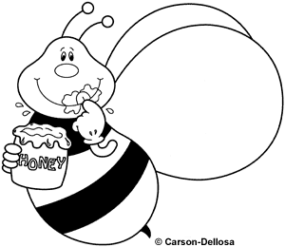



Nombre

Ejercicio 1 Continúa con la plana ubicando el cuadro correctamente.

|  |  |  |  |  |  |  |  |  |  |  |  |  |  |  |  |  |  |  |  |  |  |  |  |  |  |  |  |  |  |
| --- | --- | --- | --- | --- | --- | --- | --- | --- | --- | --- | --- | --- | --- | --- | --- | --- | --- | --- | --- | --- | --- | --- | --- | --- | --- | --- | --- | --- | --- |
|  |  |  |  |  |  |  |  |  |  |  |  |  |  |  |  |  |  |  |  |  |  |  |  |  |  |  |  |  |  |
|  |  |  |  |  |  |  |  |  |  |  |  |  |  |  |  |  |  |  |  |  |  |  |  |  |  |  |  |  |  |
|  |  |  |  |  |  |  |  |  |  |  |  |  |  |  |  |  |  |  |  |  |  |  |  |  |  |  |  |  |  |
|  |  |  |  |  |  |  |  |  |  |  |  |  |  |  |  |  |  |  |  |  |  |  |  |  |  |  |  |  |  |
|  |  |  |  |  |  |  |  |  |  |  |  |  |  |  |  |  |  |  |  |  |  |  |  |  |  |  |  |  |  |
|  |  |  |  |  |  |  |  |  |  |  |  |  |  |  |  |  |  |  |  |  |  |  |  |  |  |  |  |  |  |

Ejercicio 2

|  |  |  |  |  |  |  |  |  |  |  |  |  |  |  |  |  |  |  |  |  |  |  |  |  |  |  |  |  |  |
| --- | --- | --- | --- | --- | --- | --- | --- | --- | --- | --- | --- | --- | --- | --- | --- | --- | --- | --- | --- | --- | --- | --- | --- | --- | --- | --- | --- | --- | --- |
|  |  |  |  |  |  |  |  |  |  |  |  |  |  |  |  |  |  |  |  |  |  |  |  |  |  |  |  |  |  |
|  |  |  |  |  |  |  |  |  |  |  |  |  |  |  |  |  |  |  |  |  |  |  |  |  |  |  |  |  |  |
|  |  |  |  |  |  |  |  |  |  |  |  |  |  |  |  |  |  |  |  |  |  |  |  |  |  |  |  |  |  |
|  |  |  |  |  |  |  |  |  |  |  |  |  |  |  |  |  |  |  |  |  |  |  |  |  |  |  |  |  |  |
|  |  |  |  |  |  |  |  |  |  |  |  |  |  |  |  |  |  |  |  |  |  |  |  |  |  |  |  |  |  |
|  |  |  |  |  |  |  |  |  |  |  |  |  |  |  |  |  |  |  |  |  |  |  |  |  |  |  |  |  |  |

Ejercicio 3

|  |  |  |  |  |  |  |  |  |  |  |  |  |  |  |  |  |  |  |  |  |  |  |  |  |  |  |  |  |  |
| --- | --- | --- | --- | --- | --- | --- | --- | --- | --- | --- | --- | --- | --- | --- | --- | --- | --- | --- | --- | --- | --- | --- | --- | --- | --- | --- | --- | --- | --- |
|  |  |  |  |  |  |  |  |  |  |  |  |  |  |  |  |  |  |  |  |  |  |  |  |  |  |  |  |  |  |
|  |  |  |  |  |  |  |  |  |  |  |  |  |  |  |  |  |  |  |  |  |  |  |  |  |  |  |  |  |  |
|  |  |  |  |  |  |  |  |  |  |  |  |  |  |  |  |  |  |  |  |  |  |  |  |  |  |  |  |  |  |
|  |  |  |  |  |  |  |  |  |  |  |  |  |  |  |  |  |  |  |  |  |  |  |  |  |  |  |  |  |  |
|  |  |  |  |  |  |  |  |  |  |  |  |  |  |  |  |  |  |  |  |  |  |  |  |  |  |  |  |  |  |
|  |  |  |  |  |  |  |  |  |  |  |  |  |  |  |  |  |  |  |  |  |  |  |  |  |  |  |  |  |  |

Ejercicio 4

|  |  |  |  |  |  |  |  |  |  |  |  |  |  |  |  |  |  |  |  |  |  |  |  |  |  |  |  |  |  |
| --- | --- | --- | --- | --- | --- | --- | --- | --- | --- | --- | --- | --- | --- | --- | --- | --- | --- | --- | --- | --- | --- | --- | --- | --- | --- | --- | --- | --- | --- |
|  |  |  |  |  |  |  |  |  |  |  |  |  |  |  |  |  |  |  |  |  |  |  |  |  |  |  |  |  |  |
|  |  |  |  |  |  |  |  |  |  |  |  |  |  |  |  |  |  |  |  |  |  |  |  |  |  |  |  |  |  |
|  |  |  |  |  |  |  |  |  |  |  |  |  |  |  |  |  |  |  |  |  |  |  |  |  |  |  |  |  |  |
|  |  |  |  |  |  |  |  |  |  |  |  |  |  |  |  |  |  |  |  |  |  |  |  |  |  |  |  |  |  |
|  |  |  |  |  |  |  |  |  |  |  |  |  |  |  |  |  |  |  |  |  |  |  |  |  |  |  |  |  |  |
|  |  |  |  |  |  |  |  |  |  |  |  |  |  |  |  |  |  |  |  |  |  |  |  |  |  |  |  |  |  |

Ejercicio 5

|  |  |  |  |  |  |  |  |  |  |  |  |  |  |  |  |  |  |  |  |  |  |  |  |  |  |  |  |  |  |
| --- | --- | --- | --- | --- | --- | --- | --- | --- | --- | --- | --- | --- | --- | --- | --- | --- | --- | --- | --- | --- | --- | --- | --- | --- | --- | --- | --- | --- | --- |
|  |  |  |  |  |  |  |  |  |  |  |  |  |  |  |  |  |  |  |  |  |  |  |  |  |  |  |  |  |  |
|  |  |  |  |  |  |  |  |  |  |  |  |  |  |  |  |  |  |  |  |  |  |  |  |  |  |  |  |  |  |
|  |  |  |  |  |  |  |  |  |  |  |  |  |  |  |  |  |  |  |  |  |  |  |  |  |  |  |  |  |  |
|  |  |  |  |  |  |  |  |  |  |  |  |  |  |  |  |  |  |  |  |  |  |  |  |  |  |  |  |  |  |
|  |  |  |  |  |  |  |  |  |  |  |  |  |  |  |  |  |  |  |  |  |  |  |  |  |  |  |  |  |  |
|  |  |  |  |  |  |  |  |  | Scan0005 |  |  |  |  |  |  |  |  |  |  |  |  |  |  |  |  |  |  |  |  |

Nombre

Copia el siguiente problema y realízalo.

______________________________________________________________________________________________________­­­­­­

_____________________________________________

Operación

Resultado



Nombre

Escucha la lectura de “tabaversos” de tu cuenta cuentos ilustra la lectura y pégale palabras con Güe Güi.



Nombre

Ejercicio 1 Continúa con la plana de la letra ubicando el cuadro correctamente.

|  |  |  |  |  |  |  |  |  |  |  |  |  |  |  |  |  |  |  |  |  |  |  |  |  |  |  |  |  |  |
| --- | --- | --- | --- | --- | --- | --- | --- | --- | --- | --- | --- | --- | --- | --- | --- | --- | --- | --- | --- | --- | --- | --- | --- | --- | --- | --- | --- | --- | --- |
|  |  |  |  |  |  |  |  |  |  |  |  |  |  |  |  |  |  |  |  |  |  |  |  |  |  |  |  |  |  |
|  |  |  |  |  |  |  |  |  |  |  |  |  |  |  |  |  |  |  |  |  |  |  |  |  |  |  |  |  |  |
|  |  |  |  |  |  |  |  |  |  |  |  |  |  |  |  |  |  |  |  |  |  |  |  |  |  |  |  |  |  |
|  |  |  |  |  |  |  |  |  |  |  |  |  |  |  |  |  |  |  |  |  |  |  |  |  |  |  |  |  |  |
|  |  |  |  |  |  |  |  |  |  |  |  |  |  |  |  |  |  |  |  |  |  |  |  |  |  |  |  |  |  |
|  |  |  |  |  |  |  |  |  |  |  |  |  |  |  |  |  |  |  |  |  |  |  |  |  |  |  |  |  |  |

Ejercicio 2

|  |  |  |  |  |  |  |  |  |  |  |  |  |  |  |  |  |  |  |  |  |  |  |  |  |  |  |  |  |  |
| --- | --- | --- | --- | --- | --- | --- | --- | --- | --- | --- | --- | --- | --- | --- | --- | --- | --- | --- | --- | --- | --- | --- | --- | --- | --- | --- | --- | --- | --- |
|  |  |  |  |  |  |  |  |  |  |  |  |  |  |  |  |  |  |  |  |  |  |  |  |  |  |  |  |  |  |
|  |  |  |  |  |  |  |  |  |  |  |  |  |  |  |  |  |  |  |  |  |  |  |  |  |  |  |  |  |  |
|  |  |  |  |  |  |  |  |  |  |  |  |  |  |  |  |  |  |  |  |  |  |  |  |  |  |  |  |  |  |
|  |  |  |  |  |  |  |  |  |  |  |  |  |  |  |  |  |  |  |  |  |  |  |  |  |  |  |  |  |  |
|  |  |  |  |  |  |  |  |  |  |  |  |  |  |  |  |  |  |  |  |  |  |  |  |  |  |  |  |  |  |
|  |  |  |  |  |  |  |  |  |  |  |  |  |  |  |  |  |  |  |  |  |  |  |  |  |  |  |  |  |  |

Ejercicio 3

|  |  |  |  |  |  |  |  |  |  |  |  |  |  |  |  |  |  |  |  |  |  |  |  |  |  |  |  |  |  |
| --- | --- | --- | --- | --- | --- | --- | --- | --- | --- | --- | --- | --- | --- | --- | --- | --- | --- | --- | --- | --- | --- | --- | --- | --- | --- | --- | --- | --- | --- |
|  |  |  |  |  |  |  |  |  |  |  |  |  |  |  |  |  |  |  |  |  |  |  |  |  |  |  |  |  |  |
|  |  |  |  |  |  |  |  |  |  |  |  |  |  |  |  |  |  |  |  |  |  |  |  |  |  |  |  |  |  |
|  |  |  |  |  |  |  |  |  |  |  |  |  |  |  |  |  |  |  |  |  |  |  |  |  |  |  |  |  |  |
|  |  |  |  |  |  |  |  |  |  |  |  |  |  |  |  |  |  |  |  |  |  |  |  |  |  |  |  |  |  |
|  |  |  |  |  |  |  |  |  |  |  |  |  |  |  |  |  |  |  |  |  |  |  |  |  |  |  |  |  |  |
|  |  |  |  |  |  |  |  |  |  |  |  |  |  |  |  |  |  |  |  |  |  |  |  |  |  |  |  |  |  |

Ejercicio 4

|  |  |  |  |  |  |  |  |  |  |  |  |  |  |  |  |  |  |  |  |  |  |  |  |  |  |  |  |  |  |
| --- | --- | --- | --- | --- | --- | --- | --- | --- | --- | --- | --- | --- | --- | --- | --- | --- | --- | --- | --- | --- | --- | --- | --- | --- | --- | --- | --- | --- | --- |
|  |  |  |  |  |  |  |  |  |  |  |  |  |  |  |  |  |  |  |  |  |  |  |  |  |  |  |  |  |  |
|  |  |  |  |  |  |  |  |  |  |  |  |  |  |  |  |  |  |  |  |  |  |  |  |  |  |  |  |  |  |
|  |  |  |  |  |  |  |  |  |  |  |  |  |  |  |  |  |  |  |  |  |  |  |  |  |  |  |  |  |  |
|  |  |  |  |  |  |  |  |  |  |  |  |  |  |  |  |  |  |  |  |  |  |  |  |  |  |  |  |  |  |
|  |  |  |  |  |  |  |  |  |  |  |  |  |  |  |  |  |  |  |  |  |  |  |  |  |  |  |  |  |  |
|  |  |  |  |  |  |  |  |  |  |  |  |  |  |  |  |  |  |  |  |  |  |  |  |  |  |  |  |  |  |

Ejercicio 5

|  |  |  |  |  |  |  |  |  |  |  |  |  |  |  |  |  |  |  |  |  |  |  |  |  |  |  |  |  |  |
| --- | --- | --- | --- | --- | --- | --- | --- | --- | --- | --- | --- | --- | --- | --- | --- | --- | --- | --- | --- | --- | --- | --- | --- | --- | --- | --- | --- | --- | --- |
|  |  |  |  |  |  |  |  |  |  |  |  |  |  |  |  |  |  |  |  |  |  |  |  |  |  |  |  |  |  |
|  |  |  |  |  |  |  |  |  |  |  |  |  |  |  |  |  |  |  |  |  |  |  |  |  |  |  |  |  |  |
|  |  |  |  |  |  |  |  |  |  |  |  |  |  |  |  |  |  |  |  |  |  |  |  |  |  |  |  |  |  |
|  |  |  |  |  |  |  |  |  |  |  |  |  |  |  |  |  |  |  |  |  |  |  |  |  |  |  |  |  |  |
|  |  |  |  |  |  |  |  |  |  |  |  |  |  |  |  |  |  |  |  |  |  |  |  |  |  |  |  |  |  |
|  |  |  |  |  |  |  |  |  | Scan0005 |  |  |  |  |  |  |  |  |  |  |  |  |  |  |  |  |  |  |  |  |

Nombre

Realiza el dictado de números.

**. .**

**. .**

**. .**

**. .**

**. .**

**. .**



Nombre

Decora con material variado la W w.

Waterpolo

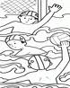



Nombre

Copia la lectura sobre las líneas y haz el dibujo.

Wenceslao y Wendy son amigos de Walter, el vino de una ciudad lejana llamada Winchester.

____________________________________________________________________________________________________________________________________________________________________________________________________________



Nombre

Escucha la lectura de “Trabalenguas de ida y vuelta” de tu cuenta cuentos y lustra con recortes y pega palabras con W w.



Nombre

Ejercicio 1 Continúa con la plana ubicando el cuadro correctamente.

|  |  |  |  |  |  |  |  |  |  |  |  |  |  |  |  |  |  |  |  |  |  |  |  |  |  |  |  |  |  |
| --- | --- | --- | --- | --- | --- | --- | --- | --- | --- | --- | --- | --- | --- | --- | --- | --- | --- | --- | --- | --- | --- | --- | --- | --- | --- | --- | --- | --- | --- |
|  |  |  |  |  |  |  |  |  |  |  |  |  |  |  |  |  |  |  |  |  |  |  |  |  |  |  |  |  |  |
|  |  |  |  |  |  |  |  |  |  |  |  |  |  |  |  |  |  |  |  |  |  |  |  |  |  |  |  |  |  |
|  |  |  |  |  |  |  |  |  |  |  |  |  |  |  |  |  |  |  |  |  |  |  |  |  |  |  |  |  |  |
|  |  |  |  |  |  |  |  |  |  |  |  |  |  |  |  |  |  |  |  |  |  |  |  |  |  |  |  |  |  |
|  |  |  |  |  |  |  |  |  |  |  |  |  |  |  |  |  |  |  |  |  |  |  |  |  |  |  |  |  |  |
|  |  |  |  |  |  |  |  |  |  |  |  |  |  |  |  |  |  |  |  |  |  |  |  |  |  |  |  |  |  |

Ejercicio 2

|  |  |  |  |  |  |  |  |  |  |  |  |  |  |  |  |  |  |  |  |  |  |  |  |  |  |  |  |  |  |
| --- | --- | --- | --- | --- | --- | --- | --- | --- | --- | --- | --- | --- | --- | --- | --- | --- | --- | --- | --- | --- | --- | --- | --- | --- | --- | --- | --- | --- | --- |
|  |  |  |  |  |  |  |  |  |  |  |  |  |  |  |  |  |  |  |  |  |  |  |  |  |  |  |  |  |  |
|  |  |  |  |  |  |  |  |  |  |  |  |  |  |  |  |  |  |  |  |  |  |  |  |  |  |  |  |  |  |
|  |  |  |  |  |  |  |  |  |  |  |  |  |  |  |  |  |  |  |  |  |  |  |  |  |  |  |  |  |  |
|  |  |  |  |  |  |  |  |  |  |  |  |  |  |  |  |  |  |  |  |  |  |  |  |  |  |  |  |  |  |
|  |  |  |  |  |  |  |  |  |  |  |  |  |  |  |  |  |  |  |  |  |  |  |  |  |  |  |  |  |  |
|  |  |  |  |  |  |  |  |  |  |  |  |  |  |  |  |  |  |  |  |  |  |  |  |  |  |  |  |  |  |

Ejercicio 3

|  |  |  |  |  |  |  |  |  |  |  |  |  |  |  |  |  |  |  |  |  |  |  |  |  |  |  |  |  |  |
| --- | --- | --- | --- | --- | --- | --- | --- | --- | --- | --- | --- | --- | --- | --- | --- | --- | --- | --- | --- | --- | --- | --- | --- | --- | --- | --- | --- | --- | --- |
|  |  |  |  |  |  |  |  |  |  |  |  |  |  |  |  |  |  |  |  |  |  |  |  |  |  |  |  |  |  |
|  |  |  |  |  |  |  |  |  |  |  |  |  |  |  |  |  |  |  |  |  |  |  |  |  |  |  |  |  |  |
|  |  |  |  |  |  |  |  |  |  |  |  |  |  |  |  |  |  |  |  |  |  |  |  |  |  |  |  |  |  |
|  |  |  |  |  |  |  |  |  |  |  |  |  |  |  |  |  |  |  |  |  |  |  |  |  |  |  |  |  |  |
|  |  |  |  |  |  |  |  |  |  |  |  |  |  |  |  |  |  |  |  |  |  |  |  |  |  |  |  |  |  |
|  |  |  |  |  |  |  |  |  |  |  |  |  |  |  |  |  |  |  |  |  |  |  |  |  |  |  |  |  |  |

Ejercicio 4

|  |  |  |  |  |  |  |  |  |  |  |  |  |  |  |  |  |  |  |  |  |  |  |  |  |  |  |  |  |  |
| --- | --- | --- | --- | --- | --- | --- | --- | --- | --- | --- | --- | --- | --- | --- | --- | --- | --- | --- | --- | --- | --- | --- | --- | --- | --- | --- | --- | --- | --- |
|  |  |  |  |  |  |  |  |  |  |  |  |  |  |  |  |  |  |  |  |  |  |  |  |  |  |  |  |  |  |
|  |  |  |  |  |  |  |  |  |  |  |  |  |  |  |  |  |  |  |  |  |  |  |  |  |  |  |  |  |  |
|  |  |  |  |  |  |  |  |  |  |  |  |  |  |  |  |  |  |  |  |  |  |  |  |  |  |  |  |  |  |
|  |  |  |  |  |  |  |  |  |  |  |  |  |  |  |  |  |  |  |  |  |  |  |  |  |  |  |  |  |  |
|  |  |  |  |  |  |  |  |  |  |  |  |  |  |  |  |  |  |  |  |  |  |  |  |  |  |  |  |  |  |
|  |  |  |  |  |  |  |  |  |  |  |  |  |  |  |  |  |  |  |  |  |  |  |  |  |  |  |  |  |  |

Ejercicio 5

|  |  |  |  |  |  |  |  |  |  |  |  |  |  |  |  |  |  |  |  |  |  |  |  |  |  |  |  |  |  |
| --- | --- | --- | --- | --- | --- | --- | --- | --- | --- | --- | --- | --- | --- | --- | --- | --- | --- | --- | --- | --- | --- | --- | --- | --- | --- | --- | --- | --- | --- |
|  |  |  |  |  |  |  |  |  |  |  |  |  |  |  |  |  |  |  |  |  |  |  |  |  |  |  |  |  |  |
|  |  |  |  |  |  |  |  |  |  |  |  |  |  |  |  |  |  |  |  |  |  |  |  |  |  |  |  |  |  |
|  |  |  |  |  |  |  |  |  |  |  |  |  |  |  |  |  |  |  |  |  |  |  |  |  |  |  |  |  |  |
|  |  |  |  |  |  |  |  |  |  |  |  |  |  |  |  |  |  |  |  |  |  |  |  |  |  |  |  |  |  |
|  |  |  |  |  |  |  |  |  |  |  |  |  |  |  |  |  |  |  |  |  |  |  |  |  |  |  |  |  |  |
|  |  |  |  |  |  |  |  | Scan0005 |  |  |  |  |  |  |  |  |  |  |  |  |  |  |  |  |  |  |  |  |  |

Nombre

Ejercicio 1 Continúa con la plana correctamente ubicando el cuadro.

|  |  |  |  |  |  |  |  |  |  |  |  |  |  |  |  |  |  |  |  |  |  |  |  |  |  |  |  |  |  |
| --- | --- | --- | --- | --- | --- | --- | --- | --- | --- | --- | --- | --- | --- | --- | --- | --- | --- | --- | --- | --- | --- | --- | --- | --- | --- | --- | --- | --- | --- |
|  |  |  |  |  |  |  |  |  |  |  |  |  |  |  |  |  |  |  |  |  |  |  |  |  |  |  |  |  |  |
|  |  |  |  |  |  |  |  |  |  |  |  |  |  |  |  |  |  |  |  |  |  |  |  |  |  |  |  |  |  |
|  |  |  |  |  |  |  |  |  |  |  |  |  |  |  |  |  |  |  |  |  |  |  |  |  |  |  |  |  |  |
|  |  |  |  |  |  |  |  |  |  |  |  |  |  |  |  |  |  |  |  |  |  |  |  |  |  |  |  |  |  |
|  |  |  |  |  |  |  |  |  |  |  |  |  |  |  |  |  |  |  |  |  |  |  |  |  |  |  |  |  |  |
|  |  |  |  |  |  |  |  |  |  |  |  |  |  |  |  |  |  |  |  |  |  |  |  |  |  |  |  |  |  |

Ejercicio 2

|  |  |  |  |  |  |  |  |  |  |  |  |  |  |  |  |  |  |  |  |  |  |  |  |  |  |  |  |  |  |
| --- | --- | --- | --- | --- | --- | --- | --- | --- | --- | --- | --- | --- | --- | --- | --- | --- | --- | --- | --- | --- | --- | --- | --- | --- | --- | --- | --- | --- | --- |
|  |  |  |  |  |  |  |  |  |  |  |  |  |  |  |  |  |  |  |  |  |  |  |  |  |  |  |  |  |  |
|  |  |  |  |  |  |  |  |  |  |  |  |  |  |  |  |  |  |  |  |  |  |  |  |  |  |  |  |  |  |
|  |  |  |  |  |  |  |  |  |  |  |  |  |  |  |  |  |  |  |  |  |  |  |  |  |  |  |  |  |  |
|  |  |  |  |  |  |  |  |  |  |  |  |  |  |  |  |  |  |  |  |  |  |  |  |  |  |  |  |  |  |
|  |  |  |  |  |  |  |  |  |  |  |  |  |  |  |  |  |  |  |  |  |  |  |  |  |  |  |  |  |  |
|  |  |  |  |  |  |  |  |  |  |  |  |  |  |  |  |  |  |  |  |  |  |  |  |  |  |  |  |  |  |

Ejercicio 3

|  |  |  |  |  |  |  |  |  |  |  |  |  |  |  |  |  |  |  |  |  |  |  |  |  |  |  |  |  |  |
| --- | --- | --- | --- | --- | --- | --- | --- | --- | --- | --- | --- | --- | --- | --- | --- | --- | --- | --- | --- | --- | --- | --- | --- | --- | --- | --- | --- | --- | --- |
|  |  |  |  |  |  |  |  |  |  |  |  |  |  |  |  |  |  |  |  |  |  |  |  |  |  |  |  |  |  |
|  |  |  |  |  |  |  |  |  |  |  |  |  |  |  |  |  |  |  |  |  |  |  |  |  |  |  |  |  |  |
|  |  |  |  |  |  |  |  |  |  |  |  |  |  |  |  |  |  |  |  |  |  |  |  |  |  |  |  |  |  |
|  |  |  |  |  |  |  |  |  |  |  |  |  |  |  |  |  |  |  |  |  |  |  |  |  |  |  |  |  |  |
|  |  |  |  |  |  |  |  |  |  |  |  |  |  |  |  |  |  |  |  |  |  |  |  |  |  |  |  |  |  |
|  |  |  |  |  |  |  |  |  |  |  |  |  |  |  |  |  |  |  |  |  |  |  |  |  |  |  |  |  |  |

Ejercicio 4

|  |  |  |  |  |  |  |  |  |  |  |  |  |  |  |  |  |  |  |  |  |  |  |  |  |  |  |  |  |  |
| --- | --- | --- | --- | --- | --- | --- | --- | --- | --- | --- | --- | --- | --- | --- | --- | --- | --- | --- | --- | --- | --- | --- | --- | --- | --- | --- | --- | --- | --- |
|  |  |  |  |  |  |  |  |  |  |  |  |  |  |  |  |  |  |  |  |  |  |  |  |  |  |  |  |  |  |
|  |  |  |  |  |  |  |  |  |  |  |  |  |  |  |  |  |  |  |  |  |  |  |  |  |  |  |  |  |  |
|  |  |  |  |  |  |  |  |  |  |  |  |  |  |  |  |  |  |  |  |  |  |  |  |  |  |  |  |  |  |
|  |  |  |  |  |  |  |  |  |  |  |  |  |  |  |  |  |  |  |  |  |  |  |  |  |  |  |  |  |  |
|  |  |  |  |  |  |  |  |  |  |  |  |  |  |  |  |  |  |  |  |  |  |  |  |  |  |  |  |  |  |
|  |  |  |  |  |  |  |  |  |  |  |  |  |  |  |  |  |  |  |  |  |  |  |  |  |  |  |  |  |  |

Ejercicio 5

|  |  |  |  |  |  |  |  |  |  |  |  |  |  |  |  |  |  |  |  |  |  |  |  |  |  |  |  |  |  |
| --- | --- | --- | --- | --- | --- | --- | --- | --- | --- | --- | --- | --- | --- | --- | --- | --- | --- | --- | --- | --- | --- | --- | --- | --- | --- | --- | --- | --- | --- |
|  |  |  |  |  |  |  |  |  |  |  |  |  |  |  |  |  |  |  |  |  |  |  |  |  |  |  |  |  |  |
|  |  |  |  |  |  |  |  |  |  |  |  |  |  |  |  |  |  |  |  |  |  |  |  |  |  |  |  |  |  |
|  |  |  |  |  |  |  |  |  |  |  |  |  |  |  |  |  |  |  |  |  |  |  |  |  |  |  |  |  |  |
|  |  |  |  |  |  |  |  |  |  |  |  |  |  |  |  |  |  |  |  |  |  |  |  |  |  |  |  |  |  |
|  |  |  |  |  |  |  |  |  |  |  |  |  |  |  |  |  |  |  |  |  |  |  |  |  |  |  |  |  |  |
|  |  |  |  |  |  |  |  |  | Scan0005 |  |  |  |  |  |  |  |  |  |  |  |  |  |  |  |  |  |  |  |  |

Nombre

Decora con material variado la letra r, rr.

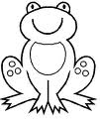

Débil

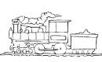

Fuerte



Nombre

Escucha la lectura de “Ronda de la risa” de tu libro cuenta cuentos y de las palabras con r arma una rima.



Nombre

Ejercicio 1 Continúa con la plana de la r ubicando correctamente el cuadro.

|  |  |  |  |  |  |  |  |  |  |  |  |  |  |  |  |  |  |  |  |  |  |  |  |  |  |  |  |  |  |
| --- | --- | --- | --- | --- | --- | --- | --- | --- | --- | --- | --- | --- | --- | --- | --- | --- | --- | --- | --- | --- | --- | --- | --- | --- | --- | --- | --- | --- | --- |
|  |  |  |  |  |  |  |  |  |  |  |  |  |  |  |  |  |  |  |  |  |  |  |  |  |  |  |  |  |  |
|  |  |  |  |  |  |  |  |  |  |  |  |  |  |  |  |  |  |  |  |  |  |  |  |  |  |  |  |  |  |
|  |  |  |  |  |  |  |  |  |  |  |  |  |  |  |  |  |  |  |  |  |  |  |  |  |  |  |  |  |  |
|  |  |  |  |  |  |  |  |  |  |  |  |  |  |  |  |  |  |  |  |  |  |  |  |  |  |  |  |  |  |
|  |  |  |  |  |  |  |  |  |  |  |  |  |  |  |  |  |  |  |  |  |  |  |  |  |  |  |  |  |  |
|  |  |  |  |  |  |  |  |  |  |  |  |  |  |  |  |  |  |  |  |  |  |  |  |  |  |  |  |  |  |

Ejercicio 2

|  |  |  |  |  |  |  |  |  |  |  |  |  |  |  |  |  |  |  |  |  |  |  |  |  |  |  |  |  |  |
| --- | --- | --- | --- | --- | --- | --- | --- | --- | --- | --- | --- | --- | --- | --- | --- | --- | --- | --- | --- | --- | --- | --- | --- | --- | --- | --- | --- | --- | --- |
|  |  |  |  |  |  |  |  |  |  |  |  |  |  |  |  |  |  |  |  |  |  |  |  |  |  |  |  |  |  |
|  |  |  |  |  |  |  |  |  |  |  |  |  |  |  |  |  |  |  |  |  |  |  |  |  |  |  |  |  |  |
|  |  |  |  |  |  |  |  |  |  |  |  |  |  |  |  |  |  |  |  |  |  |  |  |  |  |  |  |  |  |
|  |  |  |  |  |  |  |  |  |  |  |  |  |  |  |  |  |  |  |  |  |  |  |  |  |  |  |  |  |  |
|  |  |  |  |  |  |  |  |  |  |  |  |  |  |  |  |  |  |  |  |  |  |  |  |  |  |  |  |  |  |
|  |  |  |  |  |  |  |  |  |  |  |  |  |  |  |  |  |  |  |  |  |  |  |  |  |  |  |  |  |  |

Ejercicio 3

|  |  |  |  |  |  |  |  |  |  |  |  |  |  |  |  |  |  |  |  |  |  |  |  |  |  |  |  |  |  |
| --- | --- | --- | --- | --- | --- | --- | --- | --- | --- | --- | --- | --- | --- | --- | --- | --- | --- | --- | --- | --- | --- | --- | --- | --- | --- | --- | --- | --- | --- |
|  |  |  |  |  |  |  |  |  |  |  |  |  |  |  |  |  |  |  |  |  |  |  |  |  |  |  |  |  |  |
|  |  |  |  |  |  |  |  |  |  |  |  |  |  |  |  |  |  |  |  |  |  |  |  |  |  |  |  |  |  |
|  |  |  |  |  |  |  |  |  |  |  |  |  |  |  |  |  |  |  |  |  |  |  |  |  |  |  |  |  |  |
|  |  |  |  |  |  |  |  |  |  |  |  |  |  |  |  |  |  |  |  |  |  |  |  |  |  |  |  |  |  |
|  |  |  |  |  |  |  |  |  |  |  |  |  |  |  |  |  |  |  |  |  |  |  |  |  |  |  |  |  |  |
|  |  |  |  |  |  |  |  |  |  |  |  |  |  |  |  |  |  |  |  |  |  |  |  |  |  |  |  |  |  |

Ejercicio 4

|  |  |  |  |  |  |  |  |  |  |  |  |  |  |  |  |  |  |  |  |  |  |  |  |  |  |  |  |  |  |
| --- | --- | --- | --- | --- | --- | --- | --- | --- | --- | --- | --- | --- | --- | --- | --- | --- | --- | --- | --- | --- | --- | --- | --- | --- | --- | --- | --- | --- | --- |
|  |  |  |  |  |  |  |  |  |  |  |  |  |  |  |  |  |  |  |  |  |  |  |  |  |  |  |  |  |  |
|  |  |  |  |  |  |  |  |  |  |  |  |  |  |  |  |  |  |  |  |  |  |  |  |  |  |  |  |  |  |
|  |  |  |  |  |  |  |  |  |  |  |  |  |  |  |  |  |  |  |  |  |  |  |  |  |  |  |  |  |  |
|  |  |  |  |  |  |  |  |  |  |  |  |  |  |  |  |  |  |  |  |  |  |  |  |  |  |  |  |  |  |
|  |  |  |  |  |  |  |  |  |  |  |  |  |  |  |  |  |  |  |  |  |  |  |  |  |  |  |  |  |  |
|  |  |  |  |  |  |  |  |  |  |  |  |  |  |  |  |  |  |  |  |  |  |  |  |  |  |  |  |  |  |

Ejercicio 5

|  |  |  |  |  |  |  |  |  |  |  |  |  |  |  |  |  |  |  |  |  |  |  |  |  |  |  |  |  |  |
| --- | --- | --- | --- | --- | --- | --- | --- | --- | --- | --- | --- | --- | --- | --- | --- | --- | --- | --- | --- | --- | --- | --- | --- | --- | --- | --- | --- | --- | --- |
|  |  |  |  |  |  |  |  |  |  |  |  |  |  |  |  |  |  |  |  |  |  |  |  |  |  |  |  |  |  |
|  |  |  |  |  |  |  |  |  |  |  |  |  |  |  |  |  |  |  |  |  |  |  |  |  |  |  |  |  |  |
|  |  |  |  |  |  |  |  |  |  |  |  |  |  |  |  |  |  |  |  |  |  |  |  |  |  |  |  |  |  |
|  |  |  |  |  |  |  |  |  |  |  |  |  |  |  |  |  |  |  |  |  |  |  |  |  |  |  |  |  |  |
|  |  |  |  |  |  |  |  |  |  |  |  |  |  |  |  |  |  |  |  |  |  |  |  |  |  |  |  |  |  |
|  |  |  |  |  |  |  |  | Scan0005 |  |  |  |  |  |  |  |  |  |  |  |  |  |  |  |  |  |  |  |  |  |

Nombre

Escucha la lectura de “El carruaje del terror” de tu libro cuenta cuentos y con recortes pega otras palabras con doble rr.



Nombre

Ejercicio 1 Continúa con la plana de la rr ubicando el cuadro correctamente.

|  |  |  |  |  |  |  |  |  |  |  |  |  |  |  |  |  |  |  |  |  |  |  |  |  |  |  |  |  |  |
| --- | --- | --- | --- | --- | --- | --- | --- | --- | --- | --- | --- | --- | --- | --- | --- | --- | --- | --- | --- | --- | --- | --- | --- | --- | --- | --- | --- | --- | --- |
|  |  |  |  |  |  |  |  |  |  |  |  |  |  |  |  |  |  |  |  |  |  |  |  |  |  |  |  |  |  |
|  |  |  |  |  |  |  |  |  |  |  |  |  |  |  |  |  |  |  |  |  |  |  |  |  |  |  |  |  |  |
|  |  |  |  |  |  |  |  |  |  |  |  |  |  |  |  |  |  |  |  |  |  |  |  |  |  |  |  |  |  |
|  |  |  |  |  |  |  |  |  |  |  |  |  |  |  |  |  |  |  |  |  |  |  |  |  |  |  |  |  |  |
|  |  |  |  |  |  |  |  |  |  |  |  |  |  |  |  |  |  |  |  |  |  |  |  |  |  |  |  |  |  |
|  |  |  |  |  |  |  |  |  |  |  |  |  |  |  |  |  |  |  |  |  |  |  |  |  |  |  |  |  |  |

Ejercicio 2

|  |  |  |  |  |  |  |  |  |  |  |  |  |  |  |  |  |  |  |  |  |  |  |  |  |  |  |  |  |  |
| --- | --- | --- | --- | --- | --- | --- | --- | --- | --- | --- | --- | --- | --- | --- | --- | --- | --- | --- | --- | --- | --- | --- | --- | --- | --- | --- | --- | --- | --- |
|  |  |  |  |  |  |  |  |  |  |  |  |  |  |  |  |  |  |  |  |  |  |  |  |  |  |  |  |  |  |
|  |  |  |  |  |  |  |  |  |  |  |  |  |  |  |  |  |  |  |  |  |  |  |  |  |  |  |  |  |  |
|  |  |  |  |  |  |  |  |  |  |  |  |  |  |  |  |  |  |  |  |  |  |  |  |  |  |  |  |  |  |
|  |  |  |  |  |  |  |  |  |  |  |  |  |  |  |  |  |  |  |  |  |  |  |  |  |  |  |  |  |  |
|  |  |  |  |  |  |  |  |  |  |  |  |  |  |  |  |  |  |  |  |  |  |  |  |  |  |  |  |  |  |
|  |  |  |  |  |  |  |  |  |  |  |  |  |  |  |  |  |  |  |  |  |  |  |  |  |  |  |  |  |  |

Ejercicio 3

|  |  |  |  |  |  |  |  |  |  |  |  |  |  |  |  |  |  |  |  |  |  |  |  |  |  |  |  |  |  |
| --- | --- | --- | --- | --- | --- | --- | --- | --- | --- | --- | --- | --- | --- | --- | --- | --- | --- | --- | --- | --- | --- | --- | --- | --- | --- | --- | --- | --- | --- |
|  |  |  |  |  |  |  |  |  |  |  |  |  |  |  |  |  |  |  |  |  |  |  |  |  |  |  |  |  |  |
|  |  |  |  |  |  |  |  |  |  |  |  |  |  |  |  |  |  |  |  |  |  |  |  |  |  |  |  |  |  |
|  |  |  |  |  |  |  |  |  |  |  |  |  |  |  |  |  |  |  |  |  |  |  |  |  |  |  |  |  |  |
|  |  |  |  |  |  |  |  |  |  |  |  |  |  |  |  |  |  |  |  |  |  |  |  |  |  |  |  |  |  |
|  |  |  |  |  |  |  |  |  |  |  |  |  |  |  |  |  |  |  |  |  |  |  |  |  |  |  |  |  |  |
|  |  |  |  |  |  |  |  |  |  |  |  |  |  |  |  |  |  |  |  |  |  |  |  |  |  |  |  |  |  |

Ejercicio 4

|  |  |  |  |  |  |  |  |  |  |  |  |  |  |  |  |  |  |  |  |  |  |  |  |  |  |  |  |  |  |
| --- | --- | --- | --- | --- | --- | --- | --- | --- | --- | --- | --- | --- | --- | --- | --- | --- | --- | --- | --- | --- | --- | --- | --- | --- | --- | --- | --- | --- | --- |
|  |  |  |  |  |  |  |  |  |  |  |  |  |  |  |  |  |  |  |  |  |  |  |  |  |  |  |  |  |  |
|  |  |  |  |  |  |  |  |  |  |  |  |  |  |  |  |  |  |  |  |  |  |  |  |  |  |  |  |  |  |
|  |  |  |  |  |  |  |  |  |  |  |  |  |  |  |  |  |  |  |  |  |  |  |  |  |  |  |  |  |  |
|  |  |  |  |  |  |  |  |  |  |  |  |  |  |  |  |  |  |  |  |  |  |  |  |  |  |  |  |  |  |
|  |  |  |  |  |  |  |  |  |  |  |  |  |  |  |  |  |  |  |  |  |  |  |  |  |  |  |  |  |  |
|  |  |  |  |  |  |  |  |  |  |  |  |  |  |  |  |  |  |  |  |  |  |  |  |  |  |  |  |  |  |

Ejercicio 5

|  |  |  |  |  |  |  |  |  |  |  |  |  |  |  |  |  |  |  |  |  |  |  |  |  |  |  |  |  |  |
| --- | --- | --- | --- | --- | --- | --- | --- | --- | --- | --- | --- | --- | --- | --- | --- | --- | --- | --- | --- | --- | --- | --- | --- | --- | --- | --- | --- | --- | --- |
|  |  |  |  |  |  |  |  |  |  |  |  |  |  |  |  |  |  |  |  |  |  |  |  |  |  |  |  |  |  |
|  |  |  |  |  |  |  |  |  |  |  |  |  |  |  |  |  |  |  |  |  |  |  |  |  |  |  |  |  |  |
|  |  |  |  |  |  |  |  |  |  |  |  |  |  |  |  |  |  |  |  |  |  |  |  |  |  |  |  |  |  |
|  |  |  |  |  |  |  |  |  |  |  |  |  |  |  |  |  |  |  |  |  |  |  |  |  |  |  |  |  |  |
|  |  |  |  |  |  |  |  |  |  |  |  |  |  |  |  |  |  |  |  |  |  |  |  |  |  |  |  |  |  |
|  |  |  |  |  |  |  |  |  |  | Scan0005 |  |  |  |  |  |  |  |  |  |  |  |  |  |  |  |  |  |  |  |

Nombre

Observa los dibujos y únelos con la palabra correcta.

Ramo

 Ratón 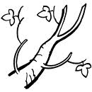

Rosa

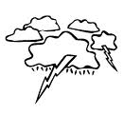 Rama 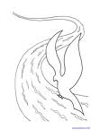

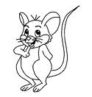 Rayo 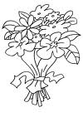

Rió



Nombre

Decora lo que celebramos en Junio.

DIA DEL PADRE.

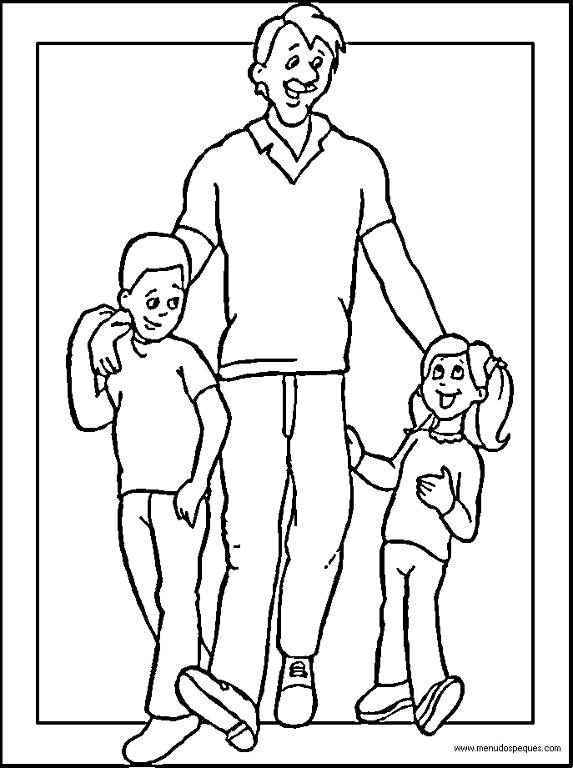



Nombre

Copia del pizarrón el párrafo en cursiva.

________________________________________________________________________________________________________________________________________________________________________________________________________________________________________________________________________________________________________________



Nombre

Decora tu nombre completo con material variado.



Nombre

Copia del pizarrón el texto en script.

________________________________________________________________________________________________________________________________________________________________________________________________________________________________________________________________________________________________________________



Nombre

Colorea de rojo los círculos, de amarillo los cuadrados, de verde los triángulos, de café los rectángulos, de morado los rombos y de azul los trapecios.

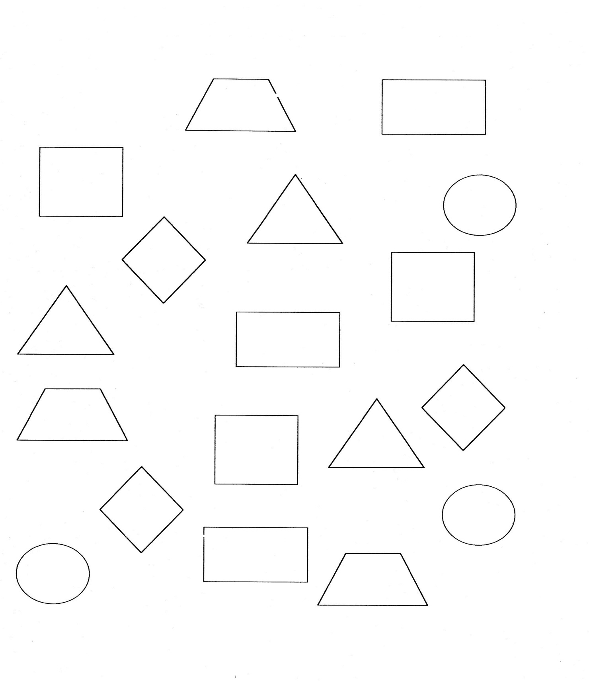



Nombre

Resuelve los siguientes problemas.

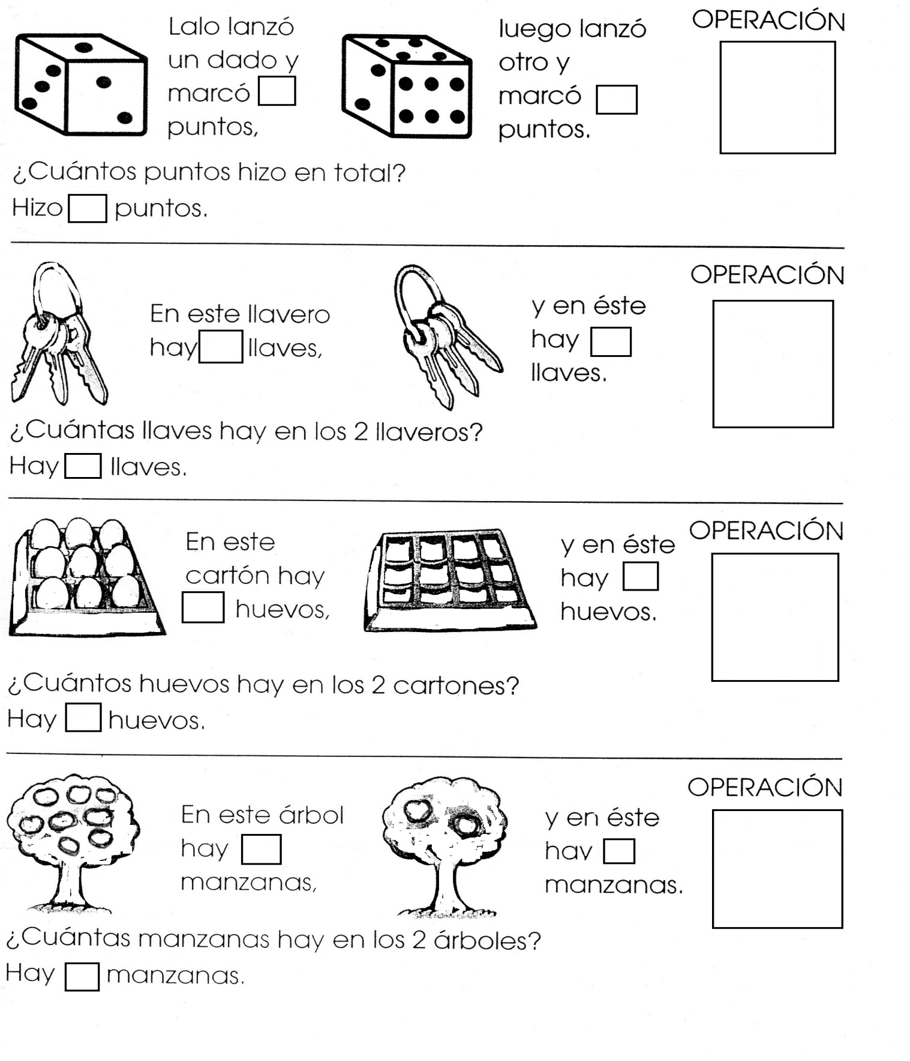



Nombre

Escribe tu nombre completo en las dos letras ubicando el cuadro. Ejercicio 1

|  |  |  |  |  |  |  |  |  |  |  |  |  |  |  |  |  |  |  |  |  |  |  |  |  |  |  |  |  |  |
| --- | --- | --- | --- | --- | --- | --- | --- | --- | --- | --- | --- | --- | --- | --- | --- | --- | --- | --- | --- | --- | --- | --- | --- | --- | --- | --- | --- | --- | --- |
|  |  |  |  |  |  |  |  |  |  |  |  |  |  |  |  |  |  |  |  |  |  |  |  |  |  |  |  |  |  |
|  |  |  |  |  |  |  |  |  |  |  |  |  |  |  |  |  |  |  |  |  |  |  |  |  |  |  |  |  |  |
|  |  |  |  |  |  |  |  |  |  |  |  |  |  |  |  |  |  |  |  |  |  |  |  |  |  |  |  |  |  |
|  |  |  |  |  |  |  |  |  |  |  |  |  |  |  |  |  |  |  |  |  |  |  |  |  |  |  |  |  |  |
|  |  |  |  |  |  |  |  |  |  |  |  |  |  |  |  |  |  |  |  |  |  |  |  |  |  |  |  |  |  |
|  |  |  |  |  |  |  |  |  |  |  |  |  |  |  |  |  |  |  |  |  |  |  |  |  |  |  |  |  |  |

Ejercicio 2

|  |  |  |  |  |  |  |  |  |  |  |  |  |  |  |  |  |  |  |  |  |  |  |  |  |  |  |  |  |  |
| --- | --- | --- | --- | --- | --- | --- | --- | --- | --- | --- | --- | --- | --- | --- | --- | --- | --- | --- | --- | --- | --- | --- | --- | --- | --- | --- | --- | --- | --- |
|  |  |  |  |  |  |  |  |  |  |  |  |  |  |  |  |  |  |  |  |  |  |  |  |  |  |  |  |  |  |
|  |  |  |  |  |  |  |  |  |  |  |  |  |  |  |  |  |  |  |  |  |  |  |  |  |  |  |  |  |  |
|  |  |  |  |  |  |  |  |  |  |  |  |  |  |  |  |  |  |  |  |  |  |  |  |  |  |  |  |  |  |
|  |  |  |  |  |  |  |  |  |  |  |  |  |  |  |  |  |  |  |  |  |  |  |  |  |  |  |  |  |  |
|  |  |  |  |  |  |  |  |  |  |  |  |  |  |  |  |  |  |  |  |  |  |  |  |  |  |  |  |  |  |
|  |  |  |  |  |  |  |  |  |  |  |  |  |  |  |  |  |  |  |  |  |  |  |  |  |  |  |  |  |  |

Ejercicio 3

|  |  |  |  |  |  |  |  |  |  |  |  |  |  |  |  |  |  |  |  |  |  |  |  |  |  |  |  |  |  |
| --- | --- | --- | --- | --- | --- | --- | --- | --- | --- | --- | --- | --- | --- | --- | --- | --- | --- | --- | --- | --- | --- | --- | --- | --- | --- | --- | --- | --- | --- |
|  |  |  |  |  |  |  |  |  |  |  |  |  |  |  |  |  |  |  |  |  |  |  |  |  |  |  |  |  |  |
|  |  |  |  |  |  |  |  |  |  |  |  |  |  |  |  |  |  |  |  |  |  |  |  |  |  |  |  |  |  |
|  |  |  |  |  |  |  |  |  |  |  |  |  |  |  |  |  |  |  |  |  |  |  |  |  |  |  |  |  |  |
|  |  |  |  |  |  |  |  |  |  |  |  |  |  |  |  |  |  |  |  |  |  |  |  |  |  |  |  |  |  |
|  |  |  |  |  |  |  |  |  |  |  |  |  |  |  |  |  |  |  |  |  |  |  |  |  |  |  |  |  |  |
|  |  |  |  |  |  |  |  |  |  |  |  |  |  |  |  |  |  |  |  |  |  |  |  |  |  |  |  |  |  |

Ejercicio 4

|  |  |  |  |  |  |  |  |  |  |  |  |  |  |  |  |  |  |  |  |  |  |  |  |  |  |  |  |  |  |
| --- | --- | --- | --- | --- | --- | --- | --- | --- | --- | --- | --- | --- | --- | --- | --- | --- | --- | --- | --- | --- | --- | --- | --- | --- | --- | --- | --- | --- | --- |
|  |  |  |  |  |  |  |  |  |  |  |  |  |  |  |  |  |  |  |  |  |  |  |  |  |  |  |  |  |  |
|  |  |  |  |  |  |  |  |  |  |  |  |  |  |  |  |  |  |  |  |  |  |  |  |  |  |  |  |  |  |
|  |  |  |  |  |  |  |  |  |  |  |  |  |  |  |  |  |  |  |  |  |  |  |  |  |  |  |  |  |  |
|  |  |  |  |  |  |  |  |  |  |  |  |  |  |  |  |  |  |  |  |  |  |  |  |  |  |  |  |  |  |
|  |  |  |  |  |  |  |  |  |  |  |  |  |  |  |  |  |  |  |  |  |  |  |  |  |  |  |  |  |  |
|  |  |  |  |  |  |  |  |  |  |  |  |  |  |  |  |  |  |  |  |  |  |  |  |  |  |  |  |  |  |

Ejercicio 5

|  |  |  |  |  |  |  |  |  |  |  |  |  |  |  |  |  |  |  |  |  |  |  |  |  |  |  |  |  |  |
| --- | --- | --- | --- | --- | --- | --- | --- | --- | --- | --- | --- | --- | --- | --- | --- | --- | --- | --- | --- | --- | --- | --- | --- | --- | --- | --- | --- | --- | --- |
|  |  |  |  |  |  |  |  |  |  |  |  |  |  |  |  |  |  |  |  |  |  |  |  |  |  |  |  |  |  |
|  |  |  |  |  |  |  |  |  |  |  |  |  |  |  |  |  |  |  |  |  |  |  |  |  |  |  |  |  |  |
|  |  |  |  |  |  |  |  |  |  |  |  |  |  |  |  |  |  |  |  |  |  |  |  |  |  |  |  |  |  |
|  |  |  |  |  |  |  |  |  |  |  |  |  |  |  |  |  |  |  |  |  |  |  |  |  |  |  |  |  |  |
|  |  |  |  |  |  |  |  |  |  |  |  |  |  |  |  |  |  |  |  |  |  |  |  |  |  |  |  |  |  |
|  |  |  |  |  |  |  |  |  |  |  |  |  |  |  |  |  |  |  |  |  |  |  |  |  |  |  |  |  |  |



Abecedario

a b c ch d

e f g h i

j k l ll m

n ñ o p q

r s t u v

w x y z



pequeño-grande

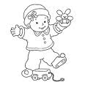

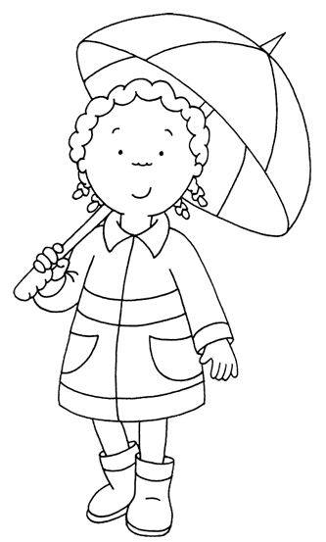

 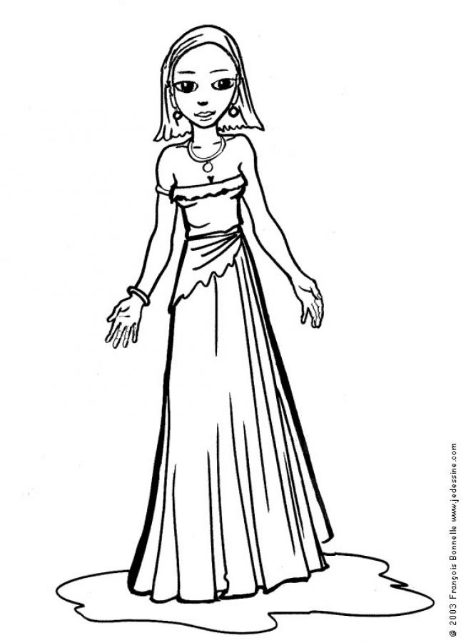

Rompecabezas

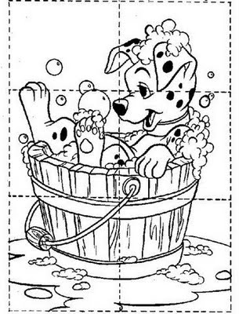



Soy niña o niño

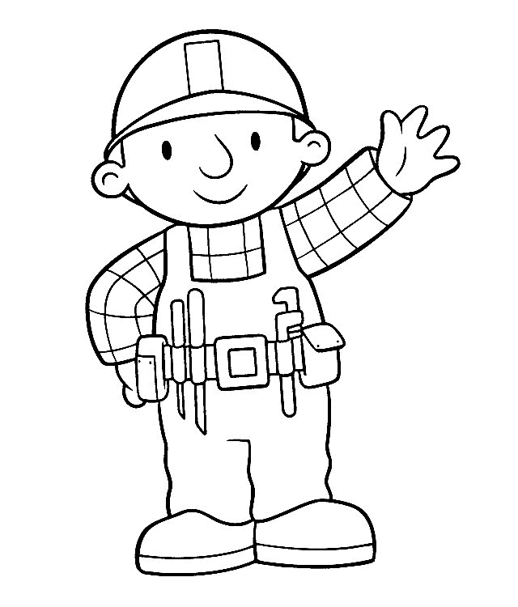 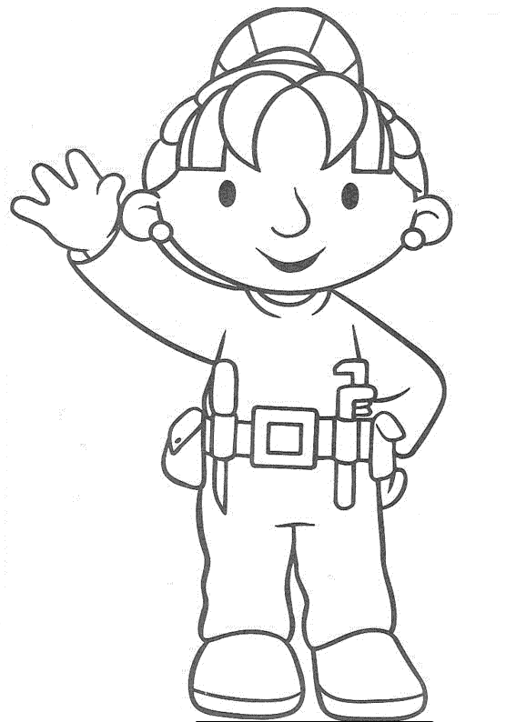



Cerca





Números ordinales



Días de la semana

Lunes

Martes

Miércoles

Jueves

Viernes

Sábado

Domingo



Familia del 40

40

41

42

43

44

45

46

47

48

49



Arriba-abajo



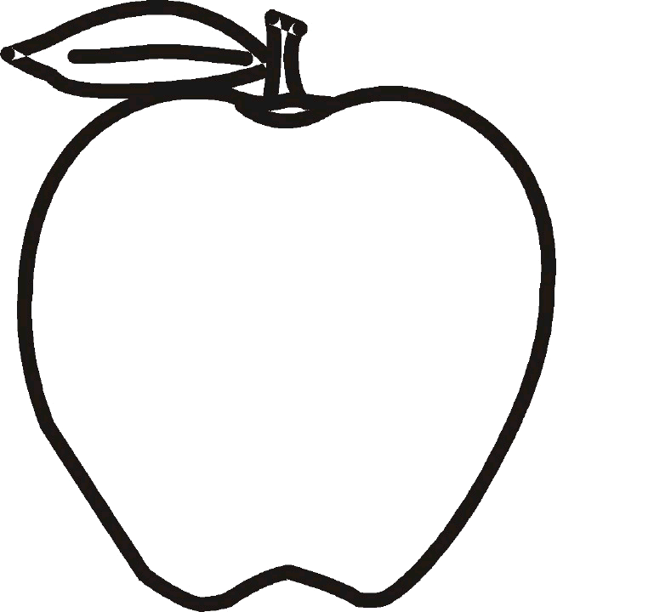



Adelante-atrás

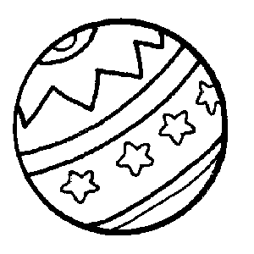

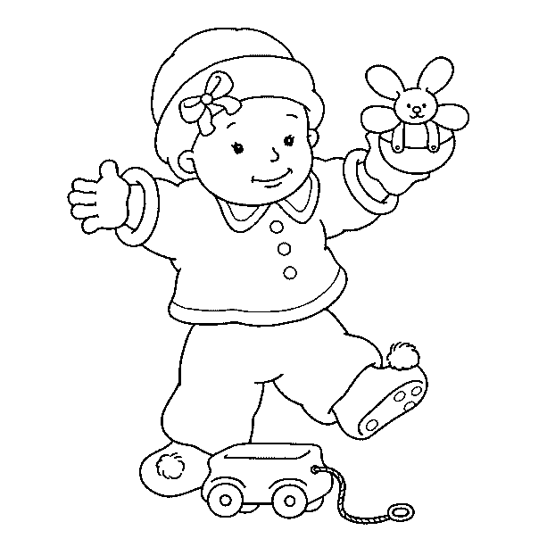



Familia del 60

60

61

62

63

64

65

66

67

68

69



Cerca-lejos

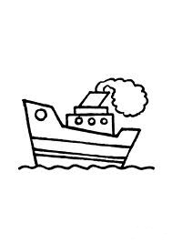

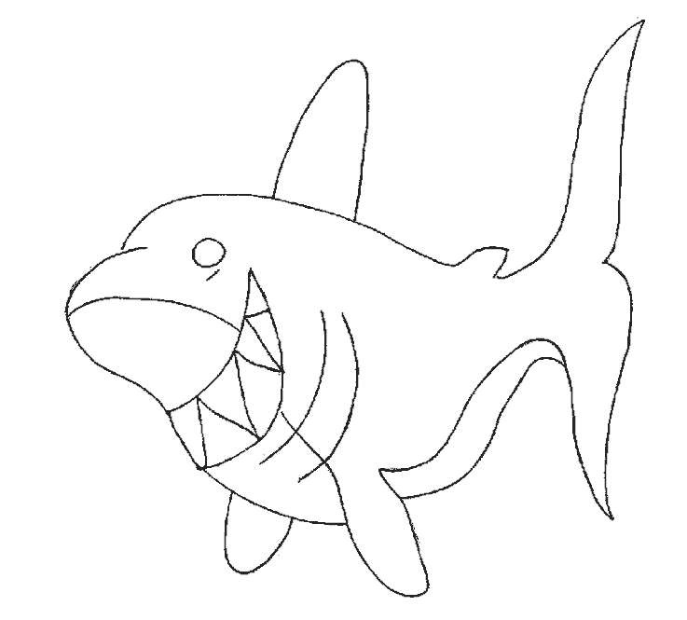



Lleno-vacio

